Csc_7 Notes

4.3 Direct proof and counterexample 3: Divisibility

Number theory

* Def) The study of properties of integers
* 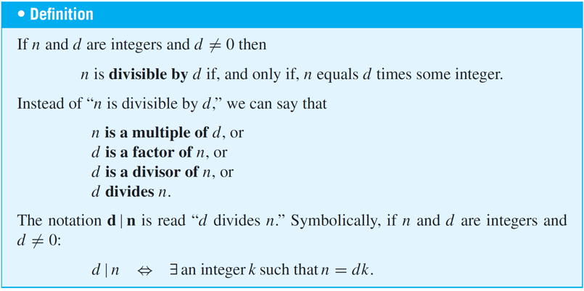
* Ex) Is 21 divisible by 3?
  + Yes, since 3 * 7 = 21

Properties of divisibility

* Property 1:
  + 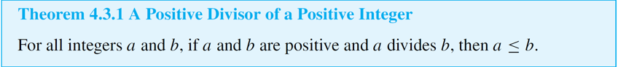
* Property 2:
  + 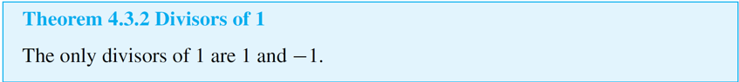
* Ex) If *a* and *b* are integers, is 3*a* + 3*b* divisible by 3?
  + Solution: Yes. By the distributive law of algebra, 3*a* + 3*b* = 3(*a* + *b*)  
     and *a* + *b* is an integer because it is a sum of two  
     integers
* One of the most useful properties of divisibility is that it is transitive.
  + If one number divides a second and the second number divides a third, then the first number divides the third.

Transitivity

* 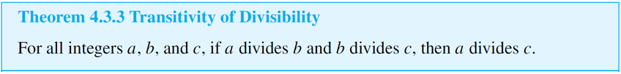

Divisibility by prime

* 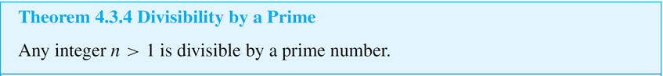

Counterexamples and Divisibility

* To show that a proposed divisibility property is not universally true, you need only find one pair of integers for which it is false.
* Ex)
  + 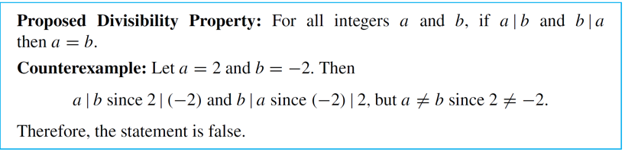

Unique factorization of integer theorem

* Also called the *fundamental theorem of arithmetic*
* States:
  + Any integer greater than 1 either is prime or can be written as a product of prime numbers in a way that is unique except, perhaps, for the order in which the primes are written.
  + Can be factored into a prime.
* 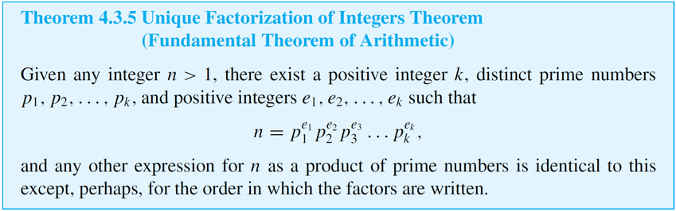

Standard factored form

* 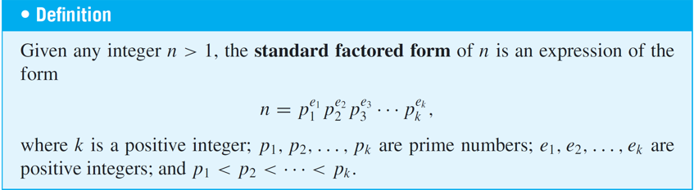

4.4) Direct proof 4: Division and quotient remainder theorem

* 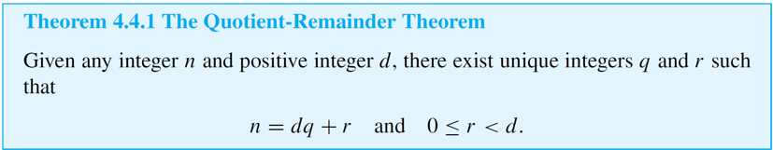

Div and Mod

* Div and mod are used to find the quotient-remainder theorem.
* 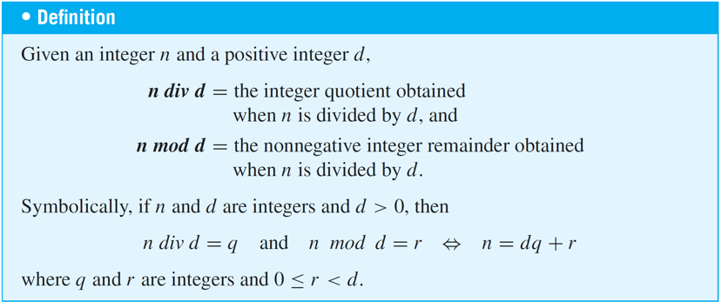

Solving/ testing Mod

* 