Section 5.2 Mathematical induction 1

Mathematical induction

* Used to check conjectures about the outcomes of process that occur repeatedly and according to definite patterns
  + Aka) a method for proving that a property defined for integers n is true.
* 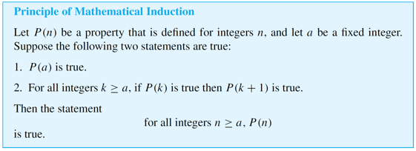

Process of math induction

* Two-step process:
  + Basis step:
    - Show that the property is true for the given value
  + Inductive step:
    - Show that the property is true for all given numbers
* Img) 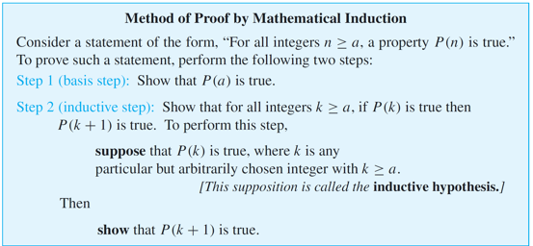
* Example:
  + Use math induction to prove:
  + 
* Solution:
  + Step 1: Identify P(n)
    - 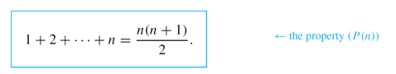
  + Step2: For basis step, you must show that the property is true for n=1
    - 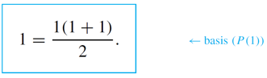
      * This example is true since 1=1
  + Step 3: For inductive step, assume P(k) is true if k > 0
    - Then show that P(k+1) is true by subbing n = k
      * 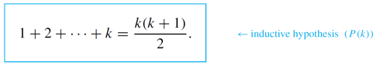
    - Then sub k = k+1
      * 