Chapter 7 Notes

Reference:

* Hackerrank.com
* Programming practice/ job reference site

**7.1: Functions defined on general sets**

Restatement of the definition of a function:

* 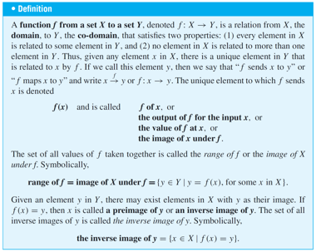

Arrow diagrams

* Defines a function when:
  + Every element of x has an arrow
  + No element of x has two arrows coming out that point to two different elements of Y
* If F: X -> Y and G: X-> Y are functions then…
  + F = G iff F(x) = G(x) for all x € X

Examples of functions

Identity function on X

* + Syntax: *IX*
    - I sub x
  + It sends each element of X to the element that it is identical to.
* Ex)
  + 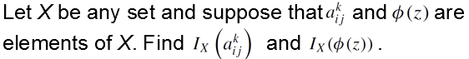
* Solution)
  + 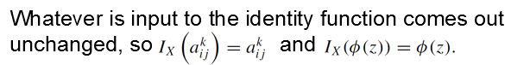

Definition of Logs and log functions

* 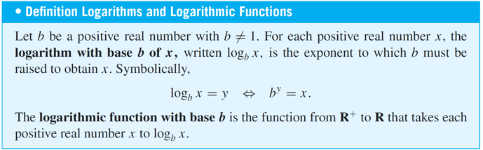

String sets

* If S is a nonempty finite set of characters
  + Then string over S is a finite sequence of elements S
* Length
  + Number of characters in a string
* Null string over S
  + String with no characters

Encoding and decoding functions

* Suppose we have a transmission and we encode it by repeating each char 3 times
  + Message: 0010 1111
  + Encoded message: 000 000 111 000 111 111 111 111
* To decode it, we replace each section of 3 bits into 1 bit
  + Decoding:
    - Let A be the set of all binary strings
    - Let T be the set of all binary strings that consist of consecutive triple identical bits
  + This is actually functions from A to T and from T to A
* Functions
  + E(s) = the string obtained is replaced by 3 of the same bit
  + D(t) = the string obtained is replaced by changing each consecutive triple by a single copy of the bit.
* Advantages of this coding scheme:
  + It makes it possible to do a certain amount of error correction when interference is received.

Boolean functions