Active Adult Performance and Greystar Counter Brief

Bottom line: the snapshot shows three communities in different lease-up stages, not a clean case that the current operator lacks 55+ capability. One of the three assets is still in phased delivery, and Greystar does not appear to have meaningful active-adult operating depth in Jacksonville or Ponte Vedra.
Executive Takeaways
- Viera data shows 53.0% occupied and 57.2% leased, only 7 occupied units and 5 leased units off March targets.
- Nocatee and Glen Kernan Park should not be judged against stabilized 55+ comps. Nocatee remains an early lease-up and Glen Kernan Park remains a phased-delivery asset.
- Industry sources note that upscale active-adult communities often lease more slowly because many prospects need to sell a home first, so raw traffic volume is a weak standalone scorecard.
- I could not verify any Greystar-managed active-adult rental community in Jacksonville or Ponte Vedra. The only current Greystar-managed public comp I confirmed in the broader scope is Parasol Melbourne.
Internal Operating Snapshot
Community | Units | Occ % | Leased % | Gap to Goal | March Funnel | Operating Read
Viera | 166 | 53.0% (88) | 57.2% (95) | -4.1 occ / -2.8 leased | 23 GC / 9 tours / 4 apps / 0 leases | 7 occ and 5 leased units to goal
Nocatee | 178 | 58.4% (104) | 64.6% (115) | -8.6 occ / -5.4 leased | 21 GC / 9 tours / 1 apps / 1 leases | 16 occ and 10 leased units to goal
Glen Kernan Park | 308 | 9.7% (30) | 14.0% (43) | -5.2 occ / -5.0 leased | 27 GC / 11 tours / 3 apps / 6 leases | 16 occ and 16 leased units to goal

Property Detail
Viera
- Current funnel: 23 guest cards, 9 tours, 4 applications, and 0 signed leases.
- Conversion view: lead-to-tour 39.1%, tour-to-app 44.4%, lead-to-lease 0.0%, app-to-lease 0.0%.
- Absorption: +0 in Mar; Q1 net absorption +1.
(Last 30 days) 11 apps and 8 leases vs. Parasol at 3 apps and 3 leases In the same timeframe
Nocatee
- Current funnel: 21 guest cards, 9 tours, 1 applications, and 1 signed leases.
- Conversion view: lead-to-tour 42.9%, tour-to-app 11.1%, lead-to-lease 4.8%, app-to-lease 100.0%.
- Absorption: +1 in Mar; Q1 net absorption -1.
Glen Kernan Park
- Glen Kernan Park is still a phased-delivery community, so its performance should be framed as an in-delivery lease-up, not a stabilized comp.
- Current funnel: 27 guest cards, 11 tours, 3 applications, and 6 signed leases.
- Conversion view: lead-to-tour 40.7%, tour-to-app 27.3%, lead-to-lease 22.2%, app-to-lease 200.0%.
- Absorption: +5 in Mar; Q1 net absorption +12.

Why the Benchmark Needs to Be Corrected
- RISE Viera and RISE at Nocatee were 2024 deliveries and held their grand openings in January 2025.
- RISE at Glen Kernan Park was announced as a phased community with first units delivering in summer 2025 and the balance in summer 2026.
- NIC separately notes stabilized active-adult communities were open at least two years have averaged about 95% occupancy.
- NIC's industry discussion featuring Carlyle and Overture notes higher-end active-adult communities often lease more slowly because prospects may first need to sell a single-family home.
Greystar Counterpoints
- Greystar's official active-adult platform highlights brands such as Overture, Everleigh, and Album, but I did not verify a Greystar-managed active-adult rental community in Jacksonville or Ponte Vedra.
- Parasol Melbourne is the only clear Greystar-managed comp I found in the broader Viera/Melbourne scope.
- Public listings for Parasol Melbourne currently show availability and concessions, including 14 to 15 available units and up to six weeks free, which confirms their 84% occupancy for March 2025.
Recommended Talking Points
- We should evaluate these assets against active-adult lease-up benchmarks, not fully stabilized two-year-plus communities.
- Viera's current March gap is measurable and manageable: 7 occupied units and 5 leased units to plan.
- Glen Kernan Park is still in phased delivery, so comparing it to fully delivered 55+ communities misstates performance.
- Greystar does not appear to have stronger local submarket proof in Jacksonville or Ponte Vedra, and its nearest confirmed comp in Melbourne still appears to be using concessions.
First Year Opening Comparison – Based on the first-year leased-units charts you shared, Viera appears to be leasing faster than Parasol.
The clean comparison is:
- Parasol first-year window on file: starts `4/24/23`
- Viera first-year window on file: starts `7/22/24`
What the charts show:
- Parasol’s first year looks mostly like `0–2 leases per week`, with some `3s` and only occasional `4–5` spikes.
- Viera’s first year shows much more frequent `3–4 lease` weeks, at least one `6`-lease week, and a `9`-lease spike.
- Viera’s leasing activity is visibly more aggressive and sustained in its first year than Parasol’s first-year pattern.
Best call-ready line:
- “Using the first-year leased-units history we have, Parasol does not appear to be leasing faster than Viera. Viera’s first-year weekly leasing pace is stronger, with more high-volume weeks and a higher peak.”
Viera still looks stronger, not weaker.
Median NER/Month – Last column is the average. Viera $2266. We are $416 higher on avg.

Source Links
- RISE active-adult platform
- RISE Viera community page
- RISE at Nocatee community page
- RISE at Glen Kernan Park community page
- RISE January 2025 grand opening announcement
- Glen Kernan Park phased delivery announcement
- NIC 4Q25 active-adult benchmark
- NIC stabilized active-adult benchmark
- NIC discussion of upscale active-adult lease-up pace
- Greystar active-adult platform
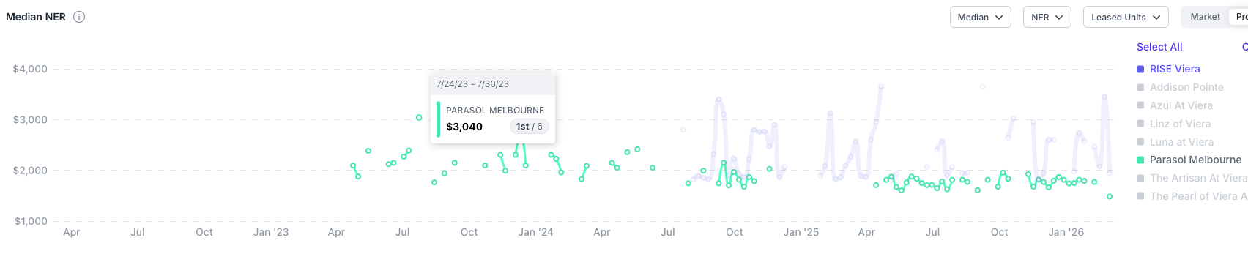
- Greystar Parasol Melbourne
- After55 listing for Parasol Melbourne
- Apartments.com listing for Parasol Melbourne
All other data from APARTMENTIQ

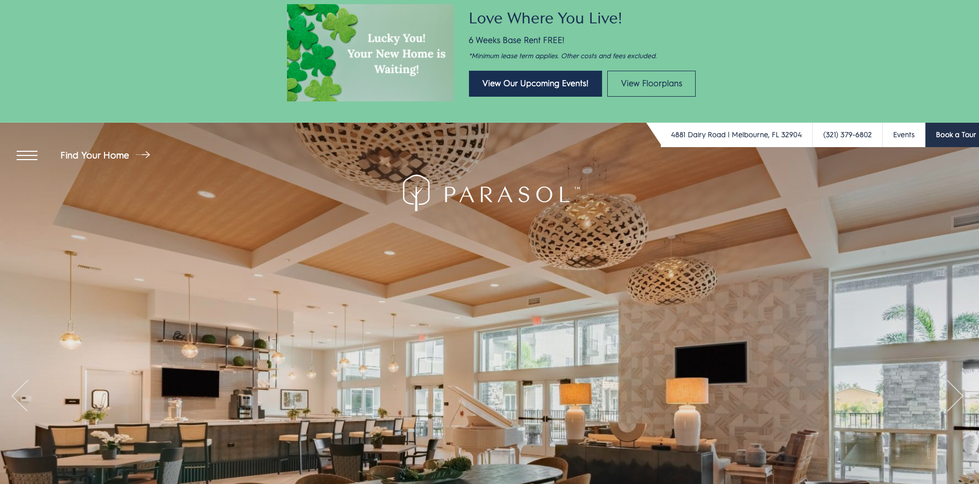

Website is also made by Jonah and they charge their residents a community amenity fee of $10 for use of the onsite amenities.

Greystar’s transparency fee guide is even more poorly constructed for this demographic then RISE.
https://parasolmelbourne.com/floorplans/

Last Bullet.
Jac has experience in managing 55+ Active Adult Community’s. The Club at Vero in Vero Beach through Concorde based out of Maintland, FL. They were a tax credit community fully equipped with all the usual amenities plus a ballroom, & hair salon.

