1. (6 marks) It makes sense that the larger the area of a region, the larger the number of species that inhabit the region. Many ecologists have modeled the species-area relation with a power function and, in particular, the number of species *S* of bats living in caves in central Mexico has been related to the surface area *A* measured in $m^{2}$ of the caves by the equation

$$S=0.7A^{0.3}$$

1. (3 marks) The cave called mission impossible near puebla, mexico, has suface area of $A=90m^{2}$. How many species of bats would expect to find in that cave?
2. (3 marks) If you discover that 5 species of bats live in cave estimate the area of the cave.

Solution:

1. $S=0.7A^{0.3}=0.7 {90}^{0.3}=2.7$, 3 species
2. (702

2. (6 marks)

Find , where

Solution:

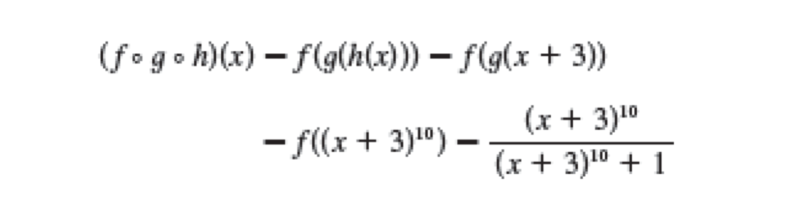

3. (20 marks. 4 marks each subproblem.) Evaluate the following limits. Answer with a real number, -∞, ∞, or does not exist. $$\left(a\right)\lim_{x→0}{\frac{x^{2}-6x+8}{x^{2}-5x+6}}$$

$$\left(b\right)\lim_{x→2}{\frac{x^{2}-6x+8}{x^{2}-5x+6}}$$

$$\left(c\right)\lim_{x→+∞}{\frac{x^{2}-6x+8}{x^{2}-5x+6}}{}$$

$$\left(d\right)\lim_{x→0}{\frac{(1+x)(1+2x)(1+3x)-1}{6x}}$$

$$\left(e\right)\lim_{x→2}{\frac{\sqrt{1+2x^{2}}-3}{x-2}}$$

Solution:

-1

4. (6 marks) using the definition of the derivative, compute the derivative of the given function and find the slope of the line that is tangent to its graph for the value of the independent variable. 

Solution:

According to the definition of the derivative





Thus, the slope of the line that is tangent to its graph at the point where  is .

5. (6 marks) ) Two curves are said to be **orthogonal** if their tangent lines are perpendicular at each point of intersection of the curves. Show that the curves of the given equations are orthogonal.

$$y-\frac{7}{4}x=\frac{π}{2}, x=\frac{7}{4}\cos{y}$$

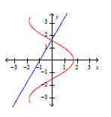

Solution:

1. The curves intersect at $(0, \frac{π}{2})$.
2. For $y-\frac{7}{4}x=\frac{π}{2},$ the tangent line is itself whose slope is $m=\frac{7}{4}.$
3. For $x=\frac{7}{4}\cos{y},$ the slope of the tangent line is at ,

6. (6 marks) Prove that if $f\left(x\right)$ is differentiable at x=0, $f\left(x\right)≤0$ for all x and $f\left(0\right)=0$, then $f^{'}\left(0\right)=0.$

Proof:

Since  is differentiable at and f(0)=0, we haveexists, i.e..

And  for all x, we know that

if x<0, , i.e. 

if x>0, , i.e. 

So, we have , i.e. .