# Lab 1.2 – Processing a Healthcare Survey

Dr. Bergen, Director of the Statistical Consulting Center at WSU, needs you to prepare the attached data for analysis. Note that **health_survey.csv** contains the responses to a series of health-related questions that we want to recode on a numeric scale and then aggregate. Dr. Bergen had a follow-up meeting with his client, and it turns out that some of the columns need a reverse coding, see the *Needs Reverse Coding?* column in **ReverseCodingItems.csv**. Please perform the following steps to prepare the required csv file.

|  |  |  |
| --- | --- | --- |
| Old Label | New Coded Value | Reverse Coding |
| “Strongly Disagree” | 1 | 5 |
| “Somewhat Disagree” | 2 | 4 |
| “Neither Agree nor Disagree” | 3 | 3 |
| “Somewhat Agree” | 4 | 2 |
| “Strongly Agree” | 5 | 1 |

1. Look at the questions that need reverse coding and explain why it makes sense to reverse the coding on these items.
2. Create a data repository for this project. Make sure that notebook is in the root of the repository and the data files are stored in a data folder.
3. You will need to redo the file construction, but now need to take the reverse coding into account.
   1. *Stack* the columns.

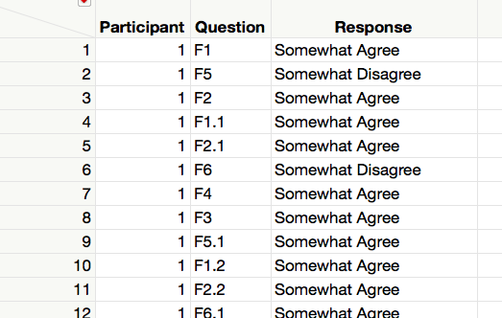

* 1. Make a new column called *Needs Reverse* by *Recoding* the Question Identifier to “Yes” or “No” per the *Needs Reverse Coding?* column in **ReverseCodingItems.csv.**

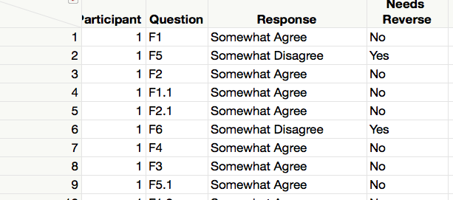

* 1. Make a new column called *Temp Coded Value* by *Recoding* the Questions Responses to the New Coded Values.

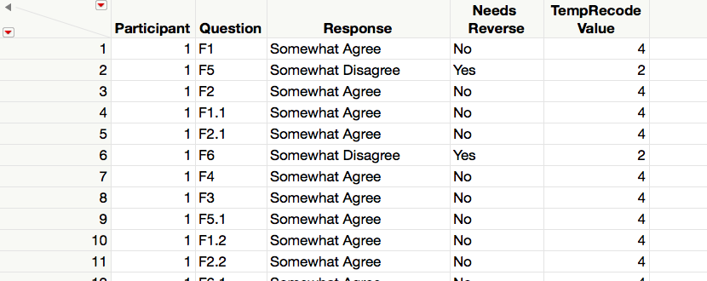

* 1. Make a new column called *Temp Coded Value* by *Recoding* the Questions Responses to the Reversed Coded Values.

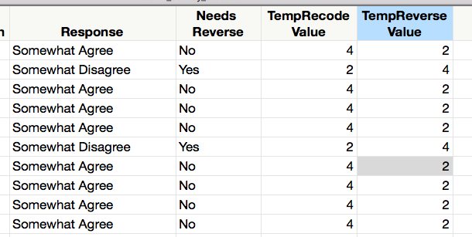

* 1. Make a new column called *Recoded Value* that holds the correct value for each question. You will want to use an case-when statement and use *Needs Reverse* to decide which temporary value to use.

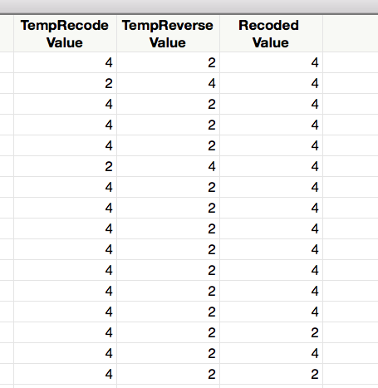

* 1. Make a new column by *Recoding* the Question Types to *F1, F2, …, F6.*

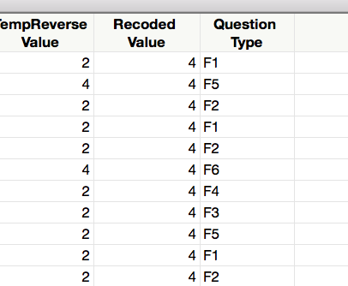

* 1. *Aggregate* and *Split.*

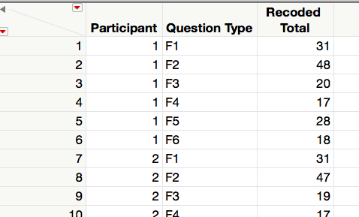 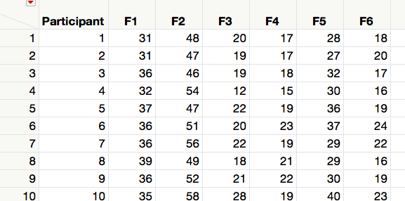

1. Write the resulting table to a CSV file named **health_survey_summary.csv** in the data folder.

**Deliverables.** Submit this document with your answer to question 1, a link to your data repository, and a csv file with your final table.