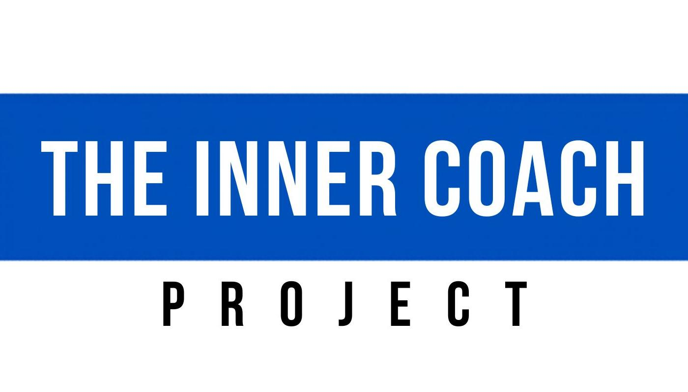
Hoffberg Coaching
This is The Inner Coach Project

Awareness → Ownership → Identity → Leadership
"You are not your thoughts. You are not your critic. You are the leader of you."

Honor High-Quality Preparation

"The most powerful relationship you will ever have is the relationship with yourself."
— Steve Maraboli

You have a short list of your top priorities. Make sure to include on that list Honor High-Quality Preparation.
Here's a quick checklist for you —
■ | Open your mind to the possibilities. Feel the freedom to imagine yourself excelling and playing at your best.
■ | Connect to your "why".
■ | There can't be any part of you that is jammed up or shut down.
■ | Focus on the No Matter What focus point: "I take full responsibility for my level of readiness."
■ | Focus on the words "I have an opportunity in front of me to step up and compete against my commitment to find a way to get better every step of the way."
■ | Check in on your level love of the game. Is your love energizing you – making you feel more confident?
■ | Take time for gratitude.
■ | Make sure your Inner Coach is in command.
Reminders – Taking full ownership of your mindset.

This is about you-leading-you.

Focus on Your Attitude

Focus on your attitude — because attitude is everything.
One of my game-day disciplines is to be very observant of myself. I focus on being intentional and aware. Part of my prep work on game-day is to assess my energy and my level of readiness.
What I'm looking for is any form of doubt. How I kill doubt is to know with full confidence that I have a great attitude for the challenges ahead. Knowing that I love my attitude – in a No Matter What sort of way – overcomes any form of distraction that comes at me. So, the key always ends up being about making sure my attitude is right.
With this type of outlook and energy, you never enter the moment of competition, worried about making mistakes or all caught up in a style of thinking that brings you down and the game hasn't even started yet.
It's all about Being Intentional in all that you do.
Focus on your love of the game. Can you easily gain a lift in your energy – your clarity – from thinking about what you love? Are you clear on what you love?

The excellence we seek isn't happening – if the top feeling going on with you is "worry" about failing.

Focus on the feeling you get when you are playing your best.

Take the Power Out of the Back Story

"Remind yourself as many times as it takes."
— Unknown

Control what you can control. Put the brakes on getting caught up in what distracts us. Focus on 2 Key Points—
■ | Take ownership of how I'm thinking.
■ | Be in command of how I choose to respond.
None of it matters.
Taking the power out of the circumstances is acknowledging the current reality without being controlled by it.

Be Unconditional.

The challenges or the adversity I face do not define me.
My truth is that I am defined by how I respond to it.
How I choose to respond is based on how I choose to think and who I choose to be.
This viewpoint unhooks me from doubt and worry.
Nothing in my way. I feel free to step up, to compete, to play.

Readiness. Ownership. Results.

"Ownership of State is taking responsibility for your feelings, regardless of what is occurring around you."
— Unknown

Honoring preparation isn't about putting in the work because we are focused on the result. We put in the work because we are focused on taking ownership of our readiness levels.
I don't focus on the results. The result isn't under my control.
Not being able to know ahead of time what the result will be
has zero impact on my choice to feel the passion
I feel towards wanting to play my best.
Fear (which is basically energy that weakens our spirit to play and compete) is minimized when we have joy in our hearts and a strong connection to the words, "I know who I am. I know what I'm all about."
The right perspective is —
■ | I am always the leader of me. I take ownership of that truth.
■ | My focus is on being ready. My focus is on my attitude.
■ | The result is not my concern. My focus is on the action.

Know Your "Why"

Know your "Why".

"Your why does not need to be big or altruistic. The only thing it needs to be is 100% honest.
My why went something like this: "I do not want another person to tell me what to do, when to do it or how to do it — ever again." To ensure that I went all in — and that there was no chance of turning back — my why had to be deeply personal and focused on a self-serving motivation.
You must declare your why, because your honesty here will act as your anchor when things get tough. The more real you get with yourself about your why, the more the worries and fears will start to pop up. But the only way I got to where I am today is by allowing my why to become bigger than my worries."
— Amy Porterfield, Success Magazine

"How different our lives are when we really know what is deeply important to us, and keeping that picture in mind, we manage ourselves each day to be and to know what matters most."
— Stephen Covey

There's no stopping the distraction that come at you. You fight them off when you're as declared as the word below.

I'm clear in my head about what matters most to me. I know why it matters and I know why the dedicated time and the effort that I put in fits with what I want to make happen.

We get in our own way.
We block our clarity and energy – screw up our attitude – because we are too quick to focus on what we think we can't do, on what worries us and the obstacles we see.
When you are good with your "why" you rise above the can't, the worry, the obstacle.
Your "why" is why you love the game, why you play, it's what drives you, it's the thing that you get to feel because you are an athlete that loves to compete, it's about finding out how good you can be.

Keep it Real. Keep it Simple.

Who you are – what your values are – your identity has nothing to do with the scoreboard. I love the words "I'm playing to win in all that I do" but not more than I love the words "The scoreboard does not tell me who I am. I am who I am because I choose the way I live my life."
Focus on your clear mind. Focus on being poised. Focus on being present. But don't focus on playing it safe. Play to win. Be free of any internal self-talk that sounds like "What if …" or "I just hope that…"
Love big moments. They are part of the game that you love to play. The more that you train yourself to embrace big moments, the more that you will find that the moment isn't bigger than you. When you are rock solid on taking ownership of leading yourself you are at-one with the moment. Always remember that what you bring to the moment is what you find in the moment.
Train yourself to feel equipped to give yourself simple instructions for how to succeed. The mind for the athlete works best when the instructions are clear. Sometimes it comes down to just one single instruction for what to do when you're in action. This is a gamechanger for you.
Take time to create cues, triggers, your Go-To Thought… Being ready is about being ready to compete, being ready to feel the energy you want to feel, being ready for situations you know will take place.

Overthinking can be focused on the past but mostly it's looking for a future to attach to.

When we're focused on one single instruction, there's no overthinking because there's no complex future to attach to. What matters more than whatever the future holds is staying dialed into our one single instruction for success. The key is simplicity. Your power is always in the simplicity. It's never in complexity.
I love the term response over reaction. We don't control much but what we do control truly matters. We can't control everything that happens. We control our readiness to lead ourselves through what is happening. Reacting is too emotional. Responding is choosing to be in alignment with who you want to be. Be poised. Be powerful.
Visualizing yourself playing the way you want to play is a skill to take responsibility for keeping sharp.
In preparation for the action, the right way to visualize is to see yourself in action in an emotional state of feeling confident while playing.
When you train yourself to be in the right place mentally thinking the thought that keeps your emotional state where it needs to be, you're more likely to find the joy of being present and at-one with the moment at hand, playing freely, competing in a let's go kind of way — in the rhythm and flow that works best for you.

Change your perspective when you need to. Pressure is a privilege, right? It's not tension.

When you change your perspective from what stresses you to "I love moments like this" you are minimizing the feeling of not being ready.
Using the right words to connect what you're feeling, changes the energy from feeling threatened to feeling totally up for the test in front of you – totally up for the challenge coming your way.
This is what being a great competitor is all about. The full embrace of the test. The love of the feeling of being ready on the level that you really do want to simply get after it and get it on, playing the way you intend to play.

The great competitor knows how to live in the moment.

When the moment is gone — in game action we are literally talking about the last play — let the moment go. This is about being disciplined. That's huge. This is about mental toughness. That's huge. This is also about creating the energy that you need to feel. That's huge.
The power of your why can help you let go of the past. Ultimately it all comes down to learning to lead yourself.

If you are curious about all that you just looked over – if you want more – if you know you've got some work to do, I have a program for you called The Inner Coach Project.

The Inner Coach Project

The training found inside The Inner Coach Project helps transform the inner dialogue from being out-of-control to focused and intentional.
The type of transformation we're talking about here requires self-awareness, the willingness to grow and change, a process that is focused on self-leadership, an understanding of what great coaching is all about – and a lot of directed practice.
Everyone nods yes when we talk about the concept of needing to learn to lead yourself first – before you can be a leader to others.
For an athlete, the "lead others" can be as simple as focusing on wanting to lead-by-example, which starts first with attitude and thought choice before it can become about hard work, execution and communication.
Understanding the concept of the inner coach shifts you from being someone that nods to someone that is fully activated in a plan for leading oneself.
Keys to The Inner Coach Project –
Here's why it matters to dedicated athletes.
What to Expect –
■ | Access to a library of videos, with new videos posted weekly that provide training in the Inner Coach Concept.
■ | The videos will feature other experts beyond Hoffberg Coaching.
■ | A legit playbook for being your best inner coach — developed in a customized way — as the progression builds throughout the training.
■ | The playbook will help with the upcoming season.
■ | The playbook will be a resource for how to be in command of the way you live your life going forward – for years to come.
The Result of the Training inside The Inner Coach Project –
■ | More awareness of the inner critic.
■ | A readiness to respond to and correct thinking that is heading in the wrong direction.
■ | An understanding of the advantages that come with the concept of "Naming The Voice".
■ | An internal leadership vocabulary that makes sense, is aligned with the values that matter most and ultimately is defaulted to.
■ | The best practice of using coaching questions within your own thought process – to gain better clarity, inspire better energy, feel the triumph of finding a perspective aligned with who you truly want to be.
■ | A deeper commitment to thinking thoughts that help with attitude – that help with clarity and energy – rather than allowing thoughts to add up that ultimately demotivate and create a weaker version of ourselves rather than a best version of ourselves.

You are not your thoughts — You are not your critic.

Weekly Newsletter –
■ | Will highlight weekly focus points.
■ | Provide new links for videos for the ongoing training process.
■ | Feature docs to download that lay out specific exercises.
■ | Include prompts for note-taking to help build the playbook.
Program Format –
The training can take place in as few as 6 weeks and shouldn't be done over a span any longer than 10 weeks.
There is minimal time committed to assessment at the beginning of the training.
Personality isn't what we are assessing as much as we are looking for your current perspective on coaching and leadership because of the way this training emphasizes self-coaching and self-leadership.
The work can be done on individual basis or in small groups.
Mind gym sessions to get in your ICP training will be done via Zoom. The session will run 60 mins. A good workout needs to.

