Always：评估一个信号在未来或者之前的一段时间是否一直满足某个状态
Always(signal, duration, restricted=False)
如果“restricted”配置为“False”(默认)，则duration定义的时间范围可以超过触发范围的限制。如果设置为True，则只在触发范围内检查该条件。
Examples:
# True if the signal always evaluates to True
# within the next 2 seconds
Always(Sig0, 2.0)（有值（不等于0，Python默认FALSE为0）就可以被trigger出来）
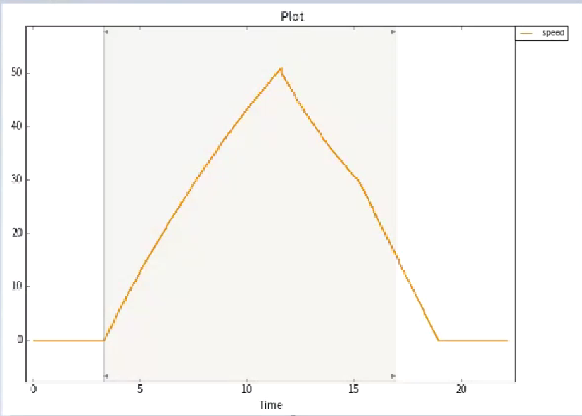
# True if the condition 'Sig0 > 5' was always
# fulfilled in the past 2 seconds
Always(Sig0 > 5, -2.0)
# True if the signal evaluates to True
# for the next second or up to the
# end of the current trigger range
Always(Sig0, 1.0, True)
# True if there is no rising edge from 0 to 1
# within the next 1.5 seconds
Always(not Edge(Sig0, 0, 1), 1.5)

AtLeastOnce：至少一次（用法同Always）

Average：平均值
Average(signal)
Example:
Average(Sig0) # Average of the signal Sig0
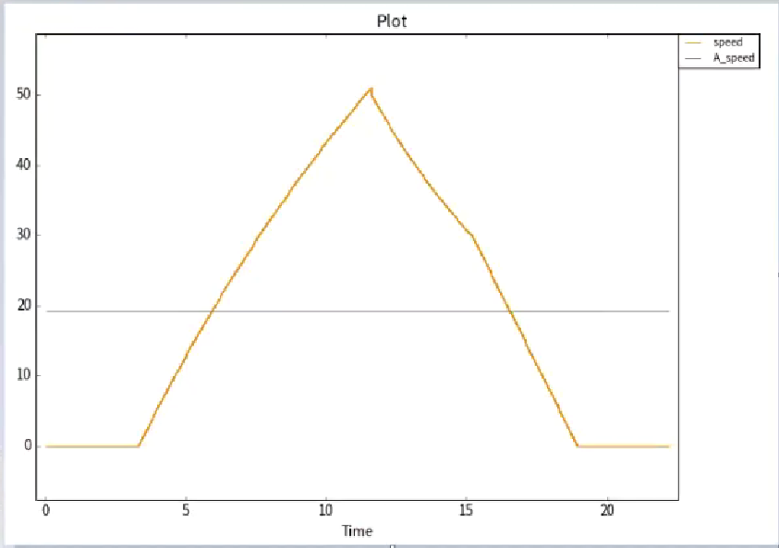
BoundControl：控制上下限
BoundControl(signal, minVal, maxVal)
Examples:
# True at timestamp t if 0 <= Sig0(t) <= 100
BoundControl(Sig0, 0, 100)
# True at timestamp t if Sig1(t) <= Sig0(t) <= Sig2(t) BoundControl(Sig0, Sig1, Sig2)

CheckAlive：检查一个信号有没有按照一个规则去变化（检查总线）
CheckAlive(signal, cycleLimit)
Example:
# True if the sequence of values in Sig0
# is (0, 1, 2, 3, 0, 1, 2, 3, 0...)
CheckAlive(Sig0, 3)

CheckTiming：检查总线信号周期
CheckTiming(signal, period（周期，默认单位为s）, tolerance（公差，此处为百分比）)
Examples:
# True if 0.9 <= time between the two most recent timestamps <= 1.1
CheckTiming(Sig0, 1, 10)
# True if 0.01 seconds passed between the two most recent timestamps
CheckTiming(Sig1, 0.01, 0)

Derivative：微分，判断一个信号的斜率
Derivative(signal)
Example:
Derivative(Sig0) # Derivative of signal Sig0

Integral：积分
Integral(signal)
Example:
# Integral of signal Sig0 up to the current timestamp
Integral(Sig0)

Edge：检测信号上升沿、下降沿
Edge(signal, valFrom='*', valTo='*')
Examples:
# any edge (any value change)
Edge(Sig0)（获取该信号所有的跳转沿）
# rising edge from 0 to 1
Edge(Sig0, 0, 1)
# falling edge from any value greater 1 to 1
Edge(Sig1, '>', 1)（从大于1到1）
# falling edge from 1 to any value less than 1
Edge(Sig2, 1, '<')
# same as Edge(Sig2, '*', '>') or Edge(Sig2, '<', '*')
# or RisingEdge(Sig2)
Edge(Sig2, '<', '>')（判断有无上升沿）

FallingEdge：检查下降沿
FallingEdge(signal, threshold='*')
Examples:
# True if Sig0(n-1) > Sig0(n)
FallingEdge(Sig0)
# True if Sig0(n-1) >= 0.5 and Sig0(n) < 0.5
FallingEdge(Sig0, 0.5)

RisingEdge：检查上升沿
RisingEdge(signal, threshold='*')
Examples:
# True if Sig0(n-1) < Sig0(n)
RisingEdge(Sig0)
# True if Sig0(n-1) <= 0.5 and Sig0(n) > 0.5
RisingEdge(Sig0, 0.5)
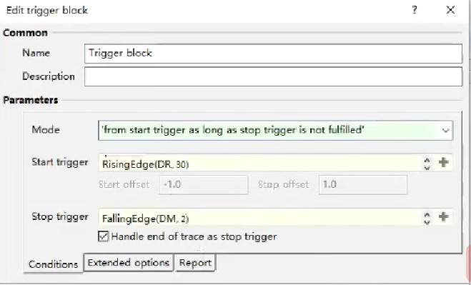
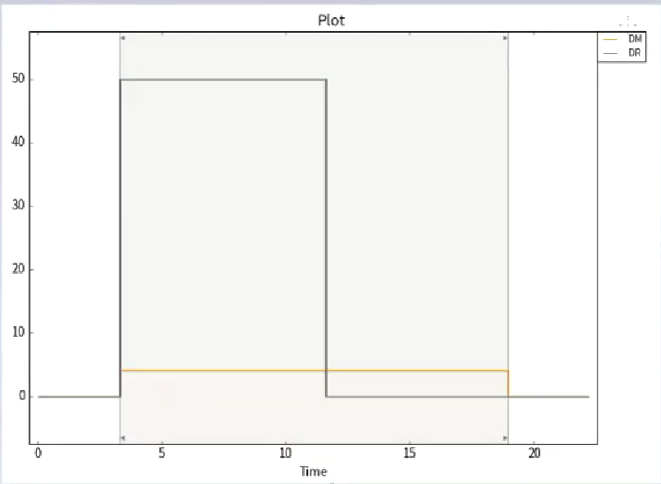
Evaluate：
Evaluate(expression)
Examples:
# equivalent to Sig0 > 0
Evaluate('Sig0 > 0')
# evaluates the expression stored in the variable 'var'
Evaluate(var)

HasSample：检查总线，检查有没有采样点，有就筛选出来
HasSample(signal)
Example:
# Checks whether signal has a sample at each
# timestamp that is part of the common time
# axis of 'signal' and 'clock':
HasSample(signal) and clock >= 0

HasValue：检查总线，有值（0）就trigger
HasValue(signal)
Example:
HasValue(Sig0) # True, if the signal has a value

HoseAbsolute：（绝对偏移量）有个基准信号，检查另外一个信号是否跟随基准信号变化
HoseAbsolute(signalA, signalB, deltaT, deltaY)
Examples:
# True if Sig1 is within a floating range based on
# Sig0 with a duration of 0.2, floating minimum and
# maximum expanded by 123.4 each.
HoseAbsolute(Sig0, Sig1, 0.2, 123.4)
# True if Sig1 is within a floating range based on
# Sig0 with a duration of 0.1, only floating maximum
# expanded by 1.33.
HoseAbsolute(Sig0, Sig1, 0.1, (0, 1.33))
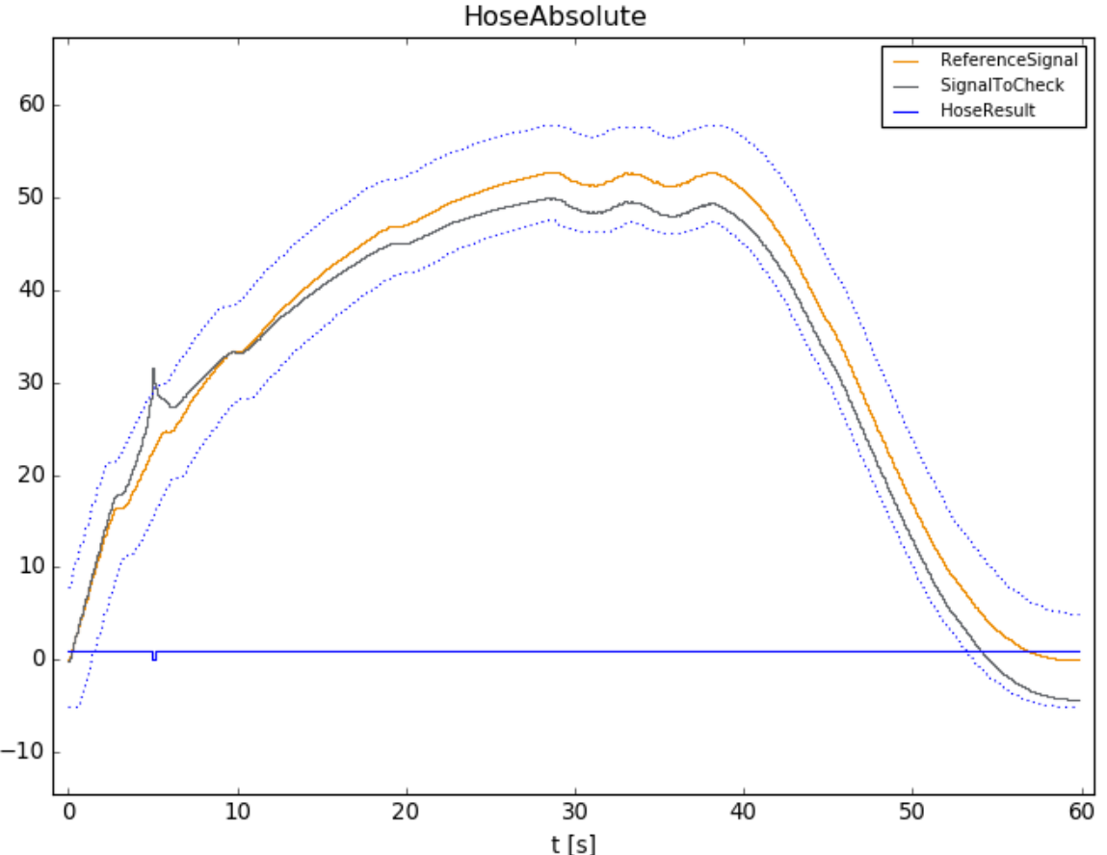
HoseRelative：（相对偏移量）用法同上
HoseRelative(signalA, signalB, deltaT, toleranceY)
Examples:
# True if Sig1 is within a floating range based on
# Sig0 with duration of 0.2,
# floating minimum and maximum expanded by 40%.
HoseRelative(Sig0, Sig1, 0.2, 40)
# True if Sig1 is within a floating range based on
# Sig0 with duration of 0.1, only floating maximum
# expanded by 10%.
HoseRelative(Sig0, Sig1, 0.1, (0, 10))
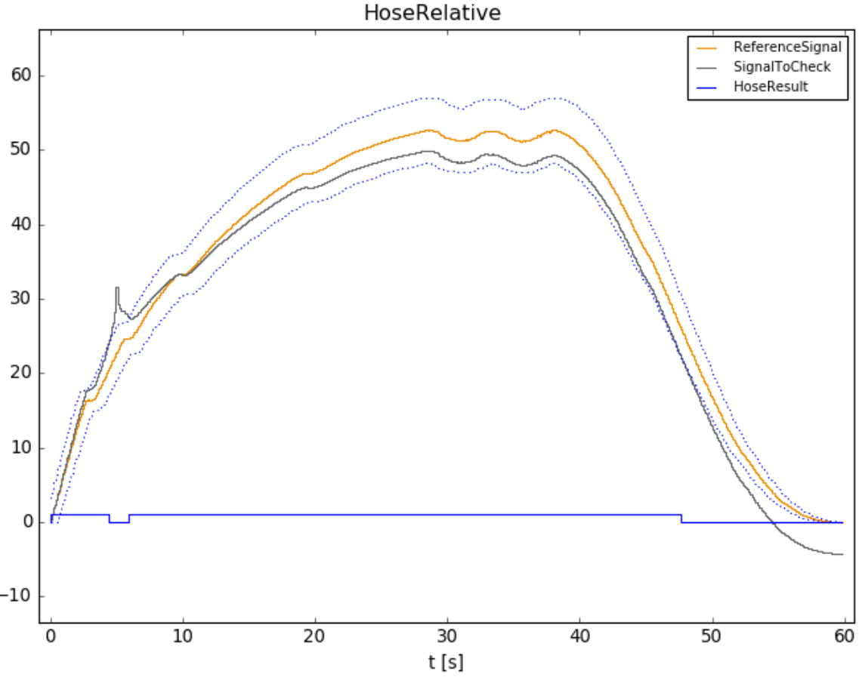
Monotony：检查是否为（严格的）单调递增、递减
Monotony(signal, type)
Examples:
# Check whether Sig1 is monotonically increasing
Monotony(Sig1, 'inc')
# Check whether Sig1 is strictly decreasing
Monotony(Sig1, 'dec_strict')
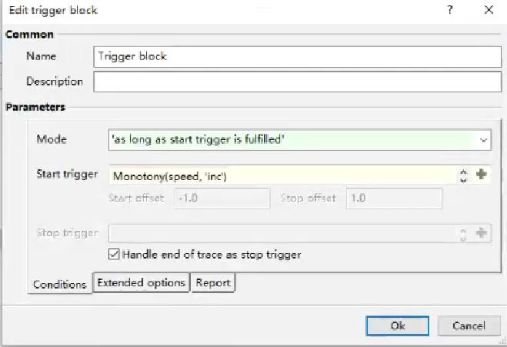
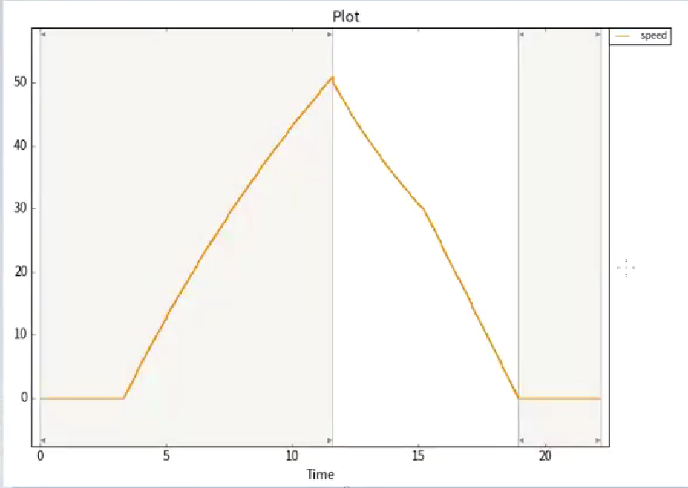
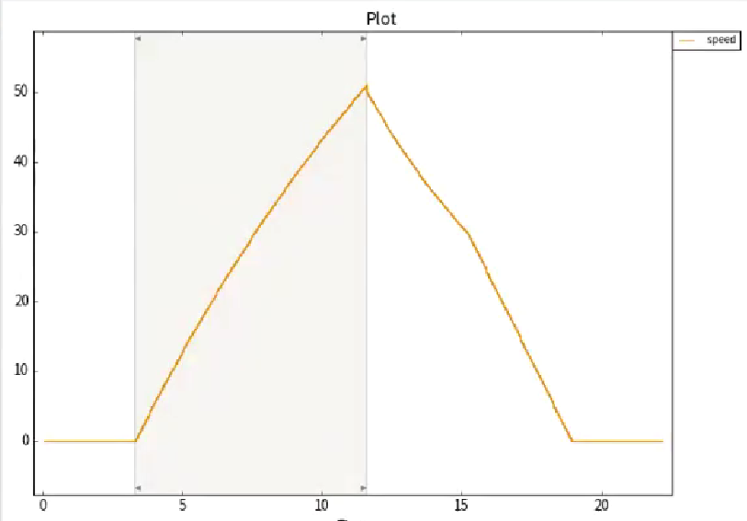
MovingAverage：滑动平均，如计算50采样点的滑动平均值：第1个采样点到第50个采样点，这些值加在一块然后求平均得到一个点，然后再把第2个和第51个之间的采样点的值加在一起求平均得到一个点，然后把这些得到的点连成一条线，滑动平均线
MovingAverage(signal, duration, durationKind='sample')
Examples:
# Moving average of the last 5 seconds
MovingAverage(Sig0, 5.0, 'time')
# Moving average of the last 3 and the next 2 seconds
MovingAverage(Sig1, (3.0, 2.0), 'time')
# Moving average of the last 10 samples (the current sample and 9 past samples)
MovingAverage(Sig1,10,durationKind='sample')
# Moving average of 5 samples (2 past samples, the current sample and 2 future samples)
MovingAverage(Sig2, (2, 2))
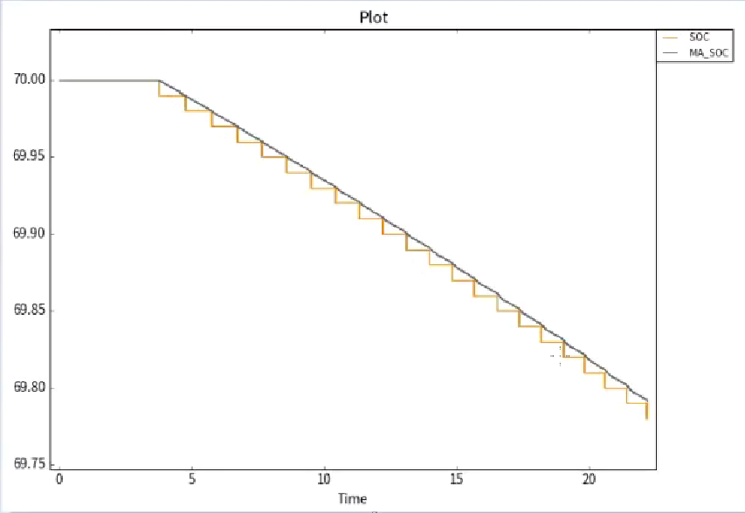
MovingMax：和上面相同但是不是取平均值，而是取一个采样点区间段的最大值
MovingMax(signal, duration, durationKind='time')
Examples:
# Moving maximum of the last 5 seconds
MovingMax(Sig0, 5.0, 'time')
# Moving maximum of the last 3 and the next 2
# seconds
MovingMax(Sig1, (3.0, 2.0), 'time')
# Moving maximum of the last 10 samples (the
# current sample and 9 past samples)
MovingMax(Sig1, 10, durationKind='sample')
# Moving maximum of 5 samples (2 past samples,
# the current sample and 2 future samples
MovingMax(Sig2, (2, 2))

MovingMin：同上
MovingMin(signal, duration, durationKind='time')
Examples:
# Moving minimum of the last 5 seconds
MovingMin(Sig0, 5.0, 'time')
# Moving minimum of the last 3 and the next 2
# seconds
MovingMin(Sig1, (3.0, 2.0), 'time')
# Moving minimum of the last 10 samples (the
# current sample and 9 past samples)
MovingMin(Sig1, 10, durationKind='sample')
# Moving minimum of 5 samples (2 past samples,
# the current sample and 2 future samples
MovingMin(Sig2, (2, 2))

Static：和Always类似，判断一个信号在某个时间段是否一直维持在一个状态
Static(signal, duration, restricted=True, constValue=True)
Examples:
# True if Sig0 == True for the next 2 seconds
Static(Sig0, 2)
# True if Sig1 == 0 for the last 0.5 seconds
Static(Sig1, -0.5, True, 0)
# Correlates to the previous example
Static(Sig1, -0.5, constValue=0)
# True if Sig2 is constant for the next second
Static(Sig2, 1, True, None)
# True if Sig3 stays greater than 1000 for the next
# second
Static(Sig3 > 1000, 1)

Time：获取一个信号所有的时间戳
Time(refSignal=None)
Examples:
# Obtain the current timestamp of Sig0
Time(Sig0)
# Add the current timestamp and the value of Sig0
Time() + Sig0
# Equivalent to Time(Sig0) + Sig0
Time(Sig0) + Sig0
# Note that the following expression is evaluated
# everytime Sig0 or Sig1 have a sample. The call
# Time(Sig0) always returns the current timestamp
# even if Sig0 has no sample. The hold value of
# Sig1 is used if Sig1 has no sample at a timestamp.
Time(Sig0) + Sig1
# True, if at the current timestamp of Sig0 at least
# one second has passed since the start trigger
# occurred.
Time(Sig0) - StartTriggerTime() >= 1
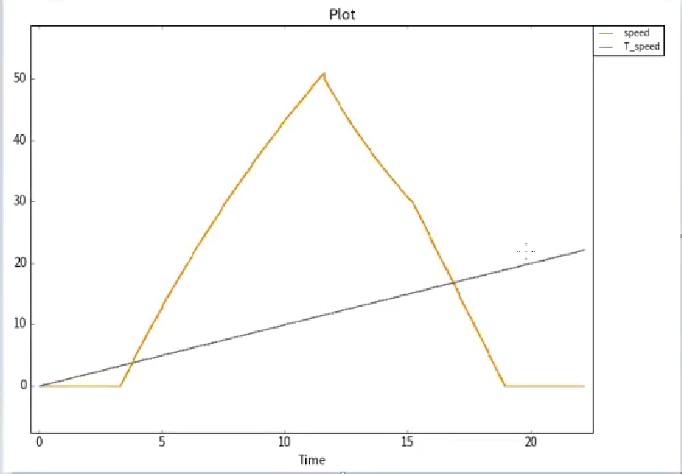
（y=x）
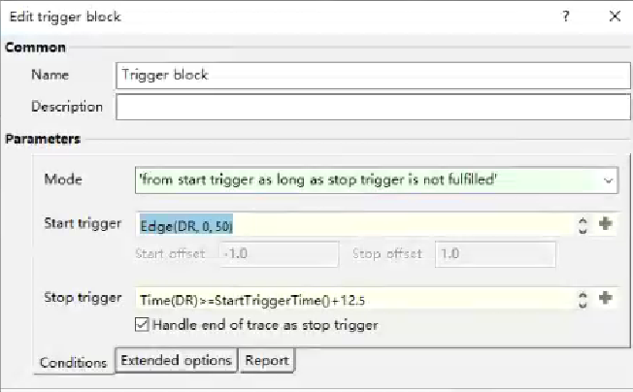
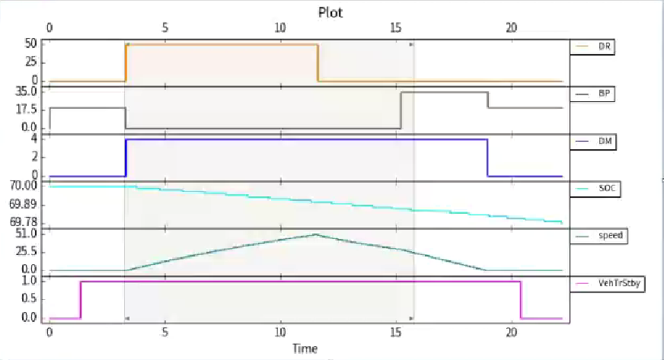
Value：获取一个信号所有的值，同时还可对该信号的值做一个偏移
Value(signal, deltaT)
Examples:
# Value of the signal Sig0 in 1 second
Value(Sig0, 1)
# Value of the signal Sig1 0.5 seconds ago
Value(Sig1, -0.5)
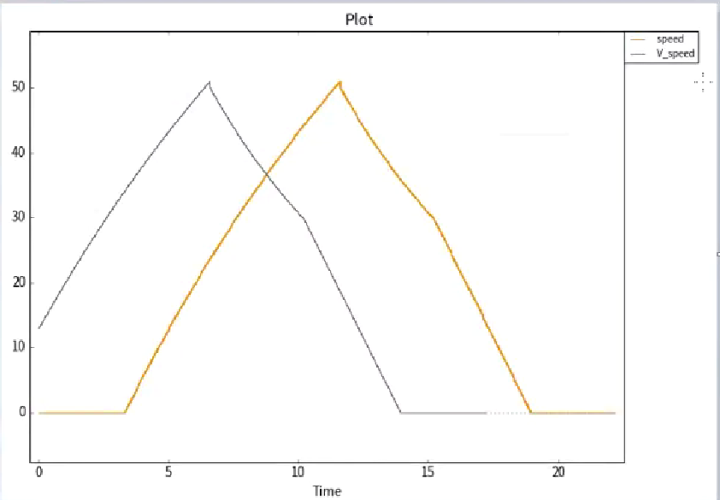
StartTriggerTime：
StartTriggerTime()
Example:
# True if - at the current timestamp of sig0 - at least one
# second has passed since the start trigger
# occurred.
Time(Sig0) - StartTriggerTime() >= 1
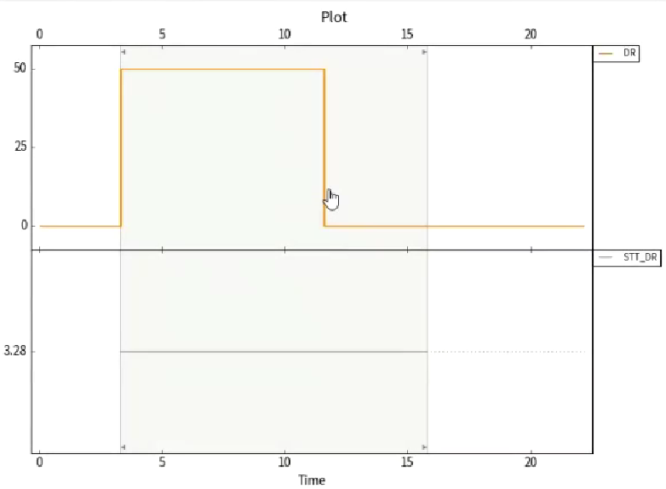
StopTriggerTime：
StopTriggerTime()
Example:
# True if at the currently processed timestamp of
# Sig0, the stop trigger occurs after more than one
# second.
StopTriggerTime() - Time(sig0) > 1

StartTriggerValue：
StartTriggerValue(signal, deltaT=0.0)
Example:
# Returns the signal value of Sig0 at the start trigger
StartTriggerValue(Sig0)

StopTriggerValue：
StopTriggerValue(signal, deltaT=0.0)
Example:
# Returns the signal value of Sig0 at the stop trigger
StopTriggerValue(Sig0)
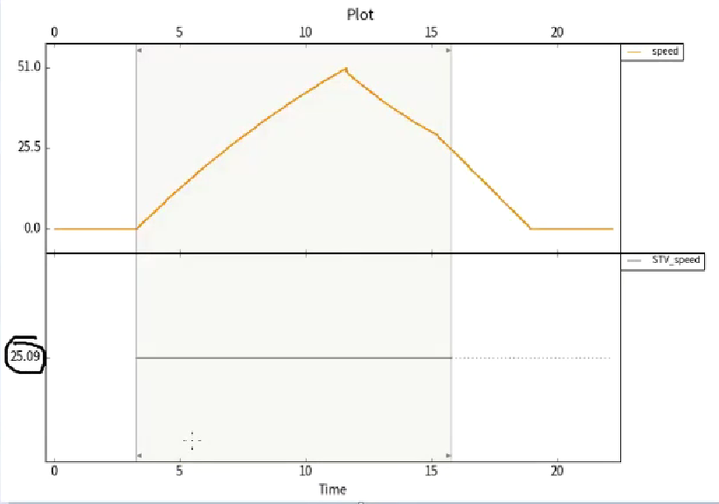
TriggerRangeStartTime：
TriggerRangeStartTime()
Example:
# True if - at the current timestamp of sig0 - at least one
# second has passed since the start of the trigger range
Time(Sig0) - TriggerRangeStartTime() >= 1

TriggerRangeStopTime：
TriggerRangeStopTime()
Example:
# True if at the currently processed timestamp of
# Sig0, the trigger range continues for more than one
# second.
TriggerRangeStopTime() - Time(sig0) > 1

TriggerRangeStartValue：
TriggerRangeStartValue(signal, deltaT=0.0)
Example:
# Returns the first signal value of Sig0 in the trigger range
TriggerRangeStartValue(Sig0)

TriggerRangeStopValue：
TriggerRangeStopValue(signal, deltaT=0.0)
Example:
# Returns the last signal value of Sig0 in the trigger range
TriggerRangeStopValue(Sig0)

