|  |  |  |  |
| --- | --- | --- | --- |
|  |  | **Binary Numbers** |  |

|  |
| --- |
| **Your Tasks (Mark these off as you go)** |
| * Brainstorm: How many three place patterns can you make with a circle and square * Watch the Circle-Triangle-Square to Binary video * Construct a Flippy-Do * Use your Flippy-Do to determine all the 4 place binary numbers * Determine the base 10 value of all the 8-bit binary numbers with exactly one *1* * Practice with conversions * Complete the reflection questions * Receive credit for the group portion of this lab |

* **Brainstorm: How many three place patterns can you make with a circle and square**

In the previous lesson you created 27 different 3-place patterns out of circles, triangles and squares, and tried to define a system of rules to generate all of the patterns.

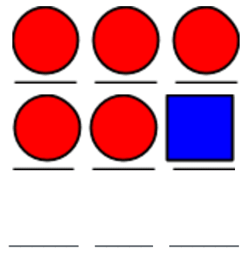What if you only had a circle and square? With only a circle and square, how many 3-place patterns are there? A few are started below. How many are there total?

|  |
| --- |
|  |

* **Watch the Circle-Triangle-Square to Binary Video**

To help with the transition from circle-triangle-square to binary check out the following video, <https://www.youtube.com/watch?v=91HLBUjCHbs>

* **Make a Flippy-Do**

Using the template provided by Ms. Pluska construct your Flippy-Do. Use the image below as a guide.

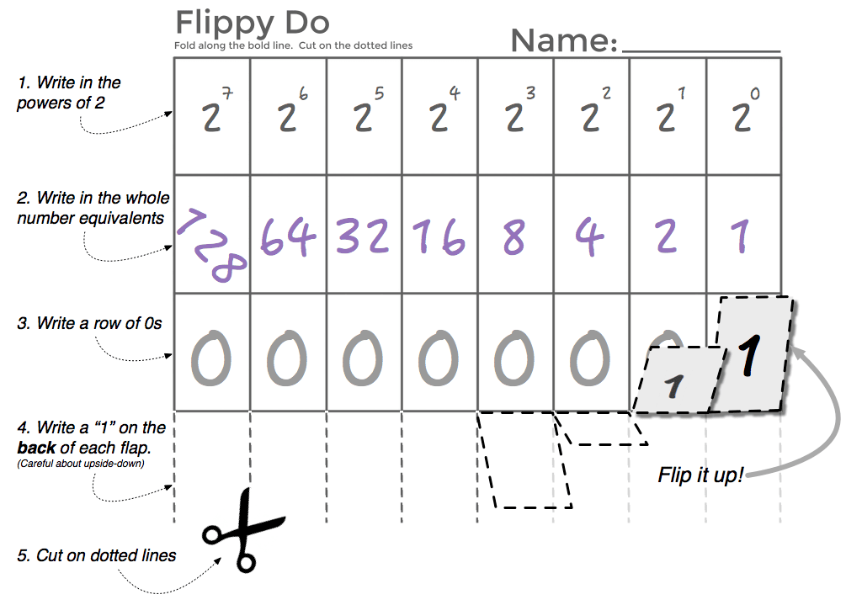

* **Have Ms. Pluska check off your Flippy-Do**



Before you continue have Ms. Pluska check off your Flippy-Do

Do not continue until you have Ms. Pluska’s (or her designated TA’s) signature ____________

* **Use your Flippy-Do to determine all the 4 place binary numbers**

If you have a binary numbers system (0 and 1’s only) how many 4 place combinations are there?

|  |
| --- |
|  |

Use your Flippy-Do to determine the binary value of each base 10 equivalent.

|  |
| --- |
|  |

* **Determine the base 10 value of all the 8-bit binary numbers with exactly one 1**

The table below contains *every* 8-bit number that has exactly one *1* in it. Write down the decimal equivalent next to each one. Do you notice a pattern?

|  |  |  |  |  |
| --- | --- | --- | --- | --- |
| **Binary: 8-bit number** (with exactly one *1*) | **Decimal** |  | **Binary: 8-bit number** (with exactly one *1*) | **Decimal** |
| 0000 0001 | 1 |  | 0001 0000 |  |
| 0000 0010 | 2 |  | 0010 0000 |  |
| 0000 0100 |  |  | 0100 0000 |  |
| 0000 1000 |  |  | 1000 0000 |  |

* **Have Ms. Pluska check off the previous tasks before you continue**



Before you continue have Ms. Pluska check off the previous tasks before you contineu

Do not continue until you have Ms. Pluska’s (or her designated TA’s) signature ____________

* **Practice with conversions**

Using your own binary skills (aided by the flippy do) fill in the decimal and binary equivalents below.

|  |  |  |  |  |
| --- | --- | --- | --- | --- |
| **What’s the Decimal Number?** | |  | **What’s the Binary Number?** | |
| **Binary** | **Decimal** |  | **Binary** | **Decimal** |
| **100** |  |  |  | **5** |
| **101** |  |  |  | **17** |
| **1101** |  |  |  | **63** |
| **0001 1111** |  |  |  | **64** |
| **0010 0000** |  |  |  | **127** |
| **1010 1010** |  |  |  | **256\*** |
| **1111 1111** |  |  |  | **513\*** |
| **NOTE**: a short binary number like **101** is assumed to have leading 0s for all the other bits, like: **00000101.**  Typically large binary numbers are grouped in 4-bit chunks to improve readability, for example: **0110 0101 1010** | |  | **\*NOTE: 256 and 513** exceed the capacity of the flippy-do but you can work it logically following what you know about patterns with binary numbers. | |

* **Complete the reflection questions**

There is a simple pattern for determining if a binary number is odd. What is it and why does this pattern occur?

|  |
| --- |
|  |

How many bits would you need if you wanted to have the ability to count up to 1000?

|  |
| --- |
|  |

How high could you count in binary if you used all 10 of your fingers as bits? (finger up means 1, finger down means 0)

|  |
| --- |
|  |

* **Receive Credit for the group portion of this lab**



* Indicate the names of all group members.
* Have Ms. Pluska check your Number Systems lab.
* Submit your lab to the needs to be graded folder to receive credit for the group portion of this lab.

Do not submit your lab until you have Ms. Pluska’s (or her designated TA’s) signature _______