|  |  |  |  |
| --- | --- | --- | --- |
|  |  | **Sending Binary Numbers** |  |

|  |
| --- |
| **Your Tasks (Mark these off as you go)** |
| * Review Binary Numbers * Get acquainted with the Internet simulator * Develop a protocol for sending binary numbers * Have Ms. Pluska check off your protocol for sending binary number * Test out your protocol * Assess your protocol * Define key vocabulary * Recieve credit for the group portion of this lab |

* **Review Binary Numbers**

In the last lesson we introduced some properties of binary numbers. Work with a partner to answer the following,

How many more numbers can be represented with 4 bits as opposed to 3?

|  |
| --- |
|  |

What is the highest value you can count to using 3 bits? What about with 4?

|  |
| --- |
|  |

* **Get acquainted with the Internet simulator**

Navigate to the following link and watch the video on the Internet Simulator

<https://www.youtube.com/watch?v=cIk2R0QuXkI&feature=youtu.be&list=PLzdnOPI1iJNdVYhNyXeP4FsbSH_AkUhxB>

Navigate to lesson 6 Stage 2 and explore the simulator

* **Develop a protocol for sending binary numbers**

Your challenge is to d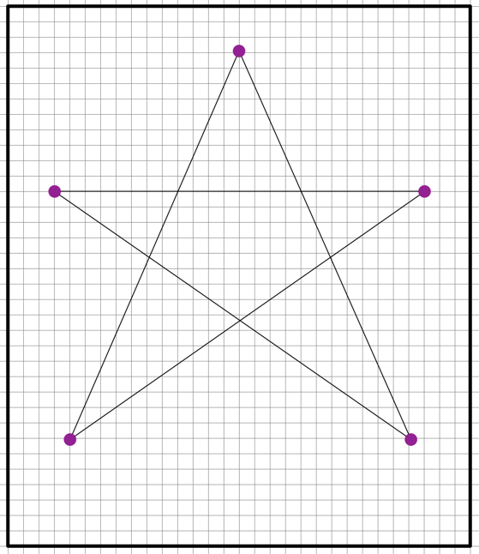evelop a protocol or set of rules for communicating a drawing to your partners using only numbers

**Challenge Rules:**

* The image will be a line drawing created by connecting points on a grid, like the one seen here.
* You can discuss and agree on a protocol ahead of time, but the image exchange must happen without communication between the two parties other than through using the Internet Simulator.
* You can only send **a single message - a single list of numbers -** through the Internet Simulator to describe the whole image.

**Things to Consider:**

1. How will your points be formatted?
2. How does the recipient know when one number ends and the next begins?

**Your Protocol:** Write the steps of your protocol below.

|  |
| --- |
|  |

* **Have Ms. Pluska check off your protocol for sending binary numbers**



Before you continue have Ms. Pluska check off your protocol for sending binary numbers

Do not continue until you have Ms. Pluska’s (or her designated TA’s) signature ____________

* **Test out your protocol**

Make a simple drawing on the graph paper. Use the protocol you developed to communicate your drawing to your partner. You partner must draw what he or she receives on a blank grid.

* **Assess your protocol**

Use the following criteria to evaluate your success in creating a protocol for sending the coordinates to draw an image described in the Sending Numbers activity. Justify your score for each rating.

|  |  |  |  |
| --- | --- | --- | --- |
| **Criteria** | **Yes** | **No** | **Comments** |
| You successfully collaborated to create a workable protocol for sending numbers. |  |  |  |
| The order of values were defined. |  |  |  |
| The recipient could distinguish when one number ended and another began. |  |  |  |
| The numbers were successfully translated, sent, and received. |  |  |  |
| The receiving team member was able to translate the numbers and re-create the drawing on the other end. |  |  |  |

* **Define key vocabulary**

Write a definition for the term(s) below

**Protocol**

|  |
| --- |
|  |

* **Receive Credit for the group portion of this lab**



* Indicate the names of all group members.
* Have Ms. Pluska check your Number Systems lab.
* Submit your lab to the needs to be graded folder to receive credit for the group portion of this lab.

Do not submit your lab until you have Ms. Pluska’s (or her designated TA’s) signature _______