|  |  |  |  |
| --- | --- | --- | --- |
|  |  | **The Need for DNS** |  |

|  |
| --- |
| **Your Tasks** |
| * Create a list of IP Numbers for your Classmates * Explore the Inernet Simulator * Interview a classmate * Have Ms. Pluska check off your Interview witha classmate * Watch the video on DNS * Define key vocabulary * Recieve credit for the group portion of this lab |

* **Create a list of IP Numbers for your Classmates**

When you walked in, you were handed a slip of paper with an IP address on it. Locate the Names and Addresses sheet on the back of this lab guide. Then, when instructed to do so, move around the room and try to complete an accurate list of IP addresses and names for all students in the room. You may only talk to one person at a time.

Do you think the system we just simulated is an efficient way of collecting IP addresses? Are there any inefficiencies you observe? How could it be made better?

|  |
| --- |
|  |

* **Explore the Internet Simulator**
* Navigate to lesson 12 stage 2 and join the simulator.
* Review the guide below on how to navigate the simulator

### **Communicating with the DNS**

To begin, click over to the “DNS” tab to see all the hostnames of people on the router. You will see the address of the DNS (always 15) but will not see an address for anyone else on the router.

The DNS server responds to a text protocol that will give you someone’s IP address. Type the IP address of the DNS into the “To” field, then use the following protocol to retrieve the IP address.

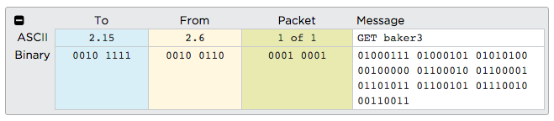

|  |
| --- |
| **The protocol is:** GET <hostnameOfPerson>  **For example:** GET baker3 |

**You can request the IP address of anyone in your class, even if they’re connected to a different router!**  
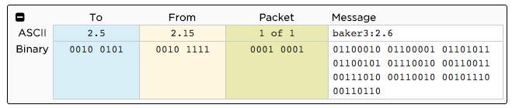

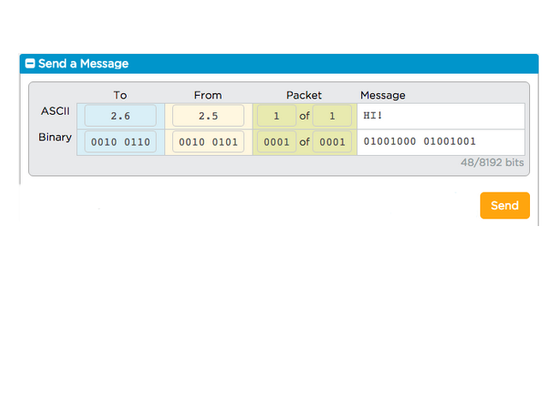

Once you’ve sent your request for the IP Address, the DNS will respond with the hostname and the IP address (shown on the left)

After the DNS has returned your partner’s IP, you may contact them directly by typing the IP address into the “To” field, entering a message, and then pressing “send.”

* **Interview a classmate**

Locate the IP address of classmate that is NOT on your router. Interview your classmate.

### **Interview questions – NO talking**

Partner's name:_________________________________

Are you a morning person or a night person?

|  |
| --- |
|  |

If you could have any superpower, what would it be and why?

|  |
| --- |
|  |

If you won the lottery, what is the first thing you’d do with the money?

|  |
| --- |
|  |

What series are currently binging?

|  |
| --- |
|  |

Do you have any pets? What are they?

|  |
| --- |
|  |

* **Have Ms. Pluska check off your interview with a classmate**



Before you continue have Ms. Pluska check off your interview with a classmate

Do not continue until you have Ms. Pluska’s (or her designated TA’s) signature ____________

* **Watch the video on DNS**

Navigate to the following link and watch the video on DNS

<https://www.youtube.com/watch?v=5o8CwafCxnU&feature=youtu.be&t=4m10s>

* **Reflect**

Use a search engine to complete the following

What does DNS stand for

|  |
| --- |
|  |

Why do we need a Domain Name System?

|  |
| --- |
|  |

Why don’t we all maintain our own DNS?

|  |
| --- |
|  |

Is there one big DNS for the entire Internet? Why not?

|  |
| --- |
|  |

What is one vulnerability of DNS and how is that vulnerability attacked?

|  |
| --- |
|  |

What are the implications of an attack on a DNS server (or servers) - how does this affect your life?

|  |
| --- |
|  |

What is a DDoS attack?

|  |
| --- |
|  |

What is DNS spoofing?

|  |
| --- |
|  |

* **Receive Credit for the group portion of this lab**



1. Indicate the names of all group members.
2. Have Ms. Pluska check your Need for DNS lab
3. Submit your lab to the needs to be graded folder to receive credit for the group portion of this lab.

Do not submit your lab until you have Ms. Pluska’s (or her designated TA’s) signature _______

**Names and Address**

|  |  |  |  |  |
| --- | --- | --- | --- | --- |
| **Name** | **IP Address** |  | **Name** | **IP Address** |
|  |  |  |  |  |
|  |  |  |  |  |
|  |  |  |  |  |
|  |  |  |  |  |
|  |  |  |  |  |
|  |  |  |  |  |
|  |  |  |  |  |
|  |  |  |  |  |
|  |  |  |  |  |
|  |  |  |  |  |
|  |  |  |  |  |
|  |  |  |  |  |
|  |  |  |  |  |
|  |  |  |  |  |