|  |  |  |  |
| --- | --- | --- | --- |
|  |  | **Colors** |  |

|  |
| --- |
| **Your Tasks** |
| * Indicate the three ways colors can be described in CSS * Distinguish between foreground and background * Interpret colors expressed in RGB * Interpret colors expressed in hexadecimal * Have Ms. Pluska check off the above tasks * Apply the hue, saturation, and lightness color scheme * Apply alpha/opacity property * Receive credit for the group portion of this lab |

* **Indicate the three ways colors can be described in CSS**

CSS supports a wide variety of colors. These include named colors, like blue, black, and LimeGreen, along with colors described by a numeric value. Using a numeric system allows us to take advantage of the whole spectrum of colors that browsers support. In this lesson, we’re going to explore all the color options CSS offers.

Colors in CSS can be described in three different ways:

* Named colors — English words that describe colors, also called keyword colors
* RGB — numeric values that describe a mix of red, green, and blue
* HSL — numeric values that describe a mix of hue, saturation, and lightness
* **Distinguish between foreground and background**

Before discussing the specifics of color, it’s important to make two distinctions about color. Color can affect the following design aspects:

1. The foreground color
2. The background color

*Foreground* color is the color that an element appears in. For example, when a heading is styled to appear green, the *foreground* color of the heading has been styled.

Conversely, when a heading is styled so that its *background* appears yellow, the *background* color of the heading has been styled

In CSS, these two design aspects can be styled with the following two properties:

1. color - this property styles an element’s foreground color.
2. background-color - this property styles an element’s background color.

In the example above, the text of the heading will appear in red, and the background of the heading will appear blue.

|  |  |
| --- | --- |
|  | |
| **Index.html** | **Styles.css** |
| <div class="one">BOX 1</div> | .one {  color: blue;  background-color: yellow;  height:2em;  } |

|  |  |
| --- | --- |
| Write css rules to style the boxes as shown | |
| **Output** | |
|  | |
| **Index.html** | **Styles.css** |
| <div class = "one">One</div>  <div class = "two">Two</div> |  |

* **Interpret colors expressed in RGB**

There is another syntax for representing RGB values that uses decimal numbers. It looks as follows,

|  |
| --- |
| h1 {  color: rgb(23, 45, 23);  } |

Here, each of the three values represents a color component, and each can have a decimal number value from 0 to 255. The first number represents the amount of red, the second is green, and the third is blue.

Recall, the number of places required to represent a given number in binary can be determined as follows

|  |  |  |  |  |  |  |  |  |  |
| --- | --- | --- | --- | --- | --- | --- | --- | --- | --- |
| **Binary – base 2** | | | | | | | | | |
|  | 28 | 27 | 26 | 25 | 24 | 23 | 22 | 21 | 20 |
| Max value | 256 | 128 | 64 | 32 | 16 | 8 | 4 | 2 | 1 |
| Places (bits) | 9 | 8 | 7 | 6 | 5 | 4 | 3 | 2 | 1 |

Based on the table above, the base 10 numbers can be represented as follows in binary

|  |  |
| --- | --- |
| **Base 10** | **binary** |
| 256 | 1000000000 |
| 128 | 10000000 |
| 64 | 1000000 |
| 32 | 100000 |
| 16 | 10000 |
| 8 | 1000 |
| 4 | 100 |
| 2 | 10 |
| 1 | 1 |

|  |
| --- |
| 1. How many bits (or places) are required to represent the number 255 in binary? 2. How many bytes are required (1 byte = 8 bits)? 3. How many bits are required to represent an RGB color? 4. How many bytes are required to represent an RGB color? 5. How many possible colors are there? |
|  |

|  |  |
| --- | --- |
| **Color** | **RGB** |
| DarkSeaGreen  Sienna  SaddleBrown3  Brown  Black  White  Aqua | 143,188,143  160, 81, 45  139, 69, 19  150, 75, 0  000, 000, 000  255, 255, 255  000, 255, 255 |

|  |  |
| --- | --- |
| Write css rules to style the boxes as shown | |
| **Output** | |
|  | |
| **Index.html** | **Styles.css** |
| <div class = "one">The background is sienna and the foreground is Aqua</div>  <div class = "two">The background is darkseagreen and the foreground is white</div> |  |

* **Interpret colors expressed in hexadecimal**

Another syntax that we can use to specify colors is called hexadecimal. Colors specified using this system are called hex colors. A hex color begins with a hash character (#) which is followed by three or six characters. The characters represent values for red, blue and green.

|  |  |
| --- | --- |
| **Color** | **Hexadecimal value** |
| DarkSeaGreen  Sienna  SaddleBrown3  Brown  Black  White  Aqua | #8FBC8F  #A0522D  #8B4513  #A52A2A  #000000 or #000  #FFFFFF or #FFF  #00FFFF or #0FF |

In the table above, you may notice that there are both letters and numbers in the values. This is because the hexadecimal number system has 16 digits (0-15) instead of 10 (0-9) like you are used to. To represent 10-15, we use A-F. This is illustrated below,

|  |  |  |  |  |  |  |  |  |  |  |  |  |  |  |  |
| --- | --- | --- | --- | --- | --- | --- | --- | --- | --- | --- | --- | --- | --- | --- | --- |
| **15** | **14** | **13** | **12** | **11** | **10** | **9** | **8** | **7** | **6** | **5** | **4** | **3** | **2** | **1** | **0** |
| F | E | D | C | B | A | 9 | 8 | 7 | 6 | 5 | 4 | 3 | 2 | 1 | 0 |

The number of places required to represent a given number in hexadecimal can be determined as follows

|  |  |  |  |  |
| --- | --- | --- | --- | --- |
|  | 163 | 162 | 161 | 160 |
| Max value | 4096 | 256 | 16 | 1 |
| Places | 4 | 3 | 2 | 1 |

Based on the table above, the base 10 numbers can be represented as follows in hexadecimal

|  |  |
| --- | --- |
| **Base 10** | **hexadecimal** |
| 4096 | 1000 |
| 256 | 100 |
| 16 | 10 |
| 1 | 1 |

|  |  |
| --- | --- |
| Convert the following hexadecimal numbers to decimal | |
| **Hexadecimal** | **Decimal** |
| A1 |  |
| B2 |  |
| FF |  |
| 1A |  |

|  |
| --- |
| How many places are required to represent the number 255 in hexadecimal? |
|  |

The following example illustrates how to convert a decimal number into hexadecimal,

|  |  |  |  |
| --- | --- | --- | --- |
| **number = 3741** | | | |
| **Base divisor** | **Number divided** | **Remainder** | **Hexadecimal value** |
| 16 | 3741 ÷ 16 = 233 | 13 | D |
| 16 | 233 ÷ 16 = 14 | 9 | 9 |
| 16 | 14 ÷ 16 = 0 | 14 | E |

Now list hexadecimal remainders from top to bottom: E9D

|  |  |
| --- | --- |
| Convert the following decimal numbers to hexadecimal. To do this following these steps: | |
| **Decimal** | **Hexadecimal** |
| 255 |  |
| 64 |  |
| 32 |  |
| 128 |  |

The RGB values associated with a color expressed in hexadecimal can be interpreted as follows,

|  |  |  |
| --- | --- | --- |
| **Color** | **Hexadecimal** | **Interpretation** |
| Sienna | #A0522D | A0 = Red  52 = Green  2D = Blue |

Notice that the last two digits of the hexadecimal number represent Red, the middle two represent Green, and the last two represent Blue. Also, notice that the maximum value for either R, G, B cannot exceed a byte of memory. Put another way,

|  |  |  |
| --- | --- | --- |
| Max R, G, B values in decimal, binary, and hexadecimal | | |
| **Decimal** | **Binary (8 bits = 1 byte)** | **Hexadecimal** |
| 255 | 11111111 | FF |

Now let’s return to our hexadecimal colors from before,

|  |  |
| --- | --- |
| **Color** | **Hexadecimal value** |
| DarkSeaGreen  Sienna  SaddleBrown3  Brown  Black  White  Aqua | #8FBC8F  #A0522D  #8B4513  #A52A2A  #000000 or #000  #FFFFFF or #FFF  #00FFFF or #0FF |

Notice that Black, White, and Aqua are all represented with both three characters and six characters. This can be done with hex colors whose number pairs are the same characters. In the example above, Aqua can be represented as #0FF because both of the first two characters are 0 and the second and third pairs of characters are both Fs. Keep in mind that all three character hex colors can be represented with six characters (by repeating each character twice).

You can include hex colors in your css rules just as you would include named colors:

|  |
| --- |
| background-color: #9932cc; |

|  |  |
| --- | --- |
| Write css rules to style the boxes as shown | |
| **Output** | |
|  | |
| **Index.html** | **Styles.css** |
| <div class = "one">The background is sienna and the foreground is Aqua</div>  <div class = "two">The background is darkseagreen and the foreground is white</div> |  |

* **Have Ms. Pluska check off the above tasks**



Before you continue have Ms. Pluska check off the above tasks

Do not continue until you have Ms. Pluska’s (or her designated TA’s) signature ____________

* **Apply the hue, saturation, and lightness color scheme**

The RGB color scheme is convenient because it’s very close to how computers represent colors internally. There’s another equally powerful system in CSS called the hue-saturation-lightness color scheme, abbreviated as HSL.

The syntax for HSL is similar to the decimal form of RGB, though it differs in important ways. The first number represents the degree of the hue, and can be between 0 and 360. The second and third numbers are percentages representing saturation and lightness respectively. Here is an example:

|  |
| --- |
| color: hsl(120, 60%, 70%); |

Hue is the first number. It refers to an angle on a color wheel. Red is 0 degrees, Green is 120 degrees, Blue is 240 degrees, and then back to Red at 360. You can see an example of a color wheel below:

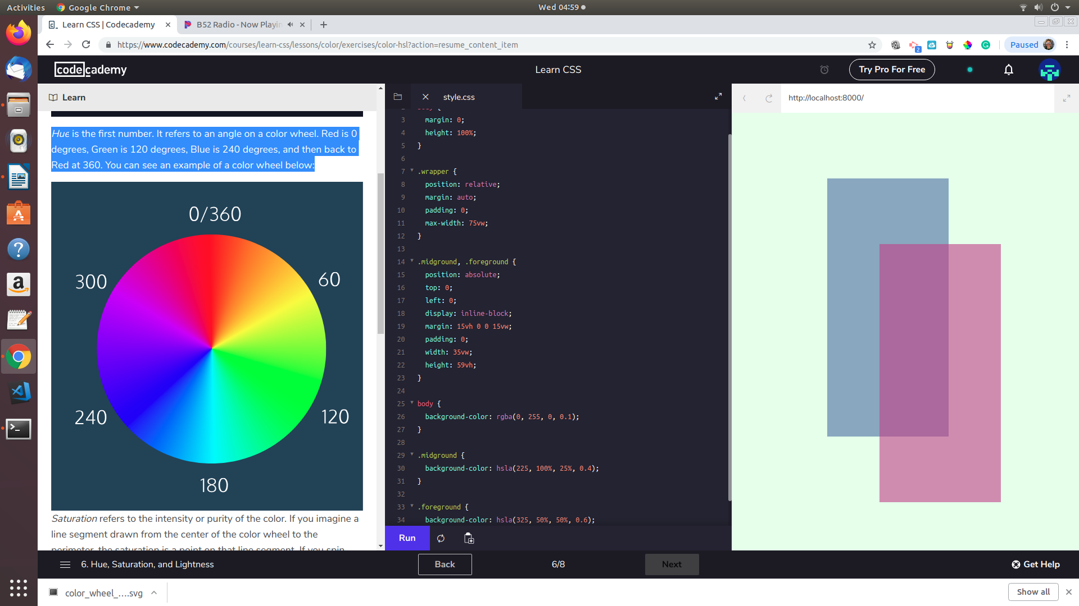

Saturation refers to the intensity or purity of the color. If you imagine a line segment drawn from the center of the color wheel to the perimeter, the saturation is a point on that line segment. If you spin that line segment to different angles, you’ll see how that saturation looks for different hues. The saturation increases towards 100% as the point gets closer to the edge (the color becomes more rich). The saturation decreases towards 0% as the point gets closer to the center (the color becomes more gray).

Lightness refers to how light or dark the color is. Halfway, or 50%, is normal lightness. Imagine a sliding dimmer on a light switch that starts halfway. Sliding the dimmer up towards 100% makes the color lighter, closer to white. Sliding the dimmer down towards 0% makes the color darker, closer to black.

|  |  |
| --- | --- |
| Write css rules to color the boxes as shown | |
| **Ouput** | |
|  | |
| **Index.html** | **Styles.css** |
| <div class = "one">One</div>  <div class = "two">Two</div>  <div class = "three">Three</div> |  |

* **Apply the alpha/opacity property**

All of the colors we’ve seen so far have been opaque, or non-transparent. When we overlap two opaque elements, nothing from the bottom element shows through the top element. In this exercise, we’ll change the *opacity*, or the amount of transparency, of some colors so that some or all of the bottom elements are visible through a covering element.

To use opacity in the HSL color scheme, use *hsla* instead of *hsl*, and four values instead of three. For example:

|  |
| --- |
| color: hsla(34, 100%, 50%, 0.1); |

The first three values work the same as hsl. The fourth value (which we have not seen before) is the alpha – also referred to as opacity.

Alpha is a decimal number from zero to one. If alpha is zero, the color will be completely transparent. If alpha is one, the color will be opaque. The value for half transparent would be 0.5.

You can think of the alpha value as, “the amount of the background to mix with the foreground”. When a color’s alpha is below one, any color behind it will be blended in. The blending happens for each pixel; no blurring occurs.

The RGB color scheme has a similar syntax for opacity, rgba. Again, the first three values work the same as rgb and the last value is the alpha. Here’s an example:

|  |
| --- |
| color: rgba(234, 45, 98, 0.33); |

Alpha can only be used with HSL and RGB colors; we cannot add the alpha value to color: green color: #FFFFF.

There is, however, a named color keyword for zero opacity, transparent. It’s equivalent to rgba(0, 0, 0, 0). It’s used like any other color keyword:

|  |
| --- |
| color: transparent; |

|  |  |
| --- | --- |
| Complete the css rules to style the boxes as shown | |
| **Output** | |
|  | |
| **Index.html** | **Styles.css** |
| <div class = "one">One</div>  <div class = "two">Two</div>  <div class = "three">Three</div> | .one {  background-color: hsl(60, 100%, 50%);  width:100px;  height:100px;  position:absolute;  top:1em;  left:1em;  line-height:5em;  text-align:center;  } |

* **Receive Credit for the group portion of this lab**



* Indicate the names of all group members.
* Have Ms. Pluska check your Box Model tasks
* Submit your lab to the needs to be graded folder to receive credit for the group portion of this lab.
* Do not submit your lab until you have Ms. Pluska’s (or her designated TA’s) signature

_______