|  |  |  |  |
| --- | --- | --- | --- |
|  |  | **Tables** |  |

|  |
| --- |
| **Your Tasks** |
| * Write code to create a table * Write code to create a table heading * Have Ms. Pluska check off the above tasks * Write code to span rows and columns * Receive credit for the group portion of this lab |

* **Write code to create a table**

There are many websites on the Internet that display information like stock prices, sports scores, invoice data, and more. This data is naturally tabular in nature, meaning that a table is often the best way of presenting the data.

In this lesson, you'll learn how to use HTML tables to present tabular data to users.

Before displaying data, you must first create the table that will contain the data by using the <table> element. All the data associated with your table will go between these tags.

|  |
| --- |
| <table>    </table> |

All tables contain rows and within those are cells in which we can store data. The table row tag, <tr></tr>, is used to create rows. The table data tag, <td></td>, is used to create cells. Consider the example below. The code below creates a table with one row. Each cell within the row displays a day of the week.

|  |  |
| --- | --- |
| <table>  <tr>  <td>Sunday</td>  <td>Monday</td>  <td>Tuesday</td>  <td>Wednesday</td>  <td>Thursday</td>  <td>Friday</td>  <td>Saturday</td>  </tr>  </table> |  |

|  |
| --- |
| Write code that could be used to create a table with two rows. In the first row, *breakfast*, *lunch*, *dinner* should be stored in separate cells. In the second row, *Eggs*, *PB & J*, *Pizza* should be stored in separate cells. When ran your code should display as follows, |
|  |

* **Create a table heading**

Table data doesn't make much sense without titles to describe what the data represents.

To add titles to rows and columns, you can use the table heading element: <th>.

The table heading element is used just like a table data element, except with a relevant title. And, just like table data, a table heading must be placed within a table row. This is demonstrated below,

|  |  |
| --- | --- |
| <table>  <tr>  <th>Sunday</th>  <th>Monday</th>  <th>Tuesday</th>  <th>Wednesday</th>  <th>Thursday</th>  <th>Friday</th>  <th>Saturday</th>  </tr>  <tr>  <td>Sleep in</td>  <td>Go to school</td>  <td>Go to school</td>  <td>Go to school</td>  <td>Go to school</td>  <td>Go to school</td>  <td>Sleep in</td>  </tr>  </table> |  |

|  |
| --- |
| Write code that could be used to create a table which displays the following months as table headers: January, May, July, September, October, November, December. In a second row, indicate a holiday that occurs in each month. When ran your code should display as follows, |
|  |

* **Have Ms. Pluska check off the above tasks**



Before you continue have Ms. Pluska check off the above tasks

Do not continue until you have Ms. Pluska’s (or her designated TA’s) signature ____________

* **Write code to span rows and columns**

Recall that rows in an HTML table go across. For example, the code below would produce the following output.

|  |  |
| --- | --- |
| <table>  <tr>  <th>Row 1</th>  <th>Row 1</th>  <th>Row 1</th>  <th>Row 1</th>  <th>Row 1</th>  <th>Row 1</th>  <th>Row 1</th>  </tr>  <tr>  <th>Row 2</th>  <th>Row 2</th>  <th>Row 2</th>  <th>Row 2</th>  <th>Row 2</th>  <th>Row 2</th>  <th>Row 2</th>  </tr>  </table> |  |

Columns on the other hand, go down as illustrated in the following example,

|  |  |
| --- | --- |
| <table>  <tr>  <th>Column 1</th>  <th>Column 2</th>  <th>Column 3</th>  <th>Column 4</th>  <th>Column 5</th>  <th>Column 6</th>  <th>Column 7</th>  </tr>  <tr>  <th>Column 1</th>  <th>Column 2</th>  <th>Column 3</th>  <th>Column 4</th>  <th>Column 5</th>  <th>Column 6</th>  <th>Column 7</th>  </tr>  </table> |  |

In a previous example, we wrote code to generate the following output,

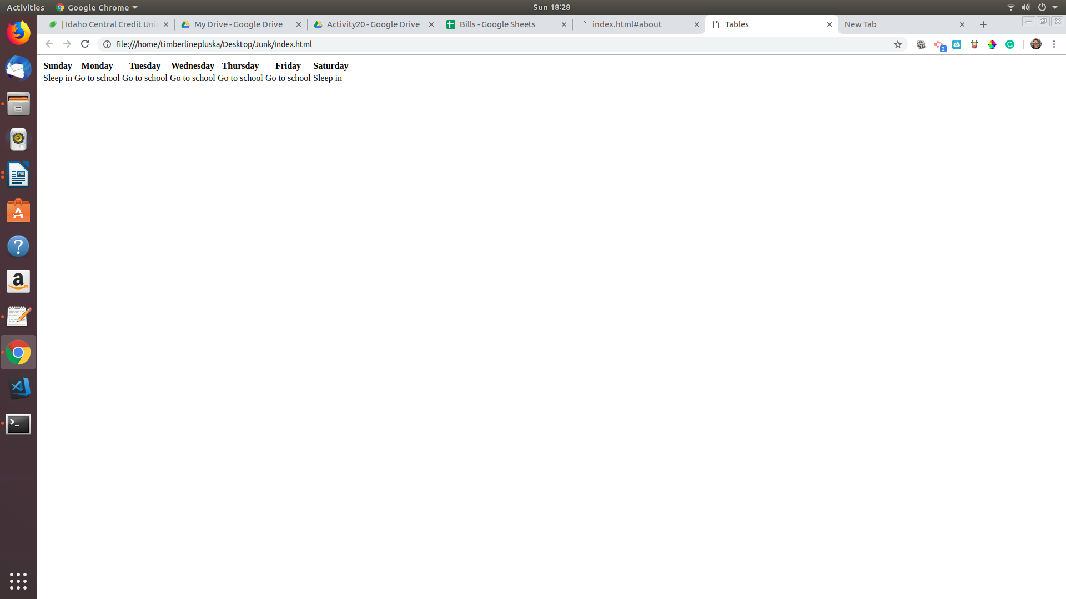

In this example we wrote “Go to school” 5 days in a row, or across 5 columns. This practice is redundant and the colspan attribute can be used to consolidate these columns and reduce the amoutn of code we need to write. See below,

|  |
| --- |
| <table>  <tr>  <th>Sunday</th>  <th>Monday</th>  <th>Tuesday</th>  <th>Wednesday</th>  <th>Thursday</th>  <th>Friday</th>  <th>Saturday</th>  </tr>  <tr>  <td>Sleep in</td>  <td colspan = 5>Go to school</td>  <td>Sleep in</td>  </tr>  </table> |
|  |

Although it may not be clear from the output, the cell *Go to school* now spans 5 columns. You can use the bgcolor attribute to change the color of the cell to make this more clear.

|  |
| --- |
| <table>  <tr>  <th>Sunday</th>  <th>Monday</th>  <th>Tuesday</th>  <th>Wednesday</th>  <th>Thursday</th>  <th>Friday</th>  <th>Saturday</th>  </tr>  <tr>  <td>Sleep in</td>  <td colspan=5 bgcolor="yellow">Go to school</td>  <td>Sleep in</td>  </tr>  </table> |
|  |

|  |
| --- |
| Write code that creates a table and displays each month as a header across the top. For each season, use the colspan attribute to indicate the season for each month. Use the bgcolor attribute to color each season (winter = lightblue, spring = green, summer = yellow, fall = orange). When ran your code should display as follows, |
|  |

To illustrate the column attribute, let’s return to our code that generated the days of the week. Depending on the time, you probably do different things on each day. For example, on Monday you may be in school from 8 to 3, whereas on Saturday you may have soccer practice from 1 to 3. The rowspan attribute enables us to indicate these blocks of time without writing unnecessary code.

|  |
| --- |
| <table>  <tr>  <th>Time</th>  <th>Saturday</th>  <th>Sunday</th>  <th>Monday</th>  <th>Tuesday</th>  <th>Wednesday</th>  <th>Thursday</th>  <th>Friday</th>  </tr>  <tr>  <th>8:00 am</th><td></td><td></td><td rowspan=8 bgcolor="yellow" >School</td><td></td><td></td><td></td><td></td>  </tr>  <tr>  <th>9:00 am</th><td></td><td></td><td></td><td></td><td></td><td></td><td></td>  </tr>  <tr>  <th>10:00 am</th><td></td><td></td><td></td><td></td><td></td><td></td><td></td>  </tr>  <tr>  <th>11:00 am</th><td></td><td></td><td></td><td></td><td></td><td></td><td></td>  </tr>  <tr>  <th>12:00 pm</th><td></td><td></td><td></td><td></td><td></td><td></td><td></td>  </tr>  <tr>  <th>1:00 pm</th><td rowspan = 2 bgcolor = "lightblue">Soccer practice</td><td></td><td></td><td></td><td></td><td></td><td></td>  </tr>  <tr>  <th>2:00 pm</th><td></td><td></td><td></td><td></td><td></td><td></td><td></td>  </tr>  <tr>  <th>3:00 pm</th><td></td><td></td><td></td><td></td><td></td><td></td><td></td>  </tr>  </table> |
|  |

|  |  |
| --- | --- |
| Consider your schedule on a typical Monday in October. Write code that could be used to display your schedule. When ran your code should look similar to that shown below, | |
|  |  |

* **Receive Credit for the group portion of this lab**



* Indicate the names of all group members.
* Have Ms. Pluska check your Tables tasks
* Submit your lab to the needs to be graded folder to receive credit for the group portion of this lab.
* Do not submit your lab until you have Ms. Pluska’s (or her designated TA’s) signature

_______