CSCI – 185 HW02

Accessibility questions:

1. I had to add ALT tags to images and add aria-label tags to buttons
2. When turning off CSS for the page, you can still tab and see everything you need. The functionality of the website stays the same with or without CSS.
3. Yes, it is tabbable.

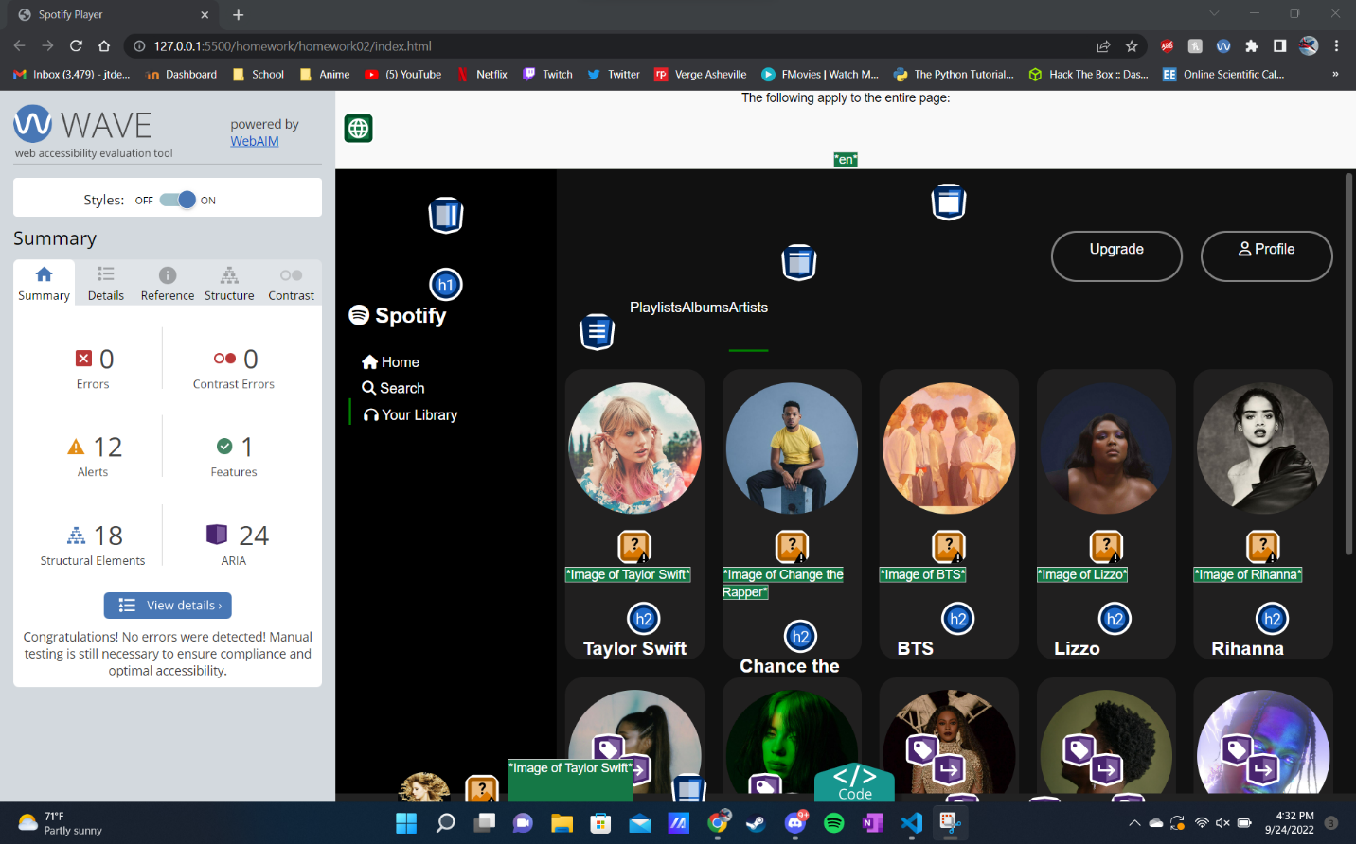

HW02 Link: <https://jacelearnspython.github.io/csci185-coursework/homework/homework02/index.html>

Home Page: <https://jacelearnspython.github.io/csci185-coursework/>