Response to Panel Comments
System Architecture, Diagrams, and Requirements Specification
Geo-Agentic RAG: A Framework for Integrated Document Services, Wayfinding, and Administrative Analytics for Local Government Offices
Jester C. Penaranda
La Consolacion University Philippines
Graduate School Department

Preamble
This document responds to the panel comments concerning the System Architecture section of the dissertation and provides the supplementary materials requested for inclusion in Chapter 2 immediately before the Technological Modules section. The response covers four discrete panel items: (1) the enhancement of system architecture clarity through supporting diagrams; (2) the addition of a unified end-to-end system architecture diagram, an integrated data flow representation, and an explicit description of the interaction between the AI module, Navigation module, and Analytics module; (3) a complete list of software requirements for development and implementation; and (4) a complete list of hardware requirements for system operation and deployment.
Two purpose-built figures accompany this document: Figure 1 (Unified System Architecture) shows the layered structure of the proposed Geo-Agentic RAG framework, and Figure 2 (Level-1 Data Flow Diagram) presents the integrated data flow representation. These figures are intended to be inserted into Chapter 2 immediately before the Technological Modules section as requested. Tabular descriptions of every component, process, data store, and inter-module flow accompany each figure to ensure that the architectural choices are fully traceable and auditable.

Panel Comment 1 — Enhancing System Architecture with Supporting Diagrams

Original Comment
"Enhance the system architecture section by including supporting diagrams such as a Data Flow Diagram (DFD) or an Entity-Relationship Diagram (ERD) to improve clarity and visualization."

Response
The Geo-Agentic RAG framework integrates three operationally distinct modules — the AI module, the Navigation module, and the Administrative Analytics module — together with four data stores and one external generative service. The intent of the original architecture text was to describe each module separately, but the panel correctly observed that a unified diagram is required to convey how the modules combine into a single municipal service platform.
In response, two diagrams have been produced: (a) a unified system architecture diagram that visualizes the layered structure of the proposed framework, and (b) a Level-1 data flow diagram that traces every inter-module flow, external entity interaction, and persistent data store. Both diagrams are presented below and will be embedded into the revised Chapter 2 prior to the Technological Modules section. A formal entity-relationship diagram is not adopted as the primary representation because the data stores in this system are document-oriented (JSON / JSONL) and vector-indexed rather than relational; the data flow diagram more accurately captures the relevant data semantics for an evaluation panel.

Panel Comment 2 — Unified Architecture, Integrated DFD, and Module Interaction

Original Comment
"The study must include: End-to-end system architecture diagram, Integrated data flow representation, Interaction between: AI module, Navigation module, Analytics module. Required Action: Add a Unified System Architecture Diagram and Data Flow Diagram (DFD – Data Flow Diagram). Location for Revision: Chapter 2 – Before Technological Modules Section."

Response
Figure 1 below depicts the end-to-end system architecture. The user (Citizen or Administrator) interacts with a Vercel-hosted static web application, which dispatches requests to three internal modules and a single external generative service (Groq cloud LLM). Each module is supported by one or more data stores: the AI module reads the Citizen's Charter document corpus and FAISS vector index; the Navigation module reads the floor and office layout (FLOOR_PRESETS and localStorage); the Analytics module reads the append-only query log.
Figure 2 below presents the corresponding Level-1 data flow diagram. Three external entities (Citizen, Administrator, and Groq Cloud LLM), five processes (P1–P5), and four data stores (D1–D4) are depicted. Tables 1 through 5 enumerate every component, every inter-module interaction, every data flow, every process, and every data store. Together, the figures and tables form a fully specified architectural description suitable for inclusion in the dissertation and reproducible by future implementers.
Beyond the diagrams, the explicit interaction between the three modules is summarized in Table 2 (Module Interaction). The AI module hands the destination department to the Navigation module when a user taps "Take me there." The Navigation module supplies the current floor and approximate location back to the AI module for location-aware queries. Both modules write structured log entries to the Analytics module, which exposes aggregated dashboards back to the Administrator. The Capture Mode within the Navigation module persists newly tagged office coordinates into the floor and office layout data store, enabling continuous expansion of the office registry without code changes.
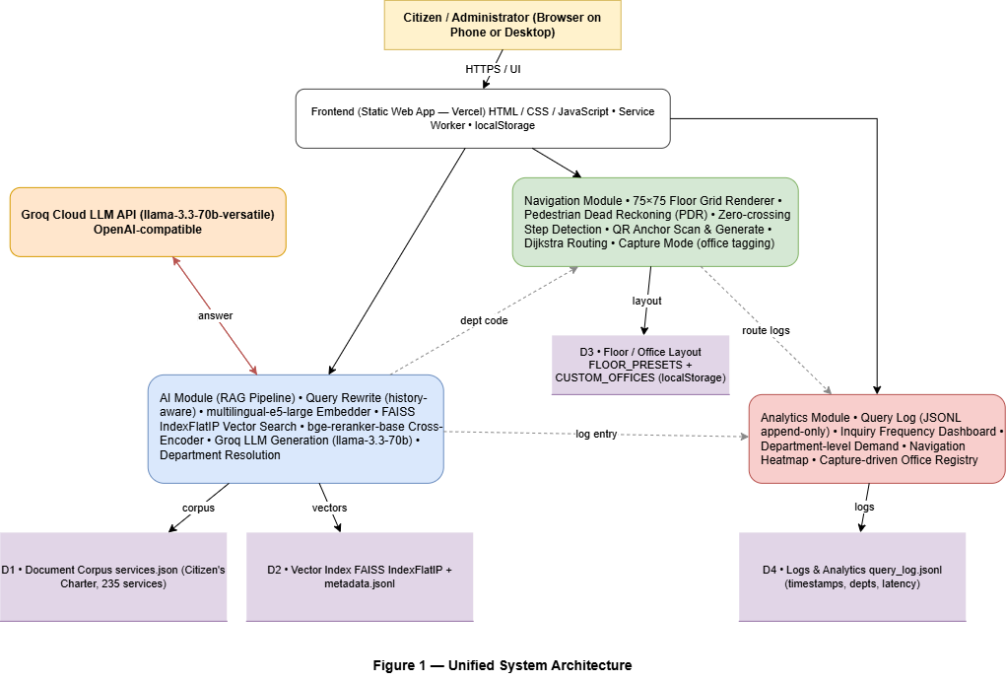
Figure 1. Unified System Architecture of the Geo-Agentic RAG framework, showing the user layer, frontend, three operational modules (AI, Navigation, Analytics), four data stores (D1–D4), and the external Groq Cloud LLM service.
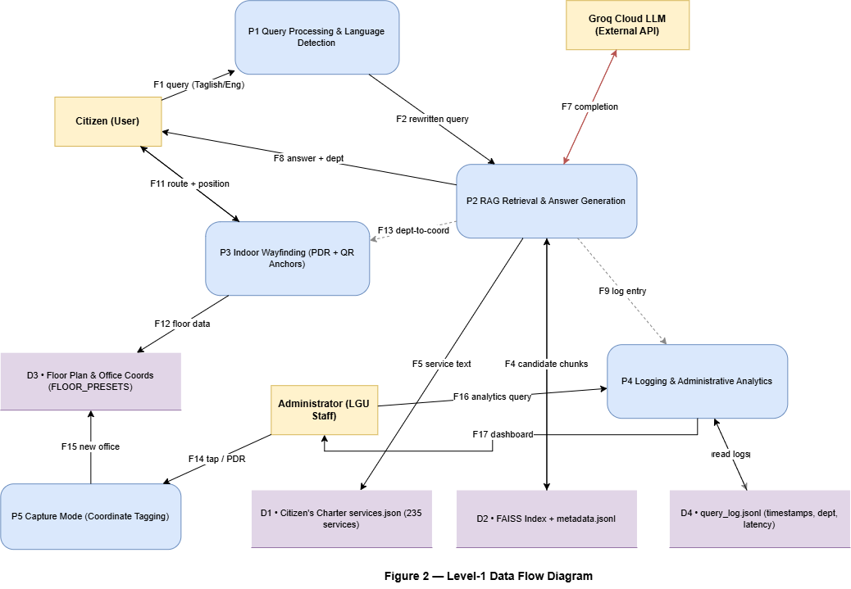
Figure 2. Level-1 Data Flow Diagram of the Geo-Agentic RAG framework, showing three external entities, five processes (P1–P5), four data stores (D1–D4), and the major inter-process data flows.

Table 1 — Component Inventory
Every component depicted in Figure 1 is enumerated below with its containing module and operational role.
# | Component | Module | Role / Function
1 | Citizen / Administrator (User) | External | Initiates queries, follows navigation, reviews analytics.
2 | Frontend Web App (Vercel) | Frontend | Static HTML/CSS/JS interface served from a global CDN; handles UI, chat widget, canvas, sensors, and capture mode.
3 | Query Rewriter | AI | Reformulates each query with conversation history for contextual retrieval.
4 | Multilingual-E5-Large Embedder | AI | Generates 1024-dimensional query and document embeddings supporting Tagalog, English, and Taglish.
5 | FAISS IndexFlatIP Vector Store | AI / Data | In-memory inner-product index over ~235 service chunks; returns top-K candidates.
6 | BGE-Reranker-Base Cross-Encoder | AI | Second-stage reranker that rescores top candidates for precision.
7 | Groq LLM (llama-3.3-70b-versatile) | AI / Cloud | Cloud generator that produces grounded, language-matched answers.
8 | Department Resolver | AI | Extracts the destination office from the answer and exposes it to the Navigation Module.
9 | 75x75 Grid Renderer | Navigation | Draws the flat-top floor plan, walls, route, and current position on an HTML canvas.
10 | Pedestrian Dead Reckoning (PDR) Engine | Navigation | Estimates user position using accelerometer and gyroscope; uses zero-crossing step detection.
11 | QR Anchor Scanner / Generator | Navigation | Scans GRID:floor:row,col labels to correct drift and exports printable QR sheets.
12 | Dijkstra Pathfinder | Navigation | Computes shortest path between current cell and destination office on the grid graph.
13 | Capture Mode | Navigation | Lets an administrator tag office coordinates on-site via tap or PDR walk.
14 | Query Logger | Analytics | Writes each query, dept, and latency to an append-only JSONL log.
15 | Inquiry Frequency Dashboard | Analytics | Aggregates queries by department and time period for operational planning.
16 | Navigation Heatmap | Analytics | Visualises high-traffic routes and target offices.
17 | Document Corpus (services.json) | Data Store | Authoritative Citizen's Charter, 235 services with requirements and steps.
18 | Vector Index (faiss.index + metadata.jsonl) | Data Store | Pre-computed dense embeddings and chunk metadata.
19 | Floor / Office Layout (FLOOR_PRESETS + localStorage) | Data Store | Walls, office anchors, and captured custom offices.
20 | Query Log (query_log.jsonl) | Data Store | Append-only telemetry for analytics and audit.

Table 2 — Module Interaction Matrix
Direct interactions between the AI, Navigation, and Analytics modules, with each row corresponding to one labeled flow in the data flow diagram.
# | Source Module | Target Module | Data / Trigger | Purpose
1 | AI | Navigation | Department code (e.g., "BPLO") | After answering a query, the chat hands the destination office to Navigation so the "Take me there" button can plot the route.
2 | Navigation | AI | Active floor / current position (optional) | Provides spatial context that the AI can include when answering location-aware queries (e.g., "the office nearest to me").
3 | AI | Analytics | Query log entry (timestamp, dept, latency, language) | Each completed answer appends a structured log row used for dashboards and audit.
4 | Navigation | Analytics | Route start / end / floor | Each navigation request appends an entry used for traffic heatmaps.
5 | Analytics | Administrator | Aggregated dashboards | LGU staff query the Analytics module for service-demand and routing reports.
6 | Capture Mode (Navigation) | Data Store D3 | New office coordinates (department code, floor, row, col) | Persists user-captured offices into the local registry for subsequent routing.

Table 3 — Data Flow Description
Each row corresponds to one labeled flow F1–F17 in Figure 2.
# | Flow | From → To | Data | Trigger
F1 | Query Submission | Citizen → P1 (Query Processing) | Natural-language query (Tagalog / English / Taglish) | User taps Send in chat widget
F2 | Rewritten Query | P1 → P2 (RAG) | History-aware reformulated query | P1 completes language detection and rewrite
F3 | Embedding Lookup | P2 → D2 (FAISS) | Query vector + top-K request | Each query
F4 | Candidate Chunks | D2 → P2 | Top-K services with metadata | Synchronous response from FAISS
F5 | Service Text Retrieval | P2 → D1 (services.json) | Service ID lookup | After reranking selects top candidates
F6 | Prompt to LLM | P2 → Groq LLM | Prompt with context + question | RAG composition stage
F7 | Completion | Groq LLM → P2 | Generated answer in matching language | Streaming or completion event
F8 | Final Answer | P2 → Citizen | Answer + department code | After Department Resolver runs
F9 | Log Entry | P2 → P4 → D4 | Timestamp, dept, latency, language flag | After F8 completes
F10 | Sensor / QR Input | Citizen → P3 (Wayfinding) | Accel, gyro, decoded QR payload | User opens map and starts walking
F11 | Route + Position | P3 → Citizen | Path coordinates and current cell | Each step or QR scan
F12 | Floor Plan Read | P3 → D3 | Active floor walls and office coordinates | On floor switch
F13 | Dept-to-Coord | P2 → P3 | Department code | On "Take me there" tap
F14 | Capture Tag | Administrator → P5 (Capture) | Department label + tap location or current PDR cell | Capture Mode active
F15 | New Office Persist | P5 → D3 | Custom office {dept, floor, row, col} | After confirmation
F16 | Analytics Query | Administrator → P4 | Dashboard filter (date, dept) | Admin opens analytics view
F17 | Dashboard Result | P4 → Administrator | Aggregated table / chart payload | P4 finishes reading D4

Table 4 — Process Description
Each process P1–P5 in Figure 2 is decomposed into its inputs, processing steps, and outputs.
# | Process | Inputs | Processing | Outputs
P1 | Query Processing & Language Detection | Raw query, last 6 history entries | Detect Tagalog/English/Taglish; rewrite with history context | Reformulated query, language flag
P2 | RAG Retrieval & Answer Generation | Rewritten query, FAISS index, services.json | Embed → vector search → rerank → build prompt → call Groq → extract department | Final answer, dept code, log entry
P3 | Indoor Wayfinding (PDR + QR) | Sensor data (accel, gyro), QR payload, dept code, floor layout | Step detect → heading update → drift correct on QR scan → Dijkstra route | Route, current cell, on-screen overlay
P4 | Logging & Administrative Analytics | Log writes from P2 / P3, admin queries | Append to JSONL; aggregate on demand | Dashboards, heatmaps, audit logs
P5 | Capture Mode (Coordinate Tagging) | Tap location or PDR position, department label | Validate, persist to localStorage | Updated office registry in D3

Table 5 — Data Store Description
Each data store D1–D4 in Figure 2 is characterized by its name, serialization format, persistence layer, and refresh lifecycle.
Store | Name | Format | Persistence | Lifecycle
D1 | Document Corpus (Citizen's Charter) | JSON (services.json, 235 services) | Git-tracked file | Refreshed when Citizen's Charter changes; rebuild index after
D2 | Vector Index | FAISS binary + JSONL metadata | On-disk | Rebuilt by build_index.py whenever D1 changes
D3 | Floor / Office Layout | JS object (FLOOR_PRESETS) + localStorage (CUSTOM_OFFICES) | Bundled JS + browser storage | Bundled walls evolve with floor plan; captures persist per device
D4 | Query Log | Append-only JSONL (query_log.jsonl) | Disk on backend host | Rotated periodically; never modified in place

Panel Comment 3 — Software Requirements

Original Comment
"Provide a complete and detailed list of software requirements needed for the development and implementation of the system."

Response
Table 6 provides a complete list of the software requirements needed for the development and implementation of the system. The list is grouped by layer, ranging from operating system and programming languages through web servers, machine-learning frameworks, embedding and reranker models, vector indexing libraries, cloud large-language-model APIs, browser application programming interfaces, evaluation tooling, and documentation tools.
The software stack is intentionally biased toward open and reproducible components. Every model used in the AI module (multilingual-e5-large, bge-reranker-base) is publicly available under permissive licenses on Hugging Face Hub. Every retrieval and ranking library (FAISS, sentence-transformers, PyTorch) is open source. The frontend is plain HTML, CSS, and vanilla JavaScript without proprietary frameworks. Cloud large-language-model inference is performed via the Groq API, with Google Gemini available as a secondary backend and Ollama as an on-premises offline fallback.

Table 6 — Software Requirements
Layer | Component | Version / Spec | Purpose
Operating System | Ubuntu Server (ARM64) | 22.04 LTS or newer | Production backend host (Oracle Always Free A1 VM).
Operating System | Windows 10/11 or macOS 13+ | current | Developer workstation.
Operating System | Android / iOS | Android 9+ / iOS 15+ | Client device runtime.
Programming Language | Python | 3.11 or 3.12 | Backend RAG pipeline and server.
Programming Language | JavaScript (ES2020+) | ES2020 baseline | Frontend, chat widget, wayfinding canvas, PDR engine.
Programming Language | HTML5 / CSS3 | current | Frontend layout and styling.
Web Server | Python http.server (dev) / nginx | nginx 1.24+ | Static file serving and TLS termination in production.
Reverse Proxy | nginx | 1.24+ | Forwards /api/* from :443 to internal Python service.
TLS | Let's Encrypt / certbot | current | Free TLS certificates auto-renewed for the backend domain.
Process Manager | systemd | current Ubuntu version | Keeps the Python API service alive and restarts on failure.
Static Host | Vercel | Hobby plan | Frontend static deployment with global edge CDN.
Source Control | Git | 2.40+ | Versioning of code, corpus, and dissertation revisions.
ML Framework | PyTorch | 2.2+ (CPU build) | Backbone for sentence-transformers and reranker.
Embedding Library | sentence-transformers | 2.7+ | Loads multilingual-e5-large and bge-reranker-base.
Embedding Model | intfloat/multilingual-e5-large | v1 | Generates 1024-dim multilingual embeddings.
Reranker Model | BAAI/bge-reranker-base | v1 | Cross-encoder scoring for top-K candidates.
Vector Index | faiss-cpu | 1.8+ | FAISS IndexFlatIP exact inner-product search.
Local LLM Fallback | Ollama | 0.3+ | Optional offline fallback (qwen2.5:3b).
Cloud LLM Backend | Groq API | current | Primary generation backend (llama-3.3-70b-versatile).
Cloud LLM Backup | Google Gemini API | v1 (gemini-2.5-flash) | Optional secondary backend.
HTTP Client | Python requests | 2.31+ | Calls Groq / Gemini REST APIs.
Config Management | python-dotenv | 1.0+ | Loads environment variables (API keys, flags) from .env.
Browser APIs | DeviceOrientation, DeviceMotion | W3C standard | PDR step and heading estimation.
Browser APIs | getUserMedia (camera) | W3C standard | QR code scanning.
Browser APIs | Service Worker | W3C standard | Offline shell + cache for the static site.
Browser APIs | localStorage | W3C standard | Persists grid edits and captured offices on the device.
QR Library | jsQR (bundled) | 1.4+ | Decodes QR images from the camera stream.
Routing Algorithm | Custom Dijkstra (vanilla JS) | in-repo | Shortest path on the 75x75 grid.
Evaluation Suite | NumPy, custom Python scripts | NumPy 1.26+ | Recall@K, Precision@K, MRR, NDCG retrieval metrics.
Build / Tooling | Node.js + npm | Node 20+, npm 10+ | docx generation, optional build scripts.
Documentation | Markdown, python-docx, LaTeX (optional) | current | Dissertation drafts, panel responses, supplementary docs.
Security | openssl | 3.0+ | Self-signed certificates for local dev only.

Panel Comment 4 — Hardware Requirements

Original Comment
"Provide a complete and detailed list of hardware requirements necessary to support system operation and deployment."

Response
Tables 7, 8, 9, and 10 enumerate the hardware requirements for the development workstation, the production server, the client devices, and the indoor infrastructure respectively. The architecture is explicitly designed to operate on the Oracle Cloud Always Free tier, which provides four ARM Ampere A1 OCPUs and 24 gigabytes of random-access memory at zero monthly cost.
Citizen-side requirements are limited to a smartphone running iOS 15 or later, or Android 9 or later, with accelerometer and gyroscope sensors and a camera. No proprietary hardware (Bluetooth Low Energy beacons, ultra-wideband transponders, or specialized handsets) is required for operational deployment. Indoor infrastructure is limited to laminated QR anchor labels printed on a standard office laser printer, mounted at predetermined grid intersections. Optional kiosk tablets, Bluetooth Low Energy beacons, and ultra-wideband modules are listed as future enhancements rather than baseline requirements.

Table 7 — Development Workstation Hardware
Component | Minimum | Recommended | Notes
CPU | 4 cores (x86-64 or ARM) | 8 cores | Required for local model load and FAISS build.
RAM | 16 GB | 32 GB | Embedder + reranker hold ~3.5 GB plus build overhead.
Storage | 50 GB free SSD | 100 GB free NVMe | Code, models, indexes, dissertation drafts.
GPU (optional) | None | CUDA, 6 GB VRAM | Accelerates reranker; FAISS-CPU is sufficient otherwise.
Network | 10 Mbps | 100 Mbps | Pulling models, calling Groq, pushing to GitHub.
Display | Single 1080p | Dual 1440p+ | For dissertation drafting and code review.

Table 8 — Production Server Hardware (Oracle Cloud Always Free)
Component | Spec | Notes
VM Shape | VM.Standard.A1.Flex (ARM Ampere) | Free under Oracle Always Free tier.
CPU | 4 OCPU (4 ARM cores) | Sufficient for embedder + reranker + FAISS in parallel.
RAM | 24 GB | ~3.5 GB models + Python overhead leaves ~18 GB headroom.
Storage | 50 GB block volume | Holds OS, code, models, indexes, logs.
Network | 10 TB egress / month | Free quota, more than enough for citizen-facing chat.
OS | Ubuntu 22.04 LTS (ARM64) | Long-term support; matches dev toolchain.
Process Management | systemd-managed Python service | Auto-restart on crash; cron-curl health check to avoid idle reclamation.

Table 9 — Client Device Hardware Requirements
Device Type | Minimum | Notes
Smartphone (iOS) | iPhone with iOS 15 or newer; Safari 15+ | Required for DeviceOrientation + camera.
Smartphone (Android) | Android 9 / Chrome 90+; accelerometer and gyroscope sensors | Required for PDR.
Tablet (optional) | Same as smartphone class | Useful for City Hall kiosk mode.
Desktop / Laptop | Any modern browser (Chrome 100+, Firefox 100+, Edge 100+) | Chat and analytics work without IMU; wayfinding is degraded without sensors.

Table 10 — Indoor Deployment Infrastructure
Item | Specification | Purpose / Notes
QR Anchor Labels | Laminated print, 5x5 cm, 600 DPI | Approximately 30 labels per floor; placed at key intersections.
Printer | Office laser printer | One-time use to print the QR set.
Lamination Pouches | 75-100 micron | Durability against humidity inside City Hall.
Mounting Tape / Adhesive | Removable | Non-damaging mounting on walls or signage.
Optional Kiosk Tablet | 10-inch tablet, browser-only | Lobby information point if budget allows.
Optional BLE Beacons | iBeacon-compatible | Future hybrid PDR + BLE fingerprinting (not required for v1).

Summary and Implementation Note
The figures and tables above operationalize the four panel comments. Figure 1 and Figure 2 are intended to be inserted into Chapter 2 immediately before the Technological Modules section, with the supporting tables placed either inline after the figures or as Appendix material at the discretion of the dissertation adviser. The component, flow, process, and data-store enumerations make the architecture fully traceable from the dissertation text to the running system, addressing the panel's call for improved clarity, visualization, and auditability.
The software and hardware requirements have been intentionally curated for cost-minimal, reproducible deployment. The proposed configuration runs at zero monthly cost on the Oracle Cloud Always Free tier and the Vercel Hobby plan, with the only paid component being an optional custom domain. This deployment posture aligns with the dissertation's stated objective of producing a framework suitable for small and resource-constrained Philippine local government units.

