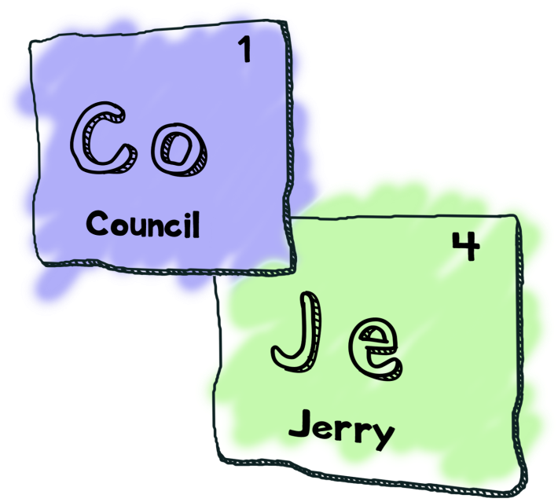

The Council of Jerry’s
Presents
Jerry’s Adventure
By
Nathan Tipper
(aka Boss Jerry)
Vincent Cote
(aka Handsome Jerry)
Jace Riehl
(aka Philosopher Jerry)
Michel Martel
(aka Artsy Jerry)

Description
Jerry is a single guy, who recently just bought himself a new house. At the beginning of the game he is moving in when he discovers that there is a room under the garage the family of the previous owner had not told him about. Being as curious as Jerry is, he looks through it finding an interdenominational portal gun and find himself in a new dimension. Having forgotten the gun, Jerry is confused as to how he’ll ever make it back home, where he is, or why everyone is dressed In medieval clothes. However, conveniently everyone still speaks English. Through trials and tribulations Jerry makes his way through to the castle, that King Jellybean resides. But he has to make a hard decision when the King betrays his morals. Leaving Jerry the only one who can take his place.

Starting the Game
This is not a the kind of game that you can get to work by blowing on cartridges. Through the terminal, move into the cloned repository and type in make. It will then compile and you can play the game.
1) This is the area where the information is displayed. For example, when talking to an NPC the dialog will be shown.
2) The list of actions available to the player.
3) You can enter your choice here based on the number displayed beside your available options.
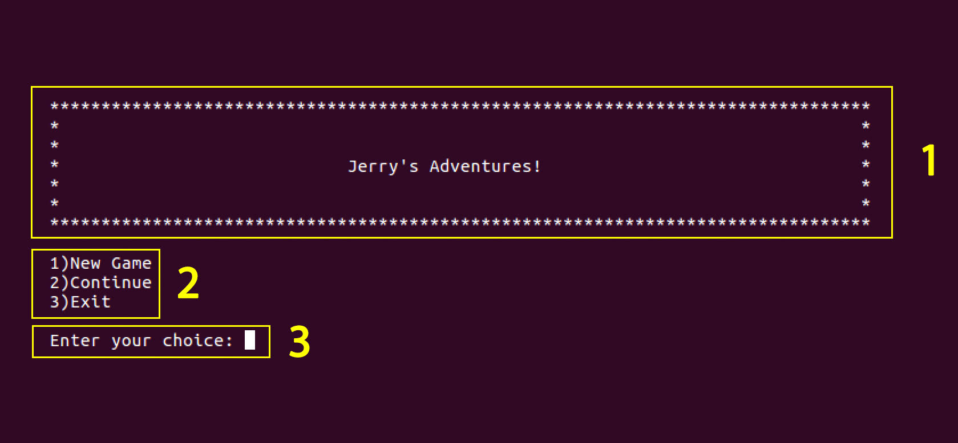

Menus
The menus are built such that the player can enter a simple input, from the list of possible inputs listed on the screen. With every room the player enters they will have a main menu of options to choose from. From there most of the inputs will take the user to a submenu and provide additional actions to take. The main menu will also provide the user with the ability to save and exit the game.

