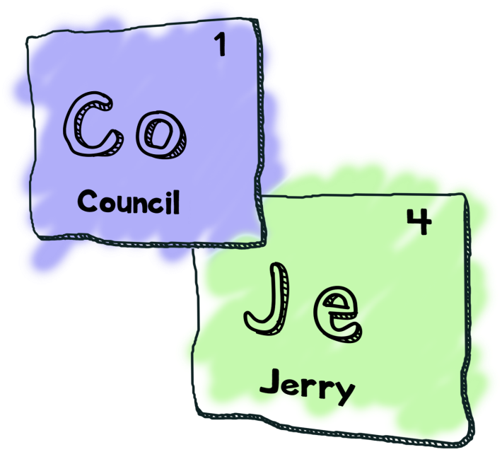

The Council of Jerry’s
Presents
Jerry’s Adventure
Maintenance Report
By
Nathan Tipper
(aka Boss Jerry)
Vincent Cote
(aka Handsome Jerry)
Jace Riehl
(aka Philosopher Jerry)
Michel Martel
(aka Artsy Jerry)

Introduction
The purpose of this document is to expend on the testing and maintenance phase of the project. This phase is divided in two sections, testing and improvement sections. For the testing section teams are given a game developed by another team and required to play it and report on any bugs found. A concrete description of our team’s procedures and techniques will follow later on in this document. The improvement section covers multiple aspects including fixing incoming bug reports, resolving any known bugs that weren’t completed by the release date, and refactoring any code that could benefit.

Testing Section
For this phase we decided to play through the game a extensively with different approaches. For the first play through we casually played the game how it was intended to be played. This first play through was intended to give us a better understanding of the game’s story, commends and features. However the game did not compile right away and we needed to file a bug report. Once we got the game running we noted down any bugs that jumped out at us to revisit later. When we found out that the game was incompletable through the abandoned house we moved on to the next approach. The second approach was more of a brute force play through, essentially trying to “break” the game from a programmers perspective. Some examples of this include, but our not limited to, inputting characters when prompted for integers, using gigantic (1000+ characters) strings of characters, and using items on other bag and environment items that shouldn’t be used together.

Improvement Section
- Made the game completable
- save features
- fix UI
- finished the last level of the game
- fix the makefile
- fixed unit testing

