‘retail_sales’ database analysis report
The following report presents conclusions from the analysis of the ‘retail_sales’ database containing information on customer ID, gender, age, purchased product category, quantity sold, unit price, COGS for a given item, total sales amount understood as the product of unit price and quantity sold, and the Profit understood as the difrence of total sales amount and COGS.
Sales profit analysis by product category, gender and age. 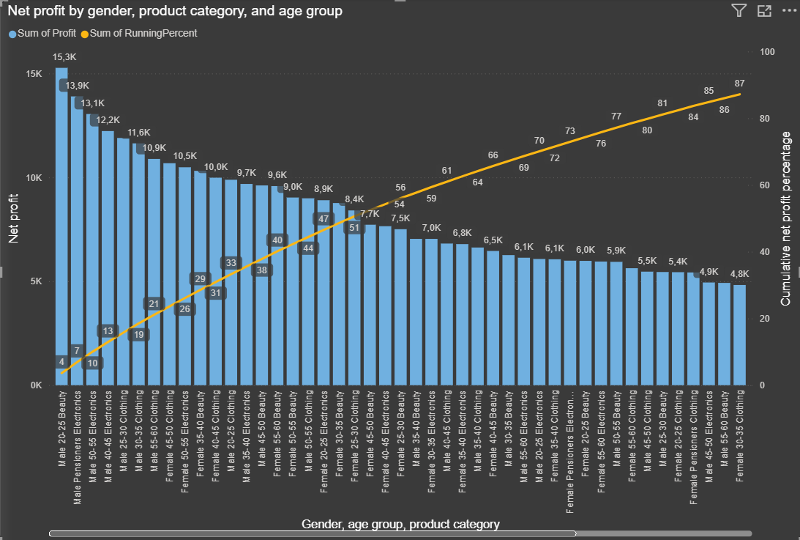
Fig.1 Result of profit analys
The highest profit 15 300 PLN, 4% of all Profit was recorded for men in the 'Beauty' category, in age group 20 - 25, 13 900 PLN (3% of all profit) for men in the ‘Electronic' category in age group Pensioners above 60 years old, 13 100 PLN for men in the ‘Electronic’ category in age group between 50 and 55 years old.
Recommendations
- Increasing the availability of bestsellers in the best-performing categories. In this database specific products names are not included, but it could be assume that for 20 – 25 years old men that could be some beard care accessories. For pensioners men in electronic category it could be hearing aids and electric bikes.
- Increasing the average basket value (AOV) through cross-selling from this and other categories. For 20 – 25 years old men that could be combination of beard oil and beard brush.

