Intelligibility among Vocabularies of the EU Languages

Jacek Pardyak

5 september 2018

## Introduction

**Clustering European Languages**

In the European Union there are 24 official languages spoken among 28 member states. The EU asserts that it is in favor of linguistic diversity. This principle is a basis of many studies on mutual intelligibility between languages. Relationship between languages in which speakers can readily understand each other without prior familiarity or special effort can be measured with distance function:

$$d(V_{1},V_{2})=1−\frac{\left|V_{1}∩V_{2}\right|}{\left|V_{1}∪V_{2}\right|}$$

For our analysis vocabularies (V) are derived from <http://hunspell.github.io/> spell checker project. For Finnish and Maltese vocabularies are not available. We perform a Hierarchical Cluster Analysis (HCA) using a set of dissimilarities for the 22 vocabularies being clustered. HCA is based on the core idea of objects being more related to nearby objects than to objects farther away. Apart from choice of distance function we also need to decide on the linkage criterion. Linkage Criterion refers to the point from where we merge two clusters. Pictures present results of HCA after applying different linkage criteria.

#mDist2 = 1 - mDist2  
#mDist2 = (1/(mDist2+0.001)) - 1  
#mDist2 = as.dist(mDist2)  
#mDist2

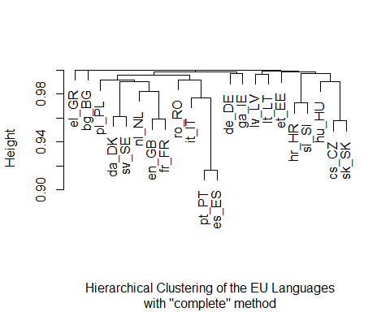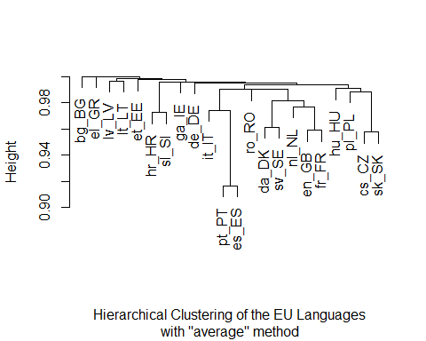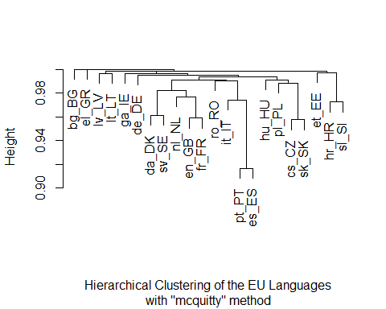

mDF <- as.matrix(mDist)  
pl_PL <- mDF[, 'pl_PL']  
pl_PL[order(pl_PL, decreasing = FALSE)]

## pl_PL en_GB cs_CZ da_DK nl_NL it_IT sk_SK   
## 0.0000000 0.9831523 0.9858495 0.9887899 0.9891335 0.9896010 0.9909898   
## sv_SE fr_FR hu_HU sl_SI es_ES pt_PT hr_HR   
## 0.9912803 0.9916465 0.9923224 0.9923790 0.9943816 0.9944366 0.9946607   
## ro_RO de_DE ga_IE et_EE lt_LT lv_LV bg_BG   
## 0.9955553 0.9956825 0.9958644 0.9974506 0.9974988 0.9987256 1.0000000   
## el_GR   
## 1.0000000

nl_NL <- mDF[, 'nl_NL']  
nl_NL[order(nl_NL, decreasing = FALSE)]

## nl_NL en_GB da_DK fr_FR sv_SE pl_PL it_IT   
## 0.0000000 0.9713650 0.9807028 0.9822716 0.9866061 0.9891335 0.9909306   
## de_DE cs_CZ hu_HU es_ES ro_RO sk_SK pt_PT   
## 0.9930614 0.9935128 0.9942315 0.9943269 0.9944476 0.9949912 0.9950583   
## sl_SI et_EE ga_IE hr_HR lt_LT lv_LV bg_BG   
## 0.9955910 0.9959729 0.9964418 0.9973061 0.9985107 0.9988675 1.0000000   
## el_GR   
## 1.0000000

en_GB <- mDF[, 'en_GB']  
en_GB[order(en_GB, decreasing = FALSE)]

## en_GB fr_FR nl_NL sv_SE da_DK pt_PT ro_RO   
## 0.0000000 0.9588505 0.9713650 0.9726686 0.9729823 0.9792359 0.9797630   
## it_IT pl_PL es_ES ga_IE hu_HU de_DE cs_CZ   
## 0.9824334 0.9831523 0.9842237 0.9865805 0.9885161 0.9896744 0.9908230   
## sk_SK sl_SI et_EE hr_HR lt_LT lv_LV bg_BG   
## 0.9932135 0.9937559 0.9970013 0.9971163 0.9975549 0.9986451 1.0000000   
## el_GR   
## 1.0000000

There are two limitations of this approach:

* we count words in two vocabularies that look the same, but differ significantly in meaning (false friends). For example: ‘hak’ (pl_PL) - ‘hook’ (en_GB) but ‘hak’ (nl_NL) - ‘heel’ (en_GB)
* we don’t count words in two vocabularies that look similar and mean the same. For example: ‘banan’(pl_PL) - ‘banaan’(nl_NL) - ‘banana’(en_GB)

In the next article I will present hierarchical cluster analysis using ‘partial word match’ instead of ‘exact word match’.

## Definitions

**alphabet** - set of letters

**word** ($w$) - sequence of elements from an alphabet

**vocabulary** ($V$) - set of words

**words similarity** - two words $x$ and $y$ are similar if $d(x,y)≤ϵ$ with regard to predetermined distance $d(x,y)$ and threshold $ϵ$.

**common vocabulary** - for two vocabularies $V_{1}$ and $V_{2}$ elements of two subsets $\overline{V_{1}}⊆V_{1}$ and $\overline{V_{2}}⊆V_{2}$ meet criterion:

$$∀x∈\overline{V_{1}}∃y∈\overline{V_{2}}:d(x,y)≤ϵ$$

**distance between vocabularies** - ratio of cardinality ${\overline{V}}_{1}∪{\overline{V}}_{2}$ and cardinality of $V_{1}∪V_{2}$. More precisely:

$$d(V_{1},V_{2})=1−\frac{\left|\overline{V_{1}}∪\overline{V_{2}}\right|}{\left|V_{1}∪V_{2}\right|}$$

In the special case of distance defined as $d(x,y)=0$ if $x=y$, and $1$ otherwise and threshold $ϵ=0$, (perfect match) we get

$$d(V_{1},V_{2})=1−\frac{\left|V_{1}∩V_{2}\right|}{\left|V_{1}∪V_{2}\right|}$$

## The data

The EU has 24 official languages used by people within 28 member states. Vocabularies were retrieved from <ftp://ftp.snt.utwente.nl/pub/software/openoffice/contrib/dictionaries/>, part of Hunspell project <http://hunspell.github.io/>. Two of 24 official EU languages, Finnish and Maltese don’t have available vocabularies. We use ISO 639-2 codes of those 22 languages: bg_BG, hr_HR, cs_CZ, da_DK, nl_NL, en_GB, et_EE, fr_FR, de_DE, el_GR, hu_HU, ga_IE, it_IT, lv_LV, lt_LT, pl_PL, pt_PT, ro_RO, sk_SK, sl_SI, es_ES, sv_SE.

## Clustering vocabularies using exact word matching

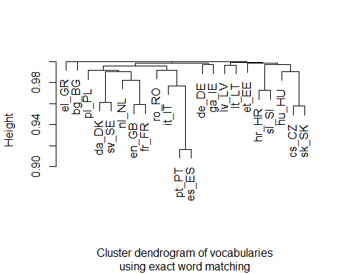

mat <- as.matrix(mDist)  
#mat[lower.tri(mat)] <- ''  
knitr::kable(mat[,2:8], caption = "Vocabularies distance using exact word matching")

Vocabularies distance using exact word matching

|  |  |  |  |  |  |  |  |
| --- | --- | --- | --- | --- | --- | --- | --- |
|  | hr_HR | cs_CZ | da_DK | nl_NL | en_GB | et_EE | fr_FR |
| bg_BG | 1.0000000 | 1.0000000 | 1.0000000 | 1.0000000 | 1.0000000 | 1.0000000 | 1.0000000 |
| hr_HR | 0.0000000 | 0.9950517 | 0.9957717 | 0.9973061 | 0.9971163 | 0.9971855 | 0.9984846 |
| cs_CZ | 0.9950517 | 0.0000000 | 0.9914238 | 0.9935128 | 0.9908230 | 0.9984447 | 0.9950095 |
| da_DK | 0.9957717 | 0.9914238 | 0.0000000 | 0.9807028 | 0.9729823 | 0.9959698 | 0.9870562 |
| nl_NL | 0.9973061 | 0.9935128 | 0.9807028 | 0.0000000 | 0.9713650 | 0.9959729 | 0.9822716 |
| en_GB | 0.9971163 | 0.9908230 | 0.9729823 | 0.9713650 | 0.0000000 | 0.9970013 | 0.9588505 |
| et_EE | 0.9971855 | 0.9984447 | 0.9959698 | 0.9959729 | 0.9970013 | 0.0000000 | 0.9976601 |
| fr_FR | 0.9984846 | 0.9950095 | 0.9870562 | 0.9822716 | 0.9588505 | 0.9976601 | 0.0000000 |
| de_DE | 0.9996456 | 0.9957151 | 0.9934287 | 0.9930614 | 0.9896744 | 0.9996248 | 0.9971923 |
| el_GR | 1.0000000 | 1.0000000 | 1.0000000 | 1.0000000 | 1.0000000 | 1.0000000 | 1.0000000 |
| hu_HU | 0.9971798 | 0.9904044 | 0.9921764 | 0.9942315 | 0.9885161 | 0.9980162 | 0.9945140 |
| ga_IE | 0.9993676 | 0.9968137 | 0.9945974 | 0.9964418 | 0.9865805 | 0.9993833 | 0.9963624 |
| it_IT | 0.9980078 | 0.9961185 | 0.9919548 | 0.9909306 | 0.9824334 | 0.9984985 | 0.9856155 |
| lv_LV | 0.9983660 | 0.9987971 | 0.9982343 | 0.9988675 | 0.9986451 | 0.9989126 | 0.9990744 |
| lt_LT | 0.9960027 | 0.9981917 | 0.9977963 | 0.9985107 | 0.9975549 | 0.9987476 | 0.9989904 |
| pl_PL | 0.9946607 | 0.9858495 | 0.9887899 | 0.9891335 | 0.9831523 | 0.9974506 | 0.9916465 |
| pt_PT | 0.9983159 | 0.9967711 | 0.9941241 | 0.9950583 | 0.9792359 | 0.9991050 | 0.9914953 |
| ro_RO | 0.9966747 | 0.9974355 | 0.9939589 | 0.9944476 | 0.9797630 | 0.9986032 | 0.9923275 |
| sk_SK | 0.9935443 | 0.9575697 | 0.9932409 | 0.9949912 | 0.9932135 | 0.9979164 | 0.9965935 |
| sl_SI | 0.9725991 | 0.9917212 | 0.9927850 | 0.9955910 | 0.9937559 | 0.9974340 | 0.9973319 |
| es_ES | 0.9974613 | 0.9975560 | 0.9945903 | 0.9943269 | 0.9842237 | 0.9982971 | 0.9879393 |
| sv_SE | 0.9951708 | 0.9941117 | 0.9611890 | 0.9866061 | 0.9726686 | 0.9953781 | 0.9907153 |

knitr::kable(mat[,9:15], caption = "Vocabularies distance using exact word matching cntd")

Vocabularies distance using exact word matching cntd

|  |  |  |  |  |  |  |  |
| --- | --- | --- | --- | --- | --- | --- | --- |
|  | de_DE | el_GR | hu_HU | ga_IE | it_IT | lv_LV | lt_LT |
| bg_BG | 1.0000000 | 1.0000000 | 1.0000000 | 1.0000000 | 1.0000000 | 1.0000000 | 1.0000000 |
| hr_HR | 0.9996456 | 1.0000000 | 0.9971798 | 0.9993676 | 0.9980078 | 0.9983660 | 0.9960027 |
| cs_CZ | 0.9957151 | 1.0000000 | 0.9904044 | 0.9968137 | 0.9961185 | 0.9987971 | 0.9981917 |
| da_DK | 0.9934287 | 1.0000000 | 0.9921764 | 0.9945974 | 0.9919548 | 0.9982343 | 0.9977963 |
| nl_NL | 0.9930614 | 1.0000000 | 0.9942315 | 0.9964418 | 0.9909306 | 0.9988675 | 0.9985107 |
| en_GB | 0.9896744 | 1.0000000 | 0.9885161 | 0.9865805 | 0.9824334 | 0.9986451 | 0.9975549 |
| et_EE | 0.9996248 | 1.0000000 | 0.9980162 | 0.9993833 | 0.9984985 | 0.9989126 | 0.9987476 |
| fr_FR | 0.9971923 | 1.0000000 | 0.9945140 | 0.9963624 | 0.9856155 | 0.9990744 | 0.9989904 |
| de_DE | 0.0000000 | 1.0000000 | 0.9951991 | 0.9969049 | 0.9977772 | 0.9996399 | 0.9990719 |
| el_GR | 1.0000000 | 0.0000000 | 0.9999342 | 1.0000000 | 1.0000000 | 1.0000000 | 1.0000000 |
| hu_HU | 0.9951991 | 0.9999342 | 0.0000000 | 0.9962753 | 0.9946500 | 0.9989956 | 0.9976632 |
| ga_IE | 0.9969049 | 1.0000000 | 0.9962753 | 0.0000000 | 0.9973169 | 0.9996068 | 0.9991826 |
| it_IT | 0.9977772 | 1.0000000 | 0.9946500 | 0.9973169 | 0.0000000 | 0.9990711 | 0.9980258 |
| lv_LV | 0.9996399 | 1.0000000 | 0.9989956 | 0.9996068 | 0.9990711 | 0.0000000 | 0.9966034 |
| lt_LT | 0.9990719 | 1.0000000 | 0.9976632 | 0.9991826 | 0.9980258 | 0.9966034 | 0.0000000 |
| pl_PL | 0.9956825 | 1.0000000 | 0.9923224 | 0.9958644 | 0.9896010 | 0.9987256 | 0.9974988 |
| pt_PT | 0.9960293 | 1.0000000 | 0.9947908 | 0.9955037 | 0.9770610 | 0.9993165 | 0.9978201 |
| ro_RO | 0.9968151 | 1.0000000 | 0.9962574 | 0.9976936 | 0.9920662 | 0.9994759 | 0.9987267 |
| sk_SK | 0.9978439 | 1.0000000 | 0.9901538 | 0.9979675 | 0.9960454 | 0.9987204 | 0.9975647 |
| sl_SI | 0.9976295 | 1.0000000 | 0.9957264 | 0.9972250 | 0.9978785 | 0.9991776 | 0.9991497 |
| es_ES | 0.9986264 | 1.0000000 | 0.9964403 | 0.9978043 | 0.9713364 | 0.9988941 | 0.9974989 |
| sv_SE | 0.9920841 | 1.0000000 | 0.9914064 | 0.9963819 | 0.9931007 | 0.9986894 | 0.9972757 |

knitr::kable(mat[,16:22], caption = "Vocabularies distance using exact word matching cntd")

Vocabularies distance using exact word matching cntd

|  |  |  |  |  |  |  |  |
| --- | --- | --- | --- | --- | --- | --- | --- |
|  | pl_PL | pt_PT | ro_RO | sk_SK | sl_SI | es_ES | sv_SE |
| bg_BG | 1.0000000 | 1.0000000 | 1.0000000 | 1.0000000 | 1.0000000 | 1.0000000 | 1.0000000 |
| hr_HR | 0.9946607 | 0.9983159 | 0.9966747 | 0.9935443 | 0.9725991 | 0.9974613 | 0.9951708 |
| cs_CZ | 0.9858495 | 0.9967711 | 0.9974355 | 0.9575697 | 0.9917212 | 0.9975560 | 0.9941117 |
| da_DK | 0.9887899 | 0.9941241 | 0.9939589 | 0.9932409 | 0.9927850 | 0.9945903 | 0.9611890 |
| nl_NL | 0.9891335 | 0.9950583 | 0.9944476 | 0.9949912 | 0.9955910 | 0.9943269 | 0.9866061 |
| en_GB | 0.9831523 | 0.9792359 | 0.9797630 | 0.9932135 | 0.9937559 | 0.9842237 | 0.9726686 |
| et_EE | 0.9974506 | 0.9991050 | 0.9986032 | 0.9979164 | 0.9974340 | 0.9982971 | 0.9953781 |
| fr_FR | 0.9916465 | 0.9914953 | 0.9923275 | 0.9965935 | 0.9973319 | 0.9879393 | 0.9907153 |
| de_DE | 0.9956825 | 0.9960293 | 0.9968151 | 0.9978439 | 0.9976295 | 0.9986264 | 0.9920841 |
| el_GR | 1.0000000 | 1.0000000 | 1.0000000 | 1.0000000 | 1.0000000 | 1.0000000 | 1.0000000 |
| hu_HU | 0.9923224 | 0.9947908 | 0.9962574 | 0.9901538 | 0.9957264 | 0.9964403 | 0.9914064 |
| ga_IE | 0.9958644 | 0.9955037 | 0.9976936 | 0.9979675 | 0.9972250 | 0.9978043 | 0.9963819 |
| it_IT | 0.9896010 | 0.9770610 | 0.9920662 | 0.9960454 | 0.9978785 | 0.9713364 | 0.9931007 |
| lv_LV | 0.9987256 | 0.9993165 | 0.9994759 | 0.9987204 | 0.9991776 | 0.9988941 | 0.9986894 |
| lt_LT | 0.9974988 | 0.9978201 | 0.9987267 | 0.9975647 | 0.9991497 | 0.9974989 | 0.9972757 |
| pl_PL | 0.0000000 | 0.9944366 | 0.9955553 | 0.9909898 | 0.9923790 | 0.9943816 | 0.9912803 |
| pt_PT | 0.9944366 | 0.0000000 | 0.9884227 | 0.9967671 | 0.9974409 | 0.9163081 | 0.9929131 |
| ro_RO | 0.9955553 | 0.9884227 | 0.0000000 | 0.9971572 | 0.9967697 | 0.9902295 | 0.9899504 |
| sk_SK | 0.9909898 | 0.9967671 | 0.9971572 | 0.0000000 | 0.9930935 | 0.9965448 | 0.9938947 |
| sl_SI | 0.9923790 | 0.9974409 | 0.9967697 | 0.9930935 | 0.0000000 | 0.9978718 | 0.9935822 |
| es_ES | 0.9943816 | 0.9163081 | 0.9902295 | 0.9965448 | 0.9978718 | 0.0000000 | 0.9934191 |
| sv_SE | 0.9912803 | 0.9929131 | 0.9899504 | 0.9938947 | 0.9935822 | 0.9934191 | 0.0000000 |

## Clustering vocabularies using approximate word matching

# using Levenshtein distance  
vocab_1 <- c("leia","uhura", "banan")   
vocab_2 <- c("ripley","leela","scully","trinity", 'banaan', 'ananas')  
vocab_3 <- c(NA)  
  
ind <- stringdist::amatch(x = vocab_1,  
 table = vocab_2,  
 method = 'lv',  
 maxDist = 3)  
ind

## [1] 2 NA 5

res_1 = vocab_1[!is.na(vocab_2[ind])]  
res_2 = vocab_2[ind][!is.na(vocab_2[ind])]  
  
1 - length(union(res_1, res_2))/ length(union(vocab_1, vocab_2))

## [1] 0.5555556

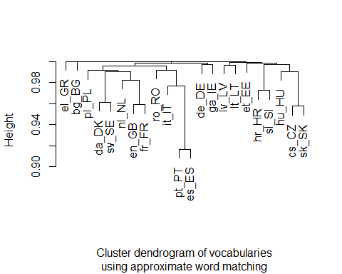

## kmed

require(kmed)

## Loading required package: kmed

result <- fastkmed(mDist, ncluster = 5, iterate = 50)