Electromagnetic Wave Theory Page 294 correction:
E(3.2.1.6):
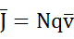
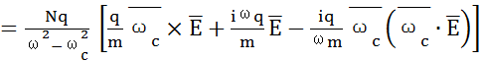
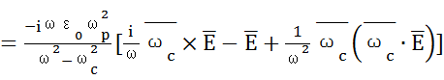

From Ampere’s law, we find
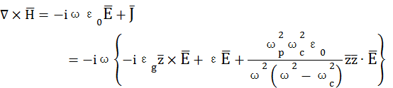
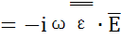
The constitutive parameters has been given as the (E3.2.1.2a), (E3.2.1.2b) and (E3.2.1.2c) in Page 293.

