1. img_label.pkl: It is a Python dictionary. The key is the name of the picture, such as “1.jpg”, the value is the RGB NumPy *ndarray* matrix and the label of the correspondent picture. This file can be got by the ‘Preparation/img2pickle.py’python program.
2. imgavg.pkl: It is a NumPy ndarray, which is the mean of all the pictures in our dataset. Its dimension is Height * Width * Channel.
3. weights_bin.pkl: It is a Python dictionary. It stores the weights and biases of each layer of the 16-layer VGGNET.
4. vggdeploypickle.py : It is the inference part of the 16-layer VGGNET, purely on Python 2 and NumPy, without using any framework, so that it can be easier to run on hardware. Its functions realize the front-forward calculation of convolution layer, max pool layer, full-connected layer, drop layer and ReLU layer, which are used in VGGNET. It calculates the convolution in the same way as Caffe, a deep learning framework, which is shown as the following picture.

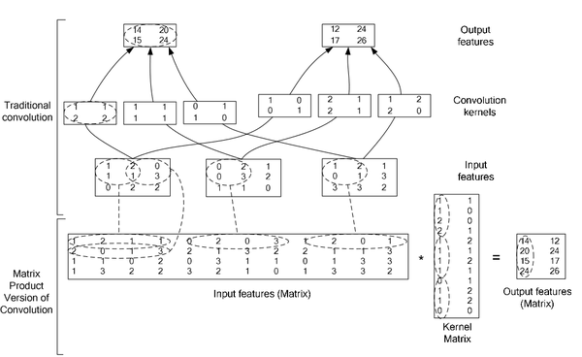

1. Preparation / train_face / : Our face images dataset.
2. Preparation / label.txt

The labels of our dataset. The format of every line is “img_name label”.

1. Preparation / img2pickle.py: It transforms the pictures in the database and the labels in ‘label.txt’into ‘img_label.pkl’, and also produces the mean image ‘imgavg.pkl’, so that they can be loaded into Python program without using other modules.

[1,2,3] are too big to be uploaded on Github, so if you need these model and data please contact zzjohn@foxmail.com