**Case Study: Simple Website Performance Test**

**Url :** <https://www.bunnycart.com/>

1. Created Test Plan named : Bunny Cart Test Plan

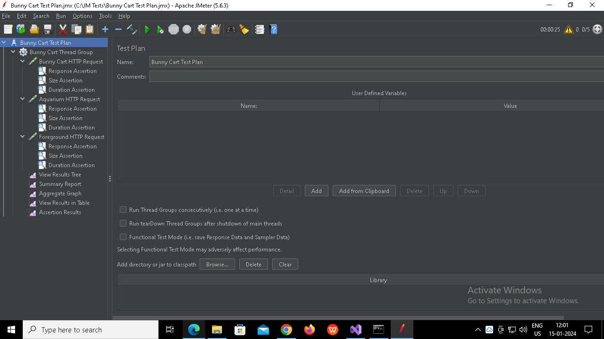

1. Created Thread Group named : Bunny Cart Thread Group

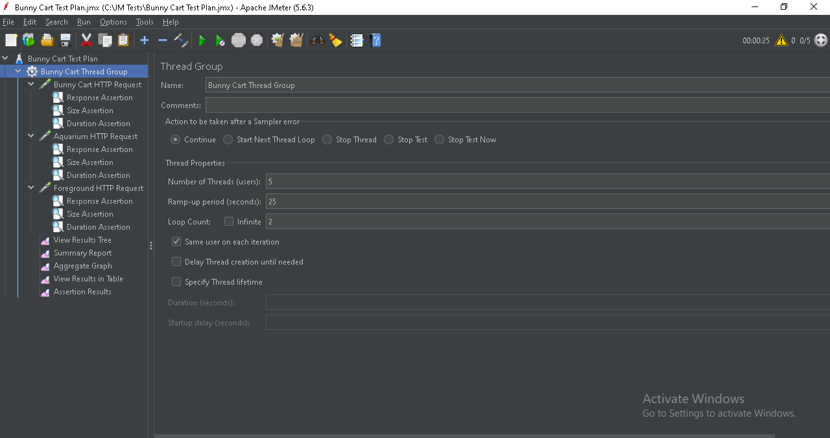

1. Created Http Sampler named : Bunny Cart Http Request

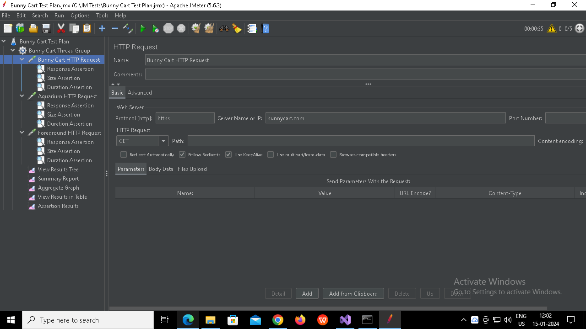

1. Created Assertion named Response Assertion

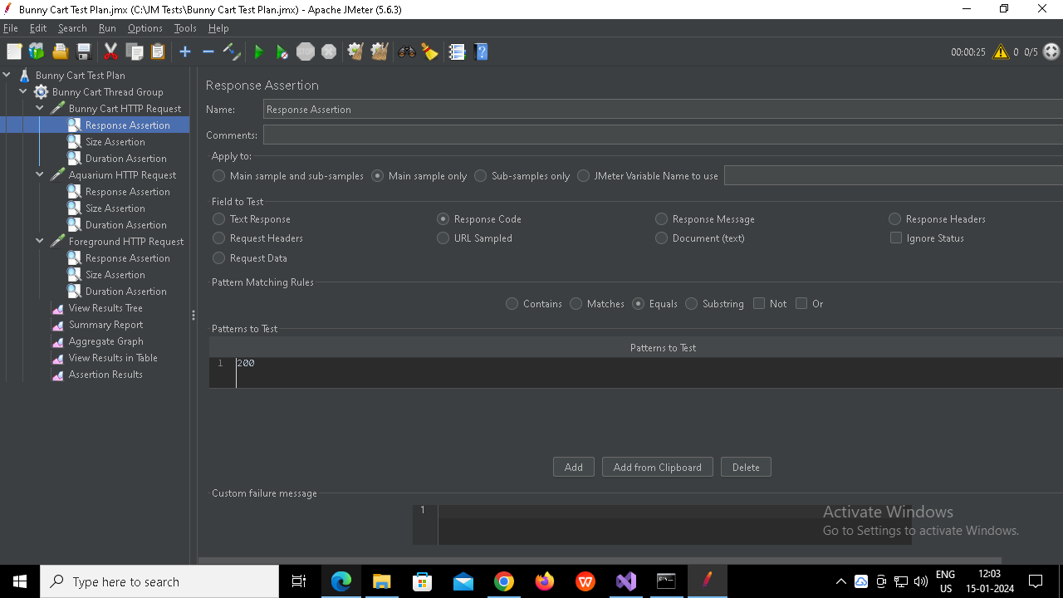

1. Created Assertion named Size Assertion

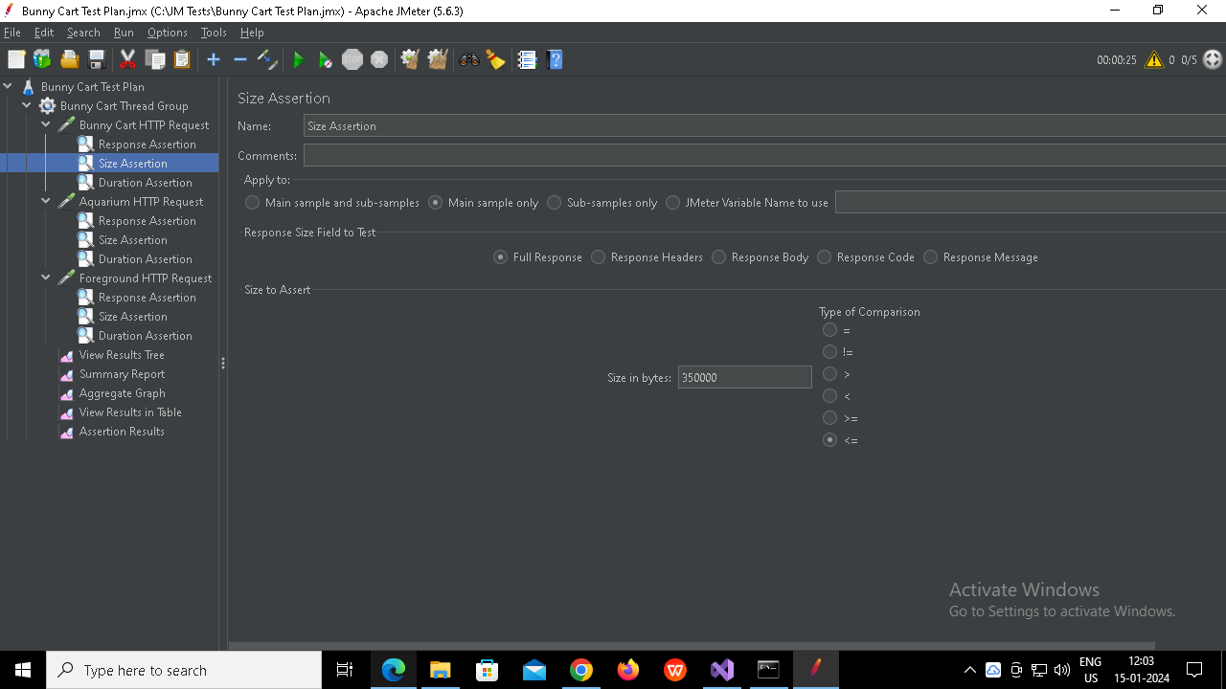

1. Created Assertion named Duration Assertion

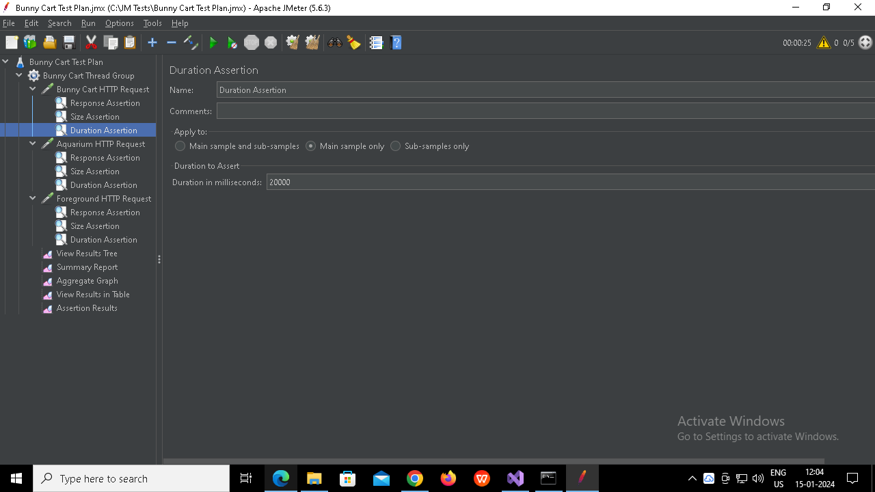

1. Created Http Sampler named : Aquarium Http Request

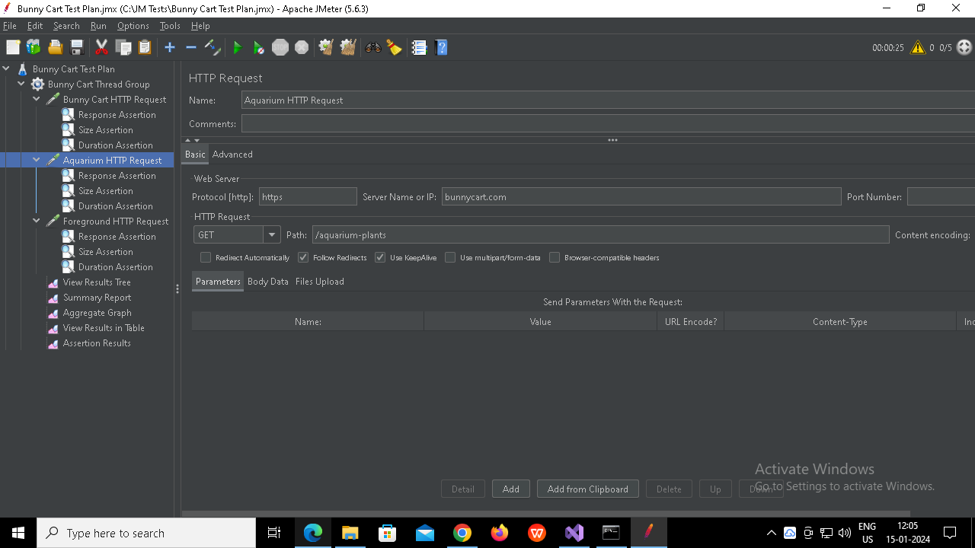

1. Created Assertion named : Response Assertion

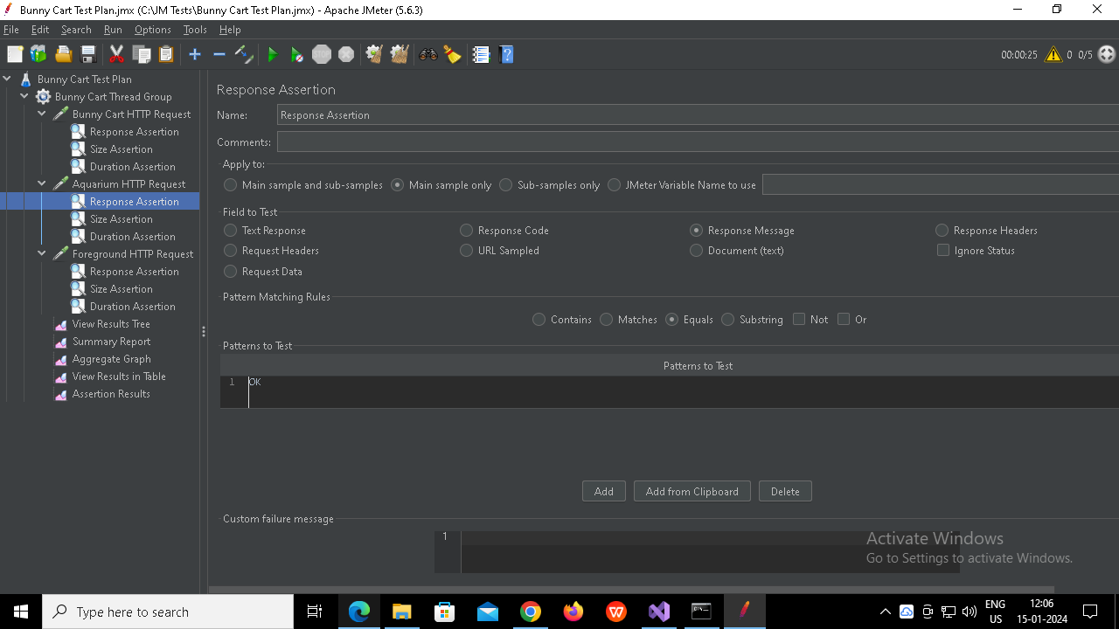

1. Created Assertion named : Size Assertion

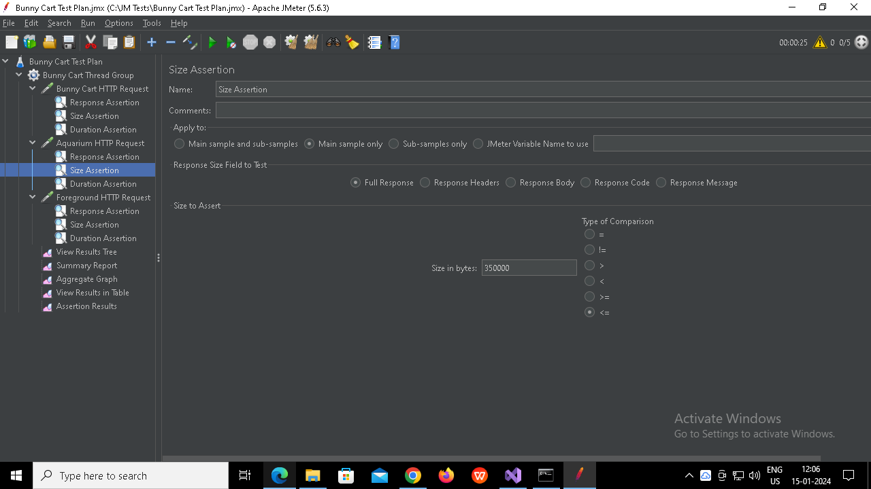

1. Created Assertion named : Duration Assertion

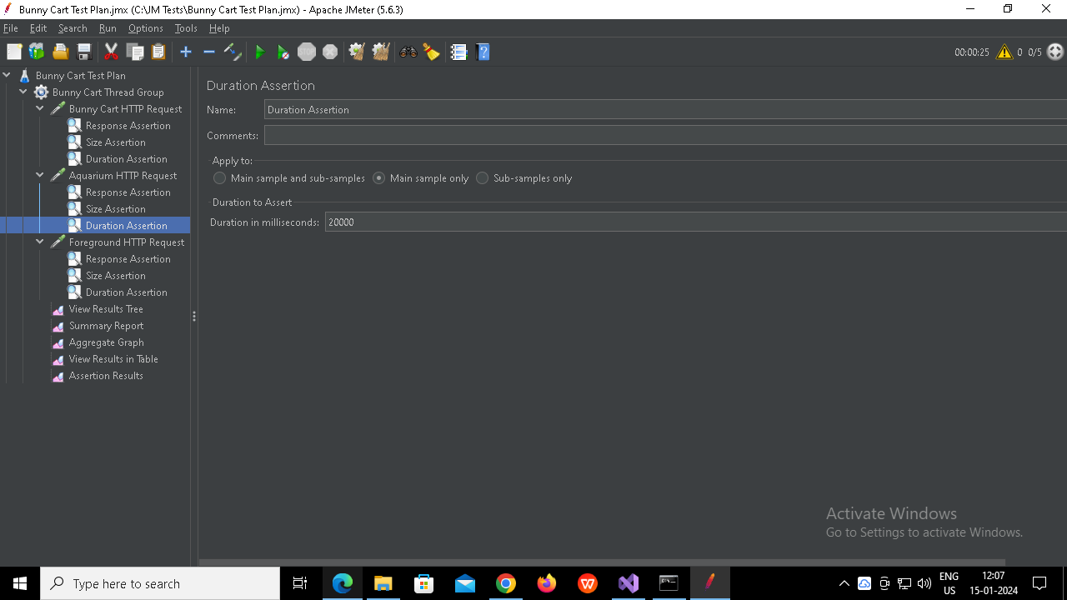

1. Created Http Sampler named : Foreground Http Request

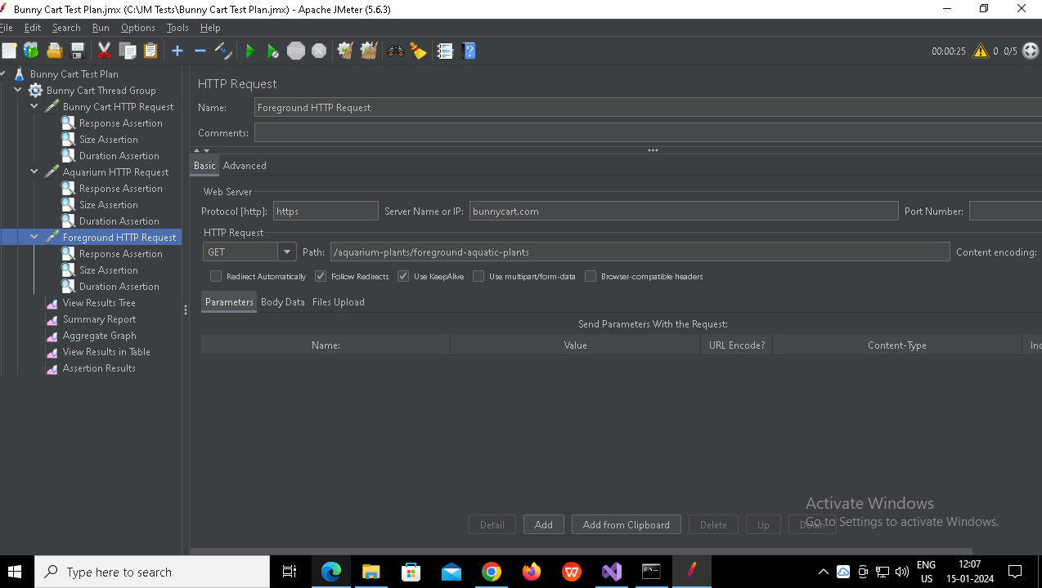

1. Created Assertion named : Response Assertion

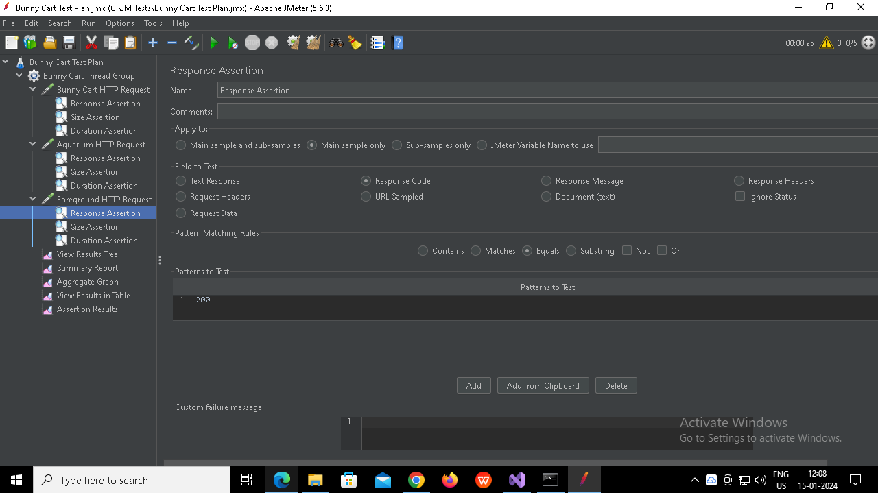

1. Created Assertion named : Size Assertion

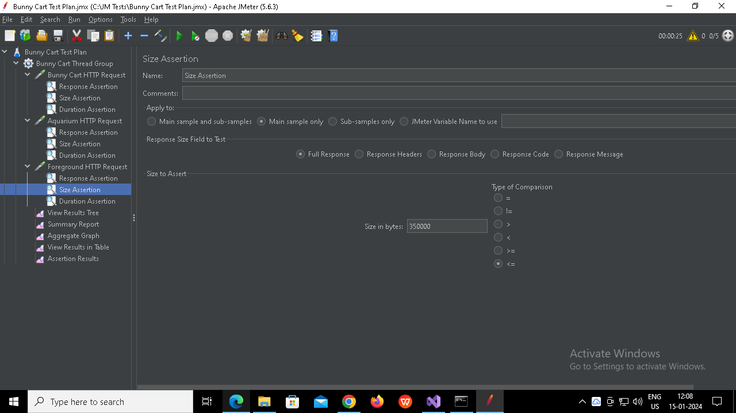

1. Created Assertion named : Duration Assertion

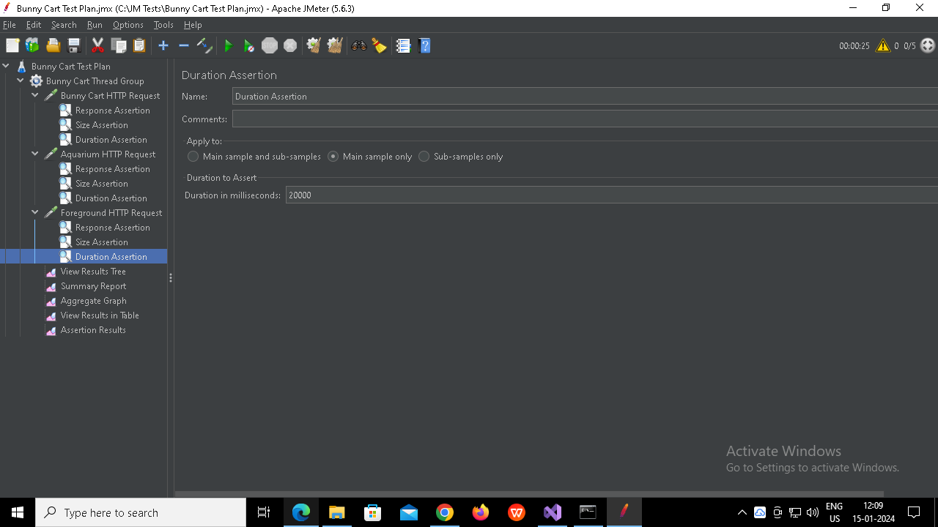

1. Created Listener named : View Results Tree

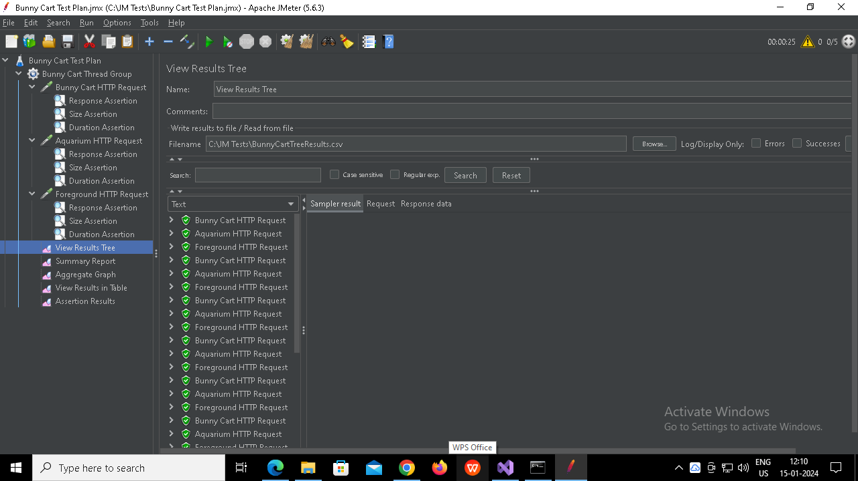

1. Created Listener named : Summary Report

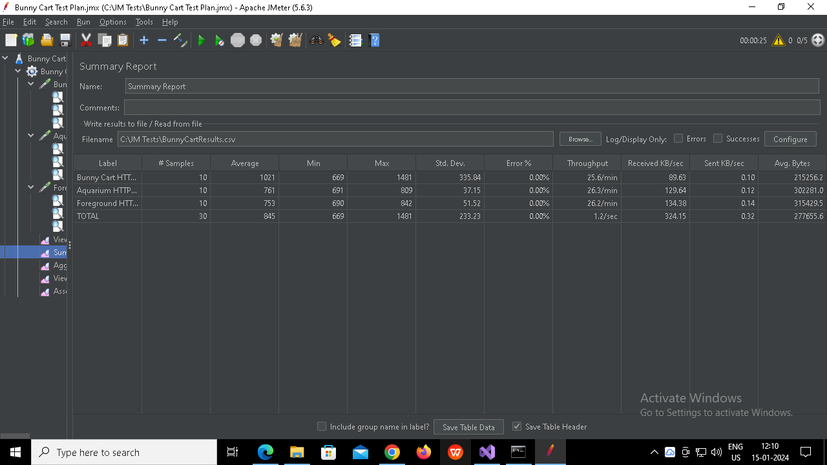

1. Created Listener named : Aggregate Graph

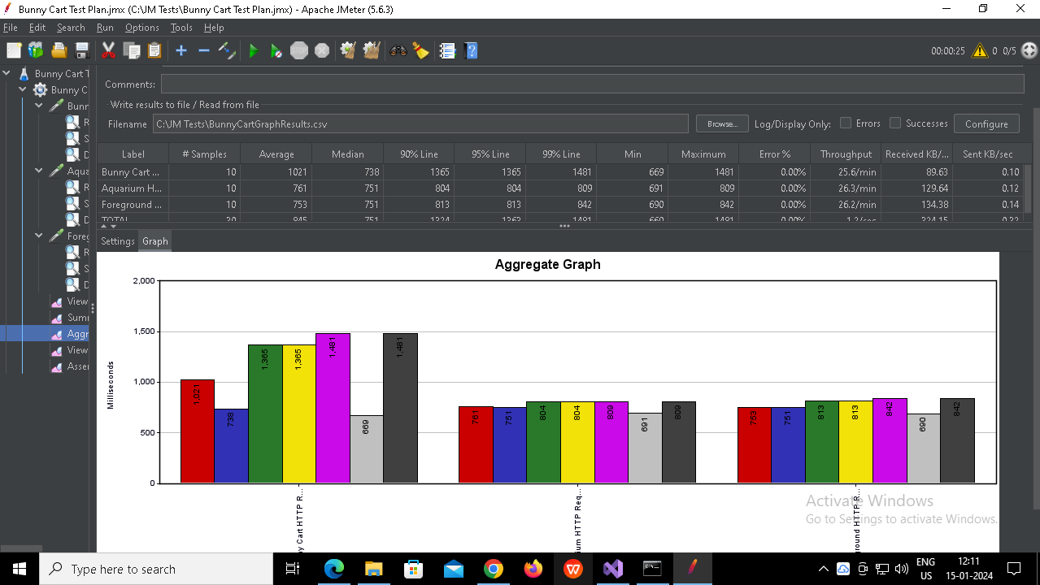

1. Created Listener named : View Results in Table

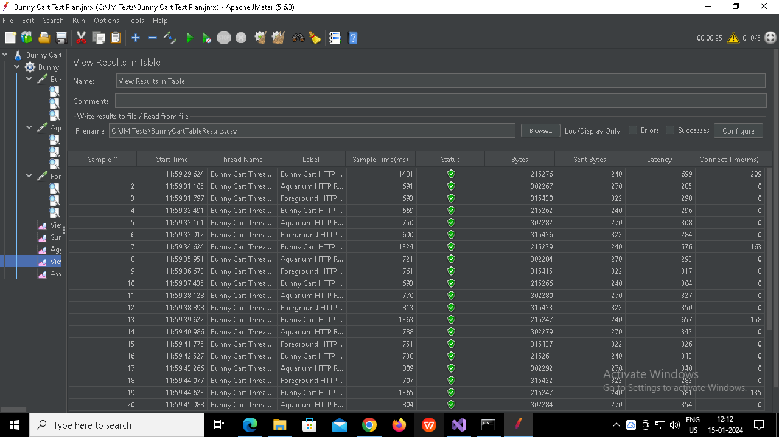

1. Created Listener named : Assertion Results

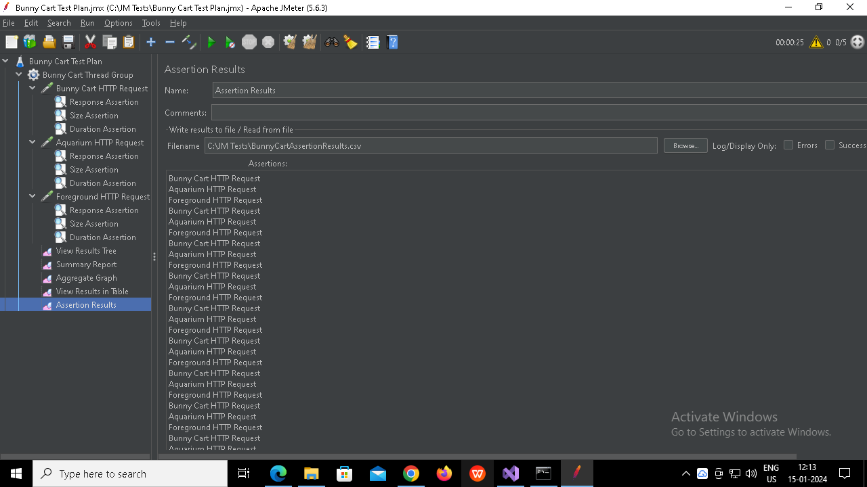

1. Created Listener named : Response Time Graph

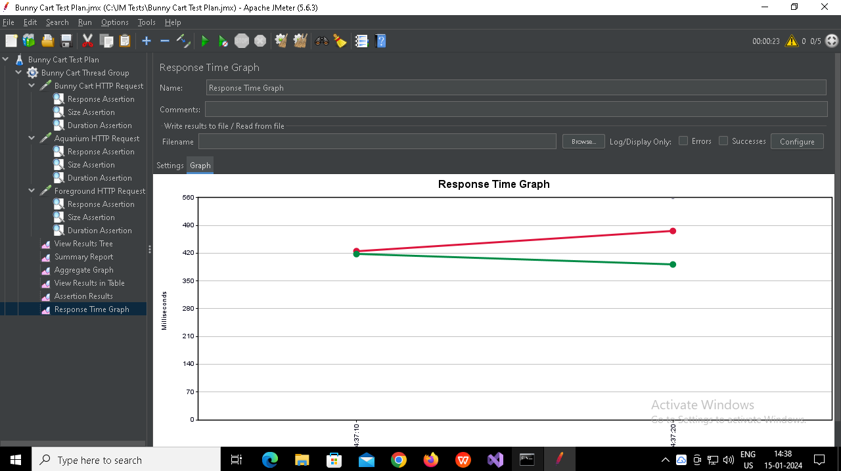

What is the average response time for the homepage of the website?

1021

Did all requests meet the assertion criteria? If not, what failed?

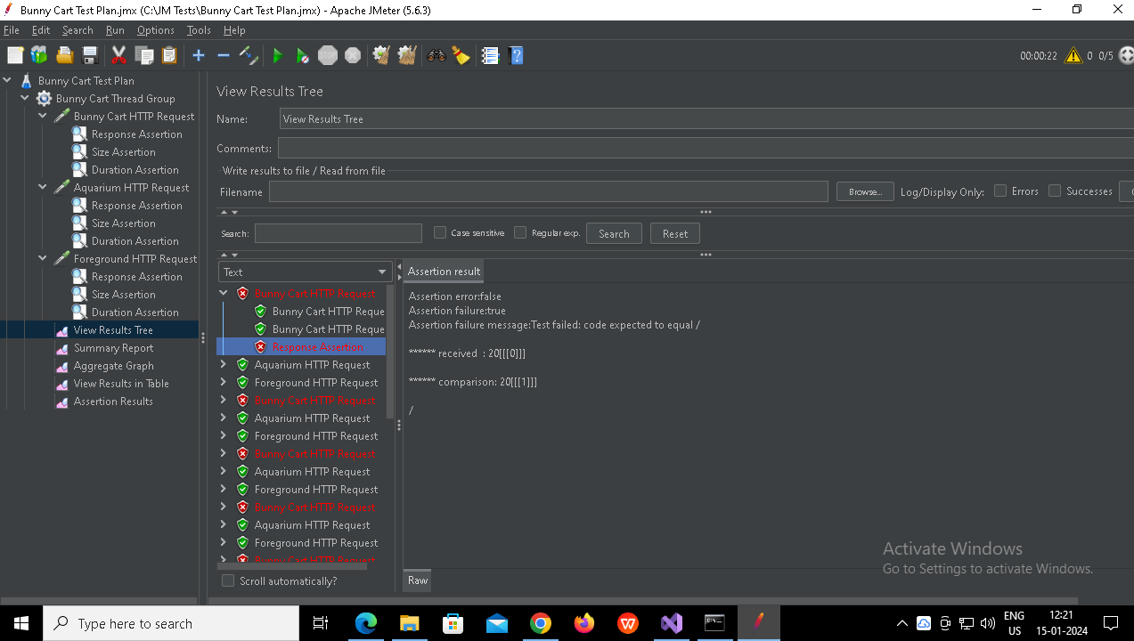

How does the response time vary over time during the test run?

Gradually decreases