张馨月 Jacinda 2023905322
雷晴 Leah 2023905937
FINDING 1 — login in transit (plain HTTP)
What's exposed: The username and password.
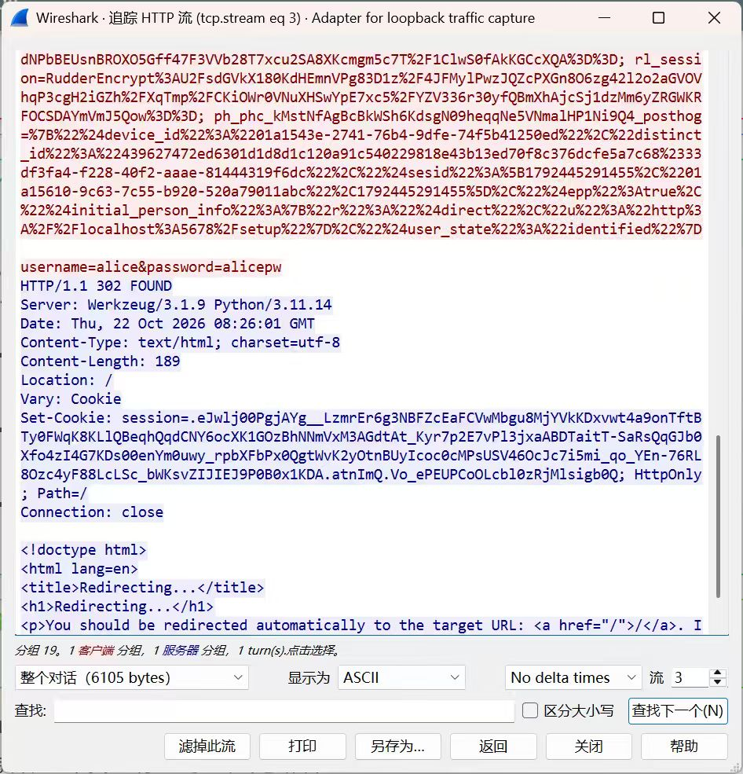
Evidence: the username=alice&password=alicepw line in the HTTP stream
Who can read it: Anyone able to capture the relevant unencrypted network traffic.
Severity: (Low / Med / High) because exposed credentials could allow unauthorized account access.
Fix: Configure HTTPS using TLS and verify that the server certificate is trusted.

FINDING 2 — certificate trust
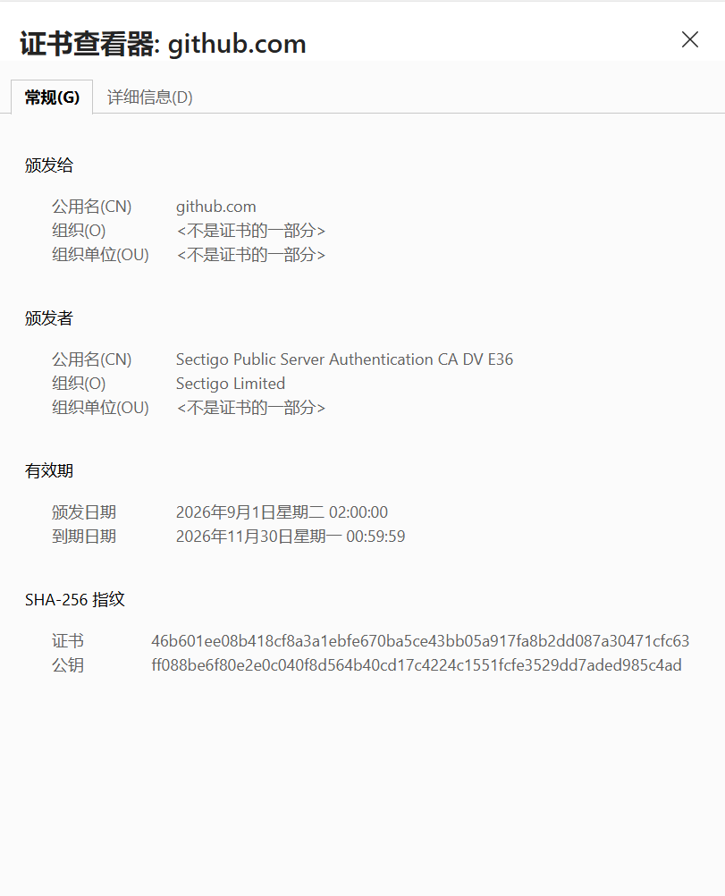
GitHub issued by: Sectigo Limited
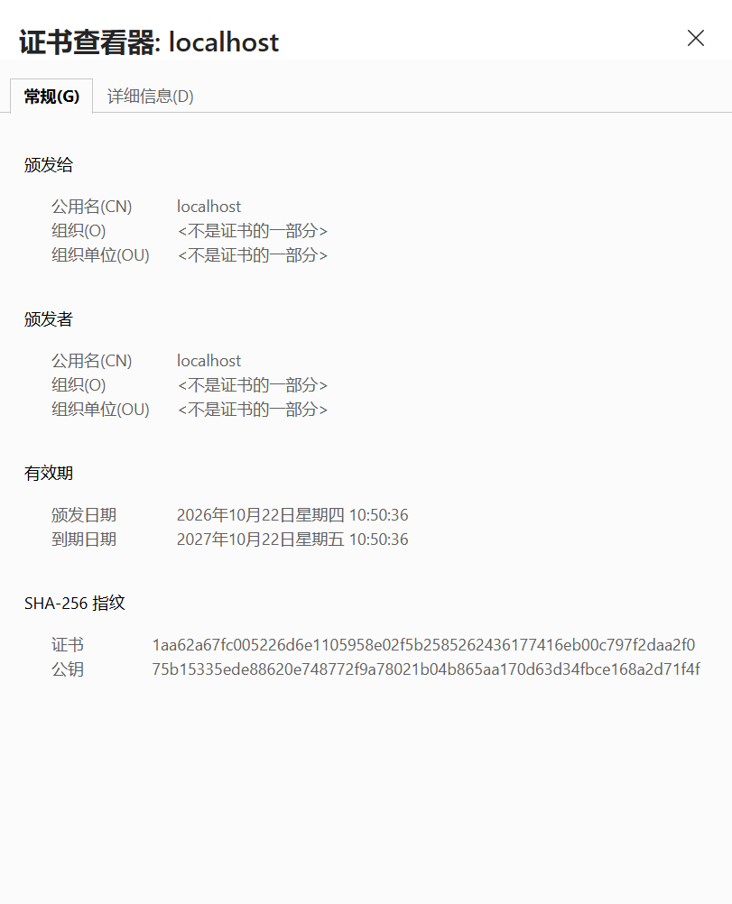
Yours issued by: localhost

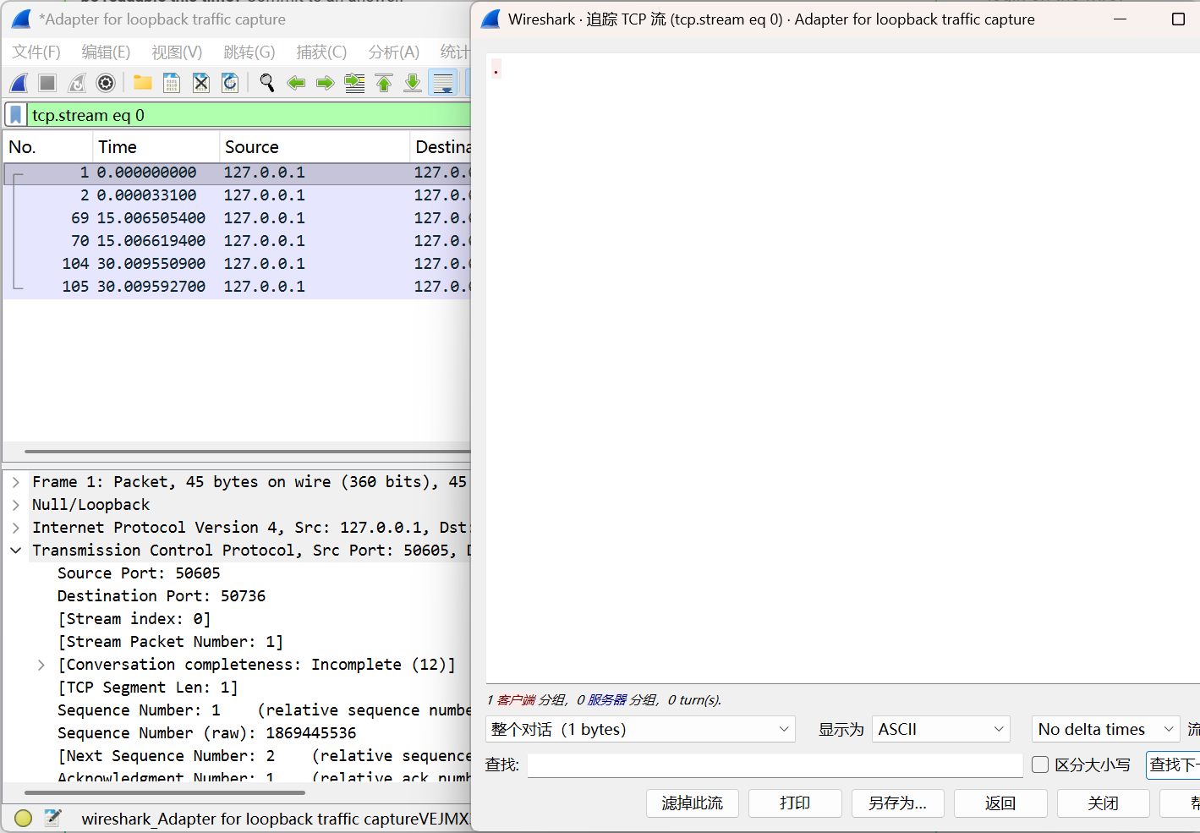
The trust yours lacks: A chain of trust to a trusted Certificate Authority (CA).
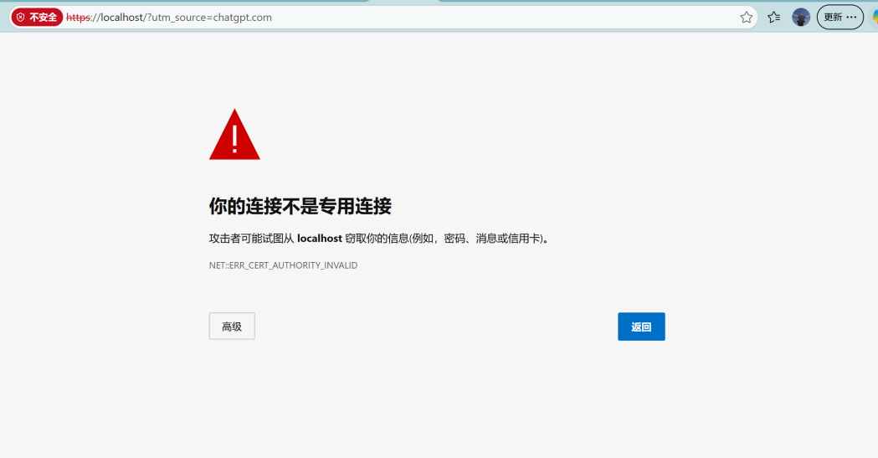
Verdict (encrypted vs trusted): No, encryption protects data in transit, but without a trusted certificate, the server's identity cannot be reliably verified.

