张馨月 Jacinda 2023905322
雷晴 Leah 202390593
FINDING 1 — stored passwords (unsalted MD5)
Cracked: 4 of 6 accounts, in 0.8 ms, with a public wordlist
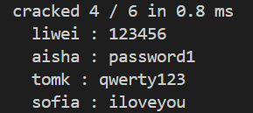
Why those fell: The passwords are common dictionary words (e.g., "123456", "password1"). Unsalted MD5 is extremely fast to compute, allowing attackers to crack them instantly using pre-computed rainbow tables or wordlists.
Any that held out, & why: 2 accounts held out because their passwords were not in this specific wordlist, but they remain highly vulnerable to larger dictionaries or brute-force due to weak hashing.
Severity: High because MD5 is cryptographically broken and unsalted hashes allow attackers to crack leaked passwords almost instantly, leading to mass account takeovers.
Fix (1 line): Use strong, slow, and salted hashing algorithms like Argon2id, bcrypt, or scrypt.

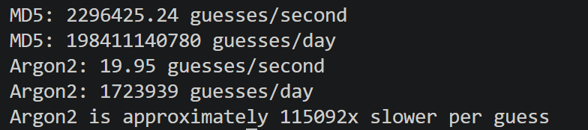
FINDING 2 — the fix, measured (MD5 vs Argon2)
Measured speed: MD5: 2,296,425 guesses/second (~198.4 billion guesses/day). Argon2: 19.95 guesses/second (~1.72 million guesses/day).
Why the difference matters: MD5 is extremely fast to compute, allowing attackers to test millions of password guesses per second. Argon2 is deliberately slower and more computationally expensive, significantly reducing the number of guesses an attacker can make.
Speed comparison: Argon2 is approximately 115,092 times slower per guess than MD5 in our benchmark.
Verdict: With a stolen password database, an attacker can test MD5 password guesses extremely quickly, while Argon2 makes each guess much more expensive. Argon2 is therefore much more resistant to offline password cracking.
Severity: High because fast, unsalted MD5 hashes expose users to rapid password cracking and potential account takeovers.
Fix (1 line): Replace unsalted MD5 with Argon2id using unique salts and appropriately configured hashing parameters.

