Process Document
Team Name: Deco May Cry
Domain: Social Creation of Digital Art in Public Spaces
Brief:
TagIt is an interactive public electronic graffiti system designed to explore creative expression and social interaction in shared urban spaces. The system integrates a digital drawing board with a mobile application, enabling users to create graffiti in designated public areas. Once created, the drawings are immediately projected onto large display screens, replicating the aesthetic and social dynamics of traditional street graffiti in a digital format. By supporting both individual and collaborative modes, TagIt fosters opportunities for spontaneous co-creation, where multiple participants can contribute simultaneously to a shared artwork. This design not only lowers the barriers to participation but also reimagines graffiti as a collective and inclusive cultural practice within public environments.
Target User Group:
TagIt is designed to engage a diverse set of users who share an interest in graffiti as a form of creative expression:
- Novices interested in graffiti: Individuals who are curious about graffiti but have never actively participated. This group often lacks accessible entry points and seeks a safe, approachable way to explore graffiti culture.
- Experienced graffiti creators: Users who have prior graffiti experience and wish to practice their art in public spaces legally and without conflict with city management.
- Collaborative participants: Individuals who are motivated by social interaction and creativity, and who are interested in co-creating graffiti artworks with others in shared public settings.
Problem Space:
- Illegality and Conflict with Urban Management:
Graffiti is often regarded as illegal, creating tension between artists who seek free expression and city authorities who prioritize cleanliness and order.
- Lack of Accessible Entry Points for New Participants:
Individuals interested in graffiti but without prior experience rarely find safe or approachable ways to engage, since they seldom have direct contact with existing graffiti creators.
- Ephemerality and Erasure of Graffiti Works:
Existing graffiti is frequently removed during urban maintenance or beautification efforts, preventing artworks from leaving lasting cultural traces.
Idea Selection:
During the concept ideation stage, we proposed four directions: collaborative digital graffiti wall, public story continuation, interactive projection, and sound-to-visual drawing based on decibel levels. After team discussions, we concluded that compared to the other three concepts, the collaborative digital graffiti wall has a lower implementation difficulty, higher feasibility, and aligns well with the team members’ interest in graffiti. Therefore, we chose the collaborative digital graffiti wall as the form for our project implementation.
Investigating and Finding:
Investigate Method: Interview
We conducted a round of interviews with five participants to gather their views on public art creation and graffiti, and to ask about their level of interest in a digital graffiti system. These insights served as the basis for designing features when developing our prototype.
Features | From
Support low-barrier participation without the need for downloading or registration | Yes, but it has to be simple. No sign-ups or app downloads.
Real-time display | Instant display gives me a sense of presence, but long-term storage means I can revisit it later.
Allow users to engage in social activities such as mutual likes, comments, and exchanges with each other. | I’d probably join in. For example, I’d like to leave my signature or even contact details. It would be cool if someone saw my graffiti, liked it, and then followed my Instagram or messaged me. I’d like the idea of people being able to “like” my work. The likes themselves don’t bring any material benefit, but when you see that others appreciate your work, it makes you smile—it feels warm and supportive.
Support switching between single mode and multiple mode | I’d find it fun, like we’re working together on a big artwork. It feels social.
Create without affecting the appearance of the city. | Well, first of all, I think graffiti should never damage historical or modern buildings. That’s important. Ideally, there should be designated spaces for graffiti—special areas where people can freely create without interruptions. That way, artists can focus, and buildings that need protection stay preserved. Having a dedicated graffiti zone sounds like the best solution to me.

Scenario Development:
- Serendipitous Participation:
In the evening, Liam is walking back to his dorm after class. Passing by the Prentice Building, he notices the public screen showing live doodles. Curious, he scans the QR code below the screen, enters the drawing canvas, and sketches a small emoji. When his doodle instantly appears on the big screen, he laughs and snaps a picture to share with his friends.
- Collaborative Creation:
On a weekend afternoon, Sophie and her friends are on their way to an exhibition. Passing by the installation screen, they decide to create a doodle together. Sophie opens the canvas and taps the collaboration button to join a shared stream. Her friends join the same stream, and they start drawing in sync on their phones. A few minutes later, they finish a collaborative artwork, leave comments for each other, and even nearby passers-by join in to like their piece.
- Discovery and Re-engagement:
The next day, Ryan opens the mobile app and switches to the “Explore” tab. He notices that yesterday’s campus doodle has received several comments. He opens the post, replies to one comment, and likes another user’s artwork. He decides to add a follow-up doodle next time he passes by, hoping to get more people engaged.

Prototype Iteration Process:
- Sketch Phase: Concept Ideation
- Goal: The sketch was only meant to capture the rough idea of combining a physical graffiti screen with online community interaction.
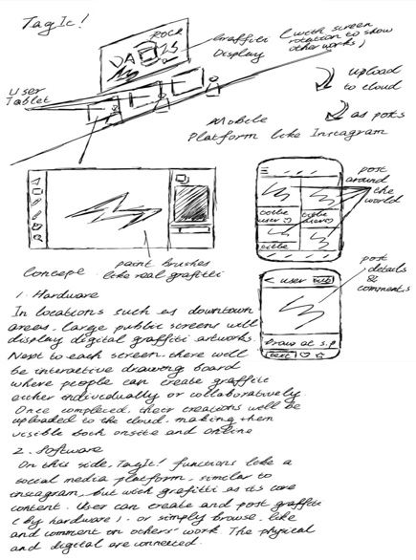
- Representation:
  - The display screen continuously cycles through user-uploaded graffiti artworks.
  - An interactive drawing board below the screen allows passersby to create instantly.
  - Graffiti is uploaded to the cloud and appears in a community feed with likes and comments.
- Characteristics: Mainly conceptual and visionary, without visual standards or complete flows.
Figure 1: Low-Fi Prototype
- High Fidelity Phase: Visual Design & Flow Completion
(1) Visual Design
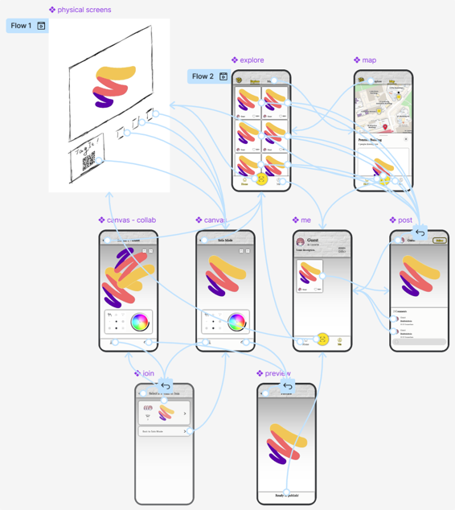
- Hand-drawn boxes in the sketch were replaced by consistent icons, color palettes, and layouts in the high-fidelity design.
- The canvas offers multiple tools such as spray brushes, rollers, and strokes.
(2) User Flow
- The high-fidelity prototype defined core pages including explore, map, canvas, post, profile, preview and their navigation.
- A map view was added to help users discover physical graffiti locations in the city.
- A preview mechanism was introduced before publishing to reduce social anxiety.
Figure 2: High-Fi Prototype
(3) Improvements from Analysis Document
- Creation without mandatory registration: guest mode lowers the entry barrier.
- History storage: artworks saved in personal profiles or aggregated public accounts.
- Collaborative/individual mode: supports jam sessions or solo creation.
- Content moderation: keyword filtering and reporting system.
Prototype Testing Process:
Test Tasks
- Join and Draw:
“Imagine you just walked past this public screen. Use the prototype to join and create a doodle.”
- Collaborate:
“Find a way to collaborate with others and add something to the same canvas.”
- Explore and Comment:
“Explore what others have drawn and leave a comment on a post.”
Data Collection & Observation
- Note where participants hesitate or get lost
- Capture their first reaction when they see their graffiti on the screen
- Observe whether they discover the collaboration feature naturally
- Record any spontaneous comments (positive or negative)
Post-Session Questions
- Would you use this in a real public space? Why or why not?
- How do you feel about others seeing your doodles in real time?
- Would you prefer to draw alone or collaborate with others?
- What would make you more likely to come back and use it again?
Success Criteria
- Users can complete all three tasks without external help (or minimal prompts)
- Users express positive or curious reactions about seeing public participation
- Users provide feedback on social and contextual aspects (not just UI details)
Prototyping Process Questions:
What is the aim & scope of the prototype?
Answer: This prototype focuses on testing the main flow of Scan → Canvas → Publish as well as the extended path for joining collaborative creation.
It does not include non-core features such as draft saving or a full user account system.
The goal is to evaluate whether users understand the flow, whether they are willing to participate, and their attitudes toward public collaboration.
How interactive does your prototype need to be?
At this stage, the TagIt prototype does not support real drawing functionality; instead, it is built in Figma with click-through navigation between screens. The level of interactivity is therefore limited to simulating user flows such as joining the canvas, switching between individual and collaborative modes, and viewing or commenting on existing artworks. While users cannot create graffiti directly, the click-through design is sufficient to communicate the core concept and to allow participants to imagine how collaborative graffiti and public display interactions would unfold in practice. This lightweight level of interactivity enables us to gather feedback on navigation, feature expectations, and social interaction design without requiring a fully functional system.
ls “data" important?
For the current prototype, data is not functionally implemented. Since the design is presented through Figma click-through screens, user-generated graffiti, likes, and comments are only represented visually rather than stored or processed. However, in the final concept of TagIt, data is highly important: artworks need to be uploaded, stored, and displayed on public screens; social features such as comments and likes rely on persistent data; and collaborative drawing requires real-time data sharing between users. Therefore, while the present prototype uses static mockups to simulate these interactions, data management and persistence are recognized as core elements of the system that will need to be addressed in later stages of development.
What technology do you have in mind for production?
-
What is the primary platform/device for your concept?
-
Next Step:
Next Step we will continue to iterate our prototype with following plan:
If the test reveals that the entry point for the collaboration flow is not noticeable enough, we plan to revise the UI.
If users are reluctant to post public comments, we will consider adding an anonymous option.

