Notes
Use Deque for lists (import collections) to append elements to the left of a list, is much quicker than a normal append. Pop() and Popleft() can also be used.
useful functions:
izip()
enumerate()
mean() from NumPy
min(), max(), sum() and len()
sorted()

Standards
91906: Use complex programming techniques to develop a computer program (6 credits)
91907: Use complex processes to develop a digital technologies outcome (6 credits)
Brief
For my program I will be creating a Hangman game in Python with a GUI. I will be using the python library Tkinter for this, I will also be using GitHub and the Git application to keep previous versions. I will be making use of classes and modules to create an object based program, I will follow naming conventions for variables to create public and private variables as they are necessary for this standard even though Python does not support them.
The program will ask users if they want to select a random word from a list stored in a text file, or a word the user has entered. The user will be able to view their previous results and see how long they took and how many guesses they needed to win, the user will be able to export their results to a text file, the user will also be able to import word lists from a text file. The user will be able to guess either letters or a word using an onscreen keyboard made in the program, or by typing into an entry box.
Specifications and Constraints
- The player will get 10 guesses per phrase.
- Only phrases consisting of alphabetical characters that are under an undecided character limit.
- The time taken and guesses remaining/used, will be stored after a game has finished.
- The average and best statistics will be displayed, all statistics will be displayed on the game history window.
- Statistics will be able to be exported to a text file.
- Wordlists will be importable from a text file.
- If the player quits the game will not save.
- The game window cannot be resized or full screen, it can be minimized and moved around
Resources used:
- Python 3.8
- Wing IDE Pro 7.2
- GitHub and Git GUI 2.26.2
- Lucid Charts Diagrams
- NumPy library
- time library
- random library
- Tkinter library

Timeline
I plan to complete the project in AMOUNT weeks.

Planned Design
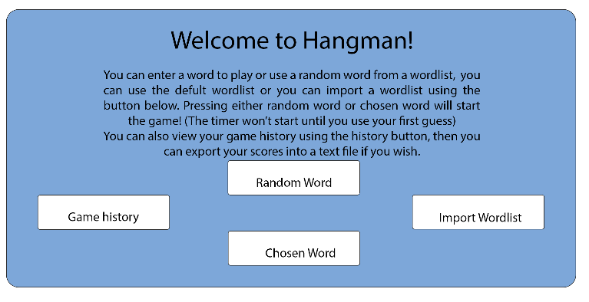
This will be the window when you open the program, it is the introduction and how you start the game. It has instructions, game history, import wordlist and random/chosen word buttons. The final design may change as this is only a prototype.

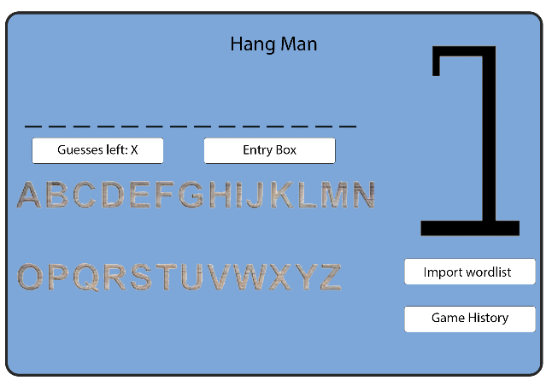
This is the game window that will open when the random/chosen word is pressed. Design is subject to change and I can already see how the import wordlist and game history buttons are irrelevant for this window. Both images are free for reuse, but I will be making my own images, each letter will be a button. The colours may change as well as the font.

Input
The user will be able to import a custom set of words stored in a text file using the ‘import wordlist’ button.
The user will input information when they are asked if they want to enter a phrase, or when one of the letter buttons is pressed in order to guess a letter.
The user can interact with various buttons to access different windows, such as the history window, wordlist window. The user can also use the ‘quit’ button to exit the game and close the program.
Output
The GUI will display a welcome message and simple instructions, as well as 5 buttons.
- Import wordlist – Opens a new window to import a different set of phrases/words.
- Export statistics – Opens a new window to export the player’s statistics for the current session to a text file.
- Random word – Makes the game use a phrase from the current wordlist and opens a new window to start the game.
- Chosen word – Asks the user for a phrase to play the game with and opens a new window to start the game.
- Quit – Exits the GUI and closes the program.

Variables
Classes
none are private.
Name | Functions:
MainWindow | __init__, game_window, history_window, game_information, get_wordlist
GameWindow | __init__, main_window, get_phrase, get_letters
HistoryWindow | __init__, export_scores, get_victory, get_winloss, get_guesses
WordlistWindow | __init__, import_wordlist

Functions
No functions are private using __ (double underscore) except init__
All variables are private using __ (double underscore) unless specified otherwise

Name | Class | Type | Purpose | Variables
export_scores | HistoryWindow | Definition | Take all the statistics for the session and export them into a file. | line – all the stats for a game will be on one line.
import_wordlist | WordlistWindow | Definition | Imports a list of phrases to be used when randomly selecting a phrase for the game. | wordlist – the current wordlist for the game.
main_window | GameWindow | Definition | Re-opens the main window and closes the game window when the game ends. | game_frame – will be destroyed when this function is called
game_window | MainWindow | Definition | Closes the main window and opens the game window when a game is started. | main_frame – will be destroyed when this function is called.
history_window | MainWindow | Definition | Opens the history window for all the game statistics. | winLoss – used to send the win/loss ratio to the history window  victory – used to send the victory bool to the history window  phrase – used to send the phrase to the history window  guesses – used to send the number of guesses taken to the history window
wordlist_window | MainWindow | Definition | Calls the WordlistWindow class to open the wordlist window | None
game_information | MainWindow | Definition | Selects a word or uses the one entered by the player, creates lists for the letters. | wordlist – list containing phrases to be used in the game  phrase – defined in this function as a random item in the wordlist, or as the entry from the user.  letters – list of character in the phrase variable
init__ | MainWindow | Definition  (Initialized) | Creates all the GUI elements for the main window and sets variables. | main_frame – the from that holds each GUI element  heading_label – hangman heading text  instruction_label – user instructions text  wordlist_button – button to call the wordlist_window function  history_button- button used to call the history_window function  random_button – calls the game_information function with a bool of ‘false’  chosen_button – calls the game_information function with a bool of ‘true’  quit_button – calls the quit function to close the GUI and stop the program
init__ | GameWindow | Definition  (Initialized) | Creates all the GUI elements for the game window and sets variables. | game_frame – the frame which holds all the GUI elements for the window  (a-z)button – buttons for each letter of the alphabet which  phrase_label – label that displays the phrase the user is finding  stats_label – label that displays the time taken, guess remaining and used.  letters_label – label that displays the letters the player has guessed.
init__ | WordlistWindow | Definition  (Initialized) | Creates all the GUI elements for the wordlist window and sets variables. | wordlist_frame – the frame that holds all the GUI elements for the wordlist window.  import_button – button which opens file explorer to select the file to be used.  instructions_label – label for the instructions text.  dismiss_button – button to close the wordlist window and re-enable the.  wordlist – list of all the possible phrases the game can use.
init__ | HistoryWindow | Definition  (Initialized) | Creates all the GUI elements for the history window and sets variables. | history_frame-the frame that hold all of the GUI elements for the history window  statistics_frame – frame inside the history frame to hold the GUI elements for each game’s statistics  statistics_label – label for each games statistics, will be updated for each game.  game_set- Queue of each game’s statistics played this session, used to order the games on the statistics_label  dismiss_button – button to close the window and re-enable the main window  export_button – button to export all the results into a text file.
get_wordlist | MainWindow | Definition | Returns the current wordlist when called. | wordlist - variable that is returned when the function is called.
get_phrase | GameWindow | Definition | Returns the current phrase when called. | phrase – variable that is returned when the function is called.
get_letters | GameWindow | Definition | Returns the current list of letters when called | letters – variable that is returned when the function is called.
get_guesses | HistoryWindow | Definition | Returns the number of guesses when called. | guesses – variable that is returned when the function is called.
get_victory | HistoryWindow | Definition | Returns a bool if the game was won or not. | victory – a bool of either True or False that is returned when the function is called.
get_winloss | HistoryWindow | Definition | Returns the number of wins and losses for this session. | winloss – variable of the winloss ratio that is returned when the function is called.

Code Flowchart 