US Urban Affordability Analysis
Rent, Salary & Cost of Living Trends | 2010 – 2024
A Data Analytics Portfolio Project

Project Overview
This project analyses rental affordability across 94 US cities from 2010 to 2024, using a longitudinal dataset covering key economic indicators including median salaries, rent prices, cost of living indices, and affordability ratios. The central question driving this analysis is: where has living in the United States become harder, and why?

The dataset contains 1,410 records with no missing values, covering cities across four tiers — megalopolis, large, medium, and small — sourced from Numbeo.

Key Findings

Rent Burden Overview — Top 10 States (2010–2024 Average)
Before filtering to 2024, the chart below shows the top 10 states by rent-to-income ratio averaged across the full 14-year period, providing a baseline view of which states have consistently carried the highest rent burden over time.
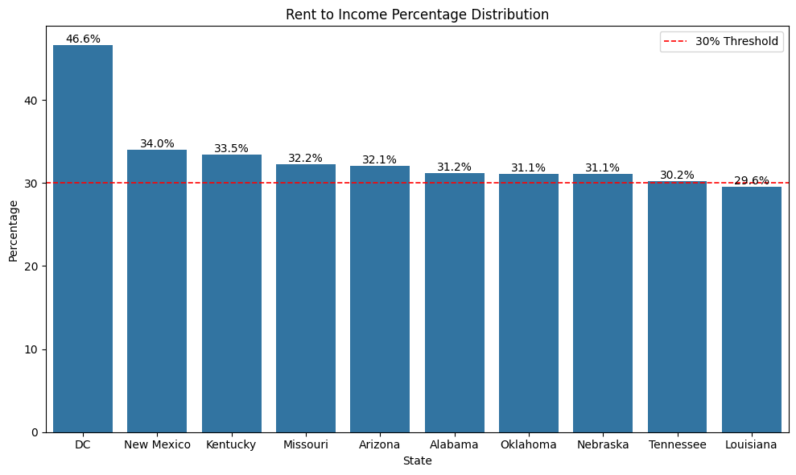
Figure 1: Average Rent-to-Income % by State (2010–2024)

1. Rent Burden Is Heavily Concentrated in Specific States (2024)
In 2024, Washington DC stands as a clear outlier with a rent-to-income ratio of 43.1% — meaning the average resident spends over two-fifths of their gross income on rent alone, well above the 30% affordability threshold. While DC is a federal district rather than a state, it is included here as it functions as an independent jurisdiction for cost of living purposes. Kentucky (33.3%), New Mexico (32.6%), and Nebraska (32.2%) follow.

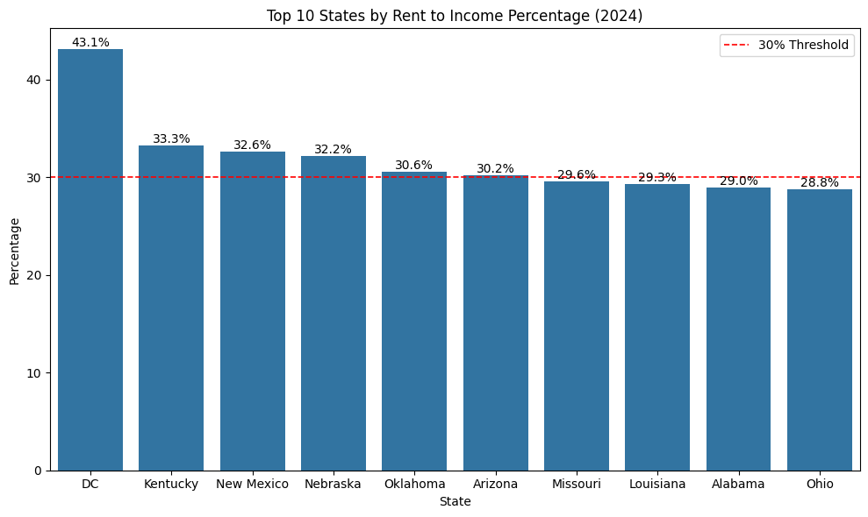
Figure 2: Top 10 Most Rent-Burdened States (2024)

State / District | Rent-to-Income % | Affordability Status
DC (District) | 43.1% | Severely Burdened
Kentucky | 33.3% | Burdened
New Mexico | 32.6% | Burdened
Nebraska | 32.2% | Burdened
Oklahoma | 30.6% | Burdened

Table 1: Top 5 Most Rent-Burdened States / Districts (2024)

💡 DC Anomaly
DC's high ratio is driven by extremely elevated rent rather than low salaries — the average annual salary in DC is $78,108, yet annual rent for a 1-bedroom city centre apartment reaches $45,876. Rent alone consumes 59% of gross salary.

2. The Least Burdened States (2024)
At the other end of the spectrum, Massachusetts (17.4%), Washington State (17.5%), and New Jersey (17.5%) have the lowest rent-to-income ratios in 2024. Notably, these are high-salary states — suggesting affordability is driven more by strong wage growth than by cheap rent.

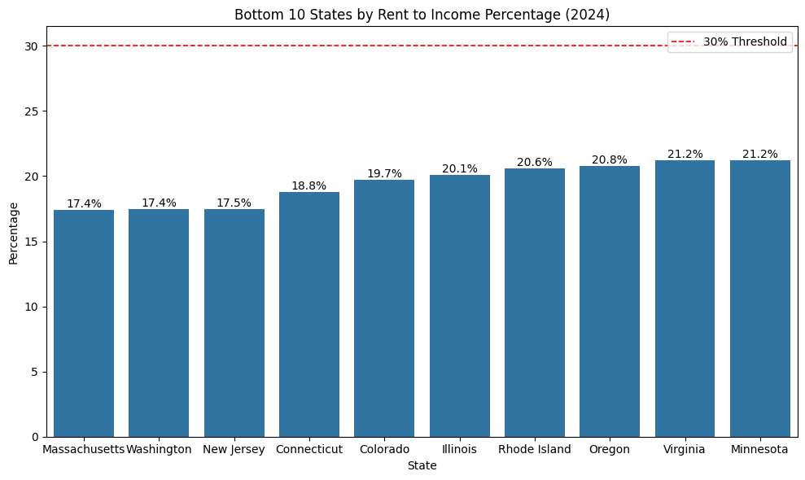
Figure 3: Bottom 10 Least Rent-Burdened States (2024)

State | Rent-to-Income % | Affordability Status
Massachusetts | 17.4% | Comfortable
Washington | 17.5% | Comfortable
New Jersey | 17.5% | Comfortable
Connecticut | 18.8% | Comfortable
Colorado | 19.7% | Comfortable

Table 2: Top 5 Least Rent-Burdened States (2024)

3. Salary vs Rent — Why Are Some States So Burdened?
Comparing annual salary against annualised rent reveals the root cause of rent burden. In the most burdened states, rent consumes a disproportionate share of salary. DC is again the standout — despite having the highest salary, its rent is so extreme that it leaves residents worse off than lower-salary states with cheaper housing.

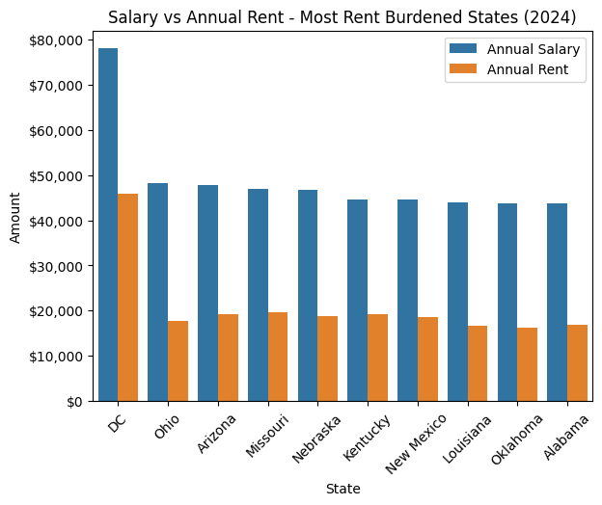
Figure 4: Annual Salary vs Annual Rent — Most Rent-Burdened States (2024)

By contrast, the least burdened states show a much healthier gap between salary and rent, with rent representing a far smaller proportion of take-home earnings.

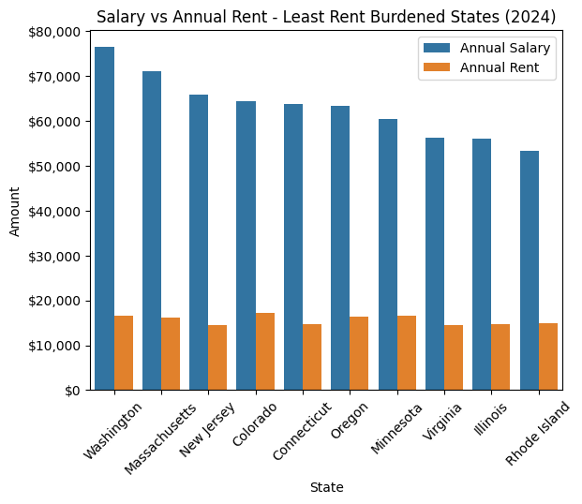
Figure 5: Annual Salary vs Annual Rent — Least Rent-Burdened States (2024)

💡 Key Insight
High salaries do not guarantee affordability. Washington DC has the highest average salary in this dataset yet the worst rent-to-income ratio, because rent growth has outpaced even strong wage growth. The least burdened states benefit from a combination of solid salaries and moderate rent levels.

4. National Trend: The Post-COVID Rent Surge (2010–2024)
Nationally, the average rent-to-income ratio peaked at 27.7% in 2013, then declined steadily to a 14-year low of 23.7% in 2021 — driven by COVID-era wage growth and stimulus effects. However, 2022 saw a sharp reversal as the post-COVID inflation surge sent rent prices soaring across the country.

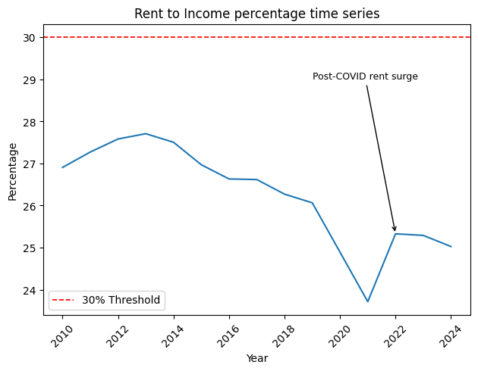
Figure 6: National Rent-to-Income % Over Time (2010–2024)

The national average has remained elevated since 2022, sitting at 25.0% in 2024 — and crucially, has never crossed the 30% threshold nationally. This masks significant regional inequality, where jurisdictions like Washington DC are severely burdened while the national figure appears healthy.

5. City Tier Is a Strong Predictor of Rent Burden
Analysing cities by tier reveals a clear and consistent pattern across all 14 years — the larger the city, the higher the rent burden. Megalopolises average 45.3% in 2024, nearly three times that of small cities at 16.1%.

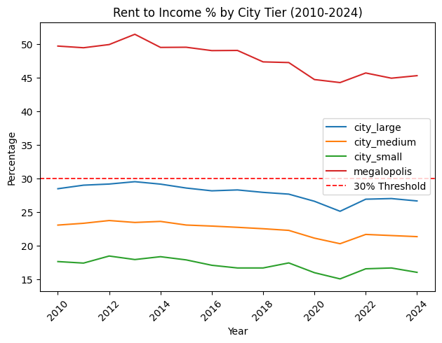
Figure 7: Rent-to-Income % by City Tier (2010–2024)

City Tier | Avg Rent-to-Income % (2024)
Megalopolis | 45.3%
Large City | 26.7%
Medium City | 21.4%
Small City | 16.1%

Table 3: Rent-to-Income % by City Tier (2024)

Methodology
This analysis was conducted using Python with the following libraries:
- pandas — data manipulation and groupby aggregations
- matplotlib & seaborn — data visualisation
- Dataset: USA Cost of Living & Salary Longitudinal Data 2010–2024 (Kaggle)

All figures are based on mean values aggregated at the state level unless otherwise stated. Rent figures were annualised by multiplying monthly 1-bedroom city centre rent by 12 for salary comparison purposes.

Conclusions
This analysis highlights three core findings about US urban affordability:

- Rent burden in the US is not a uniform national problem — it is concentrated in specific states and city tiers, with Washington DC and megalopolises significantly worse than the national average.
- The post-COVID period (2022 onwards) reversed years of gradual affordability improvements, and the effects persist into 2024.
- High salaries do not guarantee affordability — Washington DC has the highest average salary in this dataset yet the worst rent-to-income ratio, because rent growth has outpaced even strong wage growth.

These findings suggest that any policy or personal financial decisions around housing in the US must account for the enormous variation between cities and states, rather than relying on national averages alone.

Data source: Numbeo via Kaggle | Analysis conducted in Python (pandas, seaborn, matplotlib) | 2025

