Assignment 2- Case Study

Stage 3 Lab Activities

SmartCare Domain Modelling
AI OFF -> AI ON -> COMPARE -> VERIFY | 1 hour

A - Requirements Review
Highlight nouns, verbs and business rules in SmartCare v0.2.
Patient – Noun
Practitioner – Noun
Appointment – Noun
Clinic – Noun, but in this case where there is only one clinic, it will not have a class.

B - Candidate Classes
Record candidate concepts, supporting requirements, state and behaviour.
Candidate | Class? | Reason
Patient | Yes | It’s a noun, with information that comes from outside the program. We will also need to create many patient profiles and records.
Practitioner | Yes | It’s a noun, with information that comes from outside the program. We will also need to create many practitioner profiles and records.
Appointment | Yes | It’s a noun, with information that comes from outside the program. We will also need to create and attribute many appointments to patients and practitioners.
Name | No | Its an attribute of Patient or Practitioner not its own class.
Clinic | No | Creating a class for the clinic would only be useful if we had more than one clinic.
Database | No | The data base is a separate thing and has no need for a class as it doesn’t have any attributes we only need one.
Cancellation | Yes | I’m going to make a Cancellation class to store the information about the cancellation. If this information didn’t need to be stored then it wouldn’t need a class.
Status | No | Its an attribute of Appointment not its own class.

C - CRC Cards
Create CRC cards for Patient, Practitioner and Appointment.

Patient
Responsibilities | Collaborators
Personal details, Name, contact info, DOB | None
Book an appointment | Appointment
Cancel an appointment | Appointment
View appointment history | Appointment

Practitioner
Responsibilities | Collaborators
Professional details, Name and specialty | None
Own availability | Appointment
Accept / Decline an appointment | Appointment
View Appointment schedule | Appointment

Appointment
Responsibilities | Collaborators
Know the date, time and duration or appointments | None
Know and update it’s status booked, cancelled, InProgress, complete | None
Know which patient its for | Patient
Know which Practitioner its with | Practitioner
Confirmation of the booking (between patient and practitioner) | Patient and Practitioner

D - UML Model
Draw classes, attributes, operations, associations and multiplicities.
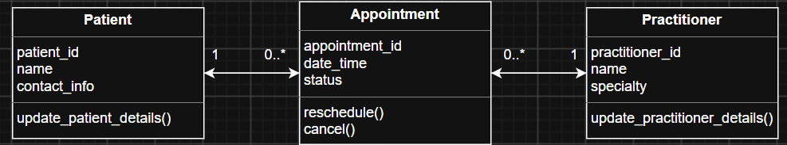

E - AI Design Review
Ask AI to suggest classes and relationships using only confirmed requirements; require supporting requirement IDs.
AI suggestion | Evidence | Decision | Reason | Model change
Patient Manager | No evidence from the client or from the client needs this suggestion. | Reject | A manager class for patients is unneeded, as the patient class is small and can already handle it. | None – as it was rejected.
Practitioner Manager | No evidence from the client or from the client needs this suggestion. | Reject | A manager class for the practitioners is also unneeded as the class won’t be that big and doesn’t achieve anything the practitioner class already will | None – as it was rejected.
Appointment Manager | This is slightly out of scope for a “simple” system this early on but not unreasonable to add later on. | Reject / Defer | Could maybe be added in the future but it’s a bit early right now, it’s also unclear what the “manager” will actually do? | None (for now) – as it was rejected / deferred to a later date.
Clinic Controller | No evidence from the client or from the client needs this suggestion. | Reject | We have already ruled out a clinic class as there is only one clinic, so it’s not needed. | None – as it was rejected.
Notification Manager | This is slightly out of scope for a “simple” system this early on but not unreasonable to add later on. | Reject / Defer | This could be a good system to remind patients or practitioners about their oncoming appointments. However out of scope as it goes against the simple system the clinic wants, but could be something to look at in the future. | None (for now) – as it was rejected / deferred to a later date.
Schedule Engine | No evidence from the client or from the client needs this suggestion. | Reject | Unclear on what an “engine” actually is, it also again adds more complexity to a system we want to keep simple. | None – as it was rejected.

F - Compare and Decide
Record at least one accepted, modified and rejected AI suggestion.
None were accepted.
The appointment Manager and Notification Manager were somewhat modified but deferred. The appointment manager would most likely just do what the system is going to do in the first place. However if the clinic ever wants more feature to a larger system modularizing this system into an all encompassing appointment manager could be something looked into. The Notification Manager could also be a feature added later on as it would be a very useful thing to have especially for people who book weeks or months in advance and forget.
The rest of the suggestions were rejected as there was no evidence that the client needed them to solve one of their problems nor did they want the feature.

G - Python Skeletons
Create simple Patient, Practitioner and Appointment class skeletons.
Can be found in the week6 folder, under the name “smartcare_skeleon_v03.py”.

H - Consistency Check
Check model-code consistency; do not implement full behaviour yet.
The model code has been based directly off the UML model as mentioned at the top of the program and is consistent with it.

Reflection
What modelling decision was hardest? Where did AI over-design? What evidence supported your final choices?
The hardest decision was probably deciding if the clinic and cancellation needed their own classes. They are both nouns, but there is only one clinic that needs to be in the design so although it could be its own class it felt as though it over complicated the program. For the cancellation although it’s a noun in the program it functions like a verb as its something the Appointment does to itself, not its own thing.
AI over-designed most areas it looked at such as all the Something_Managers, ClinicController and Schedule Engine. None of them where described in much or any detail ether leaving a lot up to interpretation. None of these had their own state or identity ether, so all where rejected or deferred to a later iteration.
The evidence that supported my final choices were the functional requirements FR-01 – FR-12 which were based off the clinics needs so nothing required was missed or added that was unnecessary. The other evidence that was used was the CRC cards which laid out the responsibility’s and colaborators.

