SmartCare v0.3 - Domain Model Workbook
Week 6 student resource

Requirement-to-Concept Trace
Requirement | Concept | State/behaviour | Decision
FR-01 Create appointments | Appointments, Patient, Practitioner | appointment_ID: date_time, status. | Appointment class, links patient and practitioner.
FR – 02 No duplicate Bookings | Practitioner, Appointments | Check active practitioner and time bookings. | Service
FR-03 Reschedule appointments | Appointments | date_time, status change. | Change in date_time or status is under appointments
FR-04 Cancel appointments | Appointments | status change to cancel. | Appointments, change of status. Cancelled appointments are not deleted.
FR-05 Patient search by ID | Patient | Patients are found though Patient_ID. | Service.
FR-06 Store appointments | Appointments | Appointment_ID, date_time, status. | Not a domain class.
FR-07 Practitioner appointment view | Practitioner, Appointments | Shows practitioner view.
FR-08 Practitioner availability view | Practitioner, Appointments | Check practitioner schedule and current bookings. | Service.
FR-09 Appointment status | Appointments | Status: booked, in_progress, completed, canceled. | Under the appointment class.
FR-10 Add and update patient info | Patient | Patient_ID, name, contact info (any other info). | Patient class.
FR-11 Add and update practitioner info | Practitioner | Practitioner_ID, name, specialty. | Practitioner class.
FR-12 Generate operational reports | Patient, Practitioner, Appointments | Collection or relevant data. | Not a domain class.

CRC Cards

Patient
Responsibilities | Collaborators
Know identity’s, patient_ID, name, contect info | None
Update its info | None
Know appointment history | Appointments

Practitioner
Responsibilities | Collaborators
Know identity’s, practitioner_ID, name, specialty | None
Update its info | None
Know list of appointments | Appointments

Appointment
Responsibilities | Collaborators
Know identity’s, appointment_ID, date_time, status. | None
Update its info (rescheduling and status changes) | None
Know which Patient and Practitioner is linked | Patient, Practitioner

Optional class
Responsibilities | Collaborators
Check for conflicts between appointments | Practitioner, Appointment
Patient or Appointment records lookup with ID | Patient, Appointments
Generate operational reports | Patient, Practitioner, Appiontment

UML Class Diagram
Insert/draw UML here. Include defensible relationships and multiplicities.
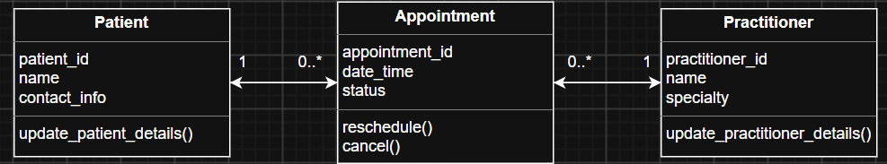
Multiplicities
Patient 1 0..* Appointment
Practitioner 1 0..* Appointment
Each appointment only has one Patient and one Practitioner.

Design Rationale
Explain class selection, responsibility allocation and key relationships.
The three classes that are going to be used are Patient, Appointment and Practitioner. As each has its own identity with their own attributes and behaviors.
Appointment – Uses information from Patient and Practitioner. A patient can have multiple appointments but an appointment can only have one patient. A practitioner can also have mutable appointments but each appointment only has one practitioner.
Each class has responsibility given to its self to change its own state. Patient and practitioner can update their own details and Appointment changes the state of appointment status and rescheduling on its own.

AI Design Review Record
AI suggestion | Evidence | Decision | Reason | Model change
Patient Manager | No evidence from the client or from the client needs this suggestion. | Reject | A manager class for patients is unneeded, as the patient class is small and can already handle it. | None – as it was rejected.
Practitioner Manager | No evidence from the client or from the client needs this suggestion. | Reject | A manager class for the practitioners is also unneeded as the class won’t be that big and doesn’t achieve anything the practitioner class already will | None – as it was rejected.
Appointment Manager | This is slightly out of scope for a “simple” system this early on but not unreasonable to add later on. | Reject / Defer | Could maybe be added in the future but it’s a bit early right now, it’s also unclear what the “manager” will actually do? | None (for now) – as it was rejected / deferred to a later date.
Clinic Controller | No evidence from the client or from the client needs this suggestion. | Reject | We have already ruled out a clinic class as there is only one clinic, so it’s not needed. | None – as it was rejected.
Notification Manager | This is slightly out of scope for a “simple” system this early on but not unreasonable to add later on. | Reject / Defer | This could be a good system to remind patients or practitioners about their oncoming appointments. However out of scope as it goes against the simple system the clinic wants, but could be something to look at in the future. | None (for now) – as it was rejected / deferred to a later date.
Schedule Engine | No evidence from the client or from the client needs this suggestion. | Reject | Unclear on what an “engine” actually is, it also again adds more complexity to a system we want to keep simple. | None – as it was rejected.

