Table of Contents
To what extent will the use of Artificial Intelligence disrupt the UK workforce? 2
1. Introduction 2
2. What Is Artificial Intelligence? 2
3. Artificial Intelligence vs. Machine Learning 2
4. How Has The Use Of AI Disrupted The UK’s Workforce In The Past? 3
5. How Will The Use Of AI Disrupt The UK’s Workforce In The Future? 3
6. How Soon Will AI Threaten To Displace UK Workers? 6
7. Corporate Attitudes Regarding AI Adoption 7
8. What Support Are Companies Providing Regarding Reskilling For Vulnerable Employees? 9
9. To What Extent Has The Use Of AI In Amazon’s Fulfilment Centres Disrupted The Company’s Employees? 10
10. Conclusion 12
Bibliography 13
Appendix A: Terms and Definitions 16
Appendix B: Figures & Charts 17

To what extent will the use of Artificial Intelligence disrupt the UK workforce?

1. Introduction
As technology advances and more research is conducted, the capabilities and possibilities of Artificial Intelligence in everyday tasks have grown ever-more. However, there is growing concern that AI will eventually outperform humans doing certain jobs, threatening to replace human workers with intelligent robots and computers.

This essay aims to explore how Artificial Intelligence will disrupt the UK’s workforce in the future, how it has done so in the past and the contextual information surrounding the economic, corporate & logistic motives behind replacing human workers with Artificial Intelligence.

2. What Is Artificial Intelligence?
To the uninitiated, Artificial Intelligence (or AI for short) is a modern technology that enables machines to make intelligent decisions, reacting to situations as a human would. Such technology can be seen frequently throughout modern life, with tools like virtual assistants appearing in almost all recent smartphones. However, on a technical level, it is much more complicated, with many definitions having been coined over the years. John McCarthy, widely considered as one of the founding fathers of Artificial Intelligence, offered the following layman definition in his 2007 paper “What is Artificial Intelligence?”:

“It is the science and engineering of making intelligent machines, especially intelligent computer programs”. (McCarthy, 2007)

This essay will follow McCarthy’s layman definition of Artificial Intelligence.

3. Artificial Intelligence vs. Machine Learning
It is also important, within the context of this essay, to clarify the difference between Artificial Intelligence and Machine Learning (or ML for short). This is because the two terms have very similar definitions and may be confused with one another or applied in the wrong contexts. IBM provides the following definition of Machine Learning:

“Machine Learning is a branch of Artificial Intelligence and computer science which focuses on the use of data and algorithms to imitate the way that humans learn, gradually improving its accuracy.” (IBM, 2020)

MIT’s School of Management provides a more specific explanation, which details how Machine Learning is accomplished and how it fits in with our definition of Artificial Intelligence:

“Machine learning starts with data – numbers, photos, or text, like bank transactions, pictures of people, [etc.] The data is gathered to be used as training data, or the information the machine learning model will be trained on. The more data, the better the program.
From there, programmers choose a machine learning model to use, supply the data, and let the computer model train itself to find patterns or make predictions.” (Brown, 2021)

With these two descriptions, it can be concluded that Machine Learning is a methodology used to attain Artificial Intelligence using large datasets representing different scenarios that the AI needs to be able to interpret.

4. How Has The Use Of AI Disrupted The UK’s Workforce In The Past?
Previously, barring the 2009 financial crisis and Covid-19 pandemic, redundancy rates in the UK have seen a downwards trend since the beginning of records in 1995 (ONS, 2022). This is in addition to a downwards trend in unemployment once the impacts of the financial crisis had run their course (ONS, 2022). Likewise, the same trend can be seen in the UK’s employment rate since the 2009 financial crisis (ONS, 2022). Thus, it can be surmised that the UK’s workforce is currently in a stable state, with unemployment and redundancy rates being the lowest they’ve been in the past several decades. See Appendix B, Figures 1, 2 & 3 for the published charts.

Since the Covid-19 pandemic, the UK has seen a number of low-skill jobs be completely replaced by robots and the like to reduce the number of humans in the workplace. For example, a Deloitte press release claims that 15% more companies were using automation during the pandemic than before the pandemic (73% of companies in 2020 – 58% in 2019) (Deloitte, 2020). Despite this, the unemployment rate in the UK has continued its downwards trend, being equal to – and in some cases lower than – pre-pandemic figures from late 2019 (ONS, 2022). With these figures in play, it can be concluded that – so far – Artificial Intelligence has had a minimal impact on the UK’s workforce. This makes it unlikely that AI would suddenly begin causing significant redundancy or unemployment without prior warning since it has yet to make any noticeable difference.

5. How Will The Use Of AI Disrupt The UK’s Workforce In The Future?
According to an ONS publication, last updated in 2019, elementary roles were at the greatest overall risk of automation (ONS, 2019). Using the estimates provided by the report, mean average of roughly 64% of roles at high risk of automation can be calculated (ONS, 2019). Similarly, sales & customer service roles have an average 54% of roles at risk, while hospitality and administration roles have an average of 51% and 56% respectively (ONS, 2019). Of these roles, waitering jobs are the most vulnerable with an estimated 73% of all waitering roles at high risk of automation at the time of publication (ONS, 2019). Ostensibly, these figures may raise alarm to some of the UK’s most vulnerable groups, mainly the poorly educated and students who rely heavily on these roles to support themselves during their studies. Some may make the argument that, should these roles be automated to the extent predicted, it could prove devastating to students and other vulnerable people trying to financially support themselves. It could even have a domino effect, leading a shortage of high-skill jobs due to a lack of students attending university. However, of the 20 million jobs sampled by the ONS, only a total of 7.4% were at a high risk of automation, a decrease of 0.7% since the previous 2011-2017 estimates (ONS, 2019). In fact, aside from a spike in redundancies during the Covid-19 pandemic, the overall redundancy rate has seen a downwards trend since early 2009 (ONS, 2022). This is despite Artificial Intelligence having advanced considerably since then. Overall, we can conclude that the report seems to indicate a significant threat to certain jobs, but that the overall threat to jobs is minimal when set in its full context. It should be noted that the report by the ONS refers to any type of automation, regardless of whether Artificial Intelligence is involved or not and there does not appear to be a way to isolate the figures specifically involving Artificial Intelligence. This means that the predicted impact of Artificial Intelligence will be even lesser than given in the report since other methods of automation have contributed to the overall figures published.

A report published by PwC, titled “Will robots really steal our jobs?” investigates how AI could impact the global workforce in the future. The report defines three separate waves, each lasting a given length of time and having their own traits which sets them apart from the other waves. Wave 1, what PwC calls the “algorithmic wave,” is expected to last until the early 2020s and is characterised as follows:

“Automation of simple computational tasks and analysis of structured data, affecting data-driven sectors such as financial services.” (PwC, 2018)

During the first wave, PwC estimates that medium- and high-education workers are at a greater risk than low-education workers (PwC, 2018). This is because the first wave indicates the gradual automation of data-analysis and processing tasks, such as the kind of data analysis a bank might make when investing customers’ money. However, the overall potential risk of automation remains low, with the number of jobs being at risk being below 5% for low, medium, and high-education workers (PwC, 2018). See Appendix B, Figure 4 for PwC’s full predictions.

The second wave, titled the “augmentation wave” is projected to last until the late 2020s. PwC summarises the augmentation wave as:
“Dynamic interaction with technology for clerical support and decision making. Also includes robotic tasks in semi-controlled environments such as moving objects in warehouses.” (PwC, 2018)

The predicted risks to jobs during this wave are significantly different from the previous wave, insofar that medium education workers are likely to face the greatest risk, with low-education workers following a little behind (PwC, 2018). High-education workers see the lowest risk during this stage by a large margin (PwC, 2018). The overall risk to jobs has increased significantly by this point, see Appendix B, Figure 4 for full details.

Finally comes the “automation wave”, which PwC expects to last until the mid 2030s. It has been defined as:

“Automation of physical labour and manual dexterity, and problem solving in dynamic real-world situations that require responsive actions, such as in transport and construction.” (PwC, 2018)

This is the point where low-education workers bare the largest risk of automation, with as many as 45% of jobs at risk (PwC, 2018). As expected, medium-education workers follow closely, while high-education workers see little risk (PwC, 2018). Interestingly, the risk to high-education workers remains considerably higher than it was in the first wave but is almost identical to the second wave, indicating that there could be an upper limit to what kinds of jobs can be automated (PwC, 2018).

PwC’s report also suggests that up to 44% of workers with low education could be made redundant by automation, with the industries likely to see the greatest long-term impact being manufacturing, construction and retail. (PwC, 2018) This differs from the ONS report, where elementary, customer service and administrative roles were expected to see the greatest impact (ONS, 2022). From this, we can conclude that both the ONS and PwC agree that the increase in redundancies due to Artificial Intelligence will largely remain within labour roles, while jobs requiring higher levels of education will remain mostly untouched. This is in addition to PwC’s claims that low-education workers will see the largest long-term impact, compared to medium- and high-education workers (PwC, 2018). Even though PwC’s report does not necessarily reinforce the predictions made by the ONS, they do support the general trend that Artificial Intelligence will continue replacing workers, and at a faster rate – at least, to an extent.

Another report, published by the Department for Business, Energy and Industrial Strategy (DBEIS), claims that the number of jobs in administration roles could drop by as much as 30% by 2031 (DBEIS, 2021). This estimate is compatible with predictions made by the ONS, however, the ONS did not predict losses as high as the DBEIS has. On the other hand, past 2031, the DBEIS has predicted that the net impact of AI on administrative roles won’t change much for the following 10 years (DBEIS, 2021). This appears to be the only occurrence of this strange pattern, and the report doesn’t seem to offer an explanation for it. Perhaps it suggests a limitation to the extent that administration roles can be automated.
The report also argues that, instead of completely replacing roles, autonomy and Artificial Intelligence will instead occupy manual, laborious tasks and leave jobs like customer service to the remaining human workforce (DBEIS, 2021). While customer service jobs were predicted to be at high risk of automation in the ONS’ report (ONS, 2022), the DBEIS’ argument is not that far-fetched, given that Artificial Intelligence is currently used to assist customer service teams rather than replace them. It should be noted that the DBEIS’ report sources other reports by PwC, which may explain any crossover between the two reports. This includes DBEIS’ reference to the algorithmic wave, augmentation wave and autonomy wave. Since the augmentation wave runs until the late-2020s, it’s possible that this may explain why net losses on administrative roles are predicted to plateau. It’s possible that certain advancements in Artificial Intelligence are expected within the augmentation wave that aren’t significantly improved upon in the following wave. Unfortunately, it is hard to say definitively how Artificial Intelligence will change in the future.

Of these three reports, none seem to agree with each other regarding exactly how much Artificial Intelligence is predicted to impact low-paid jobs and in which sectors it will impact the most. This makes it hard to reasonably give a sensible approximation on how many redundancies we can expect in the future. The only reasonable conclusion that can be drawn from these three reports is that, within the next few years, Artificial Intelligence will continue to cause further redundancies as technology improves.

On the contrary, the World Economic Forum (WEF) estimates a net-gain of 58 million (133 million new roles – 75 million redundant roles) new roles by the end of 2022 across the world (World Economic Forum, 2018). The net-gain is expected to be the result of new advancements in Artificial Intelligence. This estimation suggests there is disagreement across the world’s data analysts and economists regarding whether Artificial Intelligence will put more jobs at risk, or instead provide more opportunities. The reason behind these disagreements is, unfortunately, not clear. It may be due to a lack of research, a lack of data with which to make accurate predictions or due to differences in the use of AI across different industries and countries. This makes it difficult to gauge the legitimacy of the claims made by the PwC and WEF since their predictions may not be based on the same assumptions regarding how local industries feel about using AI in their companies, or whether it’s economically viable for them to do so.

Given the findings of my analysis of the past impacts of Artificial Intelligence on the workforce, it seems unlikely that Artificial Intelligence will begin causing large-scale unemployment or redundancy in the near future. In fact, trends from the past impacts suggest that Artificial Intelligence could lead to more upskilling while unemployment continues to drop steadily.

6. How Soon Will AI Threaten To Displace UK Workers?
The section will explore a paper published in the Journal of Artificial Intelligence Research (JAIR), by a series of five experts in the field from the University of Oxford’s Future of Humanity Institute and AI Impacts. The paper primarily focuses on identifying when “High-level Machine Intelligence” will be achieved. In the authors’ words:
“High-level Machine Intelligence (HLMI) is achieved when unaided machines can accomplish every task better and more cheaply than human workers.” (Grace, et al., 2018)

In the paper’s abstract (concise summary), the authors summarise the results of a large survey of 352 Artificial Intelligence researchers (Grace, et al., 2018):
“AI will outperform humans in many activities in the next ten years, such as translating languages (by 2024), writing high-school essays (by 2026), driving a truck (by 2027), working in retail (by 2031), writing a bestselling book (by 2049), and working as a surgeon (by 2053)” (Grace, et al., 2018)

The timings provided predict that AI may be able to displace some workers (e.g. interpreters) in as little as two years. However, the findings also suggest that retail workers may not see much displacement for another nine years,5 with other disciplines not expecting to see much disruption for even longer. It must also be considered that AI being better than humans at one task does not necessarily mean that it will immediately begin displacing people in those jobs; the paper forecasts that the full automation of labour has a 50% probability of happening within the next 122 years (Grace, et al., 2018).

Even despite the grim figures summarised by the paper, there is a huge variation in responses. For example, the paper shows that some respondents predict a 100% probability of HLMI occurring within approximately 13 years, while others say it has less than a 15% chance of occurring within the next 100 years.6 This indicates that there is a wide disagreement between AI experts all around the world regarding when we will see HLMI. See Appendix B, Figure 5 for the full results.

Overall, the variety of responses to the paper’s survey and the uncertainty it presents leads to the conclusion that there is no trustworthy answer to the question of when AI will begin to disrupt the UK workforce.

7. Corporate Attitudes Regarding AI Adoption
According to a survey of over 1000 corporate executives conducted by PwC, 52% of businesses in the US have accelerated their plans for AI adoption because of the challenges caused by the COVID-19 pandemic in 2020, with roughly 33% of businesses having reported already beginning implementing Artificial Intelligence within their operations (PwC, 2022). While this may sound alarming initially, of the respondents that claim to have accelerated their AI adoption plans, 40% cite new use cases as being the primary cause for the accelerated plans (PwC, 2022). This means that, while the data might suggest companies are looking to replace more of their workforce with AI, they are instead using AI to carry out new roles that have only recently been needed.

The goal of companies trying to implement Artificial Intelligence is ultimately quite simple: money. In fact, PwC reports that 25% of respondents who already deploy enterprise-wide Artificial Intelligence expected to increase revenue during the COVID-19 pandemic - this is compared to only 18% when considering all companies, regardless of whether they have adopted Artificial Intelligence or not (PwC, 2022). Additionally, McKinsey & Company estimates that Artificial Intelligence could provide up to $1 trillion increased value each year across banks worldwide (McKinsey & Company, 2020). If this trend continues, so too will the adoption of Artificial Intelligence across all types of businesses.

However, this does not necessarily mean that the adoption of Artificial Intelligence is directly connected to an increase in revenue. Given the extensive research and funding required to design and use Artificial Intelligence in business, it may be the case that many of the 25% are companies that would have expected to see increasing revenue throughout the pandemic regardless of whether they had adopted Artificial Intelligence or not – such as companies providing a movie streaming service.

PwC’s report also mentions the Artificial Intelligence Flywheel that is being created by businesses at the front line of Artificial Intelligence innovation (PwC, 2022). As PwC explains, this is a virtuous cycle where the use of Artificial Intelligence leads to better quality products. This leads to an increase in customers, providing more data to the company which can then be used to improve the Artificial Intelligence algorithms, leading to even higher quality products (PwC, 2022). PwC evidences the benefits enjoyed by companies that have fully embraced AI as proof that the Flywheel exists (PwC, 2022).

From a business perspective, the cycle described by PwC could be cause for great alarm. This is because, as new algorithms are developed for more and more use cases, eventually a small group of organisations will hold a monopoly on AI algorithms for certain uses. This makes it harder for small businesses to get a new AI project off the ground. In fact, virtual assistants like Alexa, Siri and Google Assistant are living examples of this problem, they are so commonplace and well-known that newer or less-known virtual assistants – such as Samsung’s Bixby – struggle to find traction in the market. If this trend appears in other applications of Artificial Intelligence, it could lead to the market for Artificial Intelligence effectively stalling in the future. As a result, it may suggest that the automation of jobs may begin to slow in the future.

8. What Support Are Companies Providing Regarding Reskilling For Vulnerable Employees?
Worryingly, the World Economic Forum estimates that at least 54% of all employees will require significant upskilling and reskilling by 2022 with up to 10% requiring training for more than a year (World Economic Forum, 2018). These estimates are concerning because they suggest a large shift in industry is required to avoid skill shortages, and with 41% of companies claiming to focus their reskilling efforts on already high-performing employees (World Economic Forum, 2018), it’s unlikely that such requirements will be satisfied until the issue has fully developed and companies begin to realise the importance of upskilling and reskilling in all areas. In fact, the WEF goes as far as to claim that “those most in need of reskilling and upskilling are the least likely to receive it” (World Economic Forum, 2018). Considering that - as mentioned earlier - elementary roles are the most vulnerable to automation, those most in need of retraining are also the most vulnerable and low-earning workers in the country.

An article by Venture Beat suggests that reskilling employees could be as simple as providing access to a digital learning platform like Skillsoft, Udacity or Udemy to the employees that need retraining (Venture Beat, 2022). This poses a significant question: why aren’t companies upskilling their employees? The largest factors here appear to be financial and time costs – an employer may ask why it should pay and wait for an employee to be retrained to do another job when they can cut corners by hiring someone that already has the skillset required. Herein lies a major problem; employers will continue this cycle until the pool of people with the required skillset is exhausted and they have no choice but to spend large amounts of time and money to reskill as many workers as they need. This is bad for both the business and the employees, as it creates instability in the job market. This issue continues despite over 45% of surveyed employees suggesting they would leave their job if their employer didn’t invest in upskilling (TechRepublic, 2020).

Despite these concerns, the World Economic Forum’s report found that 33% of respondents were planning to prioritise at-risk workers for reskilling and upskilling (World Economic Forum, 2018). It also found that over 25% of respondents planned to create new roles when old ones were made redundant (World Economic Forum, 2018). The report also projected the share of redundant roles to decrease from 31% to 21% between 2018 and 2022 (World Economic Forum, 2018), with the share of new roles increasing from 16% to 27% (World Economic Forum, 2018). This is despite over 23% of respondents claiming they are likely to adopt AI-powered robots within their own operations (World Economic Forum, 2018), with up to 37% claiming they are already considering adopting the technology (World Economic Forum, 2018). Based on this data, there is clearly some support being provided by a handful of companies when it comes to upskilling and reskilling, though it is not enough to offset the companies that refuse to provide retraining programmes. If the estimates here are to be taken as gospel, more support needs to be provided to avoid a large number of job losses.

9. To What Extent Has The Use Of AI In Amazon’s Fulfilment Centres Disrupted The Company’s Employees?
Amazon is a company that provides an online retail platform to its customers. Within its sorting centres and warehouses – what the company refers to as “Fulfilment Centres” – Amazon employs purpose-built, AI-powered robots to complement the human workforce (Amazon.com, Inc., 2019). Here, we will examine how the company is using Artificial Intelligence within its fulfilment centres, and how that impacts the company’s workforce.

Collectively, all of Amazon’s fulfilment centres have an average serious injury rate of 9.6 per 100 employees, more than double the industry average of 4 (Reveal News, 2019). However, this figure is far exceeded in some of the company’s fulfilment centres, particularly in those employing robots. For example, after deploying Amazon’s latest robot workers, the rate of serious injuries in a fulfilment centre in Tracy, California almost quadrupled (Reveal News, 2019). One facility in Kent, Washington reported a serious injury rate of 13 per every 100 employees, over 3 times the industry average. Another in Oregon reported over 26 serious injuries per every 100 employees, over 6 times the industry average (Reveal News, 2019). Furthermore, according to records obtained by Reveal, most of the fulfilment centres that had a high rate of injury deployed robots (Reveal News, 2019). According to these records, sprains and strains are the most frequently recorded injury, however, there are also records of lacerations, concussions, and fractures (Reveal News, 2019). While the abnormally high rate of injury could just be due to bad safety procedures as opposed to a result of Artificial Intelligence, the fact that several facilities have seen increased injury rates after deploying robots could suggest there is a connection. If there is a link between the AI robots Amazon has been deploying at their warehouses and the increase in injury rates, it could indicate that robots pose a significant threat to the health of workers when the correct preparations are not taken.

While Amazon’s workforce continues to grow (Institute for Local Self Reliance, n.d.), the Institute for Local Self Reliance (ILSR) claims the company fulfilled enough sales in 2015 to displace over 295, 000 US retail workers, more than double Amazon’s workforce at the time (Institute for Local Self Reliance, n.d.). This is, in part, thanks to Amazon’s use of robots, which the company says “drives faster shipping times, maximises inventory and keeps cost low” (Amazon.com, Inc., 2019). However, the huge displacement of jobs was likely the result of Amazon’s high traffic and popularity which was only aided by the use of robots – not caused by it.

Aside from robots, Amazon also employs another AI system called ADAPT which the company uses to automatically monitor employees to ensure they are meeting production quotas specified by the site managers (The Verge, 2019). The system, powered by computer vision and AI, is capable of giving warnings and even terminating employees when it detects that an employee has been off-task for too long (The Verge, 2019). This is a revolution of technology that allows companies to consistently enforce strict regulations about employee performance, and has the potential to erode labour rights – presenting a credible threat to the UK’s workforce.

According to the ILSR, the production quotas being enforced by Amazon are “dangerously high and intentionally designed to be unattainable to encourage employees to work harder” (Institute for Local Self Reliance, n.d.). If workers failed to meet these quotas, they would be given warnings and repeat offenders would be terminated. These productivity standards are in fact so unreasonable that five former Amazon safety managers claim that the site managers’ productivity demands “overwhelm the safety teams’ efforts to keep employees safe” (Reveal News, 2019). Even Amazon’s own records state that the risk of injury at its warehouses is “alarmingly, unacceptably high” (Reveal News, 2019). This is all despite the average wage for an Amazon Associate being up to 22% lower than the average wage for the rest of the industry and up to 19% lower than the living wage for the area (Institute for Local Self Reliance, n.d.). The consequences of such unreasonable productivity standards and low wages are very clear; between August 2017 and September 2018, over 900 employees were fired from the same fulfilment centre for failing to meet the productivity quotas set by the site managers (The Verge, 2019). To put the quotas into perspective, one employee was given a final written warning by Amazon’s ADAPT system despite achieving 98.45% of the expected productivity rate (Reveal News, 2019). In another fulfilment centre, workers were told they would not be given paid sick leave by managers when they complained of dizziness and vomiting during a gas leak (Reveal News, 2019).

While neither the ADAPT system nor Amazon’s robots are unto themselves responsible for causing these problems, the systems enable Amazon to enforce extremely demanding productivity quotas and provide the tools to catch employees who aren’t meeting them. This has some interesting implications; perhaps it is not Artificial Intelligence that is cause for concern, but rather the way that humans use it. This would imply that, no matter how Artificial Intelligence progresses in the future, any suggestion of mass unemployment can be avoided as long as the technology is applied in a way that displaces as few jobs as possible.

On the other hand, Amazon has committed to investing over $1.2 billion into upskilling and reskilling roughly 300, 000 of their own employees, with a further few hundred million being invested in providing cloud computing training to 29 million people around the world in September of 2021 (Amazon.com, Inc., n.d.). It has also committed to paying the full cost of higher education tuition to over 750, 000 of the company’s front-line employees (Amazon.com, Inc., n.d.). While this will certainly have a positive impact and help to prevent job losses as the company employs more and more robots, it does not fix the underlying issue of excessive production quotas that is putting Amazon employees at risk.

Based on a lack of similar cases to cite, Amazon appears to be an isolated case in the misuse of Artificial Intelligence and not wholly representative of all heavy Artificial Intelligence users. While this makes it hard to make general conclusions, this means that Amazon may be a good example of the worst impacts of Artificial Intelligence to date. Given this, we can conclude that current generations of AI technology are already capable of causing significant harm to the UK’s workforce. This is especially true if systems like ADAPT were to become mainstream in the workplace, which may lead to lower working standards & ethics, higher employer expectations and increased competition for labour roles.

10. Conclusion
Despite the forecasts of reports published by various government and expert bodies regarding future predictions of job displacement, I believe that – in the short-term – Artificial Intelligence will continue its current trend of pushing obsolete employees into new roles once their task has been automated. I have drawn this conclusion because I believe that the future predictions made by export bodies are not supported by information about how Artificial Intelligence has impacted the workforce previously. For example, PwC’s claim that 30% of the workforce could be made redundant by the mid-2030s seems unlikely given that ONS figures show the UK’s redundancy rate to be the lowest ever since records began in 1995, and that unemployment is at pre-pandemic levels despite the pandemic ushering in a wave of automation. While Amazon’s use of Artificial Intelligence in the workplace is - in my opinion - questionable, their commitment to reskilling and upskilling some 300, 000 employees reinforces my conclusion that businesses will continue to focus on retraining employees when made obsolete rather than displacing them en masse. On the other hand, the estimates provided by the World Economic Forum about how much upskilling will be necessary in the future leave some uncertainty in my conclusion, since my prediction is dependent on employers providing the retraining needed to keep the workforce steady; if not enough is provided, jobs may be lost without being replaced.

In the long-term, it is possible that Artificial Intelligence could have a much more devastating effect on the UK’s workforce. However, it is equally possible that this will not be the case, there is insufficient evidence to favour either possibility. Should the workforce remain mostly stable, advancements in AI could even prove to be beneficial for most of the UK’s workforce, as AI-powered devices and software provide new ways of solving problems.

Bibliography
AI Impacts, n.d. About - AI Impacts. [Online]
Available at: https://aiimpacts.org/about/
[Accessed 7 October 2022].
Amazon.com, Inc., 2019. What robots do (and don't do) at Amazon fulfilment centres. [Online]
Available at: https://www.aboutamazon.co.uk/news/operations/what-robots-do-and-dont-do-at-amazon-fulfilment-centres
[Accessed 12 September 2022].
Amazon.com, Inc., n.d. Our Upskilling Commitments. [Online]
Available at: https://www.aboutamazon.com/workplace/upskilling-commitments
[Accessed 12 September 2022].
Brown, S., 2021. Machine learning, explained. [Online]
Available at: https://mitsloan.mit.edu/ideas-made-to-matter/machine-learning-explained
[Accessed 7 October 2022].
Contractor Umbrella, 2022. A third of UK workers are concerned their jobs are at risk of automation. [Online]
Available at: https://www.contractorumbrella.com/a-third-of-uk-workers-concerned-their-jobs-are-at-risk-of-automation/
[Accessed 9 September 2022].
DBEIS, 2021. The Potential Impact of Artificial Intelligence on UK Employment and the Demand for Skills. [Online]
Available at: https://assets.publishing.service.gov.uk/government/uploads/system/uploads/attachment_data/file/1023590/impact-of-ai-on-jobs.pdf
[Accessed 10 September 2022].
Deloitte, 2020. Two thirds of business leaders used automation to respond to the impact of COVID-19. [Online]
Available at: https://www2.deloitte.com/uk/en/pages/press-releases/articles/two-thirds-of-business-leaders-used-automation-to-respond-to-the-impact-of-covid-19.html
[Accessed 9 September 2022].
Grace, K. et al., 2018. When will AI Exceed Human Performance?. [Online]
Available at: https://jair.org/index.php/jair/article/download/11222/26431/
[Accessed 9 September 2022].
IBM, 2020. What is Machine Learning?. [Online]
Available at: https://www.ibm.com/cloud/learn/machine-learning
[Accessed 9 September 2022].
Institute for Local Self Reliance, n.d. How Amazon Undermines Jobs, Wages and Working Conditions. [Online]
Available at: https://ilsr.org/wp-content/uploads/2018/03/AmazonLaborFactSheet_FINAL.pdf
[Accessed 12 September 2022].
McCarthy, J., 2007. What is Artificial Intelligence?. [Online]
Available at: http://jmc.stanford.edu/articles/whatisai/whatisai.pdf
[Accessed 9 September 2022].
McKinsey & Company, 2020. AI-bank of the future: Can banks meet the AI challenge?. [Online]
Available at: https://www.mckinsey.com/industries/financial-services/our-insights/ai-bank-of-the-future-can-banks-meet-the-ai-challenge
[Accessed 10 September 2022].
McKinsey & Company, n.d. Our purpose, mission and values. [Online]
Available at: https://www.mckinsey.com/about-us/overview/our-purpose-mission-and-values
[Accessed 14 October 2022].
ONS, 2019. Which occupations are at highest risk of being automated?. [Online]
Available at: https://www.ons.gov.uk/employmentandlabourmarket/peopleinwork/employmentandemployeetypes/articles/whichoccupationsareathighestriskofbeingautomated/2019-03-25
[Accessed 9 September 2022].
ONS, 2020. SOC 2020 Volume 2: the coding index and coding rules and conventions. [Online]
Available at: https://www.ons.gov.uk/file?uri=/methodology/classificationsandstandards/standardoccupationalclassificationsoc/soc2020/soc2020volume2codingrulesandconventions/soc2020volume2thecodingindexexcel260822.xlsx
[Accessed 9 September 2022].
ONS, 2022. Employment in the UK. [Online]
Available at: https://www.ons.gov.uk/employmentandlabourmarket/peopleinwork/employmentandemployeetypes/bulletins/employmentintheuk/latest#redundancies
[Accessed 9 September 2022].
ONS, 2022. LFS: ILO Redundancy Level (thousands): UK: All: SA. [Online]
Available at: https://www.ons.gov.uk/employmentandlabourmarket/peoplenotinwork/redundancies/timeseries/beao/lms
[Accessed 9 September 2022].
ONS, 2022. LFS: ILO Unemployment rate: UK: All: Aged 16-64: %: SA. [Online]
Available at: https://www.ons.gov.uk/employmentandlabourmarket/peoplenotinwork/unemployment/timeseries/lf2q/lms
[Accessed 9 September 2022].
PwC, 2018. Will robots really steal our jobs?. [Online]
Available at: https://www.pwc.co.uk/economic-services/assets/international-impact-of-automation-feb-2018.pdf
[Accessed 9 September 2022].
PwC, 2022. AI Business Survey. [Online]
Available at: https://www.pwc.com/us/en/tech-effect/ai-analytics/ai-business-survey.html
[Accessed 10 September 2022].
Reveal News, 2019. Behind the Smiles. [Online]
Available at: https://revealnews.org/article/behind-the-smiles/
[Accessed 12 September 2022].
TechRepublic, 2020. Tech workers not getting the upskilling they need in the pandemic, report says. [Online]
Available at: https://www.techrepublic.com/article/tech-workers-not-getting-the-upskilling-they-need-in-the-pandemic-report-says/
[Accessed 12 September 2022].
The Verge, 2019. How Amazon automatically tracks and fires warehouse workers for 'productivity'. [Online]
Available at: https://www.theverge.com/2019/4/25/18516004/amazon-warehouse-fulfillment-centers-productivity-firing-terminations
[Accessed 12 September 2022].
UK Parliament, 1964. Technological Change in Industry (Redundancy). [Online]
Available at: https://hansard.parliament.uk/commons/1964-03-16/debates/70c88d92-1133-4c0b-acdf-7c0a5e330eb2/TechnologicalChangeInIndustry(Redundancy)
[Accessed 9 September 2022].
US Securities & Exchange Comission, 2012. Amazon.com to Acquire Kiva Systems, Inc.. [Online]
Available at: https://www.sec.gov/Archives/edgar/data/1018724/000119312512122135/d318297dex991.htm
[Accessed 9 September 2022].
Venture Beat, 2022. AI reskilling: A solution to the worker crisis. [Online]
Available at: https://venturebeat.com/datadecisionmakers/ai-reskilling-a-solution-to-the-worker-crisis/
[Accessed 12 September 2022].
Warwick University, 2021. Under a quarter of firms report that introducing AI has led to a loss of jobs. [Online]
Available at: https://warwick.ac.uk/newsandevents/pressreleases/under_a_quarter/
[Accessed 9 September 2022].
World Economic Forum, 2018. The Future of Jobs. [Online]
Available at: https://reports.weforum.org/future-of-jobs-2018/key-findings/
[Accessed 10 September 2022].

Appendix A: Terms and Definitions

AI Impacts
A research organisation with the goal of improving research into the long-term impacts of Artificial Intelligence on the world (AI Impacts, n.d.).

IBM (International Business Machines Corporation)
A technology company engaged in research and development in several fields, including Artificial Intelligence.

McKinsey & Company
A corporate consultation firm, with the goal of helping businesses grow and improve performance (McKinsey & Company, n.d.).

PwC
A large firm offering professional services to businesses, including accounting, auditing, consultation and strategy management.

Appendix B: Figures & Charts

Figure 1: ONS, Redundancy level

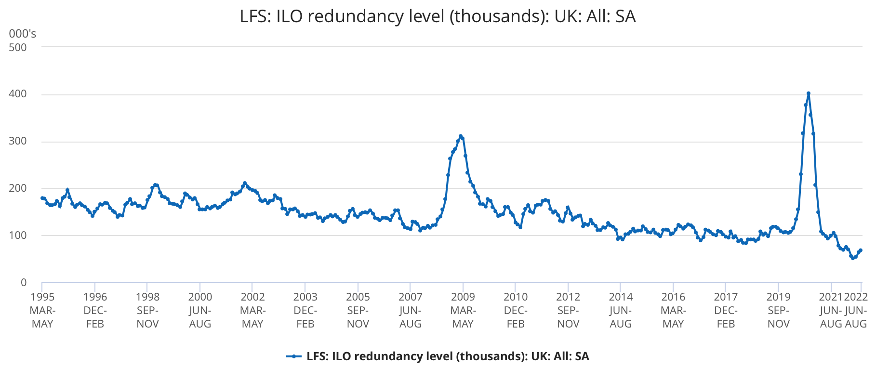

Figure 2: ONS, Unemployment Rate

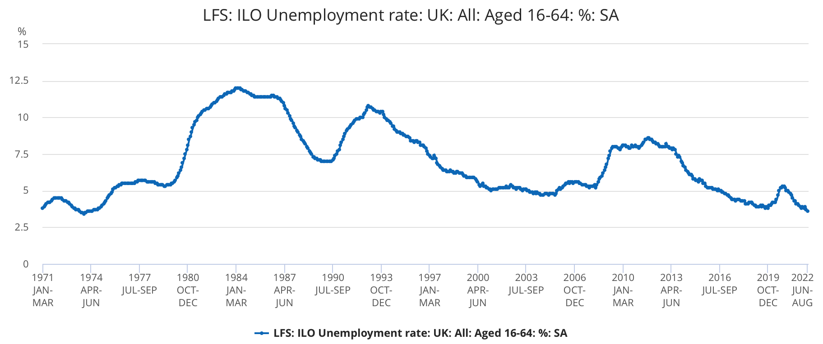

Figure 3: ONS, Employment Rate
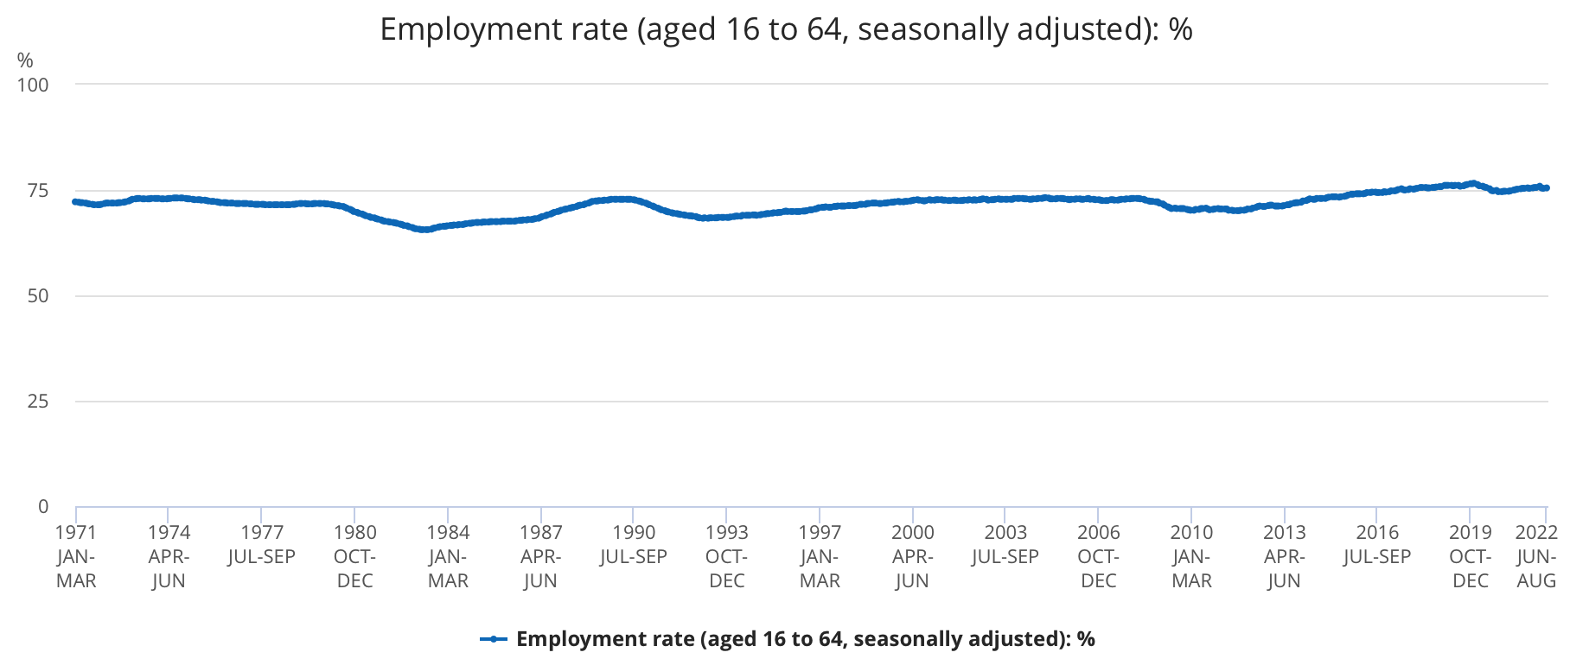

Figure 4: PwC, % of Existing Jobs at Potential Risk of Automation

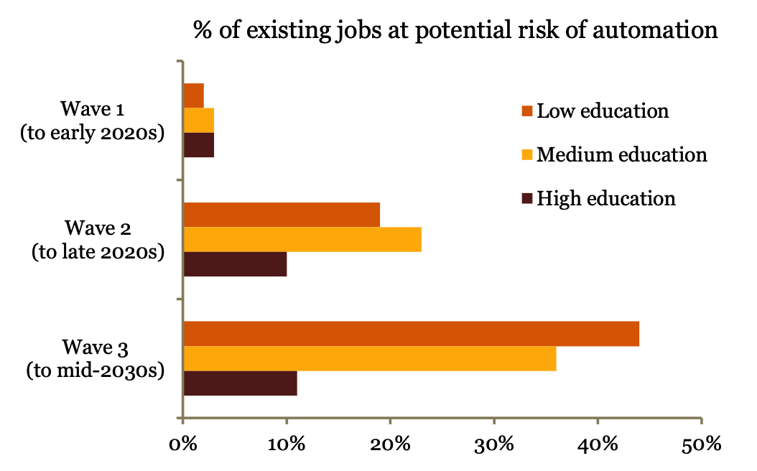

Figure 5: Grace, et al. Probability of HLMI

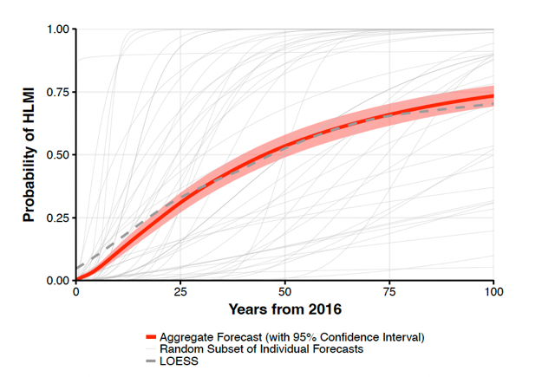

See Appendix A
See the 2020 Standard Occupation Classification for a list of elementary roles
See Appendix A
See Appendix A
From the time of writing
From 2016
See Appendix A

