KappaP—A web app for predicting lattice thermal conductivity

Yujie Liu,1,†Yang Wang,1,† Suocheng Song,1,† Jinlong Hu,1 Xiaoying Wang,1 Xuejie

Li,1Yuzhou Hao,1 Xiangdong Ding1, \*, Jun Sun1, Turab Lookman,1 and Zhibin Gao,1, ‡

1State Key Laboratory for Mechanical Behavior of Materials,

Xi’an Jiaotong University, Xi’an 710049, China

†These authors contributed equally to this work.

∗E-mail: [dingxd@mail.xjtu.edu.cn](mailto:dingxd@mail.xjtu.edu.cn)

‡E-mail: [zhibin.gao@xjtu.edu.cn](mailto:zhibin.gao@xjtu.edu.cn)

FIG. S1 presents a graphical representation of our dataset, showcasing the distribution of predicted shear modulus, bulk modulus, and lattice thermal conductivity for the 377,221 stable materials analyzed in this study. As shown in FIG. S1(a) and FIG. S1(b), the distribution of lattice thermal conductivity approximates a normal distribution, with relatively few materials exhibiting extremely high or low thermal conductivity. This pattern aligns with existing empirical data, reinforcing the validity of our predictions.

Most materials fall within a shear modulus range of 110-200 GPa and a bulk modulus range of 140-220 GPa, consistent with established findings in the field of elasticity. The red scatter points in the figure represent cubic phases, which are distributed across various regions of the plot. Notably, the data indicate a strong linear correlation between lattice thermal conductivity and shear modulus, while the correlation with bulk modulus is weaker.

To further investigate the relationship between thermal conductivity and Poisson’s ratio, FIG. S2 illustrates the two-dimensional distribution of lattice thermal conductivity against shear modulus, incorporating Poisson’s ratio. This plot reveals that Poisson’s ratio decreases from the bottom right to the top left corner. Overall, these predictive results for lattice thermal conductivity provide a valuable, filterable knowledge base for researchers, enabling them to identify suitable materials and significantly reducing the time required for experimental trial and error.

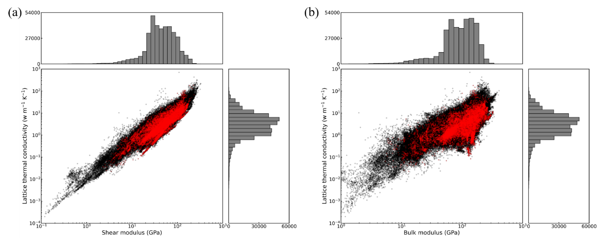

FIG. S1. Distribution of predicted shear modulus, shear modulus and lattice thermal conductivity by the high-throughput framework. Relation between lattice thermal conductivity and (a) shear modulus, (b) bulk modulus. The red dots represent the cubic phase in these materials. Bar plots indicate the distribution of materials in terms of their lattice thermal conductivity, shear modulus and bulk modulus.

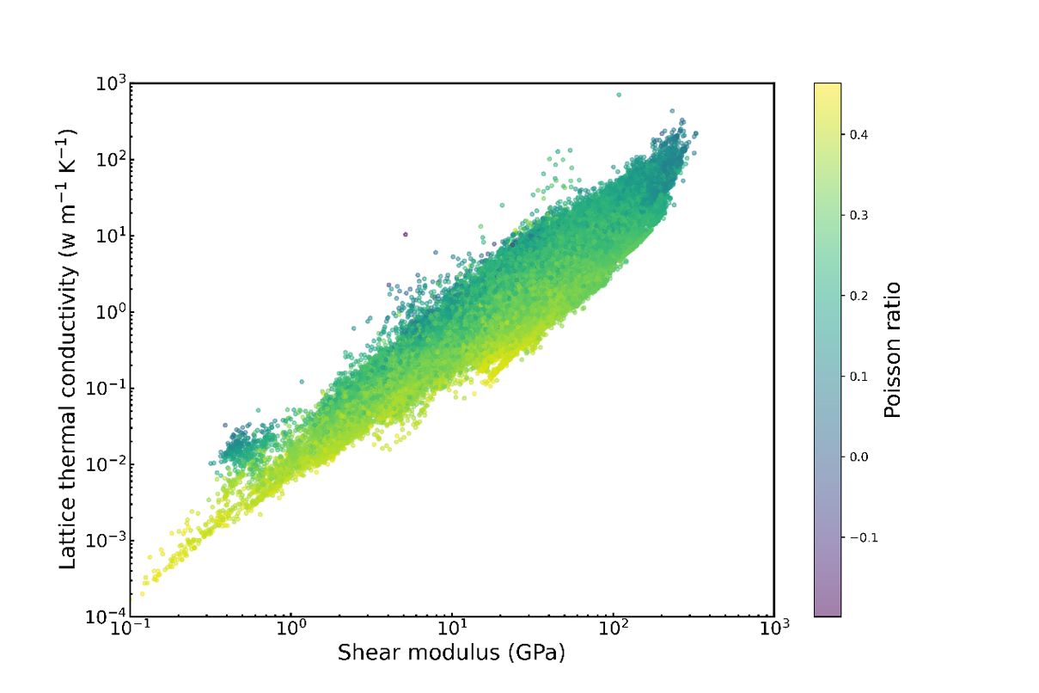

FIG. S2. A 2D map of lattice thermal conductivity vs. shear modulus with Poisson’s ratio.

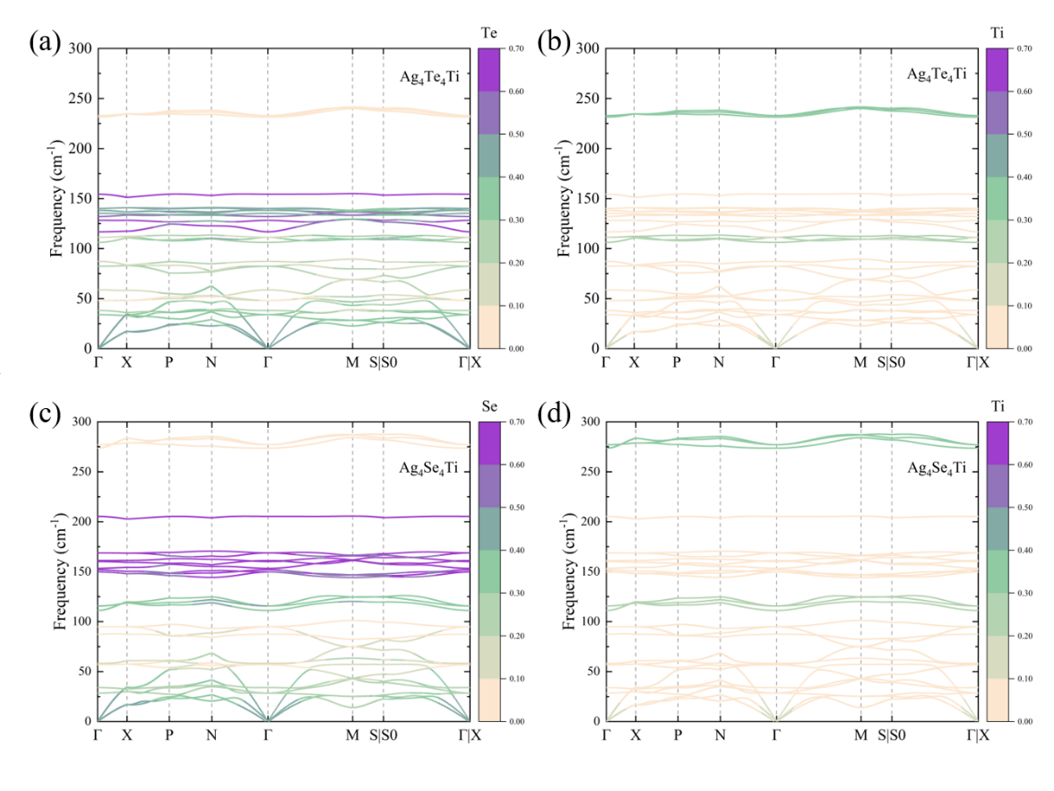

FIG. S3. The color-coded atomic participation ratio (APR) of Ag4X4Ti (X=Te, Se) projected onto the phonon bands. (a) Te atom and (b) Ti atom of Ag4Te4Ti. (c) Te atom. (d) Ti atom of Ag4Se4Ti.

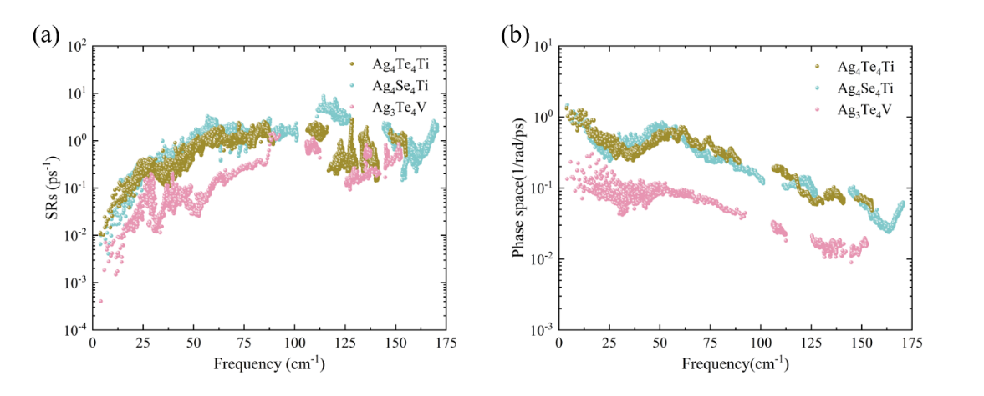

FIG. S4. (a) Scattering ratios (SRs) and (b) weighted phase space as a function of frequency of Ag4Te4Ti, Ag4Se4Ti and Ag3Te4V at 300 K.

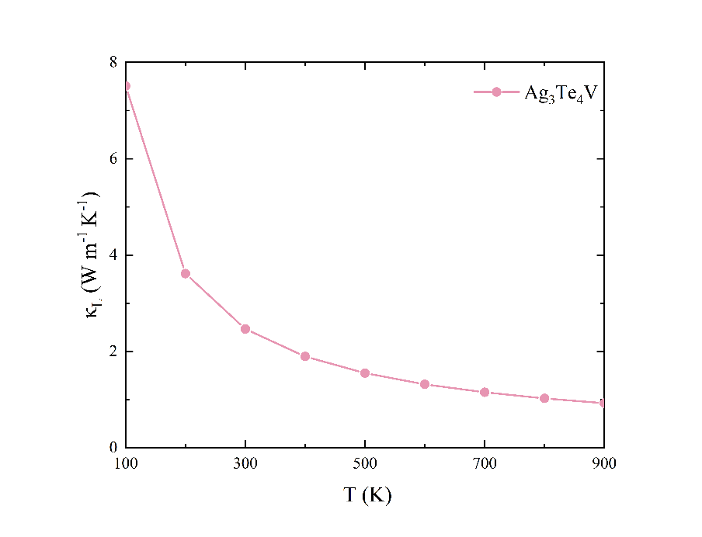

FIG. S5. The lattice thermal conductivity (κL) of Ag3Te4V.

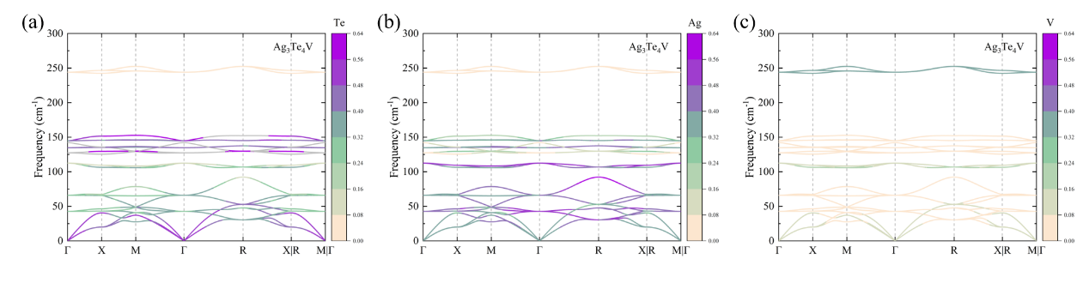

FIG. S6. The color-coded atomic participation ratio (APR) of Ag3Te4V projected onto the phonon bands. (a) Te atom, (b) Ag atom and (c) V atom.