School of Engineering
Grand Valley State University
EGR 326 – Lab #4
Interfacing a keypad and rotary encoder with the MSP432

Objectives
- To develop a C program that detects and decodes which key is pressed on a standard 12 key keypad interfaced to the MSP432
- To develop a C program that can detect rotary direction of a rotary encoder along with a pushbutton.
For the embedded system design project, you will be writing program functions in C that use the MSP432 to collect input from the user to set parameters and control actions. This lab provides an opportunity to design a user input interface that can be used in your embedded system design project.

Procedure:

The first part of lab time will be used to test your code on your MSP432 Launchpad board using the CCS debugging features. Once this interface is working, you will write a program to collect and use data input from the keypad.
---------------------------------------------------------------------------------------------------------------------
Part I – Displaying the key pressed on the CCS console

In this part, you will use the MSP432 serial port to send the key press information collected by your program to the CCS console window for display. You will need to accommodate possible switch bounce in your program that reads the keypad so that it will not sense multiple key inputs during a time when the switch may be bouncing. Also, keep the program from reporting multiple responses from a single key press when it is held down by sensing a condition of no key being pressed before reporting another key press.

Procedure:

- Connect your keypad to the MSP432 I/O port pins as designed in your pre-lab exercise.
- Run your program that prompts the user to press a key on the keypad.
- Read the keypad and print the number (or symbol) of the key that was pressed to the CCS console.
- Demonstrate the working program to the instructor.
Part II – Detecting nob direction with the rotary encoder
- The user will use the rotary encoder to control the brightness of a RED LED.

- Upon pressing the encoder button, the console will display the accumulated number of clicks, along with the resulting direction (CW or CCW)

The continuous rotary encoder has 20 positions and a built-in push-button switch. It is popular in auto entertainment systems. The outputs are based on 2-bit GRAY CODE which can be used for detecting rotation direction and magnitude.

Max contact rating: 10 mA @ 5VDC
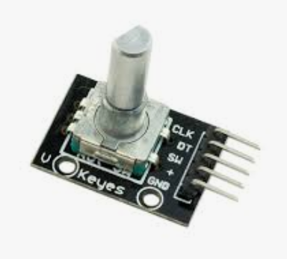
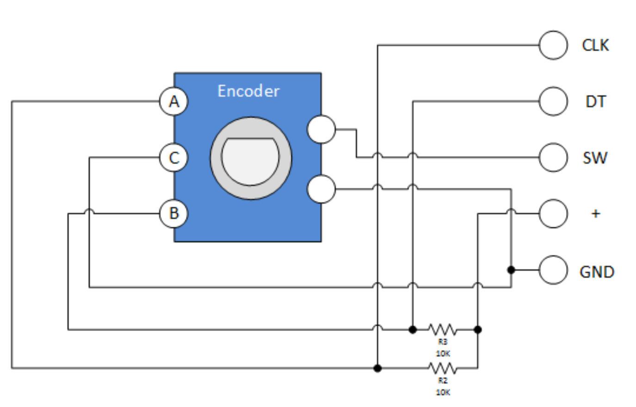
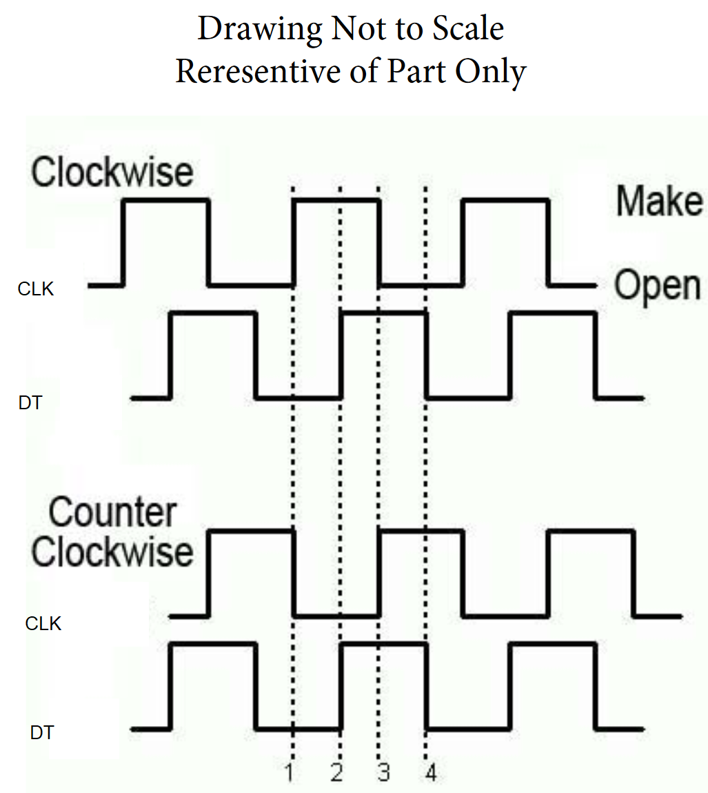
GREY CODE

- Connect your rotary encoder to the MSP432 I/O port pins as designed in your pre-lab exercise.
- Using an oscilloscope, capture the waveforms generated by the CLK and DT pins for both CW and CCW rotations. Only one or two cycles are necessary in the capture. Both signals should be on the same display.
- Design your code to count pulses as the encoder is turned. CW pulses are counted separate from CCW pulses.
- The user will turn the rotary encoder either clockwise or counterclockwise. A RED LED begins in the OFF state. As the rotary encoder is turned CW, the LED will get brighter in 5% increments/click. If the LED reaches 100% duty cycle, any more CW turns not change the brightness.
- If the user presses the pushbutton switch, the cumulative pulse count (Absolute value (CW-CCW)) should be displayed, along with the resulting cumulative direction (either CW or CCW) to the console
- Demonstrate the working program to the instructor.
Part III – Merging the keypad and rotary encoder
In this part, you will enter a value using the keypad. The user will then turn the rotary encoder until the absolution number of pulses (absolute value of CW - CCW) exceeds the keypad value. If this occurs, the RED led should be illumined. Pressing the pushbutton switch resets the count and turns off the LED.

- Monitor the rotary encoder as in part II to keep track of number of counts (CW and CCW)
- The User will be prompted to enter a number on the keypad (2 digits)
- The user will then turn the encoder (CW or CCW)
- Illuminate a BLUE LED if the CCW count is met (but not exceeded)
- Illuminate a RED LED if the CW count is met (but not exceeded).
- Nothing then will happen until the user presses the pushbutton switch to reset the count and turn off all LEDs
- The program should return to step one of Part III
- Demonstrate the working program to the instructor.
Questions:
- If your code currently uses a polling technique (continuously scanning the keypad), this ties up the microcontroller with the sole task of reading the keypad. Describe a method using interrupts to free up the microcontroller to do other tasks. Explain your proposed solution in step-by-step sequence. You may want to use this method later in your design project.
- What is the advantage of Grey encoding?

---------------------------------------------------------------------------------------------------------------------
At The End of The Laboratory

- Clean up your workstation.
- Make sure you clearly understand the laboratory deliverables and due date as posted on Blackboard.
- Logoff and reboot your laboratory computer.
-------------------------------------------------------------------------------------------------------------------
Laboratory Deliverables

- Submit a report to Blackboard before the due date/time. Follow the guidelines in the Lab Report Rubric and Score Sheet posted on Blackboard in the Assignments folder. You must demonstrate your working program to your instructor no later than the beginning of the next lab period.
- Include well commented source code listings with a detailed description header section for each routine (as you were taught in your introductory C programming course) in the appendix of your report.
- Don’t forget to restate and answer all questions.

