EGR326 Lab8 F22

Seven Segment 8 Character LED display

LED displays are commonly used as alphanumeric indicators on test equipment cockpits, and most importantly, incorporated into the Delorean dashboard in “Back to the Future”.

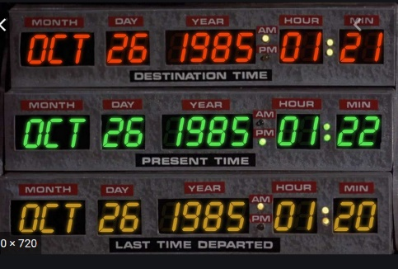

7 Segment displays come in many flavors- common cathode, common anode, etc. All of these require multiple GPIO pins/digit. Although the LED display in your kit has a limited character library, it will allow you to program 8 digits, using only 3 signal lines, along with power and ground. It can even be expanded to multiple 8-character displays, with no additional lines.

The driver for the display is the MAX7219. You can find the datasheet on Blackboard. You will be using the SPI bus to connect and control your display. If you study the datasheet carefully, you will notice several requirements when setting up your device.

1. You must power the device from 5V
2. Minimum “high” voltage = 3.5V. So this would indicate that 3.3V SPI signals will not work. You should level shift your signals to 5.0V
3. The connections from your MSP are shown below:

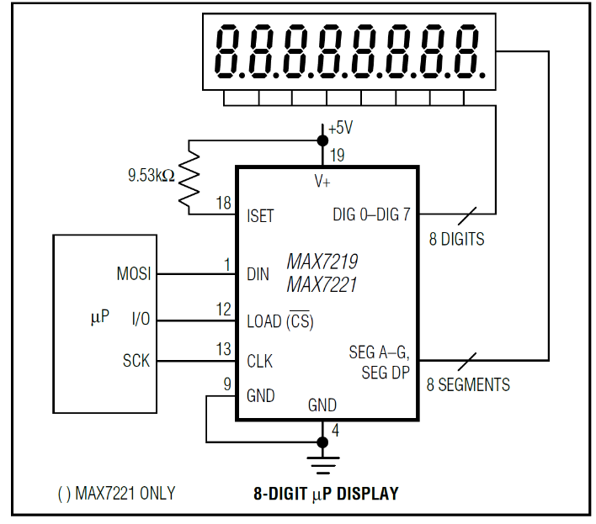You can pick your SPI port. There are 8 of them available, 4 on A ports and 4 on B ports.

The “I/O” pin shown should be substituted with a GPIO pin and not controlled by the SPI controller.

1. When programming the LED display, the following steps should be followed:
   1. Data must be sent in 16 bit chunks - 8 bits of “instruction” and 8 bits of data. The instructions are listed as addresses on page 7 of the datasheet. The SPI controller sends data out 8 bits at a time. By manually controlling the CS pin, you can send two bursts of data while holding the CS low. Data will be shifted into the MAX7219 on the rising edge of CS- which should occur after the last bit has been transmitted.
   2. The first instruction/data set to be sent should define the decode mode
   3. The Second instruction/data combo should define the Intensity
   4. The Third Instruction/data should determine the scan limit (number of digits to display)
   5. Finally, the last instruction/data, before displaying data, should disable “shutdown”
2. After the initialization of step 4 is complete, the display can be controlled by writing an address and data (one LED digit at a time). Pay attention that the clock is limited to 10MHz- This is one of the settings of the SPI control register.
3. Configure a timer for 1 second intervals. Also configure an external pushbutton to start and stop your timer. Your LED display will track your timer with updates every second, up to 100 seconds on the **FIRST** 4 digit display. Every time the button is pushed, the **SECOND** 4 digits will increment (starting at 0000), indicating the number of times the button was pressed.

Submit

1. a description of your complete schematic
2. a copy of the test program
3. a description of how it works.