# **System Context**

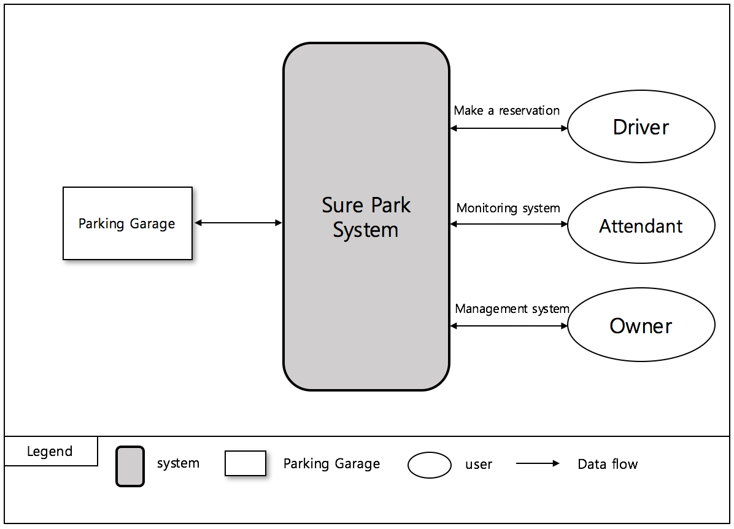

# **1st Decomposition**

|  |  |
| --- | --- |
| **Modifiability(QA08)** | **Perspective: Dynamic** |
| Architectural Pattern |  |
| Rationale |  |

# **2nd Decomposition**

## **3.1) Facility Controller to Controller Service**

### **3.1.1) How to check if the Facility Controller is alive**

|  |  |
| --- | --- |
| **Availability(QA02)** | **Perspective: Dynamic** |
| Architectural Pattern | Client-Server structure with heartbeat tactic. |
| Rationale | Facility Controller send a packet every 5 seconds to Controller Service. If Controller Service doesn’t get this packet until 15 seconds, the Controller Service notify it to Manager Service for alarming to attendant. |



### **3.1.2) How to check the slot status**

|  |  |
| --- | --- |
| **Availability(QA02)** | **Perspective: Static** |
| Architectural Pattern | Client-Server structure through heartbeat packet |
| Rationale | The Facility Controller can check whether a slot’s IR sensor is broken or not through sensitivity value. So that the Facility Controller send a heartbeat packet with all stall status. |

* Packet Define

|  |  |  |  |  |
| --- | --- | --- | --- | --- |
| **Start Symbol** | **Arduino Id** | **Code** | **Value** | **End Symbol** |
| 1byte($) | 4byte | 1byte | Variable length | 1byte(\n) |

* Send a slot status(S) from the Facility Controller to Controller Service

* value 0 means a slot is opened.

* value 1 means a slot is occupied.

* value 2 means a slot is broken.

|  |  |  |  |  |  |  |  |
| --- | --- | --- | --- | --- | --- | --- | --- |
| $ | Arduino Id | S | Slot 0 | Slot 1 | ... | Slot N | \n |

Ex1) $0001S1001\n (a Slot 0 and a slot 3 are occupied.)

Ex2) $0001S0020\n (a Slot 2 is broken.)

# **Detail Design**

## **4.1) Facility Controller to Controller Service Packet**

### **4.1.1) Packet Structure**

|  |  |  |  |  |
| --- | --- | --- | --- | --- |
| **Start Symbol** | **Arduino Id** | **Code** | **Value** | **End Symbol** |
| 1byte($) | 4byte | 1byte | Variable length | 1byte(\n) |

Start Symbol: Start point of valid packet.

Arduino Id: Assigned the Arduino Id.

Code: Indicate what kind of packet is. I means “Information”. S means “Slot Status”. G means “Entry Gate”. L means “LED”.

Value: It depends on “Code”. Please refer to “detailed packet scenario”.

End Symbol: End point of valid packet.

### **4.1.2) Detailed Packet Scenario**



|  |  |  |  |  |  |  |
| --- | --- | --- | --- | --- | --- | --- |
| Send Information | After connection, the Controller Service has to send information to the Facility Controller.   |  |  |  |  |  | | --- | --- | --- | --- | --- | | $ | Arduino Id | I | Slot No. | \n |   Ex) $0001I4\n (Garage 1 consists of 4 stalls.) |
| Send Slot Status | Basically, the Facility Controller has to send the slot status to a Controller Service every 5 seconds. And if slot status is changed, the Facility Controller send it again regardless of under 5 minutes.  The value 0 means a slot is opened, 1 means a slot is occupied. 2 means a slot is broken.   |  |  |  |  |  |  |  |  | | --- | --- | --- | --- | --- | --- | --- | --- | | $ | Arduino Id | S | Slot 0 | Slot 1 | ... | Slot N | \n |   Ex1) $0001S1001\n (Slot 0 and slot 3 are occupied.)  Ex2) $0001S0000\n (All slots are opened.) |
| Open Entry Gate | |  |  |  |  |  | | --- | --- | --- | --- | --- | | $ | Arduino Id | G | 1 | \n |   Ex1) $0001G1\n (request to open the entry gate.) |
| Turn on Slot LED | |  |  |  |  |  | | --- | --- | --- | --- | --- | | $ | Arduion Id | L | Slot No. | \n |   Ex1) $0001L1\n (Slot 1's LED has to get "Green".)  Ex2) $0001L0\n (Slot 0's LED has to get "Green".) |

## **4.2) Controller Service Package class diagram**



|  |  |
| --- | --- |
| ControllerService | ControllerService communicate with other package class. It creates socket and it consists of FacilityPacketReader and FacilityPacketWriter. |
| FacilityPacketReader | It’s a thread. It manages received packets from the Facility Controller. |
| FacilityPacketWriter | It’s a thread. It manages sending packets to the Facility Controller. |
| ArduinoInfo | ArduinoInfo class includes information of Arduinos. |
| Config | It’s singleton class. Other classes can access it for retrieving the Arduino information. |