Data Structures and Concurrency
Continuous Assessment 1 October 2022
Due Friday 11th November

N.B. Please keep your report brief and to the point.
Submit your completed document to Canvas->Data Structures and Concurrency. (Ouriginal will be used)
Student Name Jack Patterson
Submission Date 02/11/2022

Read the document “DS & C CA 1 October 2022” before you complete this report.

To insert code in this document:
N.B. Please save all the code you develop as you may be requested to demonstrate it.

1. (a) Code for keySet method of BinarySearchTreeMap
public Set<K> keySet()
{
if (root == null) return null;
return keySetSub(root, new HashSet<K>()); // used a HashSet as Set is abstract and can't be instantiated
}
private Set<K> keySetSub(Node node, Set<K> key){
key.add(node.key);
if (node.left != null) key.addAll(keySetSub(node.left, key));
if (node.right != null) key.addAll(keySetSub(node.right, key));
return key;
}
(b) JUnit test code for this method.
@Test
void keySet()
{
BinarySearchTreeMap<Integer, String> bstm1 = new BinarySearchTreeMap<>();
ArrayList<Integer> testData = new ArrayList<>();
for (int i = 0; i < 10; i++)
{
bstm1.put(i, "test " + i);
testData.add(i);
}
keySetSub((Set<E>) bstm1.keySet(), (ArrayList<E>) testData); // Have to cast it to make it work
BinarySearchTreeMap<String, String> bstm2 = new BinarySearchTreeMap<>();
ArrayList<String> testData2 = new ArrayList<>();
bstm2.put("fizz", "buzz");
bstm2.put("buzz", "fizz");
bstm2.put("buzzy", "fizz");
bstm2.put("fizzy", "fizz");
bstm2.put("buzziest", "fizz");
bstm2.put("fizzyest", "fizz");
testData2.add("buzziest"); // Flipped due to the tree
testData2.add("fizzyest");
testData2.add("fizzy");
testData2.add("buzzy");
testData2.add("fizz");
testData2.add("buzz");
keySetSub((Set<E>) bstm2.keySet(), (ArrayList<E>) testData2);
}

2. Name of the Gutenberg files you used to generate inverted index:
A Room with a view: https://www.gutenberg.org/ebooks/2641
Little Women: https://www.gutenberg.org/ebooks/37106
Middlemarch: https://www.gutenberg.org/ebooks/145
3. Use BinarySearchTreeMap implementation for index and build it using the Gutenberg files. Call height() method on the index that is generated and output it’s value.
(a) What is the height of the tree generated for the inverted index?
47
(b) How many words are in the index? (All collections classes in java api have a size() method)
23823
(c) What is the minimum height for a tree with this number of words (1 + log₂n) ?
7
(d) Explain why the actual height differs from the minimum height
Not all nodes will be filled in and there may be more than the minimum height
4. Give code for Occurrence and updated InvertedIndex. Highlight in red the changes you have made to InvertedIndex.
public class Occurance
{
private File file;
private List<Integer> lineNumbers; // What implementation would you use for this?
public Occurance(File file, List<Integer> lineNumbers)
{
this.file = file;
this.lineNumbers = lineNumbers;
}
public File getFile()
{
return file;
}
public void setFile(File file)
{
this.file = file;
}
public List<Integer> getLineNumbers()
{
return lineNumbers;
}
public void setLineNumbers(List<Integer> lineNumbers)
{
this.lineNumbers = lineNumbers;
}
@Override
public String toString()
{
return "File: " + file + " Line Numbers: " + lineNumbers.toString();
}
}
public class InvertedIndex {
// Properties
private BinarySearchTreeMap<String, List<Occurance>> index;
//private Map<String, List<Occurance>> index;
private Set<String> allWords; //set of all unique words in the index
//used in profiling the search method
int lineNo = -1;
// Methods
public InvertedIndex() {
index = new BinarySearchTreeMap<>();
//index = new TreeMap<>(); // Use HashMap in a separate run
allWords = new HashSet<>();
}
public void buildIndex(List<File> files) {
for (File file : files) {
try {
List<Integer> lineNoList = new ArrayList<>();
Scanner in = new Scanner(file);
String line;
String[] words;
while (in.hasNextLine()) {
lineNo++;
//read a line
line = in.nextLine();
// parse line into words
// the character pattern that separates words is any sequence of
// characters other than letters, numbers and apostrophe
// This strips off punctuation marks
words = line.split("[^A-Za-z0-9']+");
//add words and filename to index
for (String word : words) {
if (!word.equals("")) {
if (!index.containsKey(word)) {
List<Occurance> list = new ArrayList<>();
lineNoList.add(lineNo);
list.add(new Occurance(file, lineNoList));
index.put(word, list);
allWords.add(word);
} else {
// word already in index - check if fileName there
List<Occurance> list = index.get(word);
ArrayList<File> filesList = new ArrayList<>();
for (Occurance o: list){
filesList.add(o.getFile());
}
if (!filesList.contains(file)) {
lineNoList.add(lineNo);
list.add(new Occurance(file, lineNoList));
}
}
}
}
}
lineNo = -1;
} catch (IOException exc) {
System.out.println("File does not exist");
exc.printStackTrace();
System.exit(1);
}
}
}
public void print() {
// Print all keys and values in the map
Set<String> keySet = index.keySet();
for (String key : keySet) {
List<Occurance> value = index.get(key);
System.out.println(key + " : " + value);
}
System.out.println("\nMap Height: " + index.height());
//System.out.println("\nSize: " + index.size());
}
public List<Occurance> search(String s) {
List<Occurance> keyOccur = new ArrayList<>();
for (Occurance o: index.get(s)){
keyOccur.add(o);
}
return keyOccur;
}
//method to profile search: call search method with all words in inverted index
public void searchAllWords() {
int reps = 1000; // increase this if necessary
for (int i = 1; i < reps; i++)
for (String s : allWords) {
search(s);
}
}
}
5. JUnit test code for search() method of InvertedIndex :
@Test
void search()
{
// Reading Files
JOptionPane.showMessageDialog(null, "Hit return to continue");
InvertedIndex index = new InvertedIndex();
String projPath = System.getProperty("user.dir") + "\\Files"; // gets the project directory and adds on the files folder
File f = new File(projPath);
List<File> files = new ArrayList<>(Arrays.asList(f.listFiles()));
index.buildIndex(files);
// Actual Test
String fileEnd = "";
List<Integer> intCount = new ArrayList<>();
// Test for 1 element
intCount.add(0);
List<Occurance> listOccur = new ArrayList<>();
fileEnd = "\\File1.txt";
listOccur.add(new Occurance(new File(projPath + fileEnd), intCount));
assertEquals(index.search("Ireland").toString(), listOccur.toString());
// Test for 2/multiple elements
listOccur = new ArrayList<>();
intCount = new ArrayList<>();
intCount.add(0);
intCount.add(1);
fileEnd = "\\File1.txt";
listOccur.add(new Occurance(new File(projPath + fileEnd), intCount));
intCount = new ArrayList<>();
intCount.add(0);
fileEnd = "\\File2.txt";
listOccur.add(new Occurance(new File(projPath + fileEnd), intCount));
assertEquals(index.search("oak").toString(), listOccur.toString());
// Test for a value that doesn't exist
assertThrows(NullPointerException.class, () ->
{
index.search("Irish");
});
}
6. (a) Results of profiling the search method with searchAllWords:
 | Time 1 –see note below | Time from profiler | Big Oh
BinarySearchTreeMap | 4 | 4.182
TreeMap | 6 | 5.292 | O(log n)
HashMap | 3 | 2.089 | O(1)

Obtained with Intel Core i5 processor, 2.7 GHz, Java Version 17, Windows 10 (or specify if not…)
Note: Time 1 is the time got by getting the time before and after the relevant code executes and computing the difference between them.
Like we did in Labs – use System.currentTimeMillis();
To find the Big Oh for TreeMap and HashMap, look up these classes in the java api and see the efficiency for the get() method.
(b) Specify what the java api says about the efficiency of get method for
(1) TreeMap:
O(log n)
(2) HashMap:
O(1)
(c) Insert here the screenshot showing the values you used to populate “Time from profiler” column of the table above:
Binary Tree
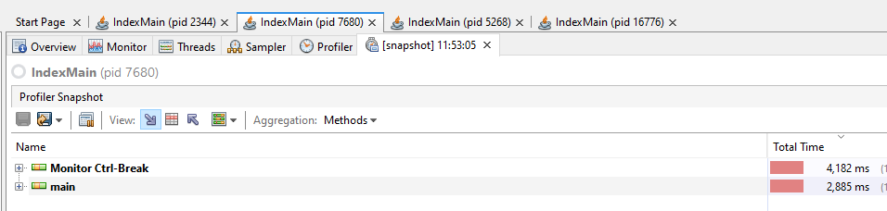
TreeMap
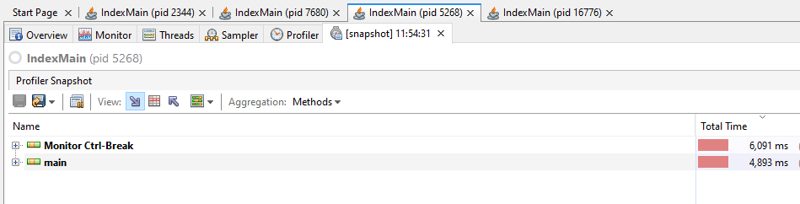
HashMap
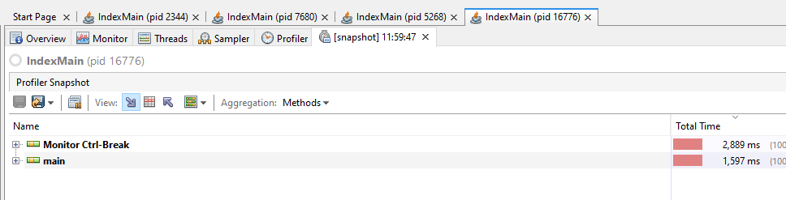
(d) Are the timings consistent with the Big Oh values? Yes
Explain your answer.
The speed is consistent with what is expected from the big O values, with hasmap being the fastest and the treemap being much slower.
7. References/Sources of information. Specify any sources you used.
Big O Values (Couldn’t find on API) https://stackoverflow.com/questions/559839/big-o-summary-for-java-collections-framework-implementations
Found addall method: https://www.geeksforgeeks.org/merge-two-sets-in-java/
Important Note: Plagiarism and Academic Dishonesty
Please familiarize yourself with IT Tralee Anti-plagiarism Policy and Procedures document. There is a copy of the document at http://www.ittralee.ie/en/InformationAbout/QualityAssurance/
At this link you will see: A5 Assessment of Learners -> A5.2 Anti-Plagiarism Policy and Procedures
The Computing Dept document “How To Cite Source Code” is available on Canvas at
https://mtukerry.instructure.com/courses/2038/files/102042?module_item_id=23484
Please note that if the work you submit is not your own, a mark of 0 will be awarded.

Appendix A
‘Declaration of Originality Form’- MTU-Kerry.
This form must be completed and signed and submitted with all assignments.
Please complete the information below (using BLOCK CAPITALS).

Name Jack Patterson

T Number t00217640

Class Group KCPGD_B_Y3

Assignment Title Data Structures and Concurrency CA 1
Students are advised to inform themselves of the Institute Anti-Plagiarism Policy.
I confirm that this assignment is my own work and that I have:

Familiarised myself with the Institute’s Anti-Plagiarism Policy | 
Used the Institute’s approved referencing style throughout | 
Clearly referenced, in both the text and the bibliography or references, all sources used in the work  Not made use of the work of any other student(s) past or present without acknowledgement. This includes any of my own work, that has been previously, or concurrently, submitted for assessment, either at this or any other educational institution |   
Not sought or used the services of any professional agencies to produce this work | 
In addition, I understand that any false claim in respect of this work will result in disciplinary action in accordance with Institute regulations | 

DECLARATION:

I am aware of and understand the Institutes’ policy on plagiarism and I certify that this assignment is my own work, except where indicated by referencing, and that I have followed the good academic practices noted above

Signed Jack Patterson

