Assignment 1 – FPGA
Digital clock
Used Components:
- Counter_generic
- Digit-splitter
- BCD_to_7seg

Explanation of components:
- Counter_generic:
The counter is implemented as a generic counter, where the bit-width and the max value of the counter is defined by the user.
The counter counts up on the falling edge of the clk input pin, and is reset to 0, if the input on the rst pin is low.
The current value of the counter is put out on the current_val output bus. When the counter has counted up to the defined max value, the cnt_full output is set to high, and when it recieves one more clock pulse, it will reset it’s value to 0, and the cnt_full is set low again. In this application, this behavior can be used to count up the next counter, for example when the seconds counter has counted to 59, and receives the next clock signal it will reset itself and the falling edge of the cnt_full pin can count up the minutes counter.
The code of the counter can be seen here:
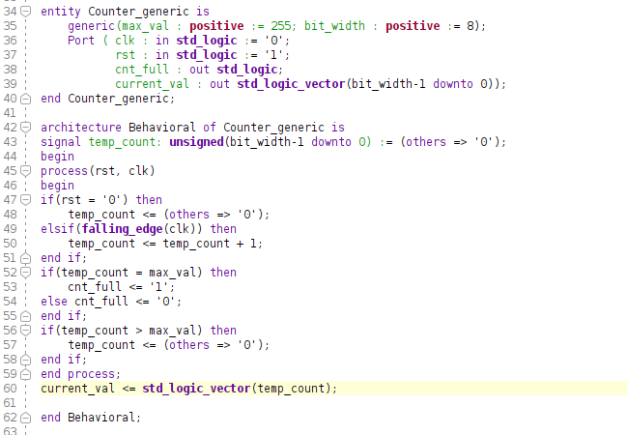
It can be noted that the current_val output bus is updated outside of the process, so this output will always be the same as the internal temp_count variable.

- Digit_splitter:
The digit splitter can take a two digit number (0-99) and split it into its individual digits. This is done using the mod and division operations on the input number.
The code can be seen here:
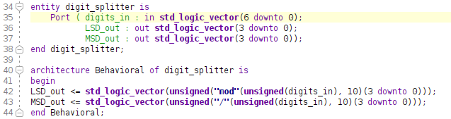
- BCD_to_7seg:
This block takes a single digit number (like the one from the digit splitter) and converts it to the format required by seven-segment displays. This is done by hardcoding the output values for each input value from 0 to 9.
The code can be seen here:
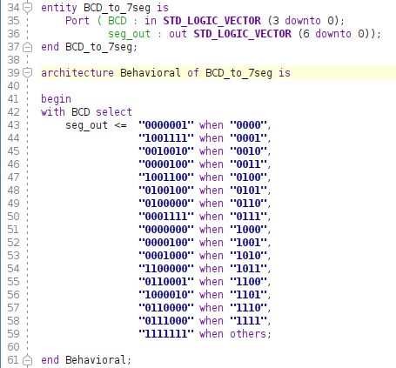

Block design of the clock
The clock itself is implemented as a block design that incorporates all of the previously mentioned components. In this case the clock works with a clk input of 10 kHz.
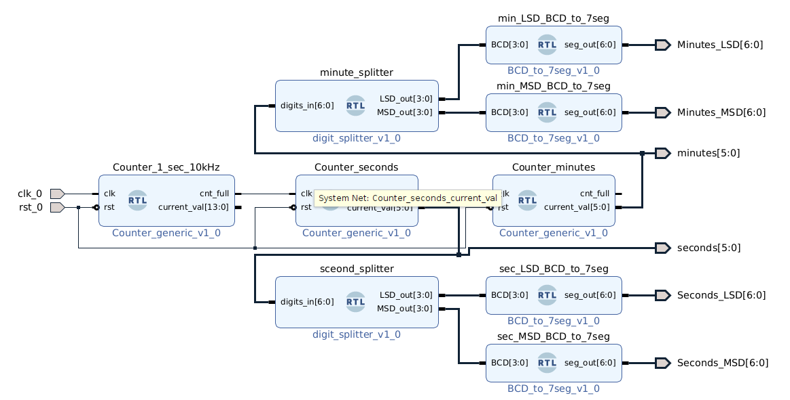
One counter counts the clock cycles that occur during one second, in this case it is assumed that the frequency is 10 kHz. When it has counted 10k signals it sends a signal to Counter_seconds and resets itself on the next clock signal. The Counter_seconds then counts this signal 60 times before sending a signal to Counter_minutes and resetting itself. Both the Counter_seconds and the Counter_minutes output their current value to digit_splitters which then feed in to two BCD_to_7seg blocks each.

Verification and simulation
Before start of simulation the inputs and outputs look like this:
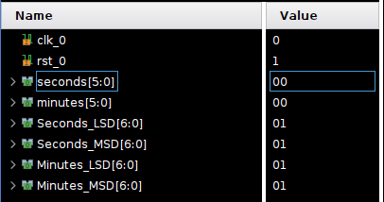

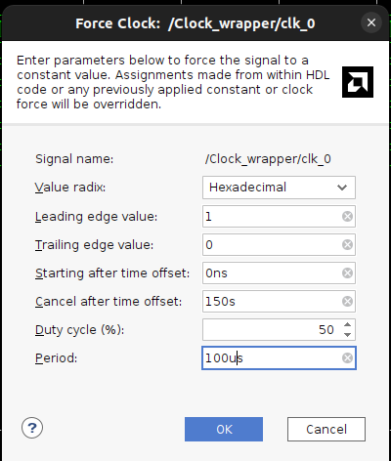
The clk input is then forced with this clock signal:

After simulation the clock should have counted to 150 seconds, which is 2 minutes and 30 seconds, and it has:
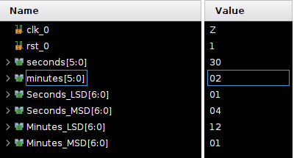

The outputs for the seven segment display also matches with the output of the clock, with the code for “0” being displayed at the most significant digit of the minutes, then the code for “2” at the least significant digit, then the code for “3” as the MSD of the seconds, and “0” again for the LSD of the seconds.

