Author: Jack Hart

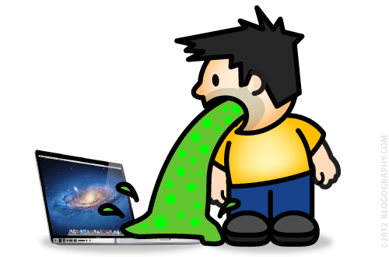Title: Paper about loops in Python

1. Introduction

2. Literature Review

3. Analysis

4. Conclusions

[THIS PAPER IS AWFUL]

**References**