# TABLE OF CONTENTS

**INDEX**

|  |  |  |
| --- | --- | --- |
| **SL.NO** | **DESCRIPTION** | **PAGE NO.** |
| 1 | INTRODUCTION |  |
| 2 | SYSTEM STUDY   * 1. Existing System   2. Proposed System   3. Problem Definition and Project Description |  |
| 3 | SYSTEM ANALYSIS   * 1. Requirements Specification   2. Feasibility Study |  |
| 4 | SYSTEM DESIGN   * 1. Architectural Design   2. Data Flow Diagram   3. User Interface Design   4. Normalization |  |
| 5 | SYSTEM TESTING   * 1. Types of Testing   2. Types of Validations   3. Error Messages |  |
| 6 | USER MANUAL   * 1. Installation Manual   2. Operational Manual |  |
| 7 | SYSTEM IMPLEMENTATION   * 1. Special features of the languages |  |
| 8 | FUTURE ENHANCEMENT |  |
| 9 | CONCLUSION |  |
| 10 | BIBLIOGRAPY |  |
| 11 | APPENDIX   * 1. Sample Screen Layouts   2. Sample Codings |  |

**INTRODUCTION**

1. **INTRODUCTION**

The File Conversion App is an offline Android mobile application designed to empower users with the ability to convert files directly on their devices without relying on internet connectivity. By eliminating the need for online services, it offers faster processing speeds, enhanced privacy, and complete control over the user’s data.

The app supports a wide range of file types, including documents, images, audio files, and videos, enabling seamless conversion between multiple popular formats. Users can simply select a file, choose the desired output format, and save the converted version locally — all within a few taps.

Developed using Java for the core application logic and XML for the user interface, the app ensures a smooth, responsive, and visually clean experience. Data is stored using Room Database, providing structured, reliable, and secure local storage for user history, preferences, and settings. This architecture allows the application to function entirely offline, making it especially useful in areas with limited or no internet access.

With its intuitive navigation, minimalistic design, and performance-focused processing, the File Conversion App delivers a fast, convenient, and secure solution for everyday file conversion needs, helping users stay organized, productive, and independent of cloud-based tools.

# SYSTEM STUDY

1. **SYSTEM STUDY**
   1. **EXISTING SYSTEM**

In the existing scenario, most users rely on multiple online tools for file conversion. Many of these services require a constant internet connection, have file size limitations, collect user- data, or charge subscription fees. Offline alternatives are often limited in format support or lack a user-friendly interface, making file conversion inconvenient and time-consuming.

Many existing mobile applications are either too basic—lacking search and customization Features or overly complex, making them difficult for casual users to adopt. This creates a demand for an app that offers the right balance between functionality and simplicity.

* 1. **PROPOSED SYSTEM**

The proposed File Conversion App addresses these gaps by offering a simple, offline, and efficient solution that supports multiple file formats in one application. It ensures fast processing, maintains user privacy, and eliminates the need for internet connectivity or costly subscriptions.

Key features of the proposed system include:

* Unified Platform: Convert documents, images, audio, and video files in multiple formats without switching between different tools.
* Offline Functionality: Convert and save files directly on your device without requiring internet connectivity.
* Robust File Handling: Utilize efficient local processing techniques for fast, reliable file conversions with support for multiple formats and secure storage.
* User-Friendly Design: A clean and visually appealing UI with smooth navigation.
* Customizable Conversions: Ability to choose output formats, quality settings, and resolution to match specific user requirements.
* Quick Retrieval: Built-in search functionality for finding files instantly.
* Data Recovery: Undo delete option via Snackbar to prevent accidental data loss.
  1. **PROBLEM DEFINITION AND PROJECT DESCRIPTION**

In today’s fast-paced digital world, individuals often struggle to manage and convert files efficiently. Online tools may be slow, limit file sizes, or compromise privacy, while traditional methods require multiple separate applications and lack flexibility in handling different file formats.

While there are many existing file conversion tools, they often come with unnecessary complexity, require constant internet connectivity, impose file size restrictions, or lack support for multiple formats in one place. This creates a gap for a lightweight, offline, and user-friendly mobile solution that can handle diverse file conversions quickly and securely.

# SYSTEM ANALYSIS

1. **SYSTEM ANALYSIS**

## REQUIREMENTS SPECIFICATION HARDWARE REQUIREMENTS

* + - Processor : Intel i3 or higher
    - RAM : 4 GB (8 GB recommended)
    - Hard Disk : 40 GB or more (for IDE, SDKs, and project files)
    - Monitor : 15’’ VGA/LED monitor
    - Keyboard : Standard 104 keys keyboard
    - Mouse : Optical mouse
    - Mobile Device (Testing) : Android smartphone, minimum 2 GB RAM, Android

6.0 or higher, 50 MB free storage

## SOFTWARE REQUIREMENTS

* Operating System : Windows 10 / 11 (64-bit) or macOS / Linux
* IDE : Android Studio (latest stable version)
* Programming Languages : Java (Backend Logic), XML (UI Design)
* Database : Room
* Build System : Gradle
* Android SDK : API Level 33 or higher (minSdkVersion 23)
* Emulator / Physical Device : For app testing and debugging

## FEASIBILITY STUDY

Before developing the Productivity App, a feasibility study was conducted to evaluate whether the project is viable and practical in terms of technology, cost, and usability. The study ensures that the system can be implemented successfully with the available resources.

## TECHNICAL FEASIBILITY

The Productivity App is technically feasible due to the following reasons:

* 1. Development Tools
* Android Studio provides a robust environment for designing, coding, debugging, and testing Android applications.
* Java is a widely used, stable, and well-supported programming language for Android development.
* XML is used for designing responsive and customizable layouts.
  1. Database & Storage
* Room Persistence Library serves as an abstraction over SQLite, offering compile-time query checks, lifecycle awareness, and easy data handling.
* Local storage eliminates the dependency on internet connectivity for note- taking and task management.
  1. Device Compatibility
* Compatible with a wide range of Android devices running API 21 (Lollipop) and above.
* Designed to work efficiently even on devices with limited hardware resources.
  1. Implementation Complexity
* The system’s architecture (Entities, DAO, Repository, UI) ensures modularity, making it easier to implement, debug, and maintain.

## ECONOMIC FEASIBILITY

The app is economically feasible because:

* 1. Low Development Cost
* No need for paid development tools; Android Studio and Java are free.
* Uses open-source libraries like Room, reducing licensing costs.
  1. No Server Costs
* The app is fully offline, eliminating expenses related to hosting, cloud storage, or API usage.
  1. Maintenance Cost
* Maintenance is minimal since data is stored locally and does not depend on external services.

1. Scalability without Additional Cost

* New features can be added without major infrastructure changes, keeping future costs low.

## OPERATIONAL FEASIBILITY

* 1. Ease of Use
* Simple and intuitive user interface designed for all age groups.
* No steep learning curve — users can start using the app immediately after installation.
  1. Maintenance and Support
* Modular code structure allows easy bug fixes and updates.
* The app does not require constant supervision or online support.
  1. Reliability in Day-to-Day Use
* Offline functionality ensures that the app is accessible anytime, even without internet.
* Data persistence through Room ensures that notes remain safe across app restarts and device reboots.

# SYSTEM DESIGN

* 1. **SYSTEM DESIGN**
     1. **ARCHITECTURAL DESIGN**

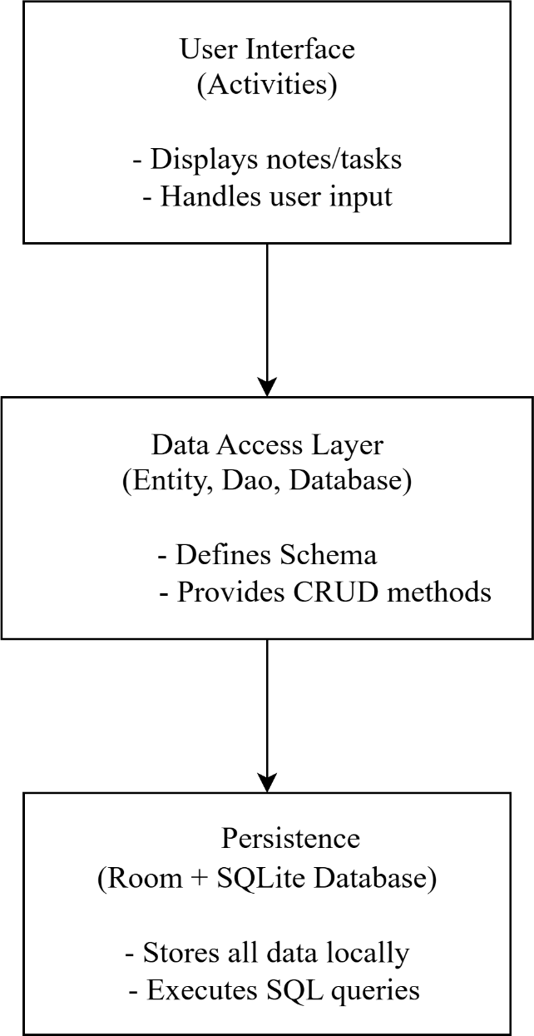

* + 1. **DATA FLOW DIAGRAM**

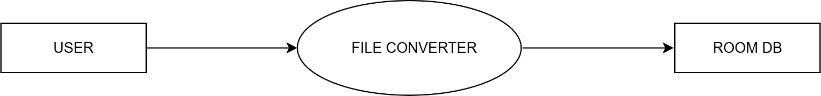**DFD Level 0 (Context Diagram)**

**DFD Level 1**

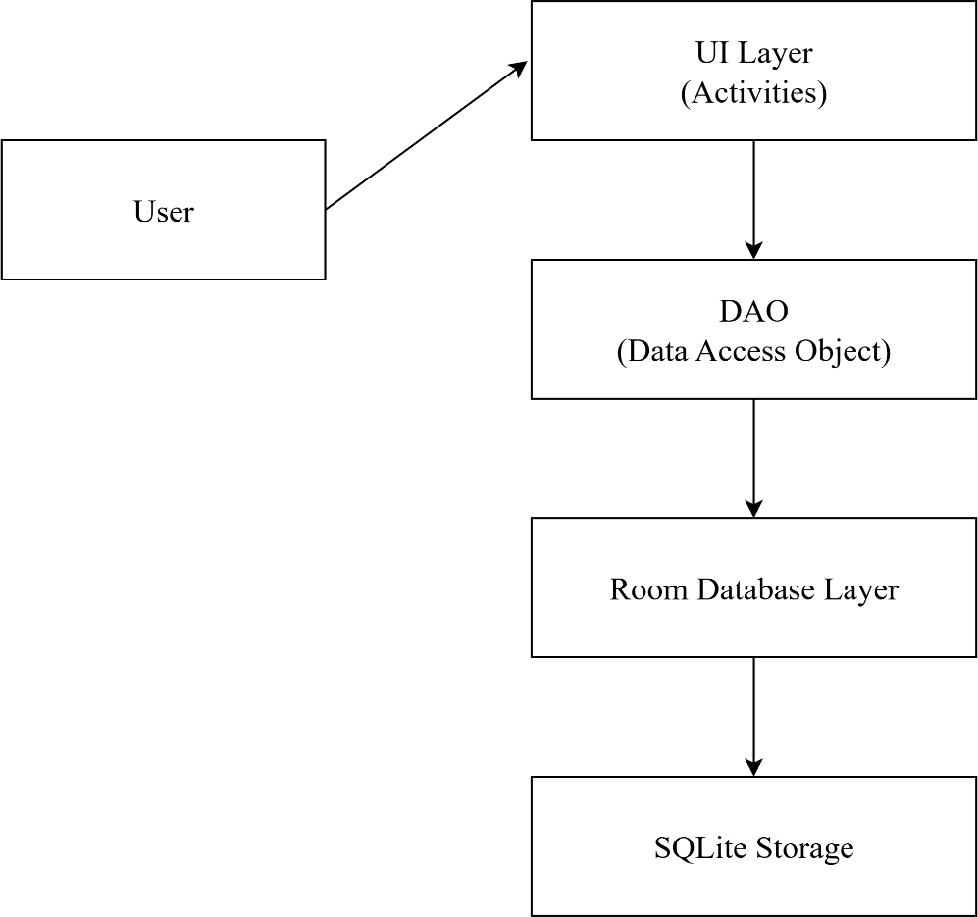

* + 1. **UI DESIGN LANDING PAGE**

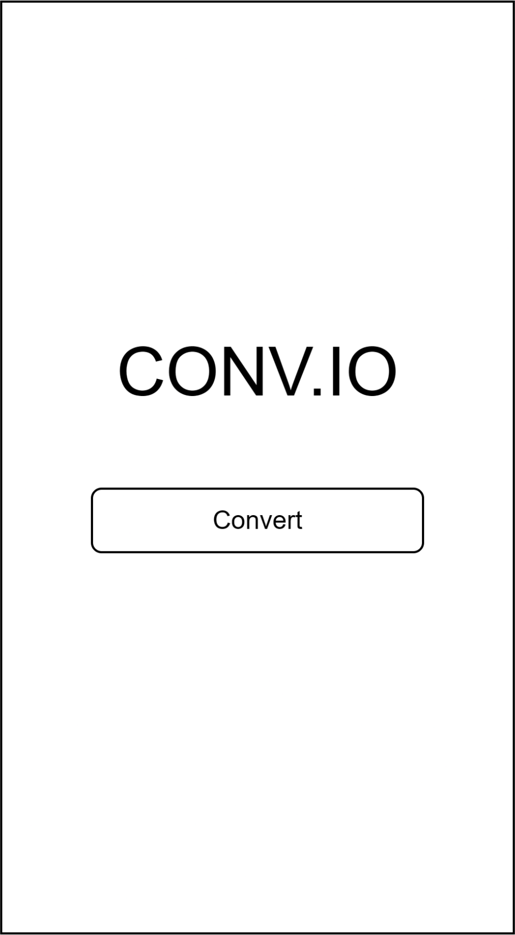

**HOME PAGE**

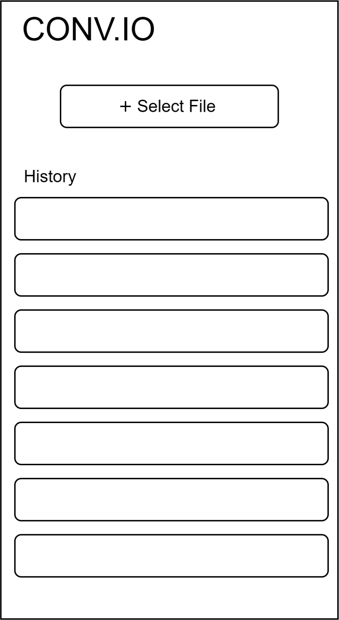

**CONVERSION PROGRESS PAGE**

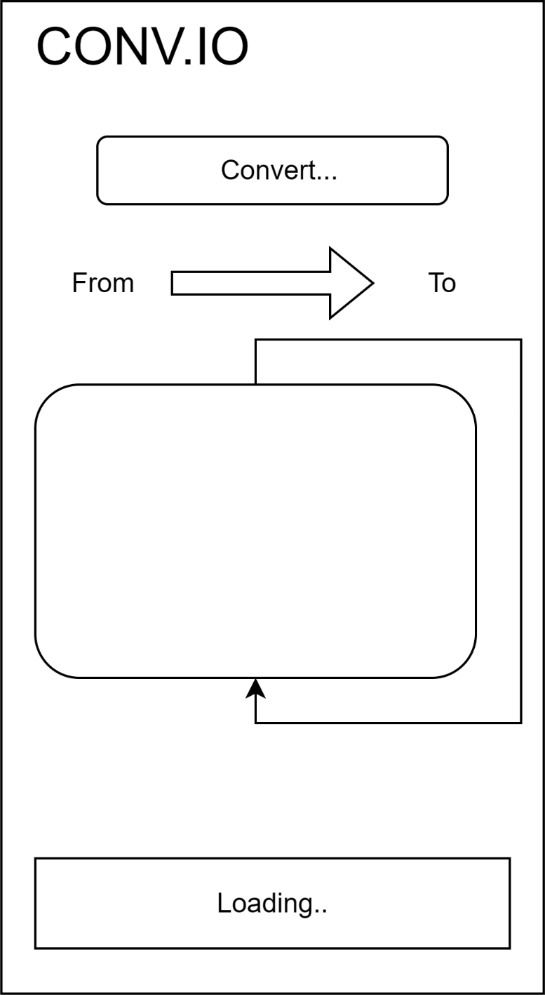

**CONVERSION COMPLETION PAGE**

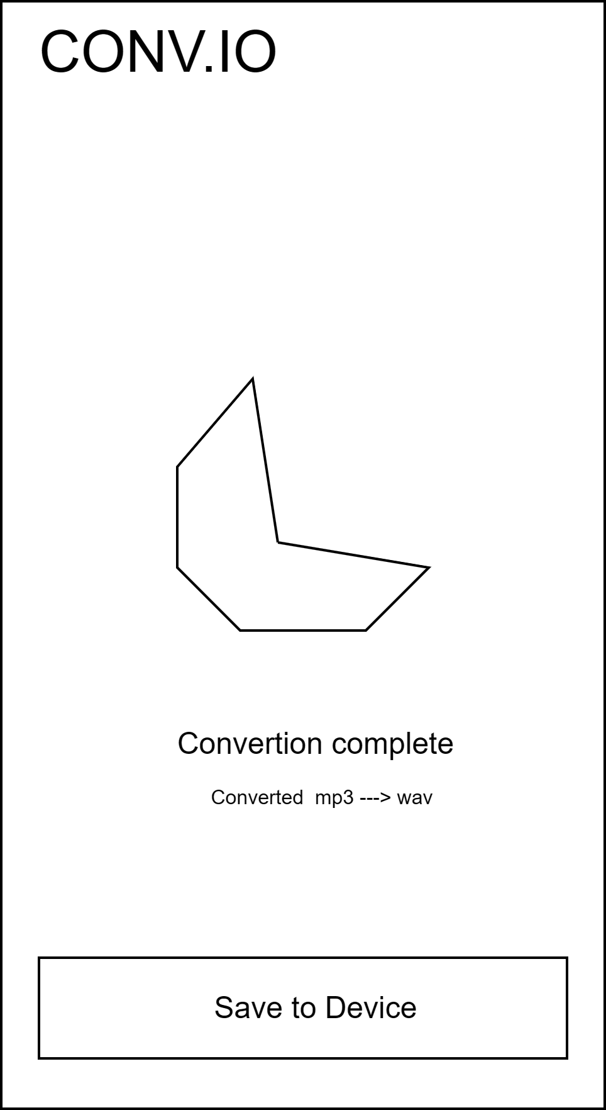

## NORMALIZATION

Normalization is the process of structuring a database to minimize redundancy and enhance data integrity. The database design of the File Conversion App follows these principles, ensuring efficient storage, quick access, and reliable data management for offline file conversions.

**First Normal Form (1NF):**

* + - Each column contains only atomic values (e.g., file name, file type, conversion format, date, status).
    - There are no repeating groups or arrays within the table.
    - Fields such as conversionSettings are stored as serialized strings to maintain atomicity while keeping structured information.

**Second Normal Form (2NF):**

* + - The table has a primary key (id) that uniquely identifies each conversion record.
    - All non-key attributes (file name, type, format, date, status, etc.) depend entirely on the primary key.

**Third Normal Form (3NF):**

* + - No transitive dependencies are present; all attributes depend solely on the primary key.
    - Attributes like outputFormat or fileSize do not depend on other non-key attributes but only on id.

By adhering to the **Third Normal Form (3NF)**, the File Conversion App’s database ensures minimal redundancy, consistent data storage, and easier maintenance, resulting in a smooth, reliable, and offline-first user experience.