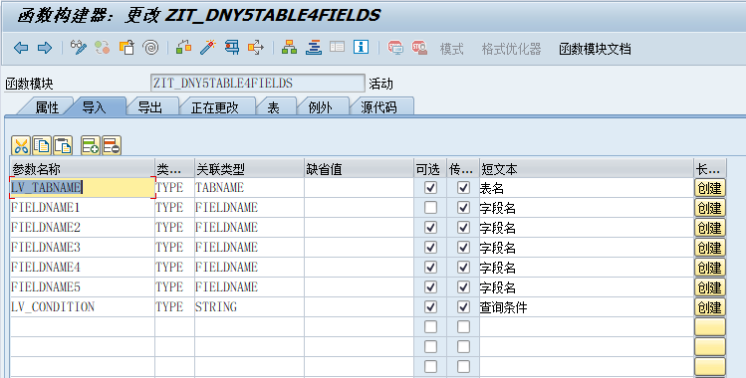

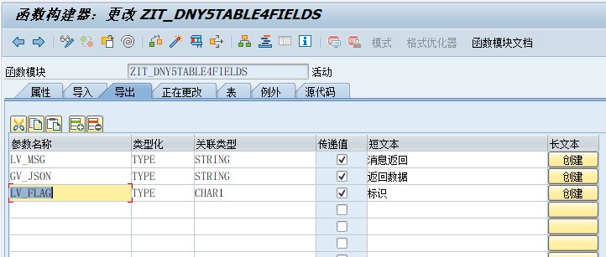

FUNCTION ZIT_DNY5TABLE4FIELDS.
*"----------------------------------------------------------------------
*"*"本地接口：
*" IMPORTING
*" VALUE(LV_TABNAME) TYPE TABNAME OPTIONAL
*" VALUE(FIELDNAME1) TYPE FIELDNAME
*" VALUE(FIELDNAME2) TYPE FIELDNAME OPTIONAL
*" VALUE(FIELDNAME3) TYPE FIELDNAME OPTIONAL
*" VALUE(FIELDNAME4) TYPE FIELDNAME OPTIONAL
*" VALUE(FIELDNAME5) TYPE FIELDNAME OPTIONAL
*" VALUE(LV_CONDITION) TYPE STRING OPTIONAL
*" EXPORTING
*" VALUE(LV_MSG) TYPE STRING
*" VALUE(GV_JSON) TYPE STRING
*" VALUE(LV_FLAG) TYPE CHAR1
*"----------------------------------------------------------------------
TRY.
DEFINE &SELECT_DATA.
SELECT (&1)
INTO CORRESPONDING FIELDS OF TABLE &2
FROM &3
WHERE (&4).
END-OF-DEFINITION.
DATA OREF TYPE REF TO CX_ROOT.
DATA : LV_FIELDS TYPE STRING .
FIELD-SYMBOLS: <DYN_TABLE> TYPE STANDARD TABLE,
<DYN_WA>,
<DYN_FIELD>.
DATA: DY_TABLE TYPE REF TO DATA,
DY_LINE TYPE REF TO DATA,
LT_STRUCTURE TYPE LVC_T_FCAT,
LS_STRUCTURE TYPE LVC_S_FCAT.
TYPES: BEGIN OF LTY_DD03L ,
TABNAME TYPE TABNAME,
FIELDNAME TYPE FIELDNAME,
ROLLNAME TYPE ROLLNAME,
INTTYPE TYPE INTTYPE,
INTLEN TYPE INTLEN,
END OF LTY_DD03L.
DATA:LV_POS TYPE I.
DATA : LT_DD03L TYPE STANDARD TABLE OF LTY_DD03L,
LS_DD03L TYPE LTY_DD03L.
DATA :LT_FIELDS TYPE STANDARD TABLE OF STRING WITH HEADER LINE .
SELECT
TABNAME
FIELDNAME
INTTYPE
INTLEN
FROM DD03L
INTO CORRESPONDING FIELDS OF TABLE LT_DD03L
WHERE TABNAME = LV_TABNAME.
IF LT_DD03L IS INITIAL.
LV_MSG = '字段不正确'.
ENDIF.
LV_POS = 0.
LV_FIELDS = ''.
LOOP AT LT_DD03L INTO LS_DD03L.
CLEAR : LS_STRUCTURE.
CASE LS_DD03L-FIELDNAME.
WHEN FIELDNAME1 OR FIELDNAME2 OR FIELDNAME3 OR FIELDNAME4 OR FIELDNAME5.
* CONCATENATE LS_DD03L-FIELDNAME ' ' LV_FIELDS INTO LV_FIELDS .
LT_FIELDS = LS_DD03L-FIELDNAME.
APPEND LT_FIELDS.
" 定义内表的结构
LV_POS = LV_POS + 1.
LS_STRUCTURE-COL_POS = LV_POS.
LS_STRUCTURE-FIELDNAME = LS_DD03L-FIELDNAME. " 列名
* LS_STRUCTURE-ROLLNAME = LS_DD03L-ROLLNAME.
LS_STRUCTURE-INTTYPE = LS_DD03L-INTTYPE. " 数据类型
LS_STRUCTURE-INTLEN = LS_DD03L-INTLEN. " 长度
APPEND LS_STRUCTURE TO LT_STRUCTURE.
WHEN OTHERS.
ENDCASE.
CLEAR : LS_DD03L.
ENDLOOP.
" 按照定义的内表结构，产生一个内表
CALL METHOD CL_ALV_TABLE_CREATE=>CREATE_DYNAMIC_TABLE
EXPORTING
IT_FIELDCATALOG = LT_STRUCTURE
IMPORTING
EP_TABLE = DY_TABLE.
ASSIGN DY_TABLE->* TO <DYN_TABLE>. " 用表类型指针 <dyn_table> 指向 数据对象的内容.
"利用宏进行数据获取。
&SELECT_DATA LT_FIELDS <DYN_TABLE> (LV_TABNAME) LV_CONDITION.
IF SY-SUBRC EQ 0 AND LINES( <DYN_TABLE> ) GT 0.
*内表转JSON接口数据
CALL METHOD /UI2/CL_JSON=>SERIALIZE
EXPORTING
DATA = <DYN_TABLE>
* COMPRESS = ABAP_FALSE
* NAME =
* PRETTY_NAME = ABAP_FALSE
* TYPE_DESCR =
RECEIVING
R_JSON = GV_JSON.
LV_MSG = '查询成功！'.
LV_FLAG = 'S'.
ELSE.
LV_MSG = '查无数据！'.
LV_FLAG = 'W'.
ENDIF.
CATCH CX_ROOT INTO OREF.
LV_MSG = OREF->IF_MESSAGE~GET_TEXT( ).
LV_FLAG = 'E'.
ENDTRY.
ENDFUNCTION.

