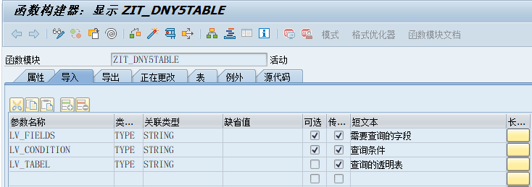

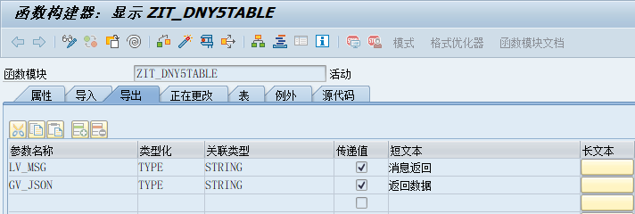

FUNCTION ZIT_DNY5TABLE.
*"----------------------------------------------------------------------
*"*"本地接口：
*" IMPORTING
*" VALUE(LV_FIELDS) TYPE STRING OPTIONAL
*" VALUE(LV_CONDITION) TYPE STRING OPTIONAL
*" VALUE(LV_TABEL) TYPE STRING
*" EXPORTING
*" VALUE(LV_MSG) TYPE STRING
*" VALUE(GV_JSON) TYPE STRING
*"----------------------------------------------------------------------
DATA OREF TYPE REF TO CX_ROOT.
DATA TEXT TYPE STRING.
DATA: LT_DYN_TABLE TYPE REF TO DATA.
DATA: LS_DYN_WA TYPE REF TO DATA.
FIELD-SYMBOLS: <LT_DYN_TABLE> TYPE TABLE,
<LS_DYN_WA> TYPE ANY.
DEFINE &SELECT_DATA.
SELECT (&1)
INTO CORRESPONDING FIELDS OF TABLE &2
FROM &3
WHERE (&4).
END-OF-DEFINITION.
* LV_TABEL = 'VBAP'.
* CONCATENATE ' VBELN ' ' ERDAT ' INTO LV_FIELDS.
* LV_CONDITION = | ERDAT = '20181227' OR VBELN = '0000000008' |.
TRY .
*创建动态表结构
CREATE DATA LT_DYN_TABLE TYPE TABLE OF (LV_TABEL).
*创建动态内表
ASSIGN LT_DYN_TABLE->* TO <LT_DYN_TABLE>.
*创建动态工作区结构
CREATE DATA LS_DYN_WA LIKE LINE OF <LT_DYN_TABLE>.
*创建动态工作区
ASSIGN LS_DYN_WA->* TO <LS_DYN_WA>.
&SELECT_DATA LV_FIELDS <LT_DYN_TABLE> (LV_TABEL) LV_CONDITION.
IF SY-SUBRC EQ 0 AND LINES( <LT_DYN_TABLE> ) > 0.
*内表转JSON接口数据
CALL METHOD /UI2/CL_JSON=>SERIALIZE
EXPORTING
DATA = <LT_DYN_TABLE>
* COMPRESS = ABAP_FALSE
* NAME =
* PRETTY_NAME = ABAP_FALSE
* TYPE_DESCR =
RECEIVING
R_JSON = GV_JSON.
ELSE.
MESSAGE S001(00) WITH '查无数据'.
ENDIF.
CATCH CX_ROOT INTO OREF.
LV_MSG = OREF->IF_MESSAGE~GET_TEXT( ).
MESSAGE S001(00) WITH LV_MSG.
ENDTRY.
ENDFUNCTION.

