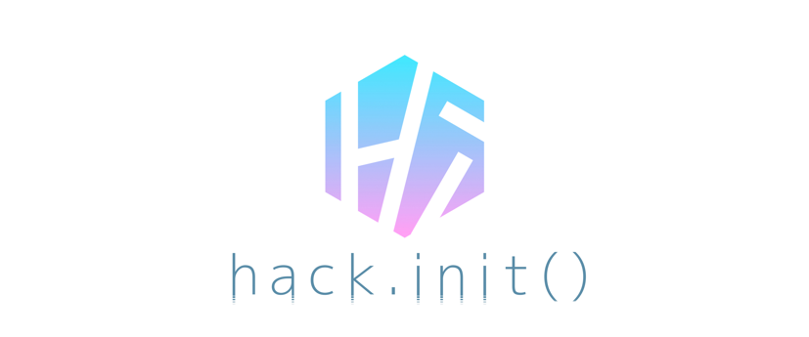

选手行为守则 | **Code of Conduct**

hack.init() 提倡包容。我们相信每一位参赛选手有权在一个安全舒适的环境中进行开发。

hack.init() stands for inclusivity. We believe every single person has the right to hack in a safe and welcoming environment.

骚扰的形式包括但不限于在公开场合提出具有攻击性的有关性别、年龄、性取向、残疾、外表、身形、种族、国籍及信仰的口头或书面评论。刻意的威胁、盯梢、跟踪、未经允许拍摄照片／视频、故意打断活动或演讲、不正当肢体接触及不受欢迎的关注也将被认定为骚扰。如果你的行为让他人感到不适，这样的行为也被认定为骚扰并应该立即停止。

Harassment includes but is not limited to offensive verbal comments related to gender, gender, age, sexual orientation, disability, physical appearance, body size, race, nationality, or religion, deliberate intimidation, stalking, following, photography or audio/video recording against reasonable consent, sustained disruption of talks or other events, inappropriate physical contact, and unwelcome sexual attention. If your behavior is making someone feel uncomfortable, that counts as harassment and is enough reason to stop doing it.

进行拍摄是被鼓励的，但是其他参赛选手应被给予合理的机会选择是否愿意被拍摄。如果他们拒绝被拍摄，请遵循该等要求。在包括洗手间、休息区在内的应保持私密的区域禁止拍摄。

Photography is encouraged, but other participants must be given a reasonable chance to opt in or out from being photographed. If they object to the taking of their photograph, comply with their request. It is inappropriate to take photographs in contexts where people have a reasonable expectation of privacy (in bathrooms or where participants are sleeping).

您在被要求停止骚扰时，须立即停止骚扰。

Participants asked to stop any harassing behavior are expected to comply immediately.

本竞赛中所有的参赛选手之项目均受限于反骚扰政策。如果任何项目被认为内容失当，组织者保留立即取消其参与之后竞赛环节资格的权利。

As this is a hackathon, we like to explicitly note that the hacks created at our hackathon are equally subjective to the anti-harassment policy. If a hack is deemed inappropriate, the Organizers reserves the right to immediately remove the hack from further hackathon proceedings.

赞助方、合作方、裁判、导师、志愿者、组织者、hack.init()工作人员及任何在活动现场的人员均应遵守反骚扰政策。参赛选手应尤其注意在开发及活动期间不应该使用任何具有性暗示的图片、活动或任何材料。

Sponsors, partners, judges, mentors, volunteers, organizers and hack.init() staff members are also subject to the anti-harassment policy. In particular, attendee should not use sexualized images, activities, or other material both in their hacks and during the event.

若任何参赛选手对他人进行骚扰，hack.init()组委团队将采取认为合理的行动，包括警告或将选手移出活动场地。若因违反上述反骚扰政策被剥夺参赛资格，选手将丧失获得旅费报销的资格。

If a participant engages in harassing behavior, the hackathon organizers may take whatever action they deem appropriate, including warning the offender, expulsion from the hackathon, or withholding reimbursements.

如果您认为受到了骚扰，或注意到他人受到骚扰，或有任何疑问，请立即联系hack.init()工作人员或志愿者。

If you are being harassed, notice that someone else is being harassed, or have any other concerns, please contact a member of the hack.init() organizing staff or volunteering staff immediately.

hack.init()行政委员会将帮助参赛选手联系保安人员或当地执法机关、提供护送或其他任何能够协助被骚扰者感到安全的措施。我们非常在意参赛选手的安全。

The hack.init() Executive Board will be happy to help participants contact campus security or local law enforcement, provide escorts, or otherwise assist those experiencing harassment to feel safe for the duration of the hackathon. We value your attendance.

我们要求所有参赛选手在本竞赛场地及所有与本竞赛有关的活动中遵守本行为守则。

We expect participants to follow these rules at the hackathon, workshop venues, and all other hackathon-related social events.

在正式宣布竞赛开始之前，所有参赛选手仅允许就其拟开发项目进行构思，不得以任何形式部分或全部于竞赛正式开始前对其项目进行开发、搭建、编程或其他任何影响竞赛公平性与完整性的活动。如有违反，取消参赛资格。

Before The hack.init() Executive Board officially announces the commencement of the hackathon, participants are only permitted to brainstorm their ideas. Develop, build, code, or conduct any other behavior that may affect the fairness and completeness of the hackathon in part or in whole of their project is forbidden and will result in disqualification.

—————————————————————————————————————————————————

hack.init()行政委员会及其法律主体上海创喵信息科技有限公司保留随时部分或全部修订、或变更上述本行为守则的权利，并保留在竞赛当天根据最新行为守则对参赛团队进行评估的权利。hack.init()行政委员会对上述政策保留最终解释权。如果你有任何关于上述政策的疑问，请通过发送电子邮件至 contact@hackinit.org 联系我们。

The hack.init() Executive Board and its parent legal entity, Shanghai InnoCat Information Technology Co., Ltd. reserve the right to revise, or otherwise amend these policies in whole or in part from time to time. The hack.init() Team reserves the right to evaluate every team in accordance to the latest policies published. The hack.init() Executive Board and its parent legal entity, Shanghai InnoCat Information Technology Co., Ltd. reserve the right to interpret the aforementioned policies. If you have any questions regarding these policies, please contact us by e-mail at contact@hackinit.org.

本选手行为守则最后修订于 **2017** 年 **6** 月 **16** 日

**This Code of Conduct was last updated on June 16, 2017**