1. Interface

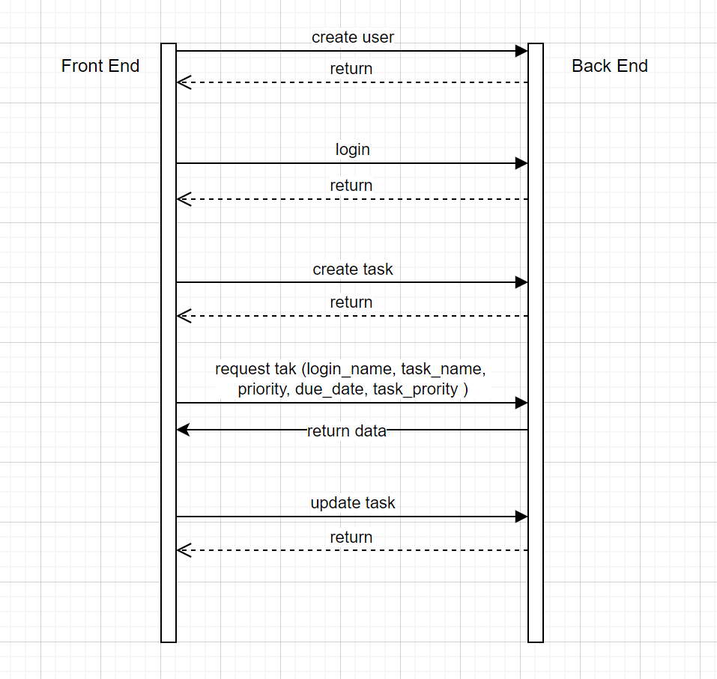

* Registration(create user)：

Input:

{

“loginName”: “Jack”,

“password”: “123456”,

“email”: [xxx@qqq.com](mailto:xxx@qqq.com),

“firstName”: “San”,

“lastName”: “Zhang”

}

Output:

{

“code”:0 stands for success, 1 stands for fail,

“message”: “user successfully created”,

“data”: null

}

* Login：

Input:

{

“loginName”: “Jack”,

“password”: “123456”,

}

Output:

{

“code”:0 stands for success, 1 stands for fail,

“message”: “user doesn’t exist”,

“data”: {

“userId”: “124232”,

“loginName”: “Jack”,

“password”: “123456”,

“email”: [xxx@qqq.com](mailto:xxx@qqq.com),

“firstName”: “San”,

“lastName”: “Zhang”

}

}

* Create Task：

Input:

{

“taskName”: “XXX”,

“priority”: 0,

“dueDate”: “2024-11-25”,

“uesrId”: “112321”

}

Output:

{

“code”:0 stands for success, 1 stands for fail,

“message”: “task create successfully”,

“data”: true/false

}

* Request Task：

Input:

{

“userId”: “XXX”,

“priority”: [0,1],

“dueDate”: “2024-11-25”,

“taskStatus”: 1

}

Output:

{

“code”:0 stands for success, 1 stands for fail,

“message”: “xxx”,

“data”: [

{

“taskId”: “12421”,

“taskName”: “XXX”,

“priority”: 0,

“dueDate”: “2024-11-25”,

“taskStatus”: 2,

“uesrId”: “112321”

},

{

“taskId”: “12421”,

“taskName”: “XXX”,

“priority”: 0,

“dueDate”: “2024-11-25”,

“taskStatus”: 2,

“uesrId”: “112321”

}

]

}

* Update Task:

Input:

{

“taskId”: “1242124”

“taskName”: “XXX”,

“priority”: 0,

“dueDate”: “2024-11-25”,

“taskStatus”: 1

}

Output:

{

“code”:0 stands for success, 1 stands for fail,

“message”: “task update successfully”,

“data”: true/false

}

* Delete Task：

Input:

{

“taskId”: “1242124”

}

Output:

{

“code”:0 stands for success, 1 stands for fail,

“message”: “task delete successfully”,

“data”: true/false

}

1. Database

