Core Logging with stratapy Instructions
Visit https://github.com/Jack6228/MW_UoE_Teaching
Scroll down to see the description of the files and brief instructions.
Click on the ‘launch binder’ button or directly visit https://mybinder.org/v2/gh/Jack6228/MW_UoE_Teaching/main?filepath=Demo_Notebook.ipynb
After a few moments, this will launch a website which will enable you to run the notebook we have provided in your browser, without any installation or login required.
You should see something like this:
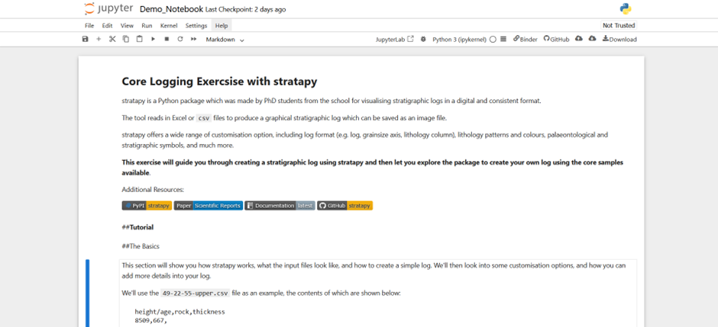
First, click on the ‘JupyterLab’ button at the top, which provides a better layout for what we want to do (see red circle).
This will open a more interactive version of the same page, as shown below:
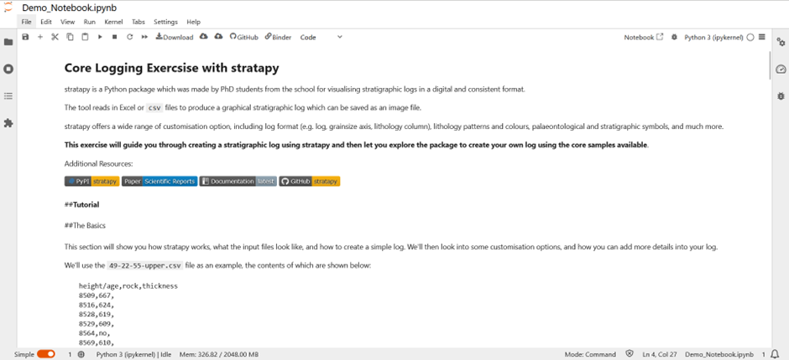
If you click the ‘File’ icon (circled in red above), you will be able to see all of the files provided, including the answers and csv templates for each log.
You can now go through the notebook in this view step by step and follow the instructions.
Cells with code in can be run by pressing Ctrl + Enter, or by pressing the ‘Play’ button in the top bar (right-pointing triangle, circled in red below):
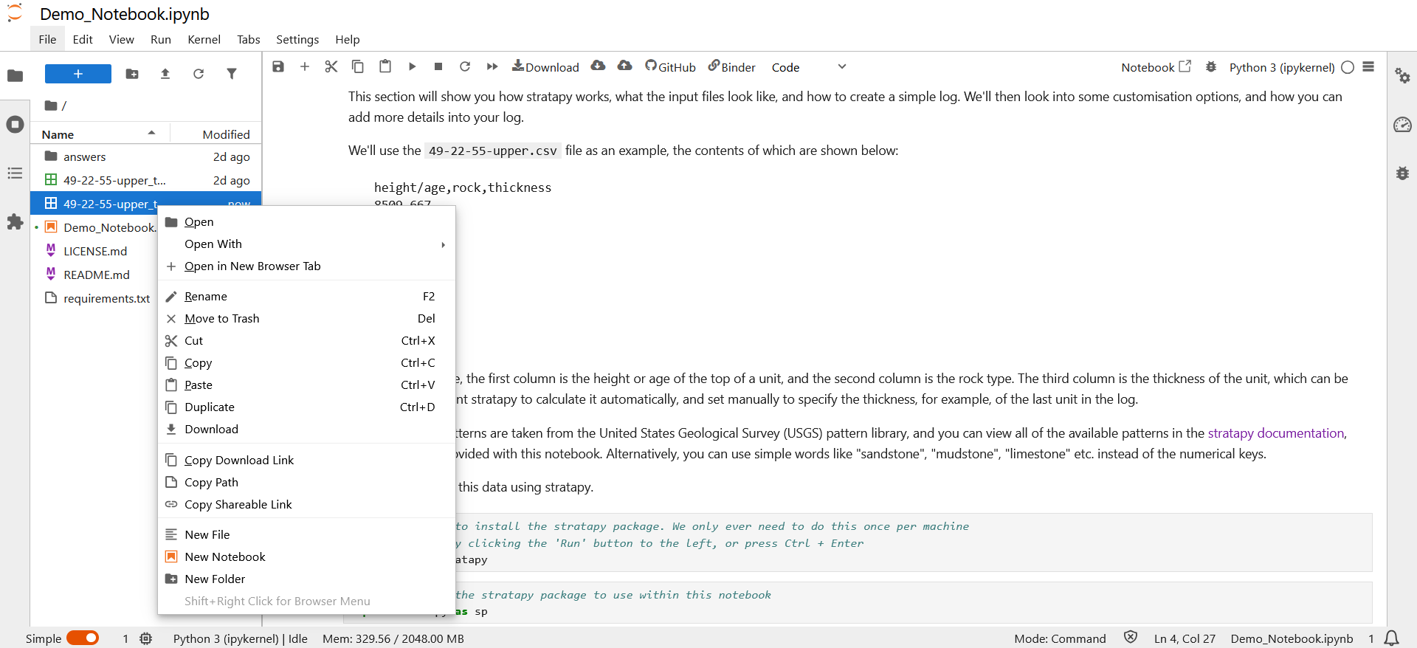
Run Code Cells
When you get to parts of the notebook where you are prompted to edit csv files, to do this, right click on the csv file you want to edit (like the one highlighted in blue above) and then click ‘Open With’ > ‘Editor’.
This will switch the view to the csv where you can adjust values.
To go back to the code notebook, simply double click on the ‘Demo_Notebook.ipynb’ entry.

When later prompted to create logs from scratch, you can either right click an existing csv file and press ‘Duplicate’ and rename the file and edit it. Or, you can right click in the empty space below the list of files and click ‘New File’. Make sure you name it something ending in .csv, instead of the default .txt extension.

