

Sentinel AI Camera
S5
Specification

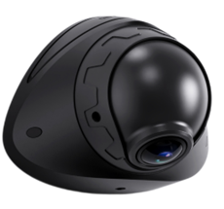

Contents
Preface 2
About the Specification 2
Trademark Notice 2
Disclaimer 2
Symbol Explanation 3
Product Introduction 4
Product Features 4
AI Features 5
Product Appearance and Component Names 5
Specification 6
Dimension Diagram 7
System Connection Diagram 8
Cables 8
Special Instructions 9

Preface

About the Specification
The Specifications provide details on the components and parameters of the S5 product. All content in this document, including text, images, and graphics, is owned by Shenzhen Streamax Technology Co., Ltd. You may not copy, modify, or use any part of this document without written permission from the company.
This document is intended for authorized users and technical support staff only. Product images and screen content are for reference—actual products may look different in color, size, or design. Please refer to the physical product for accurate details.
The data provided are based on internal lab tests and are for reference only. Actual performance may vary depending on product model, software version, usage, and environment.
Streamax may update or adjust the Specifications from time to time to reflect changes in the product's performance, features, or components, without prior notice.

Trademark Notice
is a registered trademark of Shenzhen Streamax Technology Co., Ltd. All other trademarks are the property of their respective owners.

Disclaimer
The products in this document are provided "as is" without any warranties, including those for merchantability or fitness for a specific purpose. Streamax is not responsible for any damages, such as loss of profits, data, or documents, caused by using the product or its specifications.
Streamax is not liable for internet-related risks, including hacking, cyber-attacks, or viruses. However, technical support will be provided as needed.
Users must follow all applicable laws when using this product. Streamax is not responsible for misuse or violations of third-party rights.
If there is a conflict between this document and the law, the law will apply.
Copyright © 2025 Shenzhen Streamax Technology Co., Ltd. All rights reserved.

Symbol Explanation

The following symbols are used to categorize and explain potential hazards that may arise from improper operation

Symbol | Explanation
 | Warning: Conditions that could jeopardize the safety of the user or cause injury
 | Important: Conditions that may lead to data corruption or damage to the device’s firmware or hardware
 | Note: Additional information, explanations of terms, and other relevant details

Product Introduction

The S5 is an AI-powered intelligent sentinel camera engineered to ensure comprehensive asset protection. Designed for continuous 24/7 operation, it provides uninterrupted high-definition monitoring to capture every critical moment. Featuring ultra-low power consumption and AOV standby mode, the S5 remains active even when the vehicle is turned off, maintaining constant security coverage. Integrated 4G, Wi-Fi, and GNSS modules enable real-time transmission of vehicle location, status, and operational data to the platform, supporting remote communication and video playback for precise asset management and control.

Product Features

- Built-In one ultra-wide-angle lens with up to 2 Megapixels HD video recording, supporting black light technology
- Supports human posture detection for accurate identification of theft.
- Supports H.264/H.265 encoding
- Supports 1*Micro SD storage ,up to 1TB
- Built-in Wi-Fi, 4G Cat1 communication module, and inertial navigation module
- Video data supports AES256 encryption
- Supports 1 channels of IO input, 1 channels of IO output and 1 RS232 channel
- Supports normal mode and AOV ultra-low power consumption mode
- Built-in 6-axis gravity sensor, supports detection of rapid acceleration, rapid deceleration, sharp turns, and collisions
- Built-in battery and can keep working for 5 minutes in case of a power outage (optional)

AI Features

- Vehicle collision detection, suspicious person detection
 | 
Vehicle contact inspection | Suspicious target detection

Product Appearance and Component Names

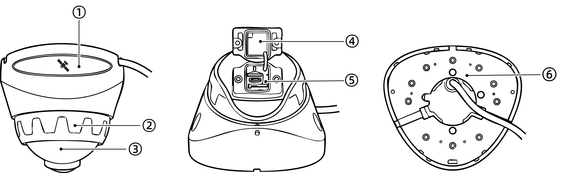

No. | Components
1 | GPS positioning module
2 | Horizontal Angle Adjustment Disc
3 | Vertical angle adjustment sphere
4 | TF card, SIM card cover
5 | TF card slot, SIM card slot, USB 3.0
6 | Rigid mounting base

Specification

General
System | Embedded Linux
Language | Options: Chinese, English, Spanish (Latin American), Portuguese (Latin American), French, Russian and Japanese  Default: English
Video
Max. Capability | Physical interface：1920*1080P @30fps
Image Setup | Adjustable brightness, chroma, contrast, color saturation, and sharpness
Video Coding | Options: H.264 and H.265  Default: H.265
Encoding Standard | Options: VBR and CBR. Default: VBR
Parameters of road facing lens
Sensor Type | 1/2.8" 2-megapixel CMOS sensor
Shutter Speed | 1/30s~1/100000s
Lens | Focal length: 1.9 mm  HFOV:175°VFOV:92
Minimum Illuminance | Color: 0.05 Lux/F1.2
Lens Mount | Built-in lens
Wide Dynamic Range (WDR) | Digital WDR
Backlight Compensation | AI-ISP，Support black light
Signal-to-Noise Ratio (S/N) | ≥42dB
Storage
Storage | 1*Micro SD,Up to1TB
Sensor
Six-axis Sensor | Harsh acceleration, Harsh deceleration, Harsh cornering, and accident detection
Port
RS232 | 1-channel
I/O Port | 1-channel input,1-channel output
USB | 1 × Type C USB2.0
Network
Wi-Fi | Support 2.4G (IEEE Std.802.11a/IEEE Std.802.11b/IEEE Std.802.11g  /IEEE Std.802.11n)
4G | Plug-in SIM card (Nano SIM card), reserved eSIM patch position, can support pre-burn-in eSIM. Plug-in SIM card and eSIM cannot be used simultaneously.   An industrial SIM card (MP2) is required. The use of a standard SIM card (MP1) is prohibited. We are not responsible for any issues caused by the use of a standard SIM card
Positioning
GNSS | Supported  GPS L1 1575.42MHz  GALILEO E1B/C1  GLONASS L1OF 1602MHz  SBAS: WAAS, EGNOS, MSAS, GAGAN
Power related
Power supply | 12V and 24V vehicles (self-adaptive)
Power consumption | - In AOV mode: about 500MW  - Typical power consumption (withSD cards installed and SIM  card for dialing): about 3.2W  Full-load power consumption (with SD cards installed, SIM card dial-up enables the device to report to the platform for streaming media preview over 4G,turn on WiFi mobile connection and preview video ): about 5W  * The above data are test data obtained in a specific environment in  the laboratory, and may vary with the individual product differences,  service environment, and testing methods
Environment
Operating Temperature | -40°C ~ +70°C (-40°F ~ +158°F) Non-Battery  -30°C ~ +60°C (-22°F ~ +140°F) Battery
Storage Temperature | -40°C ~ +85°C (-40°F ~ +185°F)
Operating Humidity | 15~95% non-condensing
Storage Humidity | 15~95% non-condensing
IP Rating | IP69K
Dimensions and Weight
Dimensions  L×W×H | L 121.2×W106.6× H 92.9mm
Weight | Net weight (device only): 290g  Gross weight (including accessories and package): 640g  Deviation: ±10g
* The actual dimensions and weight may vary with the individual product differences, manufacturing processes, and testing methods.

Dimension Diagram
(Unit: mm)

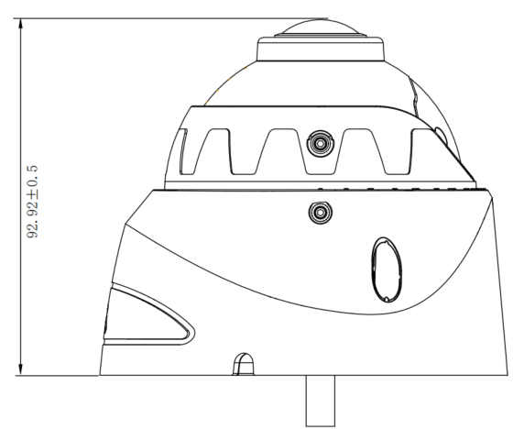 | 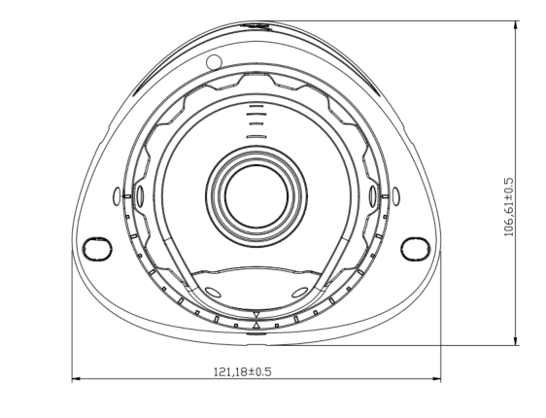
Left View | Front View
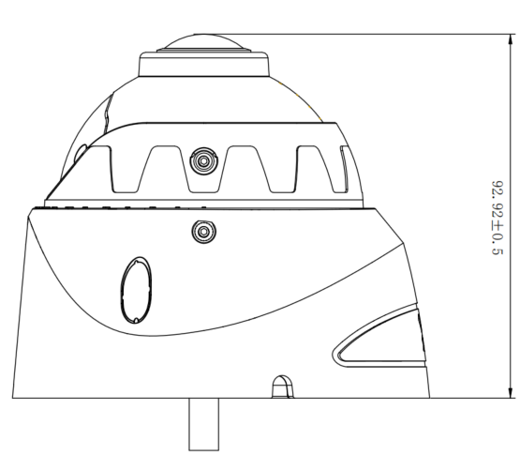 | 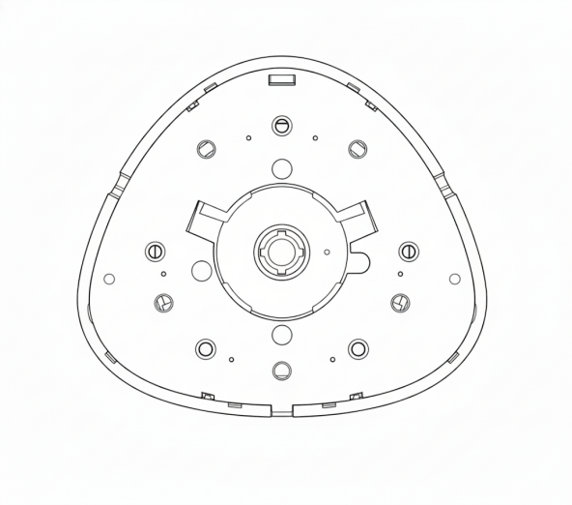
Right View | Rear View

System Connection Diagram

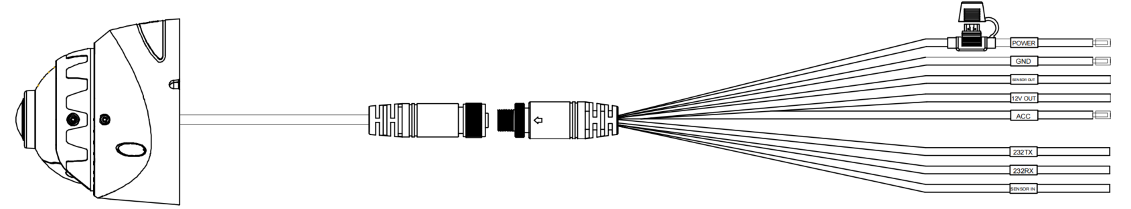

Cables

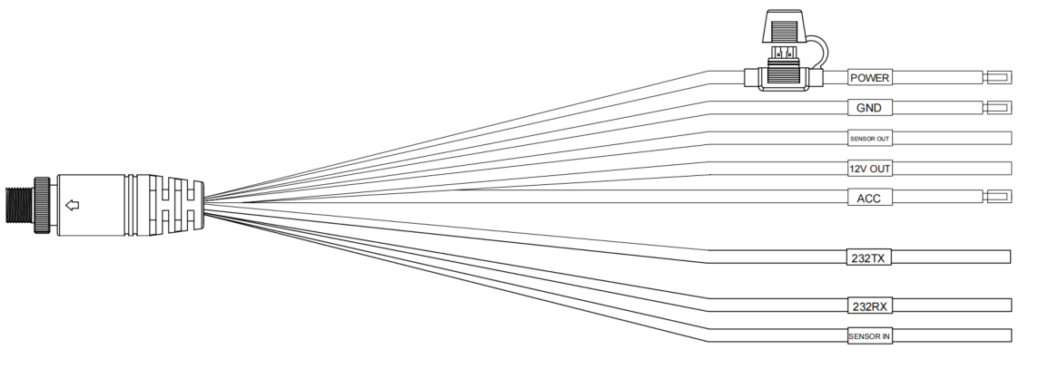

Special Instructions

- This product requires installation by professionals; otherwise, there is a risk of electric shock, damage to the vehicle wiring, impact on AI performance, and device detachment.
- When used under direct sunlight, the surface temperature of this product may exceed 60°C. Please avoid touching the sun-exposed surface to prevent burns.

