
Normally Busy Computer Consultants
"A Member of the JoeMarr Family of Companies"

From: Jack Watt / Developer
PROG1195 Applications Development Group

To: J.E.Marriott / Project Manager
Date: 2012-10-19
Re: RECs Phase 2

Lab went well, windows programming is fun. This lab was the easiest so far, only because I know understand windows programming(to a point(more than I did before)). I spent a good four or five hours on this project. I find navigating around projects was the hardest part. The coding aspect has been the easiest part. Now it’s about evan.

Testing Verification Document
[ tested & verified ] [  partially functional, explanation provided ] [  test failed or not completed ]

- [] Correct Client Input dialog design
( Size / Titlebar / Control Attributes & Alignment / Spelling / Max-Min Boundaries / Field Inits 10).

(Replace the following images with YOUR OWN matching test cases)
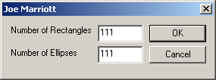
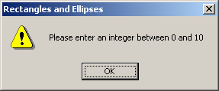

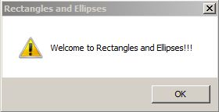
- [] Upon correct input, and OK,
Welcome message displayed.
(Replace the following image with YOUR OWN)

- [] Cancel button on dialog terminates application

- [] Rectangles / Ellipses draw on appropriate mouse clicks

- [] Rectangles / Ellipses “move” away from each other upon successive clicks

- [] Movement does not affect “current” Rectangle / Ellipse (it appears directly under mouse)

- [] Keyboard activity toggles display order (Over/Under) of Rectangles / Ellipses

- [] Keyboard activity does not “move” Rectangles / Ellipses

- [] File… New allows program to be run again with new settings

[] All personal debug code (if any) removed or deactivated.
[] Submission package complete as per requirements. (See Blackboard)

I attest I have tested and verified each of the above specifications, unless indicated otherwise.

I understand that falsely claiming a verified spec indicates my attempt to falsify results to the Quality Assurance Department, and I will be subject to additional penalties.

Name: Jack Watt

Date: 2012-10-19

