
Normally Busy Computer Consultants
"A Member of the JoeMarr Family of Companies"

From: Jack Watt / Developer
PROG1195 Applications Development Group

To: D Morris / Project Manager
Date: 2012/09/24
Re: Java 1

This lab went very well. I got stuck on what to do for no args and also for what to do with non double args. My solution for no args ended up being simple. After trying to do something like: if (args[0] == null) {} with no luck, I then tried putting that in a try/catch block. Still no luck. The answer was simple actually. Ended up just doing if (args.lenght == 0) {}. The way I fixed the non double was to use a try/catch. I took the inititive to add up all the args WHILE I was looping through the whole args array. If at any point one wasn’t double material I killed everything and didn’t proceed. Using basic first year knowledge of booleans and a simple name of isValid. I’m really liking Java. It seems very light weight and very easy to learn/use. I wondered just how portable it really was, So I booted up my mac partition and ran it from the command line. Which is more of what the program was obviously intended to do.

Really enjoying Java! Hopefully we get into DB connection and multi threading. That’s where I’d like to see the direction fo the course go.

Jack Watt

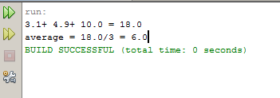
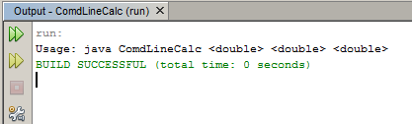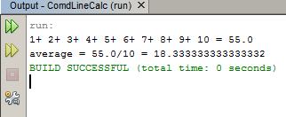
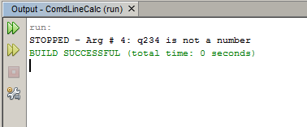

/*
* To change this template, choose Tools | Templates
* and open the template in the editor.
* Jack Watt
*/
package comdlinecalc;

/**
*
* @author 2014617
*/
public class ComdLineCalc {

/**
* @param args the command line arguments
*/
public static void main(String[] args) {
// TODO code application logic here
// double answer = args[0] + args[1];

double average = 0;
boolean isValid = true;
//looks through args using length to get all args
//Error checks all inputs
int i = 0;

//runs through array of args
//stops if reaches non numeric value
if(args.length == 0) {

isValid = false;
//outputs instructions to end user on proper syntax
System.out.println("Usage: java ComdLineCalc <double> <double> <double>");

}
while (isValid && i <= args.length - 1) {

//casts arg to double
try {

Double.parseDouble(args[i]);
average += Double.parseDouble(args[i]);
//if arg can't be cast to double stops program
} catch (NumberFormatException e) {
System.out.println("STOPPED - Arg # " + (i + 1) + ": " + args[i] + " is not a number");
isValid = false;
}
//iterate the counter
i++;
}
//given nothing has gone wrong yet it outputs the data to the screen
if (isValid) {
for (i = 0; i < args.length - 1; i++) {
System.out.print(args[i] + "+ ");

}
//Displays average
System.out.println(args[args.length - 1] + " = " + average);
System.out.println("average = " + average + "/" + args.length + " = " + average/3);

}

}
}

