Jackson Bellinger & Sean McGee
Lab6

Theoretical time complexity: matrix multiplication = O(n**3 / p) but since the matrix is a one dimensional matrix vector multiplication is O(n**2 / p): p < n
The entire algorithm is O(n**2/p * #iterations) The number of iterations depends greatly on the initial matrix and vector. If the initial vector is relatively close to the eigenvalues, then it will converge quickly, but there can be cases in which it will take a long time, or possibly not converge at all (ie singular matrices or if two eigenvalues have the same magnitude).
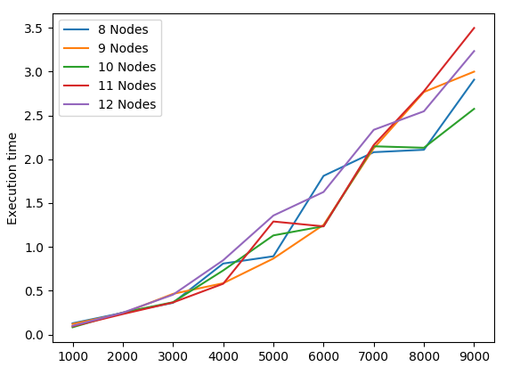
This is the graph of our actual timing

I think the main reason that more nodes doesn’t increase the speed is that we are still using the dot product version of parallel matrix multiplication. Although with matrix vector multiplication, using the dot products should be close to as parallel as possible, since the row sum is distributed. AKA ¯\_(ツ)_/¯
Matrix side len

Real World Applications:
Pretty much anything that uses matrices can benefit from finding eigenvalues. Our method only finds the principal eigenvalue. We would have to modify our algorithm to remove the columns associated with each eigenvalue as they are found. Some notable applications are image compression, special relativity (Einstein actually said that "Light is an eigenvector of the Lorentz transform."), and the Page Rank. The distribution could greatly speed up these algorithms if done right, and I’m sure that Google employs their own parallel algorithms to implement the Page Rank algorithm.

Improvements:parallelising
We plan to improve the matrix multiplication with block parallelism, and test out some other methods of parallelizing. Also I would like to experiment with parallelizing the actual power method iteration, rather than the matrix multiplication.

