HFP driver test signing

1. Open Command Prompt as Administrator and go to the driver package folder.

2. Create test certificate:

makecert -r -pe -ss PrivateCertStore -n CN=Conduit(TestCert) ConduitTest.cer

*ConduitTest.cer* file will appear in the folder.

3. Sign driver's catalog (*.cat) and the driver itself (*.sys) with the certificate:

signtool sign /v /s PrivateCertStore /n Conduit(TestCert) /t http://timestamp.verisign.com/scripts/timstamp.dll hfpdriver.cat HfpDriver.sys

Output example:

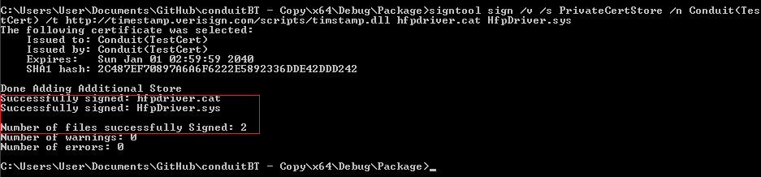

**4. Installing the** certificate in Test Computer

**certmgr.exe -add** ConduitTest.cer **-s -r localMachine root**

5. Run Windows in Test Mode

Bcdedit.exe -set TESTSIGNING ON

Reboot to take effect. After reboot, text "Test Mode" will appear, in right-hand corner of the desktop.

Now you can install test-signed drivers.

To turn off Test Mode, run

Bcdedit.exe -set TESTSIGNING OFF

and reboot.

Note:

The tools: makecert, signtool and **certmgr are part of Windows SDK.**

**To view the certificate:**

1. Click **Start** and then click Start Search.
2. To start the Certificates snap-in, type Certmgr.msc and press the **Enter** key.
3. In the left pane of the Certificates snap-in, expand the PrivateCertStore certificate store folder and double-click Certificates.

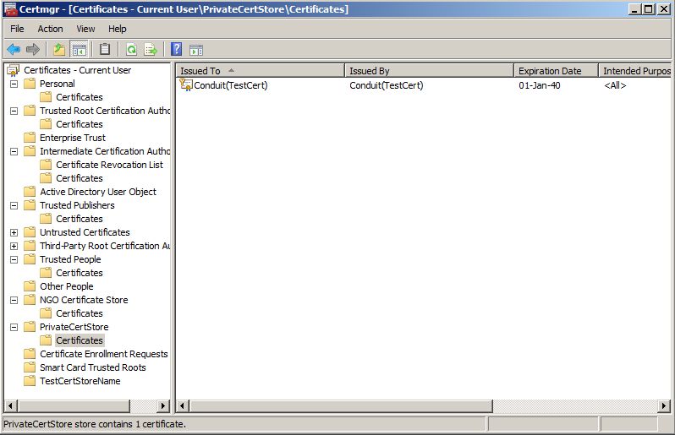

For how to sign a driver for Public Release; please refer to [Signing Drivers for Public Release](http://msdn.microsoft.com/en-us/library/windows/hardware/ff552289(v=vs.85).aspx)