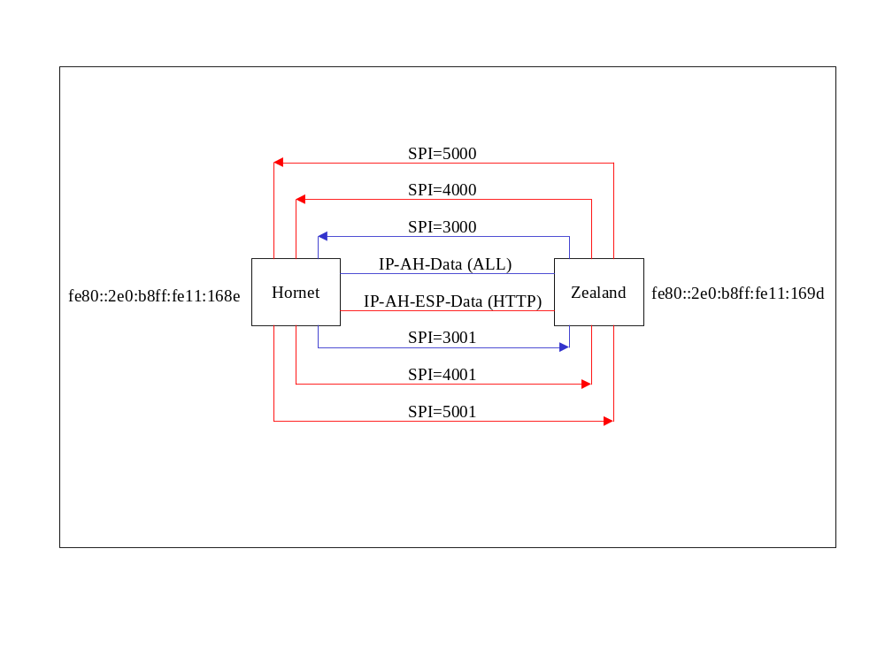
This example illustrates IPSec using manual keys. Two NT machines, Hornet and Zealand, are connected on the same link. To communicate using IPSec, the SPD and SAD of each machine must have the correct policies and associations.

Click here to see Hornet’s SPD and SAD.

Click here to see the Zealand’s SPD and SAD.

Note that both machines have loopback policies and associations, which can be used for testing, when only one machine is available.

To add policies and associations to your machines, first type ipsec c <filename> (filename has no extensions). This creates “filename.spd” and “filename.sad” in your current directory. The only policy is the default that allows all traffic. No SAs yet exist in the SAD file. You can just copy my SAD and SPD files off of the web and save them as *.sad and *.spd. To just view the current SPD and SAD, type ipsec sp or ipsec sa

Add the policies to the *.spd file and the associations to the *.sad file following the example SPD and SAD. Once the SP and SA entries are in the files, type ipsec a <filename>. This creates the SPD and SAD in the kernel. Only new entries are added to the kernel. So, the default SP entry (#1) is not modified. “New” just means the index number of the SP or SA entry is greater than the highest current SP or SA entry that is in the kernel. A more advanced IPSec utility will handle deleting and editing kernel entries. To stop and entry from being used now, you can add a newer entry that overrides the old entry. Overriding is using the same selectors with a different Action or Key or something.

The SPD is ordered from most specific to most general. Most specific entries are ones with selectors defined to specific values. Looking at Hornet’s SPD, SP entry 4 is more specific than 3 due to the “Protocol” selector being set to “TCP.”

When IKE is used, the SA entries are created from the SP entries. Looking at the SP entries, the selectors have an indicator for “take from policy (-)” or “take from packet (+).” This means that the SA entry selectors are either taken from the policy selectors or taken from the packet that causes the SA to be created. I use “take from policy” for simplicity and enter “POLICY” in the SA selectors.

