IPsec Processing

This document is based on the initial IPsec design meeting between Microsoft Research Ipv6 group (MSRIPv6) and Information Sciences Institute (ISI-East) held September 23-24, 1998. The purpose of the design meeting was clarification of the IP Security Architecture Draft and discussion of the Ipv6 implementation of IPsec.

To understand IPsec, a somewhat real-world example is used. Figure 1 shows the network topology used for the example. IPv4 addresses are used for simplification. Two Class C subnets, Net1 (10.2/16) and Net2 (15.4/16), are connected to the Internet through security gateways SG1 and SG2, respectively. A remote host, H3, is connected through a dialup connection to the Internet.
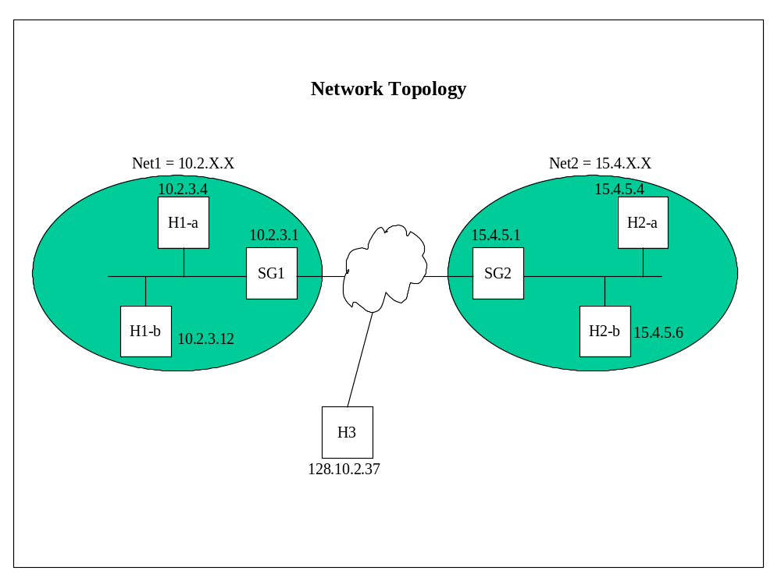
Figure 1

Before discussing IPsec traffic, the definitions of the Security Policy Database (SPD), Security Association List (SA List), and Security Association Database (SAD) are in order. First, the SPD, shown in Table 1, is an order list of rules with selectors used to match the traffic being processed to a policy. The “Bundle Spec” specifies what IPsec processing is performed. The “Action” indicates whether IPsec is done or not. The “First SADPtr” points to the first SAD, referred to as SA bundle in the Security Architecture Draft. Two SPDs exist for each IPsec interface. In the case of hosts, there is one outbound and one inbound SPD.

SPD |------------------------------------selectors---------------------------------------|
Policy Num | Dest IP Addr | Src IP Addr | Trans Proto | Dst Port | Src Port | Bundle Spec | Action | First SADPtr
order list | single value,  range, or  wildcard  (policy or packet) | single value,  range, or  wildcard  (policy or packet) | single value,  range, or  wildcard  (policy or packet) | single value,  range, or  wildcard  (policy or packet) | single value,  range, or  wildcard  (policy or packet) | IPsec mode and protocol pair | do IPsec processing, bypass IPsec, or discard | pointer to SAD entry

Table 1

Next, the SAD shown in Table 2 is comprised of the same selectors as the SPD. The first SAD is pointed to from the SPD. An inbound and outbound SAD exists like the SPDs. A SAD entry can be created during traffic processing. The SPD selector entries have an indicator to specify how the SAD entry is created. The indicator is “packet” or “policy.” Policy means the SAD selector value matches the SPD selector value. Packet means the selector value is taken from the actual packet during traffic processing. Later examples show the creation of SADs. The “SAPtr” points to the SA(s) used for the traffic processing. The “Next SADPtr” is the next entry in the SA bundle. If the “packet” indicator is used in one of the SPD selectors, the “Next SADPtr” will most likely point to another entry instead of Null. Multiple SAD entries are called SA bundles.

SAD
Memory Location | Dest IP Addr | Src IP Addr | Trans Proto | Dst Port | Src Port | SAPtr | Next SADPtr
location of the SAD entry | single value,  range, or  wildcard | single value,  range, or  wildcard | single value,  range, or  wildcard | single value,  range, or  wildcard | single value,  range, or  wildcard | pointer to SA(s) | pointer to next SAD in the bundle

Table 2

Lastly, the SA List shown in Table 3 is how two devices communicate the relevant IPsec information. The “SPI” is a unique 32-bit number specified by the receiver of IPsec traffic. For example when sending traffic to H1-a, the sending entity uses the SPI supplied by H1-a (to talk to me securely use this SPI). The “Dst IP Addr” is the destination IP address of the IPsec receiver. The “Proto” is the IPsec protocol (AH or ESP). The “Mode” is tunnel or transport. The “Security FunctionPtr” is the algorithm used to do authentication or encryption/decryption. The SAD points to the SA used for the specific SAD entry. Again, two SA Lists exist for inbound and outbound.

SA List
Memory Location | SPI | Dst IP Addr | Proto | Mode | Security FunctionPtr
location of the SAD entry | 32-bit number | IP address | AH or ESP | tunnel or transport | pointer to algorithm which contains the key, etc.

Table 3

The three databases (tables) discussed above are consulted to decide how to handle inbound and outbound traffic. Figure 2 shows the relationships of the tables to each other. The SPD points to the first entry in the SAD for the policy. The first SAD entry points to the next SAD entry and so forth. Note a SAD entry points to another SAD entry if one of the selectors in the SPD is a range or wildcard with the packet deciding the SAD entry. For example, if the SPD entry for destination IP address was a range, Net1, and the traffic was sent to multiple hosts within Net1. For every new host, a new SAD entry is created and pointed to by the previous entry.

The SAD entry points to one or more SAs in the SA List. From Figure 2, SAs can be shared by different SAD entries. SA1 is shared by SAD entries 1-1 and 1-3. SA3 is shared by SAD entries 2-1 and 1-2. The SA sharing is discussed later.

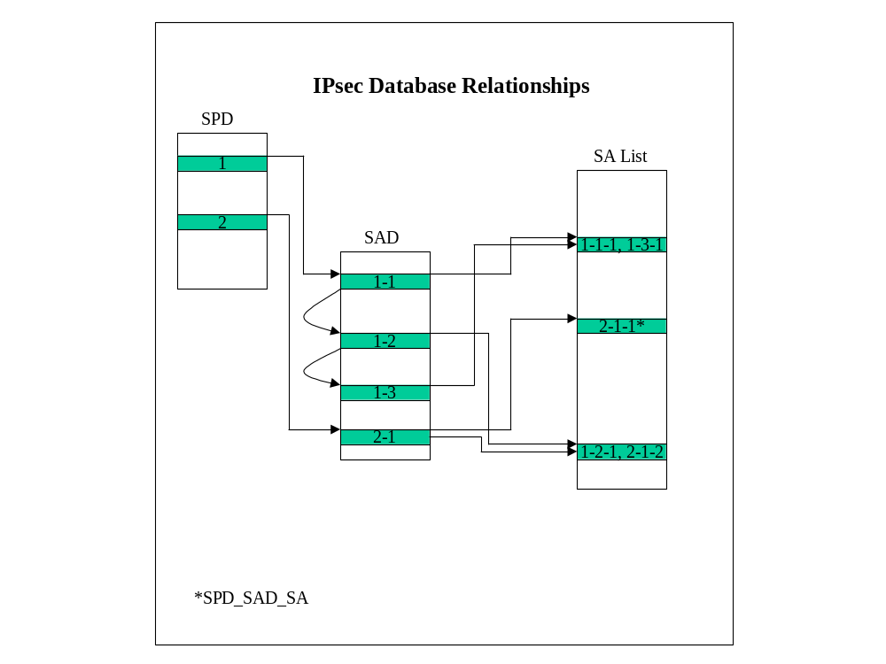Figure 2

Now that the databases (data structures) involved for IPsec have been discussed, the traffic examples are presented. Figure 3, illustrates the traffic flow for the examples. H2-a sends traffic to H1-a. H2-a also sends traffic to H3. H2-b sends traffic to H3. The SPD, SAD, and SA List are shown for each network device that participates in the traffic flow.
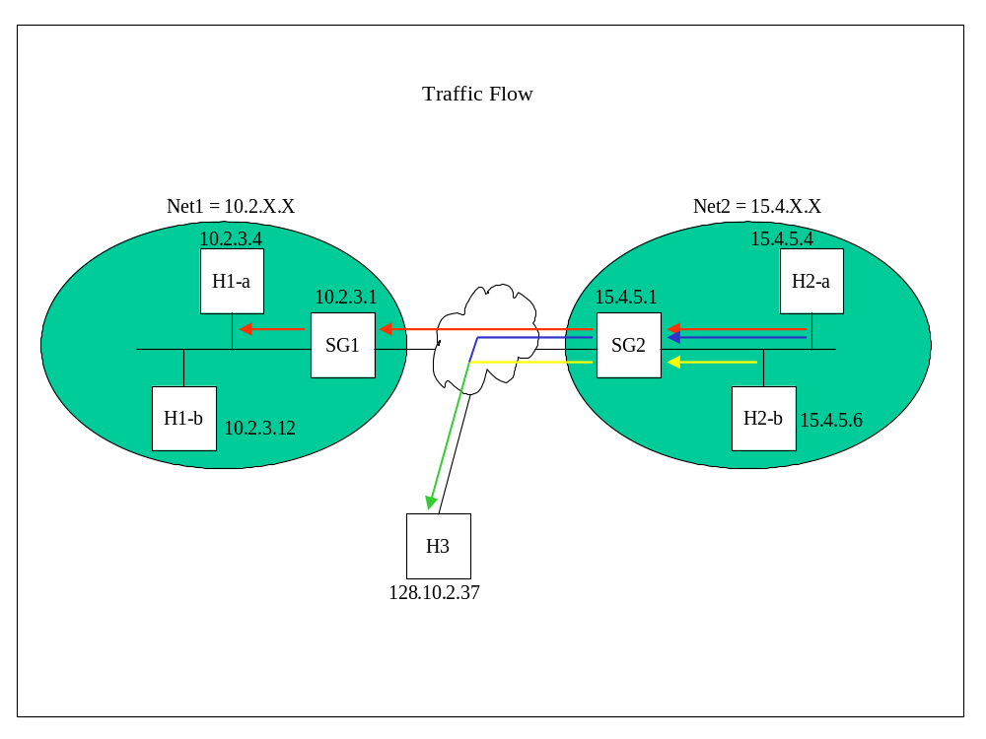Figure 3

H2-a (15.4.5.4) Outbound

The first example discusses traffic from H2-a to H1-a shown as the red arrows in Figure 3. The SPD is checked for a policy matching traffic destined for H1-a (10.2.3.4). Two policies exist in the SPD for traffic to H1-a. The first, Policy 1, is for TCP traffic. The second, Policy 2, is for any traffic destined to Net1 (10.2/16) with the packet determining the SAD entry selector, denoted by “(packet)” in the “Dst IP Addr” field. The SPD is ordered with the more specific policy before a more general case as shown by Policy 1 coming before Policy 2. Policy 1 has “TCP” value in the “Trans Proto” field while Policy 2 has the “*” wildcard.

SPD
Policy Num | Dest IP Addr | Src IP Addr | Trans Proto | Dst Port | Src Port | Bundle Spec | Action | First SADPtr
1 | 10.2.3.4 | * | TCP |  |  | Tunnel AH | IPSEC | 4
2 | 10.2/16 (packet) | * | * | * | * | Trans AH | IPSEC | 1
3 | 128.10.2.37 | * | * | * | * | Trans AH | IPSEC | 2
Last | * | * | * | * | * |  | DISCARD | Null

Looking at the SAD entries, Policy 1 points to SAD Entry 4. SAD Entry 4 denotes the memory location of the SAD entry and is not an ordered list. Policy 2 points to SAD Entry 1. The “Next SADPtr” of SAD Entry 1 points to SAD Entry 3 with the destination address of H1-b (10.2.3.12). Since the “Dst IP Addr” selector of Policy 1 has the “packet” indicator set, a new SAD entry is created for each new destination address with the network ID 10.2/16. To use the same SAD for all the hosts on Net1, Policy 2 could have the “policy” indicator set in the “Dst IP Addr” selector field.

SAD
Location | Dest IP Addr | Src IP Addr | Trans Proto | Dst Port | Src Port | SAPtr | Next SADPtr
1 | 10.2.3.4 | * | * | * | * | 1 | 3
2 | 128.10.2.37 | * | * | * | * | 3 | Null
3 | 10.2.3.12 | * | * | * | * | 2 | Null
4 | 10.2.3.4 | * | TCP | * | * | 4 | Null

The last data structure is the SA List. The SA List shown in the example does not contain all the information that is in the implementation. The relevant fields are shown. The SAD entry “SAPtr” field points to the SA in the SA List that is used for the SAD entry. Internet Key Exchange (IKE) is used to negotiate SAs; but, since the MSRIPv6 IPsec implementation uses manual keying, the SA must already exist. The SA is made up of the SPI/Dst IP Addr/Mode. If tunnel “Mode” is used, the destination IP address is the address of the outer tunnel. For host-to-host communication, the inner and outer IP addresses are usually the same.

SA Entry 1 is used to communicate to H1-a. SA Entry 4 is also used to communicate with H1-a except the SA is for TCP traffic. In the case of SPD Policy 2, a SAD entry is created when there is a new destination IP address in Net1. The SA List is searched and the SA found. Then, SAD Entry 4 points to SA Entry 4. If SPD Policy 2 had the “policy” indicator set, SAD Entry 4 would not be needed.

SA List
Memory Location | SPI | Dst IP Addr | Proto | Mode | Security  FunctionPtr
1 | 500 | 10.2.3.4 | AH | Trans | AH function
2 | 600 | 10.2.3.12 | AH | Trans | AH function
3 | 500 | 128.10.2.37 | AH | Trans | AH function
4 | 1200 | 10.2.3.4 | AH | Tunnel | AH function

Once the correct SPD entry, SAD entry, and SA are found, the packet is authenticated with the security function pointed to by “Security FunctionPtr” in the SA entry. After the all the IPsec processing is finished, the packet is sent to the network. The next network device to receive the traffic is SG2.

SG2 (15.4.5.1) Outbound

SG2 is a security gateway intercepting all traffic bound for the Internet. The SPD is check for a policy matching traffic destined for 10.2.3.4. Policy 2 is found. The SAD entry is checked to find the SA. The packet is encrypted and a new IP header is added with destination address SG1 and source address SG2. The packet is sent to the Internet.

SPD
Policy Num | Dest IP Addr | Src IP Addr | Trans Proto | Dst Port | Src Port | Bundle Spec | Action | First SADPtr
1
2 | 10.2/16 | 15.4/16 | * | * | * | Tunnel ESP | IPSEC | 1
3 | 128.10.2.37 | 15.4/16 | * | * | * | Tunnel ESP | IPSEC | 2
Last | * | * | * | * | * |  | DISCARD | Null

SAD
Location | Dest IP Addr | Src IP Addr | Trans Proto | Dst Port | Src Port | SAPtr | Next SADPtr
1 | 10.2/16 | 15.4/16 | * | * | * | 1 | Null
2 | 128.10.2.37 | 15.4/16 | * | * | * | 3 | Null
3
4

SA List
Location | SPI | Dst IP Addr | Proto | Mode | Security FunctionPtr
1 | 1300 | 10.2.3.1 | ESP | Tunnel | ESP function
2
3 | 400 | 128.10.2.37 | ESP | Tunnel | ESP function
4

SG1 (10.2.3.1) Inbound

The last two network devices did outbound IPsec processing. SG1 performs inbound processing. The packet is received on the Internet interface of SG1. The SA List is searched using the triple SPI/Dst IP Addr/Proto. A SA is found that matches the inbound packet’s selectors. The packet is decrypted with the function pointed to in the SA. Since SG1 is not the final destination of the packet, the packet must be forwarded. However before forwarding, the SPD is checked to make sure the correct IPsec processing was performed. The SPD is searched to find a policy that matches the packet. Policy 2 matches. The SAD entry is check to verify IPsec processing. The right IPsec was done so the packet is forwarded.

SPD
Policy Num | Dest IP Addr | Src IP Addr | Trans Proto | Dst Port | Src Port | Bundle Spec | Action | First SADPtr
1
2 | 10.2/16 | 15.4/16 | * | * | * | Tunnel ESP | IPSEC | 1
3
Last | * | * | * | * | * |  | DISCARD | Null

SAD
Location | Dest IP Addr | Src IP Addr | Trans Proto | Dst Port | Src Port | SAPtr | Next SADPtr
1 | 10.2/16 | 15.4/16 | * | * | * | 1 | Null
2
3
4

SA List
Location | SPI | Dst IP Addr | Proto | Mode | Security FunctionPtr
1 | 1300 | 10.2.3.1 | ESP | Tunnel | ESP function
2
3
4

H1-a (10.2.3.4) Inbound

H1-a receives the packet and does the same processing as mentioned in SG1. The packet is destined for H1-a so the IPsec processing is verified before the packet’s data is sent to the application. Remember two policies exist for traffic sent from H2-a to H1-a. So, the first policy that matches may not be the correct policy. For example if the traffic was TCP, the policy is Policy 1. If the traffic was not TCP, Policy 2 should have been used.

There is the case that H2-a sent TCP traffic to H1-a using the “wrong” SA. The “wrong” SA means H2-a probably didn’t have the policy denoting TCP in the outbound SPD. The SAD entries are checked to find the SA. The SA performed is checked against the SA for the specific SAD entry. When a match is found, the traffic is passed to the application. If a match is not found, the traffic is dropped.

SPD
Policy Num | Dest IP Addr | Src IP Addr | Trans Proto | Dst Port | Src Port | Bundle Spec | Action | First SADPtr
1 | 10.2.3.4 | * | TCP |  |  | Tunnel AH | IPSEC | 4
2 | 10.2/16 (packet) | * | * | * | * | Trans AH | IPSEC | 1
3
Last | * | * | * | * | * |  | DISCARD | Null

SAD
Location | Dest IP Addr | Src IP Addr | Trans Proto | Dst Port | Src Port | SAPtr | Next SADPtr
1 | 10.2.3.4 | * | * | * | * | 1 | 3
2
3 | 10.2.3.12 | * | * | * | * | 2 | Null
4 | 10.2.3.4 | * | TCP | * | * | 4 | Null

SA List
Location | SPI | Dst IP Addr | Proto | Mode | Security FunctionPtr
1 | 500 | 10.2.3.4 | AH | Trans
2 | 600 | 10.2.3.12 | AH | Trans
3
4 | 1200 | 10.2.3.4 | AH | Tunnel

H3 (128.10.2.37) Inbound

The above example illustrates two hosts using IPsec while protected by security gateways. The hosts use AH Transport and the security gateways use ESP Tunnel. The next example is a mobile host doing both AH Transport and ESP Tunnel. From Figure 3, H2-a sends traffic to H3 in AH Transport mode (shown with blue arrows). H2-a and SG2 do the same processing that was discussed in the previous example.

When the packet arrives at H3, the SA is found using the triple SPI/Dst IP Addr/Proto. The first IPsec processing is the ESP Tunnel mode. After the decryption, the packet is recognized to be for H3 and the second IPsec processing is done. The SA for authentication is found and the packet is authenticated. The SPD verification requires that both of the SAs used be checked. Using the selectors, the first match is found in the SPD. The SAD entry is check to see if the SAs performed match the SAs in the SAD. For example, the traffic from H2-a to H3 looks as follows when it reaches H3:

ESP_Tunnel_AH_Transport

The SA order in the SAD entry must match the order of the packet processing. If the first policy does not match, the SPD check is continued. After the packet is verified, it is passed up the stack. Again if the policy verification fails, the packet is dropped.

H3 also receives traffic from H2-b (denoted by the yellow arrows in Figure 3). H2-b and H3 do AH Transport. SG2 and H3 do ESP Tunnel. The ESP Tunnel SA is the same as the one used for traffic from H2-a to H3. In essence, the SAD entries share a SA as evident by the “SAPtr” field of SAD entry 1 and 2.

SPD
Policy Num | Dest IP Addr | Src IP Addr | Trans Proto | Dst Port | Src Port | Bundle Spec | Action | First SADPtr
1 | 128.10.2.37 | 15.4.5.4 | TCP | * | * | Trans AH | IPSEC | 3
2 | 128.10.2.37 | 15.4/16  (packet) | * | * | * | Tunnel ESP/Trans AH | IPSEC | 1
3
Last | * | * | * | * | * |  | DISCARD | Null

SAD
Location | Dest IP Addr | Src IP Addr | Trans Proto | Dst Port | Src Port | SAPtr | Next SADPtr
1 | 128.10.2.37 | 15.4.5.4 | * | * | * | 1, 2 | 2
2 | 128.10.2.37 | 15.4.5.6 | * | * | * | 5, 2 | Null
3 | 128.10.2.37 | 15.4.5.4 | TCP | * | * | 4 | Null
4

SA List
Location | SPI | Dst IP Addr | Proto | Mode | Security FunctionPtr
1 | 500 | 128.10.2.37 | AH | Trans
2 | 400 | 128.10.2.37 | ESP | Tunnel
3
4 | 1200 | 128.10.2.37 | AH | Trans
5 | 800 | 128.10.2.37 | AH | Trans

Conclusion

The discussion was based on the interpretation of the IP Security Architecture Draft. The MSRIPv6 group and ISI-East are gathering more information and this document will be revised as necessary.

